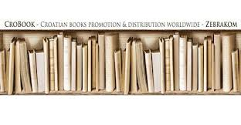


ZEBRA komunikacije d.o.o., Dubašnička 12, 10000 Zagreb – Croatia - www.zebrakom, info@zebrakom.hr

Introducing New Books from
Croatia 4/2025

Museum. Philosophy. Social Sciences. Humanities

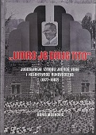
Author | Mosković, Boris
Title | "Umro je drug Tito" : Jugoslavija između jednog vođe i kolektivnog rukovodstva (1977-1982
Publisher | Zagreb : Srednja Europa, 2025
Description | 355 str. ; 25 cm
Note | Prijevod djela: Po Titovi-Tito! : přechod od charismatickeho vüdcovstvi ke kolektivnimv socialisticke Jugoslavii.
ISBN | 9789533870663 : EUR 34.70 US$ 41.60
Subject | Jugoslavija - politička povijest - 1974/1991. Tito, Josip Broz, 1892-1980 - bolest i smrt  Tito, Josip Broz, 1892-1980 - političko djelovanje
UDC | 323.1(497.1) Nacionalni, narodni, etnički pokreti i problemi... u Jugoslaviji * 94(497.1) Povijest Jugoslavije

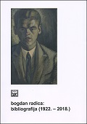
Author | Miletić, Ivan, povjesničar
Title | Bogdan Radica : bibliografija (1922. - 2018.)
Publisher | Split : Književni krug, 2025
Description | 336 str. : ilustr. ; 24 cm.
ISBN | 9789531635738 : EUR 21.00 US$ 25.20
UDC | 929Radica, B.(01)
Bogdan Radica (1904-1993) is one of the most important Croatian intellectuals of the 20th century.
The bibliography (1922-2018) covers almost the largest part of his work and is based on the citation method from The Chicago Manual of Style, 16th ed. (2010), because Bogdan Radica lived and worked in America for over 50 years and published most of his works in American publications and in the Croatian emigrant press, mainly in America and Canada.

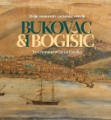
Author | Vodopija, Marko, povjesničar
Title | Bukovac i Bogišić : dvije znamenite cavtatske obitelji = Bukovac & Bogišić: Two Prominent Cavtat Families : [listopad 2025. – travanj 2026.]
Publisher | Cavtat : Muzeji i galerije Konavala, Kuća Bukovac, 2025
Description | 66 str. : ilustr. u bojama ; 31 cm.
ISBN | 9789537226527 : EUR 23.80 US$ 28.60
Subject | Katalozi izložbi
UDC | 929.52Bukovac * 929.52Bogišić
Anotation | The Bukovac and Bogišić families were the most important Cavtat families from the late 19th and early 20th centuries. The most famous members of the two families, Vlaho Bukovac and Baltazar Bogišić, spent most of their lives outside their native Cavtat, but today their contribution and influence is visible in every pore of the city of Cavtat.  The catalogue of the exhibition of the same name is rich in reproductions, photographs and transcriptions of letters from members of the Bukovac and Bogišić families.

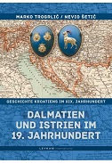
Author | Trogrlić, Marko
Title | Dalmatien und Istrien im 19. Jahrhundert
Publisher | Zagreb : Leykam international, 2025
Description | 253 str. : zemljop. crteži u bojama ; 25 cm.
Language/s | In German
ISBN | 9789533401560 : EUR 35.70 US$ 42.80
Subject | Dalmacija -- Povijest -- 1797.-1918. Istra -- Povijest -- 1797.-1918.
UDC | 94(497.5)"1527/1918" * 94(497.58)"1797/1918" * 94(497.571)"1797/1918"

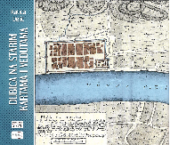
Author | Delić, Katica
Title | Dubica na starim kartama i vedutama
Publisher | Zagreb, Despot infinitus, 2025
Description | 176 str. : ilustr. ; 30 cm
ISBN | 9789537928131 : EUR 33.20 US$ 39.80
Subject | Hrvatska Dubica – Karte. Hrvatska Dubica -- U umjetnosti. Kartografski prikazi -- Hrvatska Dubica
UDC | 912(497.527Hrvatska Dubica) * 7.047(497.5)
Anotation | Katica Delić's book is a new identity for the city of Hrvatska Dubica, this time written with the intention of evaluating its geostrategic significance throughout history by analyzing old veduta and maps. The author uses cartographic and pictorial sources to present the specific border and defensive history of Dubica and the Dubica Pounje region, intertwined with the property and legal relations of knightly and church feudal structures, as well as the Ottoman conquests and demarcations resulting from the conquest of Croatian territory.

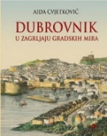
Author | Cvjetković, Aida
Title | Dubrovnik : u zagrljaju gradskih mira
Publisher | Zagreb : Zagrebački holding, Podružnica AGM, 2025
Description | 303 str. : ilustr. u bojama ; 28 cm
ISBN | 9789531745215 : EUR 68.20 US$ 81.80
Subject | Dubrovnik – povijest. Dubrovnik - kulturna povijest. Dubrovnik - monografije
UDC | 908(497.5) Monografija Hrvatske * 94(497.5-2) Povijest hrvatskih gradova
Anotation | In this exceptionally richly illustrated book, Aida Cvjetković describes Dubrovnik from street to street, as a tourist guide through its history. The book is rich in information, and is peppered with anecdotes that only Dubrovnik residents can know, and who are a bit apprehensive about the modern touristization of the city, so the book also has a nostalgic note.


Author | Stanković, Aleksandar
Title | F32
Publisher | Zagreb : Telegram media grupa, 2025
Description | 146 str. ; 21 cm.
Subject | Stanković, Aleksandar, novinar Depresivne osobe – Biografije. Psihički poremećaji -- Bolesnici – Biografije.
ISBN | 9789534950180 : EUR 21.30 US$ 25.60
UDC | 821.163.42-94. 159.97 * 159.97
Anotation | F32 is a sequel to Aleksandar Stanković's book Depra, in which the author writes about the reactions of readers after the first book was published. His personal trauma touched the souls of many who felt the need not only to tell their story but also to try to heal themselves.

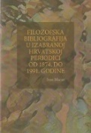
Author | Macut, Ivan
Title | Filozofska bibliografija u izabranoj hrvatskoj periodici od 1874. do 1991. godine
Publisher | Zagreb : Institut za filozofiju. 2025
Description | 470 str. ; 24 cm.
Note | Bibliografija: str. [467]-468. Kazalo. Summary.
ISBN | 9789537137939 : EUR 59.50 US$ 71.40
UDC | 1(091)(497.5)(01)

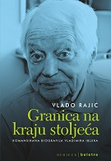
Author | Rajić, Vlado
Title | Granica na kraju stoljeća : romanisirana biografija Vladimir Iblera
Publisher | Zagreb : Durieux : Beletra, 2025
Description | 365 str. : ilustr. ; 20 cm
ISBN | 9789531885904 : EUR 24.30 US$ 29.20
UDC | 929Ibler, V.
Anotation | The fictionalized biography of Vladimir Ibler is much more than an interesting story about the private life and impressive professional career of a prominent expert in international law and a long-time professor at the Zagreb Faculty of Law, an academic who, as a representative of the SFRY, and then Croatia, participated in the creation of important international legal norms and laws. His biography is therefore not only an intimate confession of a famous intellectual who reveals to us his deep disappointment with the profession to which he dedicated his entire life, but also a precious testimony about our past.

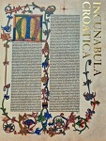
Author | Tomić, Marijana [editor]
Title | Incunabula Croatica : hrvatske inkunabule u hrvatskim ustanovama
Publisher | Zagreb : Nacionalna i sveučilišna knjižnica, 2025
Description | 434 str. : ilustr., faks. ; 30 cm
Language/s | English; German; Croatian; Italian
Note | Str. 9 -11: Predgovor / Ivanka Stričević. Bibliografija: str. 69-71, 123-124, 161; bibliografske bilješke uz tekst. Kazala
ISBN | 9789535002574 : EUR 75.00 US$ 90.00
UDC | 093 Inkunabule

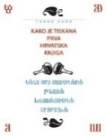
Author | Paro, Frane
Title | Kako je tiskana prva hrvatska knjiga
Publisher | Zagreb : Mozaik knjiga, 2025
Description | 175 str. : ilustr. u bojama ; 25 cm.
Subject | Misal, 1483. Brozićev brevijar Tiskarstvo -- 15. st Tiskarstvo -- 16. st. Glagoljske knjige. Inkunabule -- Hrvatska
ISBN | 9789531437646 : EUR 42.50 US$ 51.00
UDC | 655.2(091) * 093:003.349.1(497.5)

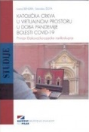
Author | Bendra, Ivana ; Šota, Stanislav
Title | Katolička crkva u virtualnom prostoru u doba pandemije bolesti COVID-19 : primjer Đakovačko-osječke nadbiskupije
Publisher | Zagreb : Institut društvenih znanosti Ivo Pilar, 2025
Description | 307 str. : ilustr. u bojama ; 25 cm.
Subject | Archdiocese of Đakovo-Osijek (Đakovo) – Research. Catholic Church -- Social conditions -- 21st century  Catholic Church – Documents. Internet in church work -- Slavonia, Eastern, COVID-19 pandemic (2020-2023) -- Religious aspects -- Christianity
ISBN | 9789538404382 : EUR 23.40 US$ 28.10
UDC | 272-67 * 272-772(497.543-37Đakovo) * 316.774:2 * 316.472:004.738.5

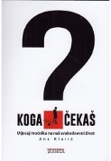
Author | Klarić, Ana
Title | Koga čekaš? : utjecaj moćnika na naš svakodnevni život
Publisher | Zagreb : Tkanica, 2025
Description | 237 str. : slika autorice ; 21 cm.
ISBN | 9789537999698 : EUR 29.30 US$ 35.20
Subject | Political psychology. Psychological abuse. Interpersonal relationships. Political propaganda
UDC | 159.922.2:32 * 364.634:32 * 323.2

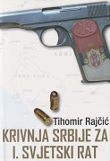
Author | Rajčić, Tihomir
Title | Krivnja Srbije za I. svjetski rat 2. dopunjeno izd
Publisher | Naklada Bošković ; Zagreb : Alfa ; Kaštela : Udruga EU Clio
Description | 211 str. : ilustr. ; 24 cm
ISBN | 9789532637861 : EUR 47.10 US$ 56.50
Subject | The First World War (1914-1918) – Causes. Sarajevo assassination (1914) .Imperialism – Serbia.  Serbia -- International relations -- 1804-1918
UDC | 94(497.11) * 327.2(497.11)(091)

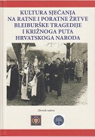
Author | Znanstveno-stručni simpozij Kultura sjećanja na ratne i poratne žrtve Bleiburške tragedije i Križnog puta hrvatskoga naroda (2024 ; Zagreb), Krašić, Wollfy ; Tepeš, Ivan
Title | Kultura sjećanja na ratne i poratne žrtve Bleiburške tragedije i Križnoga puta hrvatskoga naroda : zbornik radova
Publisher | Fakultet hrvatskih studija Sveučilišta u Zagrebu : Počasni bleiburški vod, 2025.
Description | 335 str. : ilustr. ; 27 cm.
ISBN | 9789538349652 : EUR 42.50 US$ 51.00
Subject | Križni put (1945.) -- Zbornici s konferencija, Hrvati -- Žrtve zločina -- 1941.-1945 -- Zbornici s konferencija  Kolektivno pamćenje -- Hrvatska -- 1945.-1990 -- Zbornici s konferencija
UDC | 94(497.5)"1941/1945" * 355.48(497.5) * 355.257.7(497.1=163.42) * 341.322.5(497.1=163.42) * 316.72:93(497.5)

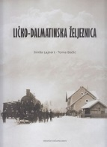
Author | Lajnert, Siniša ; Bačić, Toma
Title | Ličko-dalmatinska željeznica
Publisher | Zagreb : Hrvatski državni arhiv, 2025
Description | 396 str. : ilustr. ; 25 cm.
ISBN | 9789538461316 : EUR 31.90 US$ 38.30
UDC | 656.2(497.5)(091) * 625.1(497.5)(091)
Anotation | The publication presents the history of the Lika-Dalmatian Railway from its planning, construction and exploitation in the Austro-Hungarian Monarchy to the present day. The reason for writing this book is the celebration of the 100th anniversary of the opening of the Lika Railway in 2025, which shows increased interest in its history. Namely, on July 25, 1925, the last section of the Lika Railway, Gračac - Knin, was opened, and Dalmatia was finally connected by railway to continental Croatia.

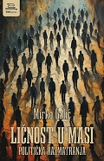
Author | Galić, Mirko, novinar
Title | Ličnost u masi : politička razmatranja
Publisher | Zagreb : TIM press, 2025
Description | 397 str. ; 21 cm.
ISBN | 9789533690667 : EUR 37.20 US$ 44.60
UDC | 32(497.5)
Anotation | The texts collected in the book cover a period of several years, and are written as a chronicle of a time and a reflection on Croatian achievements and problems, perspectives and hopes. The author draws on extensive personal experience and knowledge, but uses various sources and literature to best present the situation and political developments in Croatia. In this sense, this book will be a valuable source for understanding the times in which we operate and the country in which we live.

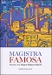
Title | Magistra famosa - 2 : Zbornik u čast Mirjani Matijević Sokol  / uredili Ivan Botica ... [et al.]
Publisher | Split : Književni krug, 2025.
Description | 815 str. : ilustr., faks., 24 cm
Note | Bibliografija iza svakog poglavlja i uz tekst. - Summaries.
ISBN | 9789531635691 : EUR 28.70 US$ 34.40
UDC | 32-05 Matijević Sokol, M.(082)
Anotation | The collection contains 48 scientific and professional papers dedicated to the distinguished and distinguished professor Mirjana Matijević Sokol. This second volume focuses on the 19th and 20th centuries (the previous volume focused on historical periods from antiquity, through the Middle Ages and up to the early modern period). In the long historical perspective of the 19th and 20th centuries, the collected works touch on key places, as well as figures of national history in that period.

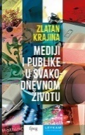
Author | Krajina, Zlatan
Title | Mediji i publike u svakodnevnom životu
Publisher | Zagreb : Leykam international : Sveučilište u Zagrebu, Fakultet političkih znanosti, 2025
Description | 259 str. ; 20 cm.
Note | Mass media - Audience. Culture and mass media. Mass media -- Social aspects
ISBN | 9789533402147 : EUR 29.10 US$ 34.90
UDC | 316.774 * 316.728

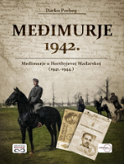
Author | Prebeg, Darko
Title | Međimurje 1942. : Međimurje u Horthyjevoj Mađarskoj (1941.-1944.)
Publisher | Zagreb : Despot Infinitus, 2025
Description | 226 str. ; 24 cm
ISBN | 9789533662220 : EUR 33.20 US$ 39.80
UDC | 94(497.5)1941/1945" * 94(497.524)"1942"
Anotation | In Horthy's Hungary, Međimurje was marked in 1942 by the war against the USSR and the implementation of the state program of rationalization of life. Both left great traces on the people of Međimurje, both those who fought on the front lines of the Eastern Front and the civilian population. Apart from a few serious Hungarian studies on war operations and heavy battles of various units on the Soviet Don River, such as Molnár and Szábo, Kemendy, Vida, Kozári and some others, there is no other published data on civilian life in Međimurje in 1942. This especially applies to the comprehensive program of rationalization of life in all of Horthy's Hungary, which began to be implemented very intensively in the first days of that year.

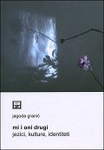
Author | Granić, Jagoda
Title | Mi i oni drugi: jezici, kulture, identiteti
Publisher | Split : Književni krug
Description | 339 str. ; 24 cm
ISBN | 9789531635752 : EUR 26.60 US$ 31.90
Subject | Nacionalni identitet -- Jezik – Uloga. Kulturni identitet – Globalizacija. Europa -- Jezična politika
UDC | 323.1(4):81 * 316.42:316.7 * 81'272:061.1EU
Anotation | In the book, the author examines the complex relationship between language and culture and the identities associated with them, viewing culture as both an anthropological and a sociolinguistic phenomenon.  The book addresses the hierarchy of languages ​​and cultures, the construction of multilingual and supranational identity, various forms of bilingualism and multilingualism, and the existing linguistic and cultural image of the European Union.

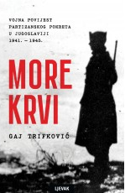
Author | Trifković, Gaj
Title | More krvi : vojna povijest partizanskog pokreta u Jugoslaviji 1941. - 1945.
Publisher | Zagreb : Naklada Ljevak, 2025
Description | XXXVIII, 659 str. : zemljop. crteži, graf. prikazi ; 24 cm.
Note | Prijevod djela: Sea of blood [hrv. prijevod]
ISBN | 9789533559162 : EUR 52.80 US$ 63.40
Subject | National Liberation War in Yugoslavia (1941-1945) -- Military operations  World War II (1939-1945) -- Military operations – Yugoslavia. Partisan warfare -- Yugoslavia -- 1941-1945
UDC | 94(497.1)"1939/1945" * 355.48(497.1) * 355.425(497.1)(091)

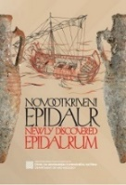
Author | Puhara, Helena
Title | Novootkriveni Epidaur: Amfore s cavtatskih lokaliteta = Newly discovered Epidaurum: Amphorae from Cavtat Sites
Publisher | Gruda ; Muzeji i galerije Konavala, 2025
Description | 67 str. ; 24 cm
Language/s | hrvatski, engleski
ISBN | 9789537226503 : EUR 17.00 US$ 20.40
Anotation | The Newly Discovered Epidaurus program is conceived as a series of exhibitions that present archaeological findings from recent research conducted in the Cavtat area. In this exhibition cycle, subtitled Amphorae from Cavtat Sites, the goal is to present the containers in which various food products were transported or stored, both liquid (wine, oil, or various fish sauces) and solid (cereals, dried fruits, nuts, mineral ores).

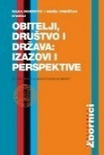
Author | Dobrotić, Ivana ; Zrinščak, Siniša
Title | Obitelji, društvo i država : izazovi i perspektive
Publisher | Zagreb : Pravni fakultet, 2025
Description | 273 str. ; 25 cm
ISBN | 9789532701951 : EUR 34.20 US$ 41.00
Subject | Families -- Croatia. Social work with families -- Croatia. Sociology of the family. Croatia -- Social policy
UDC | 364.65-055.5/.7(497.5) * 316.362(497.5)

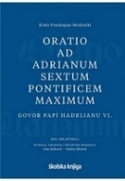
Author | Frankopan, Krsto I. Modruški
Title | Oratio ad Adrianum Sextum Pontificem Maximum : Govor papi Hadrijanu VI. : 500. obljetnica  / Studiju prijepis i prijevod pripremili Jurković, Ivan i Moretti, Violeta
Publisher | Zagreb : Školska knjiga ; Pula : Sveučilište Jurja Dobrile u Puli ; Modruš : Katedra Čakavskog sabora Modruše, 2025.
Description | 488 str. : ilustr. u bojama ; 25 cm
ISBN | 9789530625884 : EUR 58.30 US$ 70.00
UDC | 94(497.5)Frankopan, K. * 929.52Frankopan * 94(497.5)"14/15"
Anotation | This is a book with superb content and technical refinement, which enriches the corpus of Croatian literature with contextualization and analysis, as well as the edition and translation of an important speech delivered in Rome in dramatic political circumstances by one of the most prominent magnates of the Croatian late Middle Ages.

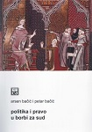
Author | Bačić, Arsen ; Bačić, Petar
Title | Politika i pravo u borbi za sud : (o sudskim odlukama koje su mijenjale odnos prava i politike) : ustavnopravna hrestomatija
Publisher | Split : Književni krug, 2025
Description | 343 str. ; 24 cm
ISBN | 9789531635714 : EUR 21.30 US$ 25.60
UDC | 342(091)
 | The book presents the emergence and development of the theory of the separation of powers, discusses the process of shaping the place and role of the judiciary and judges in constitutional democracies, and analyzes the question of the character and reasons for judicial decisions, especially those that have changed the face and back of contemporary constitutional democracies. It also highlights the position and significance of the Constitutional Court of the Republic of Croatia and its decisions in the context of the populist offensive and efforts to limit its role in the socio-political life of the Republic.

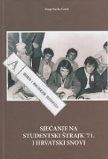
Author | Ćutuk, Drago ; Mladina, Vanja
Title | Sjećanje na studentski štrajk '71. i hrvatski snovi
Publisher | Split : Naklada Bošković
Description | 248 str. : ilustr., faks. ; 24 cm
ISBN | 9789532637755 : EUR 23.30 US$ 28.00
UDC | 323.25-057.875(497.583Split)(091) * 329.78(497.583Split)(091)
Anotation | In his historical work, the author not only investigates the events related to the Croatian Spring, but also delve into its causes and consequences. Sine ira et studio. Ćutuk writes: I will try to give an objective or more objective picture, in order to avoid or at least minimize the falsifications that have already occurred or will occur in the future, to anticipate them, offering a picture that an impartial reader could see if he were in the places and times where the author was.

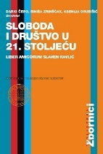
Author | Čepo, Dario ; Zrinščak, ; Siniša Grubišić, Ksenija
Title | Sloboda i društvo u 21. stoljeću – liber amicorum Slaven Ravlić
Publisher | Zagreb : Pravni fakultet ; Leksikografski zavod Miroslav Krleža, 2025
Description | XIII, 737 str. ; 25 cm
ISBN | 9789532701883 : EUR 54.80 US$ 65.80
Subject | Sociology of law. Sociology of politics. Society and politics. Democracy. Law -- Croatia
UDC | 32Ravlić, S. * 316.334.4 * 316.334.3 * 321.7 * 34(497.5)

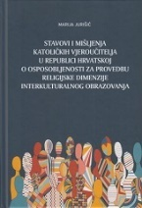
Author | Jurišić, Marija, magistra ; Razum, Ružica
Title | Stavovi i mišljenja katoličkih vjeroučitelja u Republici Hrvatskoj o osposobljenosti za provedbu religijske dimenzije interkulturalnog obrazovanja
Publisher | Zagreb : Katolički bogoslovni fakultet Sveučilišta u Zagrebu : Kršćanska sadašnjost, 2025
Description | 268 str. ; 25 cm
ISBN | 9789531120272 : EUR 28.60 US$ 34.30
Subject | Katolička crkva – Dokumenti. Religijsko obrazovanje. Multikulturalno obrazovanje. Vjeroučitelji -- Hrvatska -- Stavovi
UDC | 2-47 * 2-67 * 2-42 * 272

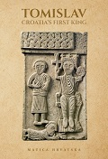
Author | Polić-Bobić, Mirjana
Title | Tomislav: Croatia’s First King : a journey into Croatia’s medieval past 1100 yearso on
Publisher | Zagreb : Matica hrvatska, 2025
Description | 307 str. ; 21 cm
ISBN | 9789533413075 : EUR 42.90 US$ 51.50
Subject | Tomislav, hrvatski kralj. Hrvatska -- Vladari -- 795.-1102. Hrvatska -- Povijest -- 795.-925
UDC | 94(497.5)Tomislav. 929.73Tomislav. 94(497.5)"09"
Anotation | This year marks the 1100th anniversary of one of the turning points in Croatian history: when the Croatian ruler Tomislav was officially recognized as king, in documents and correspondence with the Holy See. The event represents an important turning point, not only for Croatia but also for the wider history of this part of Europe.  The book Tomislav, Croatia’s First King presents fourteen outstanding studies in English dedicated to this historical figure.

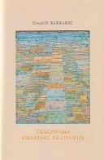
Author | Barbarić, Damir
Title | Tragovima hrvatske filozofije
Publisher | Zagreb : Institut za filozofiju, 2025
Description | 241 str. ; 24 cm
Note | Bibliografija: str. [243]; bibliografske bilješke uz tekst. Kazalo
ISBN | 9789537137915 : EUR 35.70 US$ 42.80
UDC | 1(091)(08) History of Philosophy. Collected and Printed Works

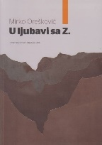
Author | Orešković, Mirko
Title | U ljubavi sa Z.
Publisher | Zagreb : Hrvatska sveučilišna naklada, 2025
Description | 245 str. ; 24 cm
ISBN | 9789531696029 : EUR 26.00 US$ 31.20
Subject | Construction contracts -- Croatia
UDC | 349.44:69
Anotation | The author manages to combine professional experience in managing complex construction projects with personal reflections on legal regulations. U ljubavi sa Z. (In Love with Z.) is not just a book about projects, procedures, and contracts – it is an inspiring account of a professional journey that shows that following the rules does not stifle creativity, but is the foundation of sustainable and successful development.

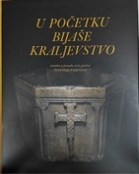
Title | U početku bijaše kraljevstvo – Izložba u povodu 1100 godina Hrvatskoga Kraljevstva
Publisher | Zagreb ; Galerija Klovićevi dvori, 2025
Description | 691 str.; ilustr. ; 29 cm
ISBN | 9789532711608 : EUR 71.40 US$ 85.70
Anotation | The exhibition on the occasion of the 1100th anniversary of the kingdom, the crowning event of the jubilee year, is divided into thematic units, designed in accordance with the dominant historical, social and cultural phenomena. From hall to hall, the emphasis is on the legal and symbolic continuity of the kingdom, which allows us to follow the idea of ​​statehood through the centuries, from the emergence of the Croatian state and national rulers in the early Middle Ages to the election of foreign dynasties in the coming periods. It manifests itself in various categories, which are not necessarily equally and simultaneously represented: people (GENS / POPULUS), religion (RELIGIO), language (LINGUA), set of customs (MOS MAIORUM / TRADITIO), nation (NATIO)

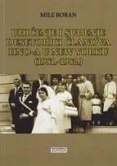
Author | Boban Otporaš, Mile
Title | Uhićenje i suđenje desetorici članova HNO-a u New Yorku (1981.-1982.) : dnevnik Annie Boban = Le journal de Annie Boban = Annie Boban’s diary : od 25. lipnja 1981. do 6. rujna 1981.
Publisher | Zagreb : Tkanica ; Sesvetski Kraljevec : Grafok, 2025
Description | 234 str. : ilustr. ; 24 cm
Language/s | engleski; francuski; hrvatski
ISBN | 9789537999674 : EUR 35.60 US$ 42.70
Subject | Boban, Annie – Dnevnici. Hrvatski narodni otpor -- Sudski procesi i parnice. Terorizam -- Sjedinjene Američke Države -- 1980.-1990. Hrvatsko iseljeništvo -- Politička aktivnost -- Sjedinjene Američke Države
UDC | 323.28-051(73=163.42) * 314.15-024.61(73=163.42)

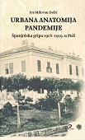
Author | Milovan Delić, Iva
Title | Urbana anatomija pandemije : španjolska gripa 1918 - 1919. u Puli
Publisher | Zagreb : Srednja Europa ; Pula : Sveučilište Jurja Dobrile u Puli, 2025
Description | 218 str., [8] str. s tablama ; 24 cm
ISBN | 9789533870670 : EUR 27.40 US$ 32.90
UDC | 94(497.5)"1918/1941" * 94(497.571Pula)"1918/1919" * 616.2-036.21(497.571Pula)(091
 | This book sheds light on the phenomenon of the Spanish flu pandemic in the area of ​​Pula and southern Istria at the end of World War I and in the immediate aftermath. Several of the author's previously published articles on the subject are gathered in one place. The lack of a large number of historical sources influenced the research to turn to the scarce existing sources that, in interweaving, depict the occurrence of the pandemic and the social issues related to its mortality. With the help of other sources and literature, the author also provides several new answers about this important medical-historical phenomenon that occurred at a time of turbulent political, social, economic and existential problems for the inhabitants of Pula.

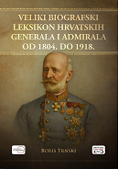
Author | Trnski, Boris
Title | Veliki biografski leksikon hrvatskih generala i admirala od 1804. Do 1918.
Publisher | Zagreb ; Despot infinitus, 2025
Description | 506 str., ilustr., 30 cm
ISBN | 9789533661957 : EUR 55.40 US$ 66.50
UDC | This biographical lexicon is mostly dedicated to Croatian generals and admirals of the Austrian Empire and the Austro-Hungarian Monarchy who, due to their success on the battlefields and their reputation, earned general and admiral ranks and high decorations, and who never concealed their devotion to the Croatian homeland. The research on which this work is based is dedicated to generals and admirals who were born in the then Croatian territory (Kingdom of Croatia and Slavonia, Kingdom of Dalmatia and Rijeka and its surroundings) or were originally from that area, regardless of their national and religious affiliation, and who served in the ranks of generals and admirals in the period from 1 January 1804 to 31 December 1918, regardless of which European army they served in.

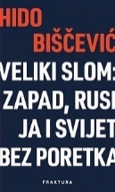
Author | Biščević, Hido
Title | Veliki slom : Zapad, Rusija i svijet bez poretka : moje stanice na putevima Hladnog rata
Publisher | Zaprešić : Fraktura, 2025
Description | 209 str. ; 23 cm
ISBN | 9789533588797 : EUR 18.90 US$ 22.70
UDC | 323 * 327.54
Journalist and diplomat Hido Biščević offers a provocative and worrying analysis of the world situation in the book Veliki slom (The Great Breakdown - The West, Russia and the World Without Order). Russian aggression against Ukraine and the unpredictable policy of the new American administration are shaking the foundations of the international order established after World War II, liberal democracy is in crisis and, as Biščević says, "dictators are no longer afraid."
Biščević dedicated a significant part of the book to memories of Russia and Turkey, where he was the Croatian ambassador in the nineties, as well as Tajikistan, where he was the head of the European Union mission.

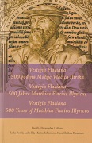
Author | Boršić, Luka... [et al.] [eds.]
Title | Vestigia Flaciana : 500 godina Matije Vlačića Ilirika = 500 Jahre Matthias Flacius Illyricus = 500 Years of Matthias Flacius Illyricus
Publisher | Zagreb : Institut za filozofiju ; Labin : Grad Labin, 2025
Description | 436 str. ; 21 cm
Language/s | Text in Croatian, German and English.
Subject | Vlačić Ilirik, Matija, 1520-1575 - život i djelo – zbornici - protestantizam - Njemačka - 16. st. -reformacija - Istra - 16. st.
ISBN | 9789537137908 : EUR 59.50 US$ 71.40
UDC | 1Vlačić Ilirik, M. * 929Vlačić Ilirik, M.

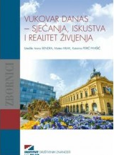
Author | Znanstveno-stručni skup Vukovar devedest prve - trideset i jedna godina poslije (25 ; 2022 ; Vukovar)
Title | Vukovar danas : sjećanja, iskustva i realitet življenja
Publisher | Zagreb : Institut društvenih znanosti Ivo Pilar, 2024
Description | 214 str. : zemljop. crteži, graf. prikazi ; 25 cm
ISBN | 9789538404238 : EUR 22.40 US$ 25.90
Subject | Domovinski rat (1991.-1995.) -- Razaranja -- Vukovar -- Zbornici s konferencija  Vukovar -- Društveni uvjeti -- 21. st -- Zbornici s konferencija
UDC | 308(497.544Vukovar) * 355.018(497.544Vukovar)

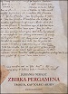
Author | Neralić, Jadranka
Title | Zbirka pergamena : Trogir, Kaptolski arhiv - Srednjovjekovni statuti i kodeksi
Publisher | Split : Književni krug, 2025
Description | 975 str. : ilustr. u bojama, faks. ; 24 cm
ISBN | 9789531635684 : EUR 42.10 US$ 50.50
Subject | Pergamentni rukopisi – Trogir. Crkveni arhivi
UDC | 091.2(497.5Trogir) * 930.253(497.5Trogir):2
Anotation | The book contains a complete transcription of the Trogir Kaptol parchment collection (1-322) in Latin with extensive notes, inventory, bibliography and a layered authorial study. In the introductory study, the author presents a clear and concise historical reconstruction of the location and composition of the parchment collection. The material ranges from the oldest document from 1185 with the conclusions of the church council in Split to the bull of Pope Pius VI from 1777.

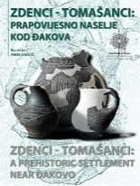
Author | Marijanović, Brunislav ; Kustić, Marija ;Vujević, Dario
Title | Zdenci - Tomašanci: prapovijesno naselje kod Đakova = Zdenci - Tomašanci: a prehistoric settlement near Đakovo
Publisher | Zadar : Sveučilište, 2025
Description | 298 str. : ilustr. u bojama, graf. prikazi ; 28 cm.
ISBN | 9789533315027 : EUR 59.50 US$ 71.40
Subject | Arheološki nalazi -- Đakovo (okolica) -- Bakreno doba. Arheološka nalazišta -- Đakovo (okolica)
UDC | 903.4(497.543-37Đakovo)"636"

Lingusitcs. Philology
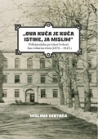
Author | Bertoša, Mislava
Title | "Ova kuća je kuća istine, ja mislim." : psihijatrijska povijest bolesti kao tekstna vrsta (1879. - 1945.)
Publisher | Zagreb : Srednja Europa, 2025
Description | 204 str. ; 24 cm.
ISBN | 9789533870533 : EUR 26.30 US$ 31.60
Subject | Medicinska dokumentacija – Jezik. Hrvatski jezik -- Medicinski hrvatski. Psihijatrija -- Hrvatska -- Povijest
UDC | 811.163.42:61 * 811.163.42'42 * 616.89(497.5)(091)
Anotation | The subject of this book is an analysis of the medical history of patients who stayed at the “Royal Land Institute for the Insane in Stenjevac” from the beginning of its operation in November 1879 until the mid-1940s. It is approached from the perspective and theoretical framework of historical pragmatics. Historical pragmatics in its broadest sense studies language use in the past, seeking to explore patterns of human behavior, their historical development and its general principles, that is, to describe and understand language use in communities in the past that are not available for direct observation, and to explain their development and changes from a diachronic perspective.

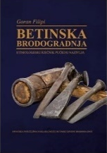
Author | Filipi, Goran
Title | Betinska brodogradnja : etimologijski rječnik pučkog nazivlja  / II. dopunjeno i prošireno izdanje
Publisher | Zagreb : Hrvatska sveučilišna naklada : Betina, 2025
Description | 276 str. : ilustr. u bojama ; 26 cm
ISBN | 9789531695718 : EUR 36.50 US$ 43.80
UDC | 629.5(038) * 811.136.42'282.2(497.581.2Betina)(038) * 811.136.42'282.2(497.583Korčula)(038)  811.163.42'373.6(038)
Anotation | Betinska brodogradnja by academician Goran Filipi is a fundamental work for understanding the rich maritime heritage and traditional shipbuilding in the Adriatic and Mediterranean context. Betina shipbuilding is a treasury of a craft and an entire culture that is today maintained by enthusiasts of this business, after having been one of the driving forces of our maritime tradition for centuries: not the epic one of oceanic voyages and sailing ships, but the other one, which conquered the Adriatic archipelago with seemingly modest gajeta and leuta.

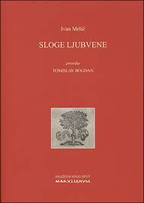
Author | Mršić, Ivan
Title | Sloge ljubvene  / priredio: Tomislav Bogdan
Publisher | Split : Književni krug, Marulianum, 2025
Description | 195 str. : faks. ; 24 cm.
ISBN | 9789531635660 : EUR 17.00 US$ 20.40
UDC | 821.163.42-1'282
Anotation | The critical edition of the book Sloga ljubvene by the Pag poet Ivan Mršić is also the first modern edition of this collection of poems published in Venice in 1647. The book was long lost to readers and literary historians because the only surviving copy disappeared in the mid-20th century.  The editor Tomislav Bogdan came across a complete copy of the book and based on it, this modern, critical edition was prepared.

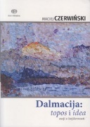
Literature. History. Theory

Author | Czerwiński, Maciej
Title | Dalmacija: topos i idea – eseji o književnosti
Publisher | Zagreb : Alfa, 2025
Description | 239 str. ; 23 cm
ISBN | 9789533645896 : EUR 24.50 US$ 29.40
Subject | Croatian literature. Literary criticism. Reviews
UDC | 821.163.42.09
Anotation | U knjizi „Dalmacija: topos i idea” Macieja Czerwińskog Dalmacija nije idealizirani Mediteran (s palmama i brodicama, maslinom i vinom) ni poprište klasnoga ili nacionalnoga sukoba, što su najčešće teme vezane uz jadranski areal, nego prostor koji stvara imaginacije koje propituju najvažnija ljudska stremljenja: opterećenje životom, potragu za smislom, razumijevanje sebe i svijeta i svoga mjesta na zemlji, prostora koji okružuje i određuje, pa pretvaranje toga čitavog nataloženog iskustva u tekst, u književni tekst, uglavnom u umjetničku prozu.

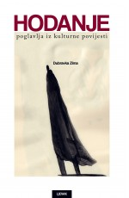
Author | Zima, Dubravka
Title | Hodanje : poglavlja iz kulturne povijesti
Publisher | Zagreb : Naklada Ljevak, 2025
Description | 245 str. ; 24 cm
ISBN | 9789533559278 : EUR 29.30 US$ 35.20
UDC | 82.09 * 821.163.42.09
Anotation | Walking has become the subject of a number of cultural and scientific books in recent decades. Now we have (the first) Croatian one. Hodanje (Walking) by Dubravka Zima is a book that explores the cultural archaeology of walking in Croatian regions. With the exception (in this case, inevitably excluded) of hiking, Dubravka Zima deals with all types of walking: idle and furious, political and religious, female and male. The subject of Zima's book is nineteenth-century flâneurs and flâneuses, continental parks and coastal waterfronts. Zima deals with processions, funerals and pilgrimages, but also protest walks, demonstrations and pogroms.

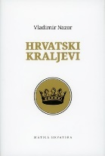
Author | Nazor, Vladimir
Title | Hrvatski kraljevi : u povodu 1100. obljetnice Hrvatskoga Kraljevstva (925.-2025.)  / predgovor Petrač, Božidar, književni povjesničar
Publisher | Zagreb : Matica hrvatska, 2025.
Description | XXV, 125 str. ; 21 cm.
Note | Faksimilno izdanje
ISBN | 9789533412962 : EUR 21.40 US$ 25.70
UDC | 821.163.42-1
Anotation | On the occasion of the 1100th anniversary of the Croatian Kingdom (925–2025), Matica Hrvatska published a facsimile edition of Vladimir Nazor's famous collection of poems, Croatian Kings, from 1912.

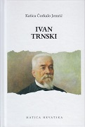
Author | Čorkalo, Katica
Title | Ivan Trnski
Publisher | Zagreb : Matica hrvatska, 2025
Description | 350 str. : ilustr. ; 22 cm
Note | Sadrži i: Novakinja hrvatskoga glumišta - gluma u jednom činu / napravio i priredio / I. T. [Ivan Trnski].
ISBN | 9789533412801 : EUR 27.90 US$ 33.50
UDC | 821.163.42.09 Hrvatska književnost. Književna kritika. Prikazi

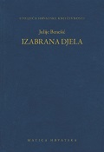
Author | Benešić, Julije
Title | Izabrana djela  / Rogić Musa, Tea [priredila]
Publisher | Zagreb : Matica hrvatska, 2025
Description | 573 str. : ilustr. ; 20 cm
Serie | Stoljeća hrvatske književnosti ; knj. 161
ISBN | 9789531503679 : EUR 38.10 US$ 45.70
UDC | 821.163.42-3 Croatian literature. Novels, novellas, short stories
 | Benešić wrote a series of critical texts that shed light on the contemporary conditions in theatre and acting life, and have long been accepted as a first-class theatre source. Benešić is the most important Croatian pre-institutional Polish scholar, the only one in Croatian culture who systematically dealt with Polish literature in the first half of the 20th century as a translator, editor, compiler, literary historian and anthologist, and cultural mediator, making an invaluable contribution to the development of Croatian-Polish literary and cultural ties.

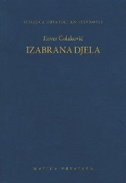
Author | Čolaković, Enver
Title | Izabrana djela  / Petrač, Božidar, književni povjesničar priredio
Publisher | Zagreb : Matica hrvatska, 2025
Description | 606 str. : ilustr. ; 20 cm
Series | Stoljeća hrvatske književnosti knj. 162
ISBN | 9789531503648 : EUR 38.10 US$ 45.70
UDC | 821.163.43(497.5)-82(082) * 821.163.42-82(082) * 821.163.43(497.5)(01)Čolaković, E. * 821.163.42(01)Čolaković, E.
Anotation | Croatian and Bosnian-Herzegovinian writer and translator from Hungarian, German and English (Budapest, 1913–Zagreb, 1976). For his novel The Legend of Ali-paša he received the Matica Hrvatska award for the best Croatian novel in 1943 (published in 1944). Due to political reasons, he was no longer able to publish after 1945. He was a member of Matica Hrvatska, the Croatian Writers' Association, the Croatian Literary Translators' Association and the PEN Club.

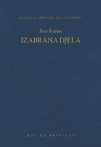
Author | Kušan, Ivan
Title | Izabrana djela  / priredila Dubravka Zima
Publisher | Zagreb : Matica hrvatska, 2025
Description | 509 str. ; 20 cm
Note | Stoljeća hrvatske književnosti knj. 163
ISBN | 9789531503686 : EUR 38.10 US$ 45.70
UDC | 821.163.42-93-82(081) * 821.163.42-82(081)
Anotation | Although children's literature is Kušan's primary field of activity, he is also the author of complex social novels with an individual at the center, political satires - prose and drama, and prose texts with an often erotic obsession, and all of these areas (their fusion and intertwining) are supported by this single-volume selection.

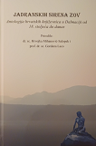
Author | Mihanović-Salopek, Hrvojka ; Laco, Gordana
Title | Jadranskih sirena zov : antologija hrvatskih književnica u Dalmaciji od 18. stoljeća do danas
Publisher | Split : Društvo hrvatskih književnika, Ogranak ; Filozofski fakultet Sveučilišta u Splitu ; Podstrana : Matica hrvatska, Ogranak, 2024
Description | 487 str. : ilustr. (pretežno u bojama) ; 23 cm
ISBN | 9789532784121 : EUR 40.70 US$ 48.80
Subject | Hrvatsko žensko pjesništvo -- Dalmacija -- Zbirke tekstova
UDC | 821.163.42-055.2-1(082) * 821.163.42-055.2-1'282(082) * 77(497.5)

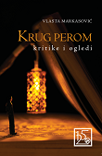
Author | Markasović, Vlasta
Title | Krug perom, kritike i ogledi
Publisher | Osijek : Društvo hrvatskih književnika, 2025
Description | 390 str. ; 20 cm.
ISBN | 9789532784213 : EUR 26.20 US$ 31.40
UDC | 821.163.42.09 * 82.09 * 821.163.42-4
Anotation | Vlasta Markasović is one of the most prominent Croatian writers and literary scholars in eastern Croatia, which is confirmed without any doubt by her new book Krug perom, in which she has collected fifty-two literary criticisms and three literary essays. This is a selection from a series of critical and essayistic texts that the author regularly publishes in print and electronic media, anthologies and other occasional publications, which, when brought together in this book, demonstrate not only Vlasta Markasović's critical and essayistic skills, but also provide insight into contemporary Croatian and translated literature in the first decades of the 21st century, with an emphasis on writers from eastern Croatia.

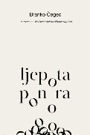
Author | Čegec, Branko
Title | Ljepota ponora : o vremenu, piscima i dobrovoljnom ropstvu
Publisher | Zagreb : Meandarmedia, 2025
Description | 257 str. ; 19 cm
ISBN | 9789533344027 : EUR 21.30 US$ 25.60
UDC | 821.163.42-4 Croatian Literature. Essays
Anotation | Čegec's new essays are preoccupied with the stumbles and sinkings, the abysses of the current time, or rather the easy giving up at the first obstacle, mostly induced by various marketing and technological tricks of the moloch of capital, whose hunger cannot be satisfied.

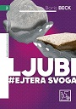
Author | Beck, Boris
Title | Ljubi hejtera svoga : retorika medija, vjere i politike, 2025
Publisher | Zagreb : Društvo hrvatskih književnika, 2025
Description | 138 str. ; 21 cm
ISBN | 9789532784336 : EUR 19.00 US$ 22.80
UDC | 821.163.42-4
Anotation | Boris Beck (1965) is one of the most prominent Croatian essayists. His "bittersweet" essays, collected in several well-known and critically acclaimed books, continue in his latest essay collection with the paradoxical title Ljubi hejtera svoga. In this book, Beck is also an engaged and critical writer, but never an empty moralist or just a skilled verbalist.

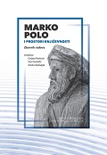
Author | Znanstveni skup Marko Polo i prostori književnosti : komparativna povijest hrvatske književnosti (2024 ; Zagreb)
Title | Marko Polo i prostori književnosti
Publisher | Zagreb : Matica hrvatska ; Korčula : Gradski muzej, 2025
Description | 527 str. ; 23 cm
ISBN | 9789533412641 : EUR 30.90 US$ 37.10
UDC | 821.163.42.091 * 821.163.42(091) * 82.0 * 929Polo, M.
Anotation | The collection is dedicated to the research of the activities and works of Marco Polo, an inspiring and intriguing medieval travel text, its influence on literary texts as well as other forms of art, the phenomenon of enduring interest in Polo's personality and work, and the phenomenon of his wide reception. The works cover topics that directly or figuratively arise from the title, from Marco Polo to the 21st century, from the Middle Ages to the present, from literature to the media.

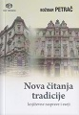
Author | Petrač, Božidar,
Title | Nova čitanja tradicije : književne rasprave i eseji
Publisher | Zagreb : Alfa, 2025
Description | 412 str. ; 19 cm.
ISBN | 9789533645889 : EUR 24.50 US$ 29.40
Subject | Hrvatska književnost -- Povijest i kritika
UDC | 821.163.42.09

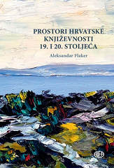
Author | Flaker, Aleksandar
Title | Prostori hrvatske književnosti 19. i 20. stoljeća  / Brnčić, Jadranka ; Kolanović, Maša
Publisher | Zagreb : Alfa, 2025
Description | 364 str. : ilustr. u bojama ; 25 cm
ISBN | 9789533645353 : EUR 37.20 US$ 44.60
Subject | Hrvatska književnost -- 19. st. Hrvatska književnost -- 20. st. Književnost -- Komparativne studije. Prostor u književnosti  Umjetnost i književnost
UDC | 821.163.42-4 * 82.091 * 821.163.42(091) * 7:82

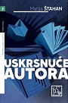
Author | Štahan, Matija
Title | Uskrsnuće autora : književne kritike i ogledi
Publisher | Zagreb : Društvo hrvatskih književnika, 2025
Description | 202 str. ; 21 cm
ISBN | 9789532784299 : EUR 22.60 US$ 27.10
UDC | 821.163.42.09 * 82.09 * 821.163.42-4
Anotation | In the last few years, the author has established himself as one of the most important writers whose texts are on the border between expertly based essays and credible/convincing literary criticism with particularly pronounced and interesting literary competences. That is why his texts are read with an appropriate dose of tense expectation and in a constant and tense dialogue between the author's refined thought "sabotages" and the expectations of consumers.

Literature. Poetry
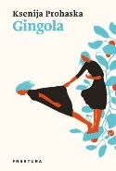
Author | Prohaska, Ksenija
Title | Gingola
Publisher | Zaprešić : Fraktura, 2025.
Description | 116 str. ; 21 cm
ISBN | 9789533588834 : EUR 18.90 US$ 22.70
UDC | 821.163.42-1 Croatian literature. Poetry

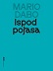
Author | Dabo, Mario
Title | Ispod pojasa
Publisher | Zagreb : Meandarmedia, 2025
Description | 119 str. ; 21 cm
ISBN | 9789533344034 : EUR 21.30 US$ 25.60
UDC | 821.163.42-1 Croatian literature. Poetry

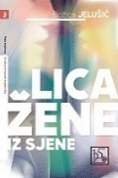
Author | Jelušić, Božica
Title | Lica žene iz sjene : pjesnički slikopis
Publisher | Zagreb : Društvo hrvatskih književnika, 2025
Description | 78 str. : ilustr. ; 21 cm.
ISBN | 9789532784176 : EUR 16.70 US$ 20.00
UDC | 821.163.42-1 Croatian literature. Poetry

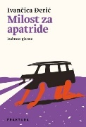
Author | Đerić, Ivančica
Title | Milost za apatride : izabrane pjesme
Publisher | Zaprešić : Fraktura, 2025
Description | 129 str. ; 21 cm.
ISBN | 9789533588841 : EUR 26.30 US$ 31.60
UDC | 821.163.42-1 Croatian literature. Poetry

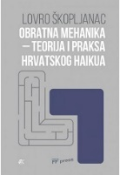
Author | Škopljanac, Lovro
Title | Obratna mehanika : teorija i praksa hrvatskog haikua
Publisher | Zagreb : Filozofski fakultet, 2025,
Description | 94 str. ; 24 cm
ISBN | 9789533792415 : EUR 14.70 US$ 17.60
Subject | Haiku pjesništvo -- Hrvatska književnost. Haiku pjesništvo -- Teorija
UDC | 821.163.42.09-1 * 82.09-1

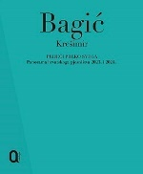
Author | Bagić, Krešimir (sastavljač) (autor predgovora)
Title | Prijeći preko svega : panorama hrvatskog pjesništva 2023. i 2024.
Publisher | Zagreb : Meandar media, 2025
Description | 359 str. ; 20 cm
ISBN | 9789533344041 : EUR 31.90 US$ 38.30
Subject | Hrvatsko pjesništvo -- 2020.-2025 -- Književne zbirke
UDC | 821.163.42-1(082

Literature. Prosa. Novels. Short stories. Essays.
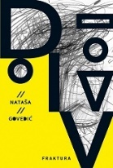
Author | Govedić, Nataša
Title | Div
Publisher | Zaprešić : Fraktura, 2025
Description | 320 str. ; 21 cm
ISBN | 9789533588810 : EUR 26.30 US$ 31.60
UDC | 821.163.42-31
Anotation | Nataša Govedić's book Div ​​is a unique hybrid work that combines prose, poetry, and philosophy into a powerful exploration of loss, love, and madness as creative forces. Emotional, witty, and inclusive, this unconventional prose opens a space for anyone who has ever felt different, celebrating vulnerability, intimacy, and the freedom of identity.

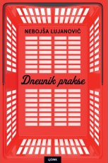
Author | Lujanović, Nebojša
Title | Dnevnik prakse
Publisher | Zagreb : Naklada Ljevak, 2025
Description | 184 str. ; 21 cm
ISBN | 9789533559209 : EUR 26.10 US$ 31.30
UDC | 821.163.42-3
Anotation | On a small Mediterranean stage, colored with warmth, wit and colorful characters, a touching and humorous story unfolds that, despite its local roots, becomes a powerful mirror of a universal reality.

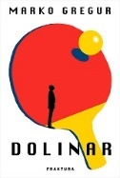
Author | Gregur, Marko
Title | Dolinar
Publisher | Zaprešić : Fraktura, 2025
Description | 363 str. ; 21 cm
ISBN | 9789533588902 : EUR 26.30 US$ 31.60
UDC | 821.163.42-312.6 Croatian literature. Romanticized biographies
Anotation | Marko Gregur's novel Dolinar tells the exciting and multi-layered story of Žarko Dolinar – a sports champion, scientist and humanist who risked his life saving the persecuted in wartime Zagreb. This dynamic novel about courage, love and cosmopolitanism paints a portrait of an exceptional man through the turbulent history of the 20th century, with the rhythm of a sports match and the splendor of a film story.

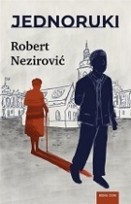
Author | Nezirović, Robert
Title | Jednoruki
Publisher | Zagreb : Hena com, 2025
Description | 236 str. ; 22 cm
ISBN | 9789532595420 : EUR 20.90 US$ 25.10
UDC | 821.163.42-31
Anotation | The novel Jednoruki follows Ante Prujić, a war veteran who lives with one arm, torn between the past, the present, and his love for Radmila. As he tries to survive in a seaside town, he faces injustice, corruption, and his own demons — but also the hope of a new beginning. The story raises the question of how much of the wounds of war remain invisible, yet deeply imprinted in everyday life.

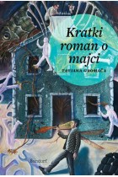
Author | Gromača, Tatjana
Title | Kratki roman o majci
Publisher | Zagreb : Sandorf, 2025
Description | 185 str. ; 21 cm
ISBN | 9789533515960 : EUR 20.00 US$ 24.00
UDC | 821.163.42-31
Anotation | Tatjana Gromača has written another novel about a mother in which the author actually writes the most intimate, without sarcasm or cynicism, novelistic diary for all those who are both adults and young, and who are not interested in excuses. Only the truth, without euphemisms.

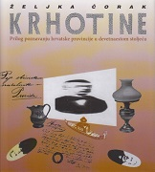
Author | Čorak, Željka
Title | Krhotine : prilog poznavanju hrvatske provincije u devetnaestom stoljeću
Publisher | Zagreb : Litteris, 2025
Description | 304 str. : ilustr., faks ; 22 cm
ISBN | 9789538195242 : EUR 44.00 US$ 52.80
UDC | 821.163.42-4 * 821.163.42-94
Anotation | Krhotine : prilog poznavanju hrvatske provincije u devetnaestom stoljeću (Fragments: A Contribution to the Knowledge of the Croatian Province in the Nineteenth Century) is an extraordinarily impressive depiction of the Croatian province at the turn of the century and an occasion to use an evocative-confessional tone, collage technique and fragmentary nature to arrive at one's own identity preserved in small, yet exemplary family objects.

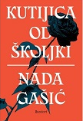
Author | Gašić, Nada
Title | Kutijica od školjki
Publisher | Zagreb: Sandorf, 2025
Description | 375 str. ; 21 cm
ISBN | 9789533515984 : EUR 26.30 US$ 31.60
UDC | 821.163.42-31
Anotation | Kutijica od školjki (A Box of Shells) reconstructs a bygone era, Zagreb and other cities, the language of the then Trogir, recipes and clothing, interpersonal relationships and values ​​of a world turned towards the future, telling a story of forbidden love in which the Hero of Our Time and the Little Town of Peyton meet, Mediterranean romance and socialist enthusiasm, progress and conservatism.

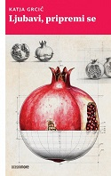
Author | Grcić, Katja
Title | Ljubavi, pripremi se
Publisher | Zagreb : OceanMore, 2025
Description | 155 str. ; 21 cm
ISBN | 9789533322155 : EUR 22.70 US$ 27.20
UDC | 821.163.42-3
Anotation | Katja Grcić's book speaks in a contemporary female voice from various perspectives and through various fragments of text - poetic, realistic, essayistic. All of them depict the psyche's striving for its own wholeness. Not shying away from the intimate and painful, whether it is about family, love or social aspects of reality, the narrator also enters the world of dreams, symbols and archetypes.

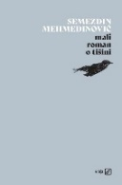
Author | Mehmedinović, Semezdin
Title | Mali roman o tišini
Publisher | Zagreb : V. B. Z., 2025
Description | 327 str. ; 21 cm
ISBN | 9789535208716 : EUR 24.90 US$ 29.90
UDC | 821.163.4(497.6)-31=163.42
Anotation

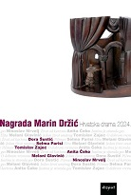
Author | Čeko, Anita
Title | Nagrada Marin Držić : Hrvatska drama 2024.
Publisher | Zagreb : Disput, 2025
Description | 250 str. ; 21 cm
ISBN | 9789532605136 : EUR 14.90 US$ 17.90
Subject | Hrvatska drama -- Zbirke tekstova
UDC | 821.163.42-2(082)

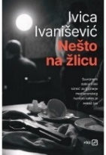
Author | Ivanišević, Ivica
Title | Nešto na žlicu : Kriminalistički vodvilj
Publisher | Zagreb : V. B. Z, 2025
Description | 169 str. ; 20 cm
ISBN | 9789535208730 : EUR 20.30 US$ 24.40
UDC | 821.163.42-31
Anotation | The book Nešto na žlicu (Something on a Spoon) – although the author himself, not without reason, calls it vaudeville – is an exciting and humorous crime novel that parades both old-fashioned characters, such as the retired, grumpy police inspector Nalis or the dedicated revolutionary and first-rate fighter Comrade Polpeta, and newly composed characters of transitional winners: successful entrepreneurs, wealthy lawyers, upstarts of all kinds, petty and somewhat larger criminals.

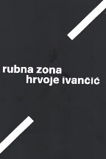
Author | Ivančić, Hrvoje
Title | Rubna zona
Publisher | Zagreb : Sandorf, 2025
Description | 315 strr. : ilustr. u bojama ; 24 cm
ISBN | 9789533515816 : EUR 31.60 US$ 37.90
UDC | 910.4Ivančić, H. * 821.163.42-992 * 821.163.42-92
Anotation | Hrvoje Ivančić writes his reports about people and events from one end of the world to the other.  With his reports and his own reporter's view of everything around him that interests him, Hrvoje sets out in search of his own answers, in fact about the meaning of journalism that we remember - he gives a clear answer.

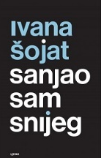
Author | Šojat, Ivana
Title | Sanjao sam snijeg
Publisher | Zagreb : Naklada Ljevak, 2025
Description | 339 str. ; 22 cm
ISBN | 9789533559179 : EUR 27.80 US$ 33.40
UDC | 821.163.42-31
Anotation | Sanjao sam snijeg (I Dreamed of Snow) is a new novel by Ivana Šojat – an extremely intimate story about loss, memory and the fragility of family ties. A novel about family, grief, death, afterlife, love, delusions, friendship

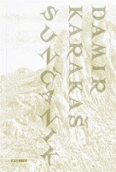
Author | Karakaš, Damir
Title | Sunčanik
Publisher | Zagreb : Naklada OceanMore, 2025
Description | 119 str. ; 21 cm
ISBN | 9789533322216 : EUR 22.70 US$ 27.20
UDC | 821.163.42-1
Anotation | Damir Karakaš's new novel brings a layered lyrical story, both tender and harsh, about the journey of a grandfather and grandson, about their search for the devil - does he even exist? Walking through stunning nature, they witness unusual events and meet peculiar people, building a mutual connection and closeness.

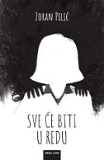
Author | Pilić, Zoran
Title | Sve će biti u redu
Publisher | Zagreb : Hena com, 2025
Description | 216 str. ; 22 cm
ISBN | 9789532595529 : EUR 20.90 US$ 25.10
UDC | 821.163.42-31
Anotation | What happens to the Goršin family in Zagreb one Saturday begins as a story about the sudden death of their husband, father and grandfather, which is more than enough to disrupt and rearrange family relationships. The continuation of this family drama was hardly something anyone could have expected, least of all its actors themselves, and after them, the readers. The family is in the most chaotic moment because after the death, the truths about the unhappy marriage and double life will come to light, as will the mother's confession, which makes all this chaos seem insoluble.

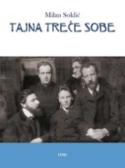
Author | Soklić, Milan
Title | Tajna treće sobe : romansirana razglednica münchenskoga Fin de Sièclea
Publisher | Pula : Istarski ogranak Društva hrvatskih književnika, 2025
Description | 159 str. : ilustr. (djelomice u bojama) ; 21 cm
ISBN | 9789532784275 : EUR 28.60 US$ 34.30
UDC | 821.163.42(497.6)-31
Anotation | The novel Tajna treće sobe (The Secret of the Third Room) describes the events that led to the breakup of the Munich Cosmic Circle (Der Kosmikerkreis, Die Kosmiker) in late 1903 and early 1904. Most of the characters are historical figures, among whom the famous Stefan George (1868 – 1933), one of the most important German poets of the 20th century, stands out.

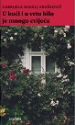
Author | Rukelj Kraškovič, Gabrijela
Title | U kući i u vrtu bilo je mnogo cvijeća : (iz arhive ili dok je život bio cvijeće)
Publisher | Zagreb : Naklada OceanMore, 2025
Description | 228 str. ; 21 cm
ISBN | 9789533322087 : EUR 22.70 US$ 27.20
UDC | 821.163.42-31
Anotation | “This is an exceptional, powerful and devastating literary text, the likes of which are few in any literature (…) A novel like this is a rare solemn moment in Croatian literature.”  Miljenko Jergović, Večernji list

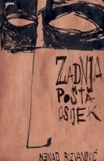
Author | Rizvanović, Nenad
Title | Zadnja pošta Osijek : roman
Publisher | Zagreb : Naklada Ljevak, 2025
Description | 187 str. ; 22 cm
ISBN | 9789533559261 : EUR 25.50 US$ 30.60
UDC | 821.163.42-31
Anotation | The novel Zadnja pošta Osijek (The Last Post Office Osijek) is an unusual picaresque antihero who, by narrating his own life - a biography that, of course, should not be fully believed - actually narrates the twentieth century in Osijek, but also the Slavonian, Croatian, Austro-Hungarian and Yugoslav ones.

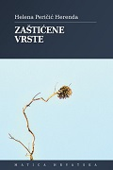
Author | Peričić, Helena
Title | Zaštićene vrste
Publisher | Zagreb : Matica hrvatska Zagreb, 2025
Description | 175 str. ; 21 cm
ISBN | 9789533412849 : EUR 23.80 US$ 28.80
UDC | 821.163.42-3 Croatian literature. Novels, novellas, short stories
Anotation | In the book Zaštićene vrste, Helena Peričić Herenda has gathered a series of diverse short realistic stories connected by an interest in vulnerable, lonely or unhappy characters, who suffer some kind of social injustice or personal disappointment due to their own moral choices.

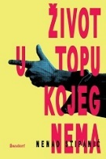
Author | Stipanić, Nenad
Title | Život u topu kojeg nema
Publisher | Zagreb : Sandorf, 2025
Description | 158 str. ; 21 cm
ISBN | 9789533515861 : EUR 22.10 US$ 26.50
UDC | 821.163.42-31
Anotation | Sometimes sad, more often comic in its collision with reality, with naturalistic elements and psychedelic outbursts, most often simply touching, this novel is a story about childhood, love and emigration, with episodes of Apocalypse Now for the poor and the occasional truly cowardly and heroic act.

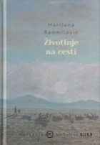
Author | Radmilović, Marijana
Title | Životinje na cesti
Publisher | Zagreb : Mozaik knjiga, 2025
Description | 266 str. ; 21 cm
ISBN | 9789531441216 : EUR 23.40 US$ 28.10
UDC | 821.163.42-32
Anotation | In the everyday grind that grinds us down, in moments when we don't know whether the driver will brake in time, we are all – animals on the road. This collection of stories reminds us that we are all insecure and exposed, a constant target, just like animals that stray onto the road.

Arts. General
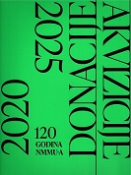
Title | Akvizicije/Donacije 2020. – 2025. : 120 godina NMMU-a Oktogon, Nacionalni muzej moderne umjetnosti, Zagreb, 8. 7. – 31. 8. 2025. = Acquisitions/Donations 2020 – 2025 : 120 Years of NMMU, Octagon, National Museum of Modern Art / [urednik, editor [i] uvodnik, introduction Branko Franceschi ;
Publisher | Zagreb : Nacionalni muzej moderne umjetnosti = National Museum of Modern Art, 2025.
Format | 112 str. : ilustr. u bojama ; 24 cm.
Note | Katalog izložbe.
ISBN | 9789533481852 : EUR 27.30 US$ 32.80
Subject | Nacionalni muzej moderne umjetnosti (Zagreb) -- Hrvatska umjetnost --Moderna umjetnost
UDC | 7.036/.038(497.5)

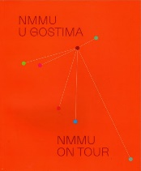
Title | Nacionalni muzej moderne umjetnosti u gostima = National museum of modern art on tour : 2022. - 2025. / [tekst, essay Branko Franceschi ... [et al.] ; prijevod, translation Robertina Tomić].
Publisher | Zagreb : Nacionalni muzej moderne umjetnosti, 2025.
Description | 200 str. : ilustr. u bojama ; 30 cm.
Note | Katalog izložbe.
Language/s | Tekst usporedo na hrv. i na engl. jeziku.
ISBN | 9789533481777 : EUR 36.40 US$ 43.70
Subject | Nacionalni muzej moderne umjetnosti (Zagreb) --Moderna umjetnost -- Hrvatska -- Katalozi izložbi
UDC | 7.036/.038(497.5) * 069:7.036(497.5)


Author | Popović, Dimitrije
Title | Umjetnost između ideje i ideologije
Publisher | Zagreb : Litteris, 2025
Description | 247 str. : ilustr. ; 21 cm
ISBN | 9789538195402 : EUR 34.50 US$ 41.40
Subject | Likovne umjetnosti - eseji
UDC | 7.01:316.75
 | The literature of painter Dimitrij Popović is a natural extension of his artistic expression, a medium in which he moves confidently and skillfully. In the book Art Between Idea and Ideology, the author explores engaged art and its possible abuses, art in the age of rapid information flow and social networks, questions the representation of the body in visual culture, and exposes the boundaries between the sacred and the profane.

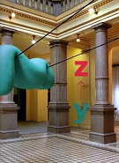
Title | Y-Z gradilište nove generacije = Y-Z New - generation construction site : Nacionalni muzej moderne umjetnosti, Oktogon = National Museum of Modern Art, Octagon, Zagreb, 17. 04. - 17. 06. 2025. / [tekst, essay Marta Radman ; urednici, editors Branko Franceschi, Marta Radman].
Publisher | Zagreb : Nacionalni muzej moderne umjetnosti, 2025.
Description | 104 str. : ilustr. u bojama ; 30 cm.
Note | Katalog izložbe.
Language/s | Tekst usporedo na hrv. i na engl. jeziku.
ISBN | 9789533481821 : EUR 27.30 US$ 32.80
Subject | Hrvatska umjetnost -- 2020.-2030. -- Katalozi izložbi. Moderna umjetnost -- Hrvatska -- 21. st. -- Katalozi izložbi
UDC | 7.036/.038(497.5)

Urbanism. Architecture
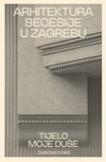
Author | Kisić, Dubravka
Title | Arhitektura secesije u Zagrebu : tijelo moje duše
Publisher | Zagreb : Srednja Europa, 2025
Description | 504 str. : ilustr. ; 24 cm.
ISBN | 9789533870755 : EUR 50.50 US$ 60.60
Subject | Secesijska arhitektura – Zagreb. Zagreb -- Zgrade i građevine -- 19. st . Zagreb -- Zgrade i građevine -- 20. st
UDC | 72.035.93(497.521.2) * 72(497.521.2)
 | The book Arhitektura secesije u Zagrebu was created by systematizing and interpreting the results of research into Zagreb's architectural production in the period from 1895 to 1914, marked by the Art Nouveau stylistic idiom.

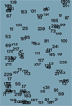
Author | Čulek, Jana et al.
Title | Intelligence of errors : foundations and fieldnotes
Publisher | Zagreb : Institute of Philosophy : Croatian Architect's Association, 2025.
Description | 242 str. : ilustr. u bojama ; 19 cm.
ISBN | 9789537137977 : EUR 23.60 US$ 28.60
UDC | 7.038.55(497.5) * 72.091(450) * 72.01
 | This book represents a statement of the paradigm underpinning the Croatian Pavilion at the 19th International Architecture Exhibition—La Biennale di Venezia 2025. Titled Intelligence of Errors”, the pavilion is an artistic and research-based installation dedicated to investigating ways in which errors in spa tial design and policy can be used as resources for learning and making new worlds.

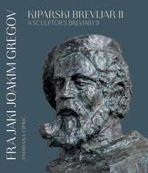
Sculpture and related art

Author | Ciprić, Andriana
Title | Fra Jaki Joakim Gregov : kiparski brevijar 2 = a sculptor's breviary 2
Publisher | Zagreb : Alfa, 2025.
Description | XXIII, 499 str. : ilustr. (pretežno u bojama) ; 31 cm
ISBN | 9789533645759 : EUR 74.70 US$ 89.60
Subject
UDC | 73Gregov, J. * 272-789.3Gregov, J.

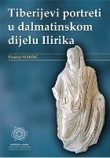
Author | Maršić, Dražen
Title | Tiberijevi portreti u dalmatinskom dijelu Ilirika
Publisher | Zadar : Sveučilište, 2025.
Description | 166 str. : ilustr. u bojama ; 24 cm.
ISBN | 9789533315010 : EUR 29.80 US$ 35.80
 | Tiberius, rimski car – Portreti. Rimsko antičko kiparstvo – Dalmacija. Portretno kiparstvo -- Dalmacija -- Antika
UDC | 73.032(497.58) * 73.041.5(497.58) * 73.032(37)
Anotation | The work studies Tiberius' portraits from the province of Illyricum (later Dalmatia).  Readers are first introduced to the issues of portrait typology of the second Roman ruler (colloquially emperor) Tiberius, the successor of Augustus. There are six types of portraits that are called differently in the literature, and their reasons for introduction are interpreted differently.

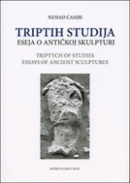
Author | Cambi, Nenad
Title | Triptih studija / eseja o antičkoj skulpturi = Triptych of studies / essays of ancient sculptures
Publisher | Split : Književni krug, 2025
Description | 215 str. : ilustr. ; 24 cm
Note | Tekst na hrv. i na engl. jeziku. - Bibliografija: str. 197-208
ISBN | 9789531635677 : EUR 29.80 US$ 35.80
Subject | Antika – Povijest. Ikonografija -- Eseji i studije
UDC | 7.04"652")

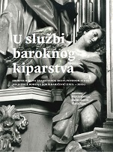
Author | Znanstveni skup U službi baroknog kiparstva (2023 ; Zagreb)
Title | U službi baroknog kiparstva : zbornik radova znanstvenog skupa povodom stote obljetnice rođenja Doris Baričević (1923. – 2016.)  / Ožanić, Martina (urednik) (prevoditelj) (autor teksta) ; Šourek, Danko (urednik) (autor teksta)  Zajec, Vlasta (urednik)
Publisher | Zagreb : Institut za povijest umjetnosti, 2025
Description | 359 str. : ilustr. u bojama ; 22 cm.
ISBN | 9789533730455 : EUR 29.80 US$ 35.80
Subject | Baričević, Doris -- Zbornici s konferencija. Barokno kiparstvo -- Hrvatsko kiparstvo -- 17. st. Hrvatsko kiparstvo -- 18. st .
UDC | 7.072.2Baričević, D. * 73.034.7(497.5) * 73(497.5)

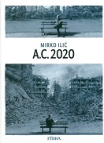
Drawings

Author | Ilić, Mirko
Title | A.C. 2020
Publisher | Zagreb : Fibra, 2025
Description | 70 str. : ilustr. ; 29 cm
ISBN | 9789533219578 : EUR 25.00 US$ 30.00
UDC | 741.5

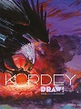
Author | Kordej, Igor
Title | Draw!
Publisher | Zagreb : Fibra, 2025
Description | 480 str. : ilustr. u bojama ; 34 cm
Language/s | Hrvatski, engleski, francuski
ISBN | 9789533219271 : EUR 62.50 US$ 75.00
UDC | 741.52Kordej, I. * 741Kordej, I.
Anotation | With this unique compilation of over 1000 works, globally renowned comic artist Igor Kordey reveals his alter ego – an artist who simultaneously produces graphic design and illustration, and thus celebrates 50th anniversary of his professional life.

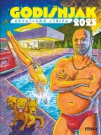
Author | Macan, Darko
Title | Godišnjak hrvatskog stripa 2025
Publisher | Zagreb : Fibra, 2025
Description | 135 str. : ilustr. (pretežno u bojama) ; 29 cm
ISBN | 9789533219516 : EUR 27.50 US$ 33.00
Subject | Stripovi. Kratki stripovi. Antologije
UDC | 741.52(497.5)

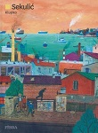
Author | Sekulić, Miroslav
Title | Klupko : Ljeto/Jesen/Zima/Proljeće
Publisher | Zagreb : Fibra, 2025
Description | 224 str. : ilustr. u bojama ; 29 cm
ISBN | 9789533219738 : EUR 43.70 US$ 52.40
Subject
UDC | 741.5


Author | Kordej,Igor ; Macan, Darko
Title | Maršal Bass 6  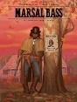  Proklete pare - Suton
Publisher | Zagreb : Fibra, 2025
Description | 176 str. : ilustr. (pretežno u bojama) ; 32 cm
ISBN | 9789533219844 : EUR 31.20 US$ 37.40
Subject | Vestern stripovi
UDC | 741.52(497.5)

Paintings
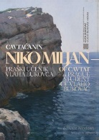
Author | Puhara, Helena
Title | Cavtaćanin Niko Miljan - praški učenik Vlaha Bukovca
Publisher | Muzeji i galerije Konavala, 2025
Description | 79 str., 30 cm
Language/s | hrvatski, engleski
ISBN | 9789537226510 : EUR 25.00 US$ 30.00
UDC | 75(450)

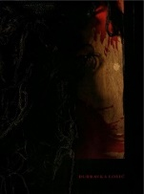
Author | Lošić, Dubravka
Title | Dubravka Lošić: Punćela : The Silkworm's Cocoon : Oktogon NMMU = Octagon NMMU, Zagreb, 24. 11. 2024. − 16. 2. 2025.
Publisher | Zagreb : Nacionalni muzej moderne umjetnosti = National Museum of Modern Art, 2024
Description | 101 str. : ilustr. u bojama ; 29 cm.
Note | Katalozi izložbi
ISBN | 9789533481739 : EUR 27.30 US$ 32.80
UDC | 7.038.5Lošić, D.

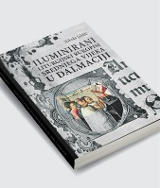
Author | Jakšić, Nikola, povjesničar umjetnosti
Title | Iluminirani liturgijski rukopisi srednjega vijeka u Dalmaciji : odabrane studije
Publisher | Zadar : Sveučilište u Zadru, 2025
Description | 260 str. : ilustr. (pretežno u bojama) ; 28 cm.
ISBN | 9789533315720 : EUR 59.50 US$ 71.40
Subject | Iluminacija knjiga i rukopisa -- Dalmacija -- Srednji vijek
UDC | 75.057(497.58) * 272-282(497.58) * 091(497.58)

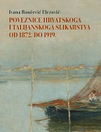
Author | Rončević Elezović, Ivana
Title | Poveznice hrvatskoga i talijanskoga slikarstva od 1872. do 1919.
Publisher | Zagreb : Leykam international : Nacionalni muzej moderne umjetnosti, 2025
Description | 615 str. : ilustr. u bojama ; 29 cm.
ISBN | 9789533402215 : EUR 107.10 US$ 128.50
Subject | Hrvatsko slikarstvo -- 19. st. Hrvatsko slikarstvo -- 20. st. Hrvatsko slikarstvo -- Talijanski utjecaji
UDC | 75(497.5) *

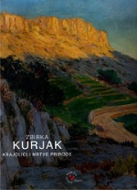
Title | Zbirka Kurjak : Krajolici i mrtve prirode : [izložba slika : Galerija Mona Lisa, Zagreb, ožujak, 2025.] / [urednik Martin Henc ; fotografije Goran Vranić, Martin Henc].
Publisher | Zagreb : Galerija Mona Lisa, 2025.
Description | 176 str. : ilustr. u bojama ; 30 cm.
Note | Katalog izložbe.
ISBN | 9789537352271 : EUR 36.40 US$ 43.70
Subject | Hrvatsko slikarstvo -- Mrtva priroda u slikarstvu. Pejzažno slikarstvo -- Hrvatska -- Katalozi izložbi
UDC | 75(497.5)

Photography
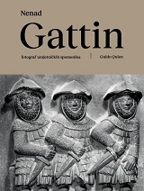
Author | Quien, Guido
Title | Nenad Gattin : fotograf umjetničkih spomenika
Publisher | Trogir : "Radovan", Društvo za zaštitu kulturnih dobara Trogira : Ogranak Matice hrvatske u Trogiru ; Zagreb : ULUPUH - Hrvatska udruga likovnih umjetnika primijenjenih umjetnosti, 2025.
Description | 151 str. : ilustr., faks. ; 25 cm.
ISBN | 9789537041205 : EUR 50.00 US$ 60.00
UDC | 77Gattin, N. * 77.03:73(497.5) * 77.03:72(497.5)

Theatar. Film. Dance
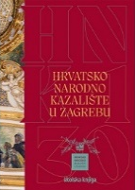
Author | Petranović, Martina [urednica]
Title | Hrvatsko narodno kazalište u Zagrebu : 130 godina zgrade
Publisher | Zagreb : Hrvatsko narodno kazalište : Školska knjiga, 2025
Description | 749 str. : ilustr. ; 31 cm
Subject | Hrvatsko narodno kazalište (Zagreb) - zgrade – povijest. Hrvatsko narodno kazalište (Zagreb) – povijest zgrade kazališta
ISBN | 9789530625808 : EUR 94.00 US$ 112.80
UDC | 792(497.5)(091) Povijest kazališta u Hrvatskoj * 725.1:792 Zgrade kazališta

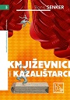
Author | Senker, Boris
Title | Književnici i kazalištarci : ogledi o hrvatskim dramatičarima, redateljima, glumcima i teatrolozima
Publisher | Zagreb : Društvo hrvatskih književnik, 2025
Description | 230 str. ; 21 cm
ISBN | 9789532784343 : EUR 23.80 US$ 28.60
Subject | Hrvatski dramatičari. Hrvatska drama -- Povijest i kritika. Kazališni redatelji – Hrvatska. Kazališni glumci -- Hrvatska  Teatrolozi -- Hrvatska
UDC | 821.163.42.09-2 * 792-051(497.5) * 792.072(497.5)

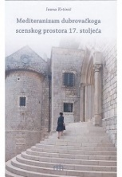
Author | Krtinić, Ivana
Title | Mediteranizam dubrovačkoga scenskog prostora 17. stoljeća
Publisher | Zadar : Matica hrvatska, Ogranak, 2024
Description | 207 str. : ilustr., faks. ; 25 cm
ISBN | 9789532472011 : EUR 29.80 US$ 35.80
Subject | Hrvatsko kazalište -- Dubrovnik -- 17. st. Hrvatska komedija -- Dubrovnik -- 17. st. Mediteran u književnosti  Mediteranska kultura. Dubrovnik -- Društveni život i običaji -- 17. st.
UDC | 821.163.42.09-2 * 792(497.584Dubrovnik) * 792.2(497.5) * 39(497.584Dubrovnik) * 39(210.5)(262)
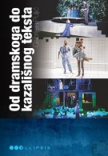

Author | Bionda, Gabrijela
Title | Od dramskoga do kazališnog teksta : stilističko čitanje suvremene hrvatske drame
Publisher | Zagreb : Durieux, 2025
Description | 277 str. : ilustr. u bojama ; 24 cm
ISBN | 9789531885805 : EUR 24.60 US$ 29.50
Subject | Književnost i kazalište. Hrvatska drama -- 21. st. Hrvatska drama -- Scenske izvedbe -- 21. st. Hrvatsko kazalište -- 21. st
UDC | 792(497.5) * 792.2.02 * 821.163.42.09-2 * 792.2(497.5)

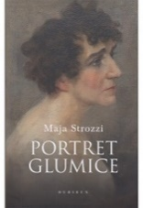
Author | Strozzi, Maja
Title | Portret glumice
Publisher | Zagreb : Durieux, 2025.
Description | 331 str. ; 24 cm.
ISBN | 9789531885898 : EUR 24.60 US$ 29.50
UDC | 792Strozzi, M.
Anotation | In her new book Portret glumice (Portrait of an Actress), Maja Strozzi, with equal courage and exceptional writing talent, has stepped into a completely new literary field. In Portrait of an Actress, the author, based on historical documents, family stories and photographs, but also her own imagination, reconstructs the private and professional life of her grandmother Marija Ružička Strozzi, a legend of Croatian acting from the late 19th and early 20th centuries, who delighted audiences on the stages of the old Upper Town Theatre, and then the Zagreb Croatian National Theatre, from its opening, for more than fifty years and embodied more than 600 dramatic characters.

