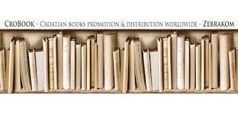

**Introducing New Books from**

**Croatia 2/2025**

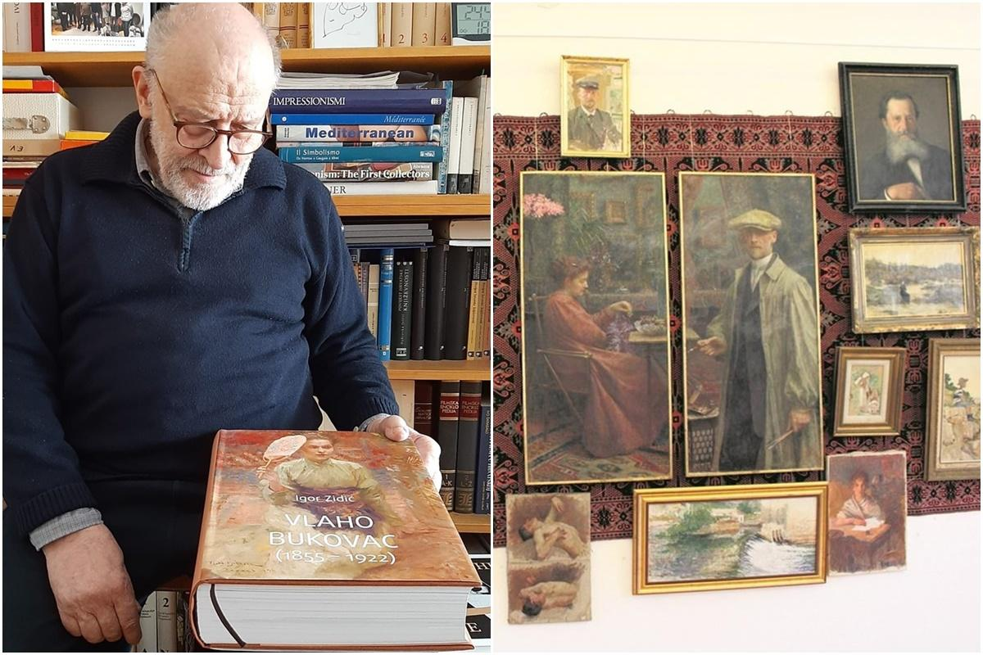

*The most comprehensive monograph on Vlaho Bukovac has just been published, the work of renowned Croatian art historian Igor Zidić. It was he who*

*organized numerous retrospective exhibitions of the founder and main representative of Croatian modernism, one of the greatest Croatian painters in*

*general, our Cavtat genius Vlaho Bukovac. Zidić has already prepared several monographs on Dubrovnik painters (Ignjat Job, Ivo Dulčić, Antun Masla)*

*including Bukovac, so this is actually the crowning achievement of his work on the figure and work of our great man..*(Page 21)



**ZEBRA komunikacije d.o.o.,**

**Dubašnička 12, 10000 Zagreb – Croatia**

**tel./fax 385 1 3668 993**

[**www.zebrakom**](http://www.zebrakom)**,** [**info@zebrakom.hr**](mailto:info@zebrakom.hr)**,**

Museums. Religion. Social Sciences. Humanities

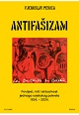Title **Antifašizam :** povijest, mit i aktualnost jednoga svjetskog pokreta 1924. - 2024. .

Impresum Zagreb : Plejada ; Split : VeDRA, 2024.

Description 503 str. ; 24 cm.

ISBN 9789537782962 : **EUR 42.50 US$ 49.70**

UDC 329.18-025.44(091)

Anotation The author seeks to explain antifascism as history, and then the subsequent use of that history, and to highlight the most important lessons and experiences. The book contains a preface and seven chapters: “Introduction: Antifascism, the Big Picture”; “Historical Antifascism: 1921–1945”; “Contributions to a Cultural History of Antifascism: Symbols, Myths and Narratives”; “Moral Strength and the Reconciliatory Potential of Antifascism”; “(Counter)Myths about Antifascism in Serbian and Croatian Nationalism”; “Fascism and Antifascism of Our Time”; “Concluding Considerations: What Was Historical Antifascism and Who Does It Concern Today”. The breadth of the approach allows Perica not only a historical analysis – a study of the history of antifascism in the world and in our country – but also a presentation of contemporary forms of antifascism, and their potential for the future.

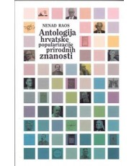

Author Raos, Nenad

Title **Antologija hrvatske popularizacije prirodnih znanosti**

Impresum Zagreb : In.Tri, 2025.

Description 224 str. : ilustr. ; 23 cm.

ISBN 9789538178344 ; **EUR 22.60 US$ 26.40**

Subject Prirodne znanosti -- Hrvatska – Povijest. Znanstvenici -- Hrvatska -- Biografije

UDC 001.92:5(497.5)(091)

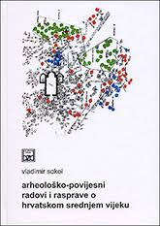

Author Sokol, Vladimir

Title **Arheološko-povijesni radovi i rasprave o hrvatskom srednjem vijeku**

Impresum Split : Književni krug, 2025.

Description 411 str. : ilustr. ; 24 cm.

Notes Summaries: Archeological-historical papers and discussions on the Croatian middle ages.

ISBN 9789531635646 : **EUR 31.90 US$ 37.30**

UDC 904(497.5)"653" * 930.85(497.5)

Anotation The book presents the Croatian historical space in the early Middle Ages, primarily through an archaeological perspective. The book selects archaeological and historical works by authors who have been created over many years and have previously been verified and published in reputable journals, proceedings of scientific conferences, or as chapters in books. In some cases, these are also unpublished presentations from scientific conferences. All contributions are arranged chronologically according to the corresponding topic.

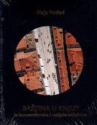

Author Nodari, Maja

Title **Baština u knjizi** : iz konzervatorske i radijske bilježnice (1991. - 2021.)

Impresum Dubrovnik : Društvo prijatelja dubrovačke starine, 2024.

Description 432 str. : ilustr. u bojama ; 26 cm.

ISBN 9789538550003 : **EUR 49.60 US$ 56.20**

Subject Kulturna baština – Dubrovnik. Dubrovnik -- Kulturna povijest

UDC 930.85(497.584Dubrovnik) * 7.096(497.584Dubrovnik)

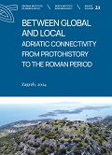Title **Between global and local**: Adriatic connectivity from protohistory to the Roman period : proceedings of the conference : Stari Grad, Hvar Island, 28th - 29th October 2022

/ [urednice, editors Marina Ugarković... [et al.] ; prijevod, translation Marko Maras].

Impresum Stari Grad, Hvar : Institute of Archaeology = Institut za arheologiju, 2024.

Description 244 str. ; 29 cm.

Language/s Tekst na hrv. i na engl. jeziku.

ISBN 9789536064731 : **EUR 23.80 US$ 27.80**

Subject Arheološki nalazi -- Jadranska regija -- Stari vijek -- Zbornici s konferencija Jadranska regija -- Starine -- Zbornici s konferencija

UDC 903’1(497.58)"637/638" * 904(398) * 902.2(497.5)

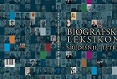

Title **Biografski leksikon središnje Istre**

/ [glavni urednik Josip Šiklić ; suradnik Robert Matijašić]

Impresum Pazin : Katedra Čakavskog sabora za povijest Istre, 2024

Description 467 str. : ilustr. (djelomice u bojama) ; 24 cm

ISBN 9789535955528 : **EUR 87.50 US$ 102.40**

Subject Istra -- Enciklopedija

UDC 929(497.571)(031)

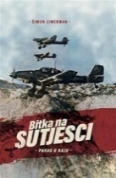Author Cimerman, Šimun

Title **Bitka na Sutjesci** : pakao u raju

Impresum Zagreb : Naklada Jesenski i Turk, 2025.

Description 412 str. : ilustr. ; 24 cm.

ISBN 9789533810812 : **EUR 62.80 US$ 73.50**

UDC 94(497.1)"1939/1945" * 355.48(497.1) * 355.425(497.1)

Anotation The most difficult partisan battle of WW II that changed the history of Yugoslavia. This is an overview of the key events of World War II: from the attack of Nazi Germany on the Kingdom of Yugoslavia and the beginnings of the uprising to the beginning of anti-partisan operations from autumn 1941 to summer 1943, with an emphasis on two key events – the Battle of the Neretva (Operation Weiss) and the Battle of the Sutjeska (Operation Schwarz). Relying on historical facts, authentic documents and testimonies of participants, the author creates a vivid picture of the reality of war and the courage of those who lived through it.

Author Đikić, Ivica

Title **Budimir Lončar** : prije i poslije kraja

Impresum Zaprešić : Fraktura, 2025.

Description 240 str. : ilustr. ; 24 cm.

ISBN 9789533588094 : **EUR 24.50 US$ 28.70**

UDC 32Lončar, B.

Anotation Ivica Đikić's book Budimir Lončar – Before and After the End consists of the stories of a world-renowned diplomat, the last Yugoslav foreign minister and foreign policy advisor to two Croatian presidents. The historical figure tells history itself, from his first encounter with the once Italian Zadar, his departure to join the partisans, his first diplomatic service in New York, ambassadorial mandates in Indonesia, West Germany and the United States, his duties as head of Yugoslav diplomacy and the futile but epic attempt to prevent war in Yugoslavia, to this book – before and after the end – when Lončar speaks about today's world, with the authority of his – literally – one hundred years of experience and political and personal wisdom.

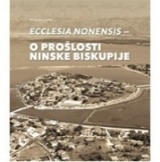

Title **Ecclesia Nonensis** : o prošlosti Ninske biskupije

/ [urednik Zdenko Dundović]

Impresum Zadar : Sveučilište, 2024

Description 448 str., [1] presavijeni list sa zemljop. kartom : ilustr. u bojama ; 29 cm

ISBN 9789533314778 : **EUR 71.40 US$ 83.50**

UDC 272-772(497.581.1Nin)(062)(082)

Anotation The collection of papers brings together studies by twenty eminent Croatian experts from several social and humanistic disciplines (historians, archaeologists, conservators, archivists, demographers, ethnologists and geographers) gathered around a common goal – to present new data on the past of the Nin Diocese, clarify certain topics from its rich ecclesiastical history, present new scientific knowledge, or expand some older but still valuable conclusions with new contributions, especially with regard to the available sources in church and secular archives in Zadar, Split, Zagreb, and in Vienna, Paris, Rome or Venice.

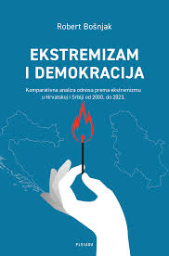

Author Bošnjak, Robert, politolog

Title **Ekstremizam i demokracija** : komparativna analiza odnosa prema ekstremizmu u Hrvatskoj i Srbiji od 2000. do 2023.

Impresum Zagreb : Plejada, 2024.

Description 269 str. ; 23 cm.

Note Imensko kazalo. Summary.

ISBN 9789537782979 : **EUR 26.60 US$ 31.10**

UDC 329-028.81(497.5) * 329-028.81(497.11)

Anotation The aim of the book is to explore the phenomenon of extremism, a very important problem that dominates Southeastern Europe (but also numerous other countries, regardless of whether they are consolidated democracies or hybrid regimes) and to present scientifically established differences in the relationship between Croatia and Serbia. In the first part, the author elaborates in detail the theoretical foundations, and in the second part of the book he analyzes the phenomena detected by relevant international bodies (Human Rights Watch and the European Commission against Racism and Intolerance).

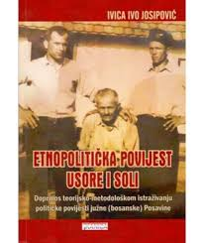Title **Etnopolitička povijest Usore i Soli** : doprinos teorijsko-metodološkom istraživanju političke povijesti južne (bosanske) Posavine

Impresum Zagreb : Tkanica ; Sesvetski Kraljevec : Grafok, 2023.

Description 136 str. ; 23 cm.

ISBN 9789537999544 : **EUR 26.50 US$ 31.00**

Subject Hrvati -- Posavina (Bosna i Hercegovina) – Povijest. Hrvati -- Posavina (Bosna i Hercegovina) -- Etnički identitet

Posavina (Bosna i Hercegovina) -- Politička povijest

UDC 323.17(497.6=163.42)(091) * 94(497.6)

Anotation This study is the first attempt at a multidisciplinary (political) research of different aspects of the area of ​​southern Posavina - because a complete ethnopolitical history of southern Posavina has not been written so far - with a focus on ethnic and political relations. This indicates the social justification of research that proves the peculiarities that distinguish this historical land from others. The very writing of the ethnopolitical history of Usora and Soli implies a revision of the concept of a Yugoslav land, since it is the central place of Yugoslav, but, unfortunately, partly also Croatian historiography. From an administrative point of view, the lands of Usora and Soli throughout history were a constituent part of Slavonia, which was part of the dual kingdom of Croatia and Hungary. Slavonia was governed by a ban, and the lands of Usora and Soli by prefects. (...)

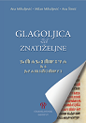

Author Mihaljević, Ana, profesorica hrvatskog jezika

Title **Glagoljica za znatiželjne**

Impresum Zagreb : Hrvatska sveučilišna naklada : Staroslavenski institut, Milan Mihaljević, Ana Šimić., 2024.

Description 88 str. : ilustr. u bojama ; 20 cm.

Note Bibliografija. Kazalo.

ISBN 9789536080687 : **EUR 14.90 US$ 17.40**

UDC 003.349.1(497.5)

Anotation

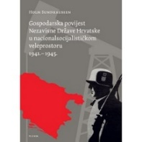Author Sundhaussen, Holm

Title **Gospodarska povijest Nezavisne Države Hrvatske u nacionalsocijalističkom veleprostoru 1941.-1945.** : propast jedne eksploatacijske strategije / Holm Sundhaussen ; prevela Mira Kolar-Dimitrijević ; redigirao i priredio Matko Globačnik.

Impresum Zagreb : Plejada, 2025.

Description 439 str. : graf. prikazi, zemljop. karte ; 24 cm.

Note Prijevod djela: Wirtschaftsgeschichte Kroatiens im nationalsozialistischen Großraum 1941-1945 : Das Scheitern einer

ISBN 9789537782948 : **EUR 42.50 US$ 49.70**

Subject Gospodarstvo -- Hrvatska -- 1941.-1945. Nezavisna Država Hrvatska -- Ekonomski uvjeti

UDC 338(497.5)(091) * 94(497.5)"1941/1945"

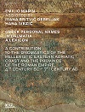Author Marin, Emilio

Title **Greek personal names in Dalmatia a lexicon** : a contribution to the onomastics of the hellenistic eastern jdriatic coast and the province of the Roman Empire, 4th century BC – 7th century AD

Impresum Zagreb : Arheološki muzej u Zagrebu, 2024.

Description 325 str. : ilustr. ; 30 cm.

ISBN 9789538143663 : **EUR 41.70 US$ 48.80**

UDC 81.14’373.23(497.58)(031) * 81’373.23(497.58)(091)(031) * 003.071=14(497.58) * 003.071=124(497.58)

The scientific monograph represents the first onomasticon of Greek names recorded in epigraphic material from the area of ​​Dalmatia from the Hellenistic and Roman periods. This book is the result of research that began more than four decades ago, thanks to an invitation

Peter M. Fraser referred to Academician Emilio Marino to join his

to the Oxford project of editing the Lexicon of Greek Personal Names (under the auspices of

British Academy).



Author Žebčević Matić, Maja

Title **Grgurevo** : uz 800. obljetnicu prvog spomena grada Požege 1227. i 200. obljetnicu prvog spomena običaja Grgureva 1825. godine

Impresum Požega : Gradski muzej Požega, 2025.

Description 292 str. : ilustr. (pretežno u bojama) ; 27 cm.

Note Bibliografija. Kazalo.

ISBN 9789537838263 ; **EUR 65.50 US$ 76.60**

Subject Vinogradarski običaji --Vinogradarstvo -- Vino i vinarstvo -- Požega (Hrvatska) -- Društveni život i običaji

UDC 398.332.4(497.541Požega) * 634.8(497.541Požega)(091)

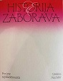Title **Historija zaborava** : prve žene zagrebačkih muzeja

/ [urednica Ana Solter ; autorica tekstova Štefka Batinić ... [et al.].

Impresum Zagreb : Arheološki muzej u Zagrebu : Hrvatski školski muzej : Etnografski muzej Hrvatski školski muzej : Muzej za umjetnost i obrt, 2024.

Description 176 cm. ilustr. u bojama ; 25 cm.

Note Katalog izložbe.

ISBN 9789538143755 : **EUR 35.70 US$ 41.80**

UDC 069-055.2(497.521.2)

Anotation The exhibition **Historija zaborava** : prve žene zagrebačkih muzeja (History of Forgetfulness – The First Women of Zagreb Museums) presents the stories of pioneers of the museum profession – curators, painters, sculptors, poets, designers and textile experts, who, despite numerous obstacles, left an indelible mark in the fields of ethnology, anthropology, museology, art, design and education. Through archival materials, multimedia installations and interviews with the descendants of museum workers, the exhibition brings new readings of history and contextualizes the contribution of these exceptional women.

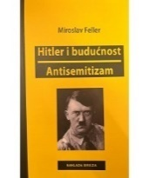

Author Feller, Miroslav

Title **Hitler i budućnost ; Antisemitizam**

Impresum Zagreb : Naklada Breza, 2025.

Description 156 str. ; 21 cm.

Note Prijevod djela: 1. Hitler und die Zukunft ; 2. Antisemitismus

ISBN 9789538139772 ; **EUR 26.20 US$ 30.60**

UDC 32Hitler, A. * 32(430)(091) * 323.12(=411.16)

Anotation This book brings together translations of two texts by the versatile author Miroslav Feller (Donja Stubica, 5.3.1901 - Silba, 30.5.1961), a very important but also very neglected Croatian author, who address, unfortunately, still very current problems of our Western civilization: Hitler and his role in our history and the phenomenon of anti-Semitism inextricably linked to him, and not only to him. (...)

These are very stimulating texts for understanding both the era in which they were written and the present, because we constantly witness anti-Semitism, not totalitarianism, and totalitarianism, it seems, is not just a thing of the past.

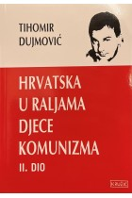

Author Dujmović, Tihomir

Title **Hrvatska u raljama djece komunizma 2. dio**

Impresum Zagreb : Kružić, 2025.

Description 256 str. ; 21 cm.

ISBN 9789535754688 : **EUR 35.70 US$ 41.80**

UDC 323(497.5)

Anotation Our tireless Tihomir Dujmović, analytical, courageous, upright and dignified, continues his analysis of the Croatian present. Before us is the second part of the book Croatia in the Jaws of the Children of Communism, ten years after the publication of the first book. The author has spent months studying past events in politics and economics and has accurately painted today's Croatia. The current picture of Croatia is worse than it was ten years ago because the leaders of the state are not leading a sovereign but still a vassal policy, one towards Brussels and the other towards Moscow.

- Professor emeritus dr. sc. Andrija Hebrang, dr. med.

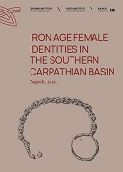

Title **Iron Age Female Identities in the Southern Carpathian Basin**

/ editor Marko Dizdar ; [prijevod, translation Marko Maras, Tamara Levak Potrebica].

Impresum Zagreb : Institute of Archaeology Zagreb, 2022.

Description 289 str. : ilustr. u bojama ; 29 cm.

ISBN 9789536064632 : **EUR 30.90 US$ 36.10**

Subject Žene -- Društveni uvjeti -- Željezno doba. Žene -- Identitet -- Željezno doba. Latenska kultura -- Hrvatska, istočna

Halštatska kultura -- Hrvatska, istočna

UDC 903’1(497.54)"638" * 305-055.2(497.54)(091)

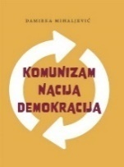Author Mihaljević, Damirka

Title **Komunizam, nacija, demokracija**

Impresum Zagreb : Srednja Europa, 2025.

Description VIII, 212 str. ; 24 cm.

ISBN 9789533870120 : **EUR 25.50 US$ 29.80**

UDC 321.74(497.1) * 32(4)

Anotation The book is an attempt to shed light on the relationship between communism and nations and the causal links between this relationship and the democratic transition. It does not contain the established political science and sociological repertoire of interpretations that have become a kind of arbiter for understanding social and political processes in this part of the world. The basic argument is that national movements were not crushed in the communist era, nor was the communist period a vacuum in the process of nation-building.

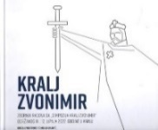

Title **Kralj Zvonimir** : zbornik radova sa Simpozija Kralj Zvonimir održanog 11. i 12. lipnja 2022. godine

/ uredili Ivica Šimić i Tomislav Galović ; [fotografije Vladimir Jelić].

Impresum Zagreb : Sveučilište ; Knin : Narodna knjižnica, 2025.

Description 330 str. : ilustr. ; 26 cm.

Note Imensko i zemljopisno kazalo. Abstracts.

ISBN 9789535965725 : **EUR 58.30 US$ 67.20**

Subject Zvonimir, hrvatski kralj -- Hrvatska -- Vladari -- 925.-1102. --Hrvatska -- Povijest -- 925.-1102. -- Zbornici s konferencija

UDC 94(497.5)"0630/1102" * 94(497.5)Zvonimir



Author Bõsze, Sándor

Title **Kraljevski gubernij za Rijeku i Ugarsko-hrvatsko primorje** : inventar fonda

/ [Sándor Bõsze, Ágnes Ordasi, Tamás Polgár, Boris Zakošek ; prijevod na hrvatski jezik Đerđ Čović, Ivan Tomek].

Impresum Rijeka : Državni arhiv u Rijeci ; Kaposvár : Magyar Nemzeti Levéltár Somogy Megyei Levéltára, 2024.

Description 304 str. : ilustr. ; 30 cm.

Note Bibliografija: str. 20-21; bibliografske bilješke uz tekst uvoda.

ISBN 9789537134419 : **EUR 58.30 US$ 67.20**

UDC 930.255(497.561Rijeka)

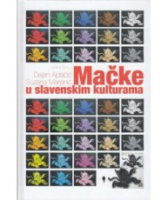Title **Mačke u slavenskim kulturama**

/ uredili Dejan Ajdačić, Suzana Marjanić ; [prijevod s poljskoga Mislav Graonić, Željka Kruljac ; prijevod s bjeloruskoga Dajana Lazarević ; prijevod s ukrainskoga Dariya Pavlešen].

Impresum Zagreb : Durieux, 2024.

Description 323 str. : ilustr., graf. prikazi ; 24 cm.

Language/s Tekst na hrv. i na srp. jeziku.

Note Bibliografija iza svakog poglavlja.. Summaries. Imensko kazalo.

ISBN 9789531885591 : **EUR 24.60 US$ 28.80**

Subject Mačke u popularnoj kulturi -- Slavenske zemlje. Mačke -- Slavenske zemlje – Folklor. Slavenski jezici -- Frazeologija

UDC 39:59 * 811.16’373.7

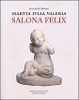

Author Jeličić Radonić, Jasna

Title **Martia Ivlia Valeria** : Salona Felix

Impresum Split : Književni krug ; Solin : Rižinice, društvo za očuvanje kulturne i prirodne baštine Solina, 2024.

Description 254 str. : ilustr. u bojama ; 27 cm.

Language/s Tekst na hrv. i na eng. jeziku.

ISBN 9789531635592 : **EUR 31.90 US$ 37.70**

Subject Arheološki nalazi – Salona. Arheološka nalazišta -- Solin

UDC 904(398Salona) * 902.2(497.583Solin)

Author Škegro, Ante

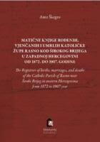Title **Matične knjige rođenih, vjenčanih i umrlih Katoličke župe Rasno kod Širokog Brijega u zapadnoj Hercegovini od1872. do 1907. godine** = **The Registries of births, marriages, and deaths of the Catholic Parish of Rasno near Široki Brijeg in western Herzegovina from 1872 to 1907 year**

Impresum Zagreb : Hrvatski institut za povijest, 2024. ([Zagreb] : Sveučilišna tiskara)

Description 451 str. ; 25 cm.

Language/s Tekst na hrv., lat. i engl. jeziku.

ISBN 9789538335464 : **EUR 63.80 US$ 74.60**

Subject Matice umrlih -- Široki Brijeg (okolica). Matice vjenčanih -- Široki Brijeg (okolica). Matice krštenih -- Široki Brijeg (okolica)

Matične knjige rođenih. Matične knjige umrlih

UDC 929.532(497.6)

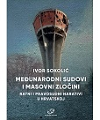

Author Sokolić, Ivor

Title **Međunarodni sudovi i masovni zločini** : ratni i pravosudni narativi u Hrvatskoj

Impresum Zagreb : Srednja Europa, 2025.

Description 280 str. : ilustr. ; 21 cm.

Note Prijevod djela: International Courts and mass atrocity : narratives of war and justice in Croatia .

ISBN 9789533870328 : **EUR 27.70 US$ 32.40**

Subject Domovinski rat (1991.-1995.) – Zločini. Ratni zločini -- Hrvatska -- 1991.-1995. Ratni zločini (međunarodno pravo)

UDC 341.322.5(497.5) * 323(497.5) * 316.334.3(497.5)

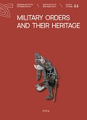Title **Military orders and their heritage** : proceedings of the 8th International Conference on Mediaeval Archaeology of the Institute of Archaeology : Zagreb, 9th - 10th November 2022

/ Editors Juraj Belaj ... [et al.].

Impresum Zagreb : Institute of Archaeology = Institut za arheologiju, 2024.

Description 324 str. ; 21 cm.

Language/s Tekst na engl. i na hrv. jeziku.

ISBN 9789536064779 : **EUR 23.80 US$ 27.80**

Subject Arheološki nalazi -- Hrvatska -- Srednji vijek -- Zbornici s konferencija. Viteški redovi -- Hrvatska -- Zbornici s konferencija

UDC 904(497.5)"653" * 272-788.4(497.5)

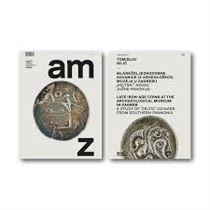Author Bilić, Tomislav, arheolog

Title **Mlađeželjeznodobne kovanice iz Arheološkog muzeja u Zagrebu** : "keltski" novac južne Panonije = **Late iron-age coins at the Archaeological Museum in Zagreb** : a study of "Celtic" coinage from Southern Pannonia

/ fotografije i izrada tabli, photographs and layout of plates Igor Krajcar].

Impresum Zagreb : Arheološki muzej = Archaeological Museum : Hrvatsko arheološko društvo = Croatian Archaeological Society, 2024.

Description 355 str. : ilustr., zemljop. crteži, graf. prikazi ; 30 cm.

Language/s Tekst usporedo na hrv. i na engl. jeziku.

ISBN 9789538143618 : **EUR 101.20 US$ 118.40**

Subject Arheološki muzej (Zagreb). Numizmatička zbirka. Keltski novac – Hrvatska. Kovani novac -- Hrvatska, sjeverozapadna -- Željezno doba

UDC 069.51:737(497.5-16) * 737.1(497.5-16)

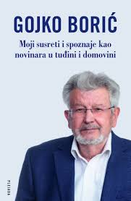Author Borić, Gojko

Title **Moji susreti i spoznaje kao novinara u tuđini i domovini**

Impresum Zagreb : Plejada, 2024.

Description 195 str. ; 24 cm.

ISBN 9789538549007 : **EUR 21.30 US$ 24.90**

UDC 070-051(497.5) * 316.774(430)

Anotation Croatian political emigrant Gojko Borić spent almost his entire life in the Federal Republic of Germany, working as a journalist for Deutsche Welle and collaborating in Croatian emigrant publications, never losing sight of the political and cultural developments in his homeland. In the pages of this book, the author recounts his encounters with today's prominent figures in Croatian politics and culture, as well as his views on the past of the Croatian nation and political emigration, assessments of the literary work of writers of Croatian origin, polemical contributions on Croatian historiography, and considerations on geopolitical relations in the world.

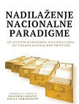Title **Nadilaženje nacionalne paradigme** : od historiografskog nacionalizma do transnacionalnih pristupa

/ izabrali i uredili Branimir Janković, Nikola

Impresum Zagreb : Srednja Europa, 2025.

Description XXXVI, 286 str. ; 26 cm.

ISBN 9789533870403 : **EUR 23.40 US$ 27.40**

UDC 930

Anotation The collection of papers edited by Branimir Janković and Nikola Tomašegović presents new approaches in the study of nations and nationalism that challenge prevailing views on ethnic and national identifications. In contrast, the papers advocate concepts such as national indifference and point to the pervasive relationship between emotions and nationalism, as well as the omnipresent everyday nationalism. The collection also includes papers that criticize the problematic relationship between historiography and nationalism,...

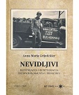

Author Grünfelder, Anna Maria

Title **Nevidljivi** : repatrijacija i reintegracija žrtava holokausta u Hrvatskoj

Impresum Zagreb : Stajer-graf : Židovska vjerska zajednica Bet Israel u Hrvatskoj, 2024.

Description 230 str. : ilustr. u bojama ; 24 cm.

Note Bibliografija. Kazalo. Summary.

ISBN 9789538105562 : **EUR 29.10 US$ 34.00**

Subject Repatrijacija – Hrvatska. Holokaust (1939.-1945.). Židovi -- Hrvatska -- Društveni uvjeti -- 1945.-1991.

Drugi svjetski rat (1939.-1945.) -- Izbjeglice – Jugoslavija. Drugi svjetski rat (1939.-1945.) -- Evakuacija civila

UDC 314.15-024.61(497.5=411.16) * 355.01-058.65(4=411.16) * 308(497.5=411.16) * 341.43(497.5)

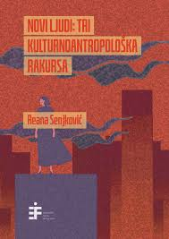

Author Senjković, Reana

Title **Novi ljudi** : tri kulturnoantropološka rakursa

Impresum Zagreb : Institut za etnologiju i folkloristiku, 2024.

Description 220 str. ; 21 cm.

ISBN 9789538518072 : **EUR 23.80 US$ 27.80**

Subject Ekonomska antropologija – Jugoslavija. Omladinske radne akcije -- Socijalni aspekti. Radnice -- Društveni uvjeti -- Jugoslavija

Nostalgija -- Zemlje u tranziciji

UDC 39:33(497.1)

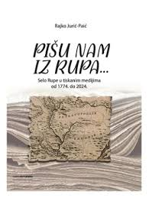

Author Jurić-Paić, Rajko

Title **Pišu nam iz Rupa... .** : selo Rupe u tiskanim medijima 1774. – 2024.

Impresum Skradin : Ogranak Matice hrvatske u Skradinu, 2024.

Description 296 str. : ilustr. (pretežno u bojama), graf. prikazi i faks. ; 27 cm.

Note Bibliografija.

ISBN 9789537868161: **EUR 35.70 US$ 41.80**

Subject Rupe (Skradin) -- U masovnim medijima

UDC 316.774(497.581.2Rupe)

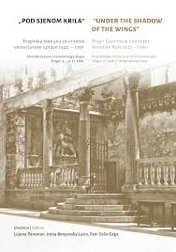Title **Pod sjenom krila**: Trogirska komuna za vrijeme venecijanske uprave 1420. - 1797. : zbornik radova znanstvenoga skupa, Trogir, 4. – 5. 11. 2021. = **Under the shadows of the wings**: Trogir Commune under the Venetian Rule 1420 - 1797 : proceedings of the Scientific Conference, Trogir, 4th and 5th of November 2021

/ [urednice, editors Lujana Paraman, Irena Benyovsky Latin, Fani Celio Cega ; prijevod, translation Marina Schumann].

Impresum Trogir : Muzej grada Trogira ; Zagreb : Hrvatski institut za povijest, 2024.

Description 348 str. : ilustr. (djelomice u bojama) ; 24 cm.

Language/s Tekst na hrv. i na engl. jeziku.

ISBN 9789538335549 : **EUR 41.50 US$ 48.60**

Subject Trogir -- Povijest -- Novi vijek -- Zbornici s konferencija. Trogir -- Kulturna povijest -- Zbornici s konferencija

UDC 94(497.5)"1102/1527" * 94(497.583Trogir)"14/17" * 930.85(497.583Trogir)

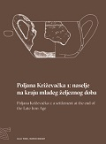

Author Tonc, Asja

Title **Poljana Križevačka 1**: naselje na kraju mlađeg željeznog doba = **Poljana Križevačka 1**: a settlement at the end of the Late Iron Age / Asja Tonc, Marko Dizdar.

Impresum Zagreb : Institut za arheologiju, 2024.

Description 214 str. : ilustr. (pretežno u bojama), graf. prikazi u bojama, zemljop. crteži u bojama ; 29 cm.

ISBN 9789536064755 : **EUR 23.80 US$ 27.80**

Subject Arheološka istraživanja -- Križevci (okolica, Hrvatska). Arheološka nalazišta -- Križevci (okolica, Hrvatska)

Arheološki nalazi -- Poljana Križevačka -- Željezno doba. Prapovijesne kulture -- Križevci (okolica, Hrvatska) -- Željezno doba

UDC 903.4(497.525.1Poljana Križevačka)"638"

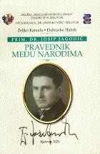

Author Karaula, Željko, povjesničar

Title **Pravednik među narodima** : prim. dr. Josip Jagodić (1897. - 1973.)

Impresum Bjelovar : Družba "Braća Hrvatskog Zmaja"- Zmajski stol Bjelovar : Opća bolnica "Dr. Anđelko Višić" : Ogranak Matice hrvatske u Bjelovaru ; Zagreb : Židovska vjerska zajednica "Bet Israel", 2023.

Description 100 str. : ilustr. ; 24 cm.

ISBN 9789536928422 **EUR 25.00 US$ 29.20**

Subject Jagodić, Josip – Biografije. Liječnici -- Hrvatska – Biografije. Drugi svjetski rat (1939.-1945.) -- Židovi -- Spašavanje -- Hrvatska

Pravednici među narodima -- Hrvatska

UDC 929Jagodić, J. * 94(497.5)"1941/1945" * 61Jagodić, J. * 614.2(497.5)(091)

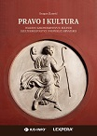

Author Zlatović, Dragan

Title **Pravo i kultura** : ogledi o zakonodavstvu u kulturi i kulturnoj politici u Republici Hrvatskoj

Impresum Zagreb : Lexpera, 2024.

Description 418 str. ; 30 cm.

Note Bibliografija.

ISBN 9789534986967: **EUR 83.30 US$ 95.80**

Subject Kulturne djelatnosti -- Pravna regulativa – Hrvatska. Hrvatska -- Kulturna politika

UDC 008(497.5)(094)

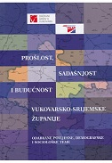Title **Prošlost, sadašnjost i budućnost Vukovarsko-srijemske županije** : odabrane povijesne, demografske i sociološke teme

/ [urednici Dražen Živić, Petar Elez].

Impresum Vukovar : Državni arhiv, Zagreb : Institut društvenih znanosti Ivo Pilar, 2024.

Description 399 str. : ilustr. u bojama, graf. prikazi u bojama ; 25 cm.

Note Bibliografija iza svakog poglavlja. Sumaries.

ISBN 9789538404443 (Institut društvenih znanosti Ivo Pilar)

9789537980368: **EUR 21.30 US$ 24.90**

Subject Vukovarsko-srijemska županija

UDC 908(497.544) * 353(497.544)

Title **Prvi beramski misal 1-2** : hrvatskoglagoljični rukopis iz 15. stoljeća

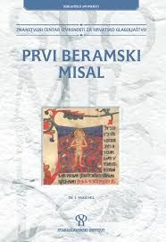/ [glavni urednik Milan Mihaljević ; uredništvo Vesna Badurina Stipčević ... et al.].

Impresum Zagreb : Staroslavenski institut, 2024.

Description 2 sv. ; 33 cm.

ISBN 9789536080618 (1-2) : **EUR 236.90 US$ 277.20**

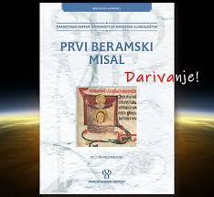UDC 272-282.7 * 003.349.1(497.5

Anotation The edition contains a Latin transliteration of the First Beram Missal (15th century), a Croatian Glagolitic manuscript codex kept in the National and University Library in Ljubljana (call number Ms 162). It is the result of the work of the Scientific Center of Excellence for Croatian Glagolitic. The edition features a facsimile in the first volume, and a Latin transliteration in the second.

Title **Svezak 1**: Faksimil.

Description 495 str. : faks.

Napomena Faks. pretisak izd. iz 15. stoljeća.

Language/s Glag.

Serie Prvi beramski misal, sv. 1

ISBN 9789536080625

Title **Svezak 2** : Transliteracija / transliterirali Vesna Badurina Stipčević ... [et al.].

Description 555 str.

Serie Prvi beramski misal, sv. 2

ISBN 9789536080595

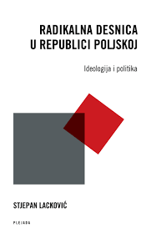

Author Lacković, Stjepan

Title **Radikalna desnica u Poljskoj** : ideologija i politika

Impresum Zagreb : Plejada, 2024.

Description 334 str. ; 24 cm.

ISBN 9789537782887 : **EUR 31.90 US$ 37.30**

Subject Politička desnica – Poljska. Radikalizam – Poljska. Poljska -- Politika i vlast -- 21. st.

UDC 329-024.528(438) * 323(438)

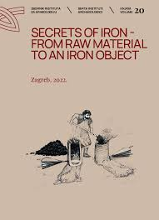

Title **Secrets of iron - from raw material to an iron object** : proceedings of the 7th International Conference of Mediaeval Archaeology of the Institute of Archaeology Zagreb, 10th - 11th September 2020

/ [editors-in-chief and managing editors Tajana Sekelj Ivančan ... et al.].

Impresum Zagreb : Institute of Archaeology Zagreb, 2022.

Description 220 str. : ilustr. u bojama, zemljop. karte u bojama ; 29 cm.

ISBN 9789536064663 : **EUR 31.60 US$ 37.00**

Subject Arheološki nalazi -- Europa, srednja -- Zbornici s konferencija. Željezo -- Metalurgija -- Europa, srednja -- Zbornici s konferencija

UDC 904:669(4)"652/654" * 669.1(4)(091)

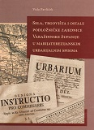Author Pavliček, Vida

Title **Sela, trgovišta i ostale podložničke zajednice Varaždinske županije u Marijaterezijanskim urbarijalnim spisima**

/ [tekst i izrada kazalag Vida Pavliček ; [fotografije Kruno Sudec ; prijevod i korektura latinskih tekstova Karmen Levanić].

Impresum Zagreb : Hrvatska akademija znanosti i umjetnosti ; Varaždin : Državni arhiv u Varaždinu, 2024. (

Description 275 str. : ilustr., faks. ; 24 cm.

Napomena Imensko kazalo ; Kazalo pojmova. Summary.

ISBN 9789533475622 : **EUR 29.80 US$ 34.90**

Subject Urbari -- Varaždin (okolica) -- 18. st. Povijesni izvori -- Hrvatska -- Novi vijek. Varaždin (okolica) -- Povijest -- 18. st. -- Arhivski izvori

UDC 94(497.5)"1527/1918" * 94(497.523-37Varaždin)"17"(093) * 930.253(497.523-37Varaždin) * 347.4(497.523-37Varaždin)(091)

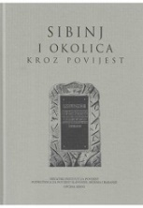

Title **Sibinj i okolica kroz povijest** : zbornik radova

/ uredio Marijan Šabić

Impresum: Slavonski Brod : Hrvatski institut za povijest - Podružnica za povijest Slavonije, Srijema i Baranje ; Sibinj : Općina, 2025

Description 424 str. : ilustr. ; 24 cm

Napomene Bibliografija. - Summaries.

ISBN 9789538102516 : **EUR 31.60 US$ 37.00**

Subject Sibinj i okolica -- Povijest

UDC (497.542-37Sibinj)(082)

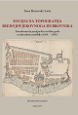Author Benyovsky Latin, Irena

Title **Socijalna topografija srednjovjekovnoga Dubrovnika** : transformacija predgrađā u središte grada

u mletačkom razdoblju (1205. – 1358.)

Impresum Zagreb : Hrvatski institut za povijest, 2025.

Description 385 str. ; 25 cm.

ISBN 9789538335532 : **EUR 35.70 US$ 41.80**

Subject Urbanizacija -- Dubrovnik -- Razvijeni srednji vijek. Plemstvo -- Dubrovnik -- Razvijeni srednji vijek

Dubrovnik -- Povijest -- Razvijeni srednji vijek

UDC 94(497.5)"1102/1527" * 94(497.584Dubrovnik)"1205/1358" * 911.375(497.584Dubrovnik) * 929.7(497.584Dubrovnik)

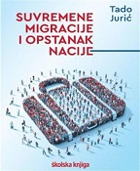Author Jurić, Tado

Title **Suvremene migracije i opstanak nacije**

Impresum Zagreb : Školska knjiga, 2025.

Description 432 str. : graf. prikazi u boji ; 27 cm.

ISBN 9789530624535 : **EUR 46.40 US$ 54.30**

UDC 314.15:314.113(497.5) * 314.15:314.113(4)

Anotation Entering the topic of contemporary migration is like entering a minefield of the most politically sensitive issues in Europe today. In a situation where a certain country (like Croatia) has extremely negative demographic trends, the consequences of emigration and immigration are immeasurable and become the cause of numerous political and social problems. Croatia is not the only European country losing population. The rapid decline in population in Croatia is primarily caused by emigration and lost birth rates due to emigration. The author hopes that his book will shed some light on the understanding of contemporary migration, draw attention to the complexity of migration and the integration of migrants, with a focus on what needs to be done immediately in Croatia and with concrete proposals on how to do it.

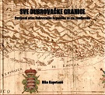

Author Kapetanić, Niko

Title **Sve dubrovačke granice** : povijesni atlas Dubrovačke Republike sa sto zemljovida

Impresum Dubrovnik : vlast.nakl., 2022.

Description 227 str. : zemljop. crteži u bojama ; 22 cm.

ISBN 9789535766964 : **EUR US$**

Subject Zemljopisne karte – Dubrovnik- Dubrovačka Republika -- Povijest – Karte. Dubrovačka Republika -- Granice -- Karte

UDC 94(497.584Dubrovnik)“10/18" * 912.43(497.584Dubrovnik)(091)

Anotation **Sve dubrovačke granice**, the latest book by Niko Kapetanić, brings a historical atlas with more than a hundred maps that show the extremely lively pulse of changes in Dubrovnik's borders from the 10th century until the collapse of the Republic in 1808, while also recording the persistent repetition of attempts to territorially expand the state's borders on land (e.g. to Trebinje, Popovo, Bileća...), at sea (to Korčula, Vis and Brač) and along the coast (even to Omiš, and to the east to Novi, Risan, and even Kotor). These maps were created with research conscientiousness and versatility, already well-known characteristics of Kapetanić's work, proven in this "historical genre" in the hyper-carefully processed problem of borders in the area of ​​the Klek peninsula...

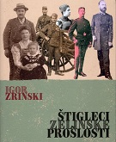Author Zrinski, Igor

Title **Štigleci zelinske prošlosti**

Impresum Sveti Ivan Zelina : Muzej Sveti Ivan Zelina, 2025.

Description 246 str. : ilustr. ; 26 cm.

ISBN 9789538052156 : **EUR 29.80 US$ 34.90**

Subject Sveti Ivan Zelina – Povijest. Sveti Ivan Zelina -- Kulturna povijest

UDC 908(497.521Sveti Ivan Zelina)

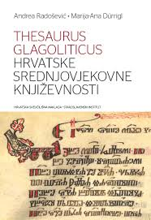

Author Radošević, Andrea

Title **Thesaurus glagoliticus hrvatske srednjovjekovne književnosti**

Impresum Zagreb : Hrvatska sveučilišna naklada : Staroslavenski institut, 2025.

Description 364 str. ; 25 cm.

ISBN 9789531695381 : **EUR 29.80 US$ 34.90**

Subject Glagoljica – Hrvatska. Glagoljska književnost -- Hrvatska -- Srednji vijek. Hrvatskoglagoljske knjige -- Hrvatska -- Srednji vijek

UDC 003.349.1(497.5) * 821.163.42.09 * 272-282.7

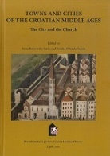Title **Towns and cities of the Croatian middle ages** : the city and the Church

/ edited by Irena Benyovsky Latin and Zrinka Pešorda Vardić.

Impresum Zagreb : Hrvatski institut za povijest = Croatian Institute of History, 2025.

Description 334 str. : ilustr. ; 25 cm.

Note Conference proceedings.

ISBN 9789538335518 : **EUR 53.20 US$ 62.20**

Subject Gradovi --Urbanizacija --Hrvatska -- Društveni uvjeti -- Srednji vijek -- Hrvatska -- Stanovništvo -- Srednji vijek.

UDC 94(497.5)"0630/1102" * 911.375(497.5) * 711.4(497.5) * 316.42(497.5)(091)

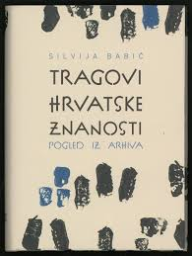Author Babić, Silvija, arhivistica

Title **Tragovi hrvatske znanosti** : pogled iz arhiva

Impresum Zagreb : Hrvatski državni arhiv, 2024.

Description 439 str. : ilustr. (pretežno u bojama) ; 25 cm.

Note Summary: Traces of the Croatian science - a view from archives. Imensko kazalo ; Kazalo zemljopisnih i upravno-teritorijalnih naziva.

ISBN 9789538461156 : **EUR 21.30 US$ 24.90**

Subject Arhivsko gradivo – Hrvatska. Arhivistika -- Hrvatska – Povijest. Znanost -- Znanstvene ustanove i udruge -- Hrvatska -- Povijest

UDC 930.25(497.5)(091) * 001(497.5)(091)

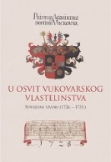Title **U osvit vukovarskog vlastelinstva** : povijesni izvori (1726. - 1731.)

/ priređivači Sanja Lazanin, Milan Vrbanus, Ante Grubišić ; prijevod s latinskog jezika Irena Galić Bešker ; prijevod s njemačkog jezika Sanja Lazanin

Impresum Vukovar : Državni arhiv u Vukovaru : Gradski muzej Vukovar ; Slavonski Brod : Hrvatski institut za povijest - Podružnica za povijest Slavonije, Srijema i Baranje ; Zagreb : Institut za istraživanje migracija : Hrvatski državni arhiv ; Osijek : Muzej Slavonije, 2024.

Description: 346 str. : ilustr. (djelomice u bojama), graf. prikazi ; 30 cm

Note Sažeci na više jezika. - Bibliografija. - Kazala.

ISBN 9789538102462 : **EUR 21.30 US$ 24.90**

Subject Vukovarsko vlastelinstvo -- Povijest -- 1726.-1731.

UDC 94(497.544)(093)

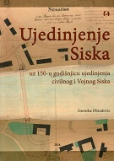

Author Obradović, Davorka

Title **Ujedinjenje Siska** : uz 150-u godišnjicu ujedinjenja Civilnog i Vojnog Siska

Impresum Sisak : Gradski muzej Sisak, 2024.

Description 209 str. : ilustr. u bojama ; 30 cm.

ISBN 9789538389214 : **EUR 40.50 US$ 47.40**

Subject Sisak -- Povijest -- 1868.-1918. -- Katalozi izložbi

UDC 94(497.5)"1527/1918" * 94(497.527Sisak)"186/191"

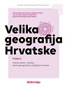Title **Velika geografija Hrvatske 4** : Stanovništvo i naselja (demogeografska obilježja) Hrvatske

/ Damir Magaš ... [et al.] ; [izrada zemljovida Tomislav Kaniški... [et al.] ; izrada ilustracija Davorka Horvat ; izrada kazala Kata Magaš].

Impresum Zagreb : Školska knjiga ; Zadar : Sveučilište, 2025.

Description 384 str. : ilustr. (pretežno u bojama), zemljop. karte (pretežno u bojama).

Serie Velika geografija Hrvatske, knj. 4

ISBN 9789530624573 : **EUR 55.90 US$ 65.40**

Subject Naselja – Hrvatska. Hrvatska -- Stanovništvo

UDC 314.1(497.5) * 911.37(497.5)

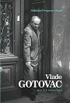Author Novak, Slobodan Prosperov

Title **Vlado Gotovac** : život i djela

Impresum Zagreb : Matica hrvatska, 2025.

Description 207 . str. ; 25 cm.

ISBN 9789533412917 : **EUR 23.80 US$ 27.80**

UDC 821.163.42.09Gotovac, V. * 32Gotovac, V.

Anotation Slobodan Prosperov Novak has written the first biography of the famous Croatian poet, essayist, politician and dissident Vlado Gotovac, whose death has been a quarter of a century. **Vlado Gotovac : život i djela** tells the story of Gotovac's life, his suffering and the literary works with which he marked Croatian history and culture in the second half of the 20th century. The book is a sharp, intriguing and emotional tribute to the difficult and suffering life of one of the most vocal advocates of Croatian freedom in Yugoslavia, whose thoughts on freedom and homeland we should remember more often.

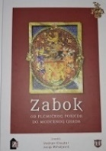

Title **Zabok** : od plemićkog posjeda do modernog grada

/ uredili Vedran Klaužer i Josip Mihaljević.

Impresum Zagreb : Hrvatski institut za povijest, 2023.

Description XIII, 427 str. ; 25 cm.

ISBN 9789538335419 : **EUR 53.20 US$ 62.20**

Subject Zabok -- Povijest

UDC 908(497.522Zabok)

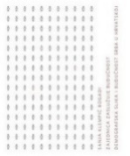Author Klempić Bogadi, Sanja

Title **Zajednica zaslužuje budućnost** : demografska slika i budućnost Srba u Hrvatskoj

Impresum Zagreb : Srpsko narodno vijeće : Jesenski i Turk, 2024.

Description 268 str. : ilustr. u bojama ; 24 cm.

ISBN 9789533810829 : **EUR 37.20 US$ 43.50**

Subject Srbi -- Hrvatska – Statistika. Srbi -- Hrvatska -- Stanovništvo

UDC 314.1(497.5=163.41) * 323.15(497.5=163.41)



Author Rogić, Ivan, sociolog

Title **Zapisi o različitom i istom** : prinos raspravi o hrvatskom nacionalnom identitetu

Impresum Zagreb : Hrvatska sveučilišna naklada ; Hrvatsko katoličko sveučilište, 2025.

Description 429 str. ; 24 cm.

ISBN 9789531695534 : **EUR 31.90 US$ 37.30**

Subject Kolektivno pamćenje – Hrvatska. Nacionalni identitet -- Hrvatska -- 20. st. Domovinski rat (1991.-1995.)

UDC 316.32(497.5) * 316.72:93(497.5) * 316.347(=163.42) * 323(497.5)

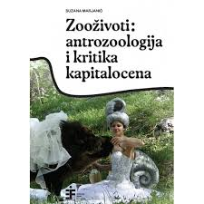

Author Marjanić, Suzana

Title **Zooživoti**: antrozoologija i kritika kapitalocena

Impresum Zagreb : Institut za etnologiju i folkloristiku, 2024.

Description 467 str. : ilustr. ; 21 cm.

ISBN 9789538518133 : **EUR 29.80 US$ 34.90**

Subject Kulturna animalistika

UDC 39:59



Author Karaula, Željko, povjesničar

Title **Židovi u Daruvaru** : život i uništenje jedne zajednice

Impresum Daruvar : Židovska općina Daruvar : Savez atifašističkih boraca i antifašista Republike Hrvatske, Ogranak : Matica hrvatska, Ogranak ; Zagreb : Družba "Braća Hrvatskoga Zmaja" ; [s. l.] : Dutch Jewish Humanitarian Fund ; [s. l.] : NIOD - Institute for War, Holocaust and Genocide Studies, 2024.

Description 306 str. : ilustr. (djelomice u bojama) ; 24 cm.

ISBN 9789534897416 : **EUR 33.30 US$ 39.00**

UDC 323.15(497.526Daruvar)=411.16)(091) * 929.52(497.526Daruvar=411.16)

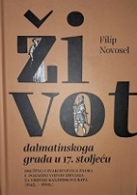

Author Novosel, Filip, povjesničar

Title **Život dalmatinskoga grada u 17. stoljeću** : svakodnevica Zadra u pozadini vojnih zbivanja za vrijeme

Kandijskoga rata (1645. – 1669.)

Impresum Zagreb : Hrvatski institut za povijest, 2025.

Description str. ; 25 cm.

ISBN 9789538335525 : **EUR 31.90 US$ 37.30**

Subject Zadar -- Društveni uvjeti -- 17. st. Zadar -- Društveni život i običaji -- 17. st. Zadar -- Povijest -- 17. st.

UDC 94(497.581.1Zadar)"16" * 304(497.581.1Zadar)(091)

Linguistics. Philology

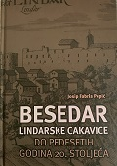

Author Fabris, Josip

Title **Besedar lindarske cakavice do pedesetih godina 20. stoljeća**

Impresum Žminj : Čakavski sabor ; Pazin : Katedra Čakavskog sabora za povijest Istre, 2024.

Description 368 str. ; 25 cm.

ISBN 9789537176358 : **EUR 33.30 US$ 39.00**

Subject Hrvatski jezik -- Narječja -- Lindar – Rječnici. Čakavsko narječje -- Lindar -- Rječnici

UDC 811.163.42’282.2(497.571Lindar)(038)

Anotation The Lindar Cakavica Dictionary, until the 1950s, contained a large lexical treasure of Lindar dialect, consisting of around 5,000 words. The methodology used to create the dictionary makes it clear that it was intended primarily for speakers of Lindar dialect, who, in the era of globalization and exposed on the one hand to the relentless influence of the Croatian standard language through education and the media, and on the other hand to the extinction of the old farming and livestock-raising Lindar civilization with its own ethnological characteristics, are gradually losing their lexical treasure and forgetting words.

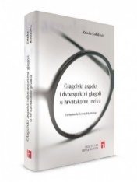

Author Kolaković, Zrinka

Title **Glagolski aspekt i dvoaspektni glagoli u hrvatskome jeziku** : formalno-funkcionalni pristup

Impresum Zagreb : Institut za hrvatski jezik, 2024.

Description 420 str. ; 22 cm.

ISBN 9789538390296 : **EUR 19.10 US$ 22.30**

Subject Hrvatski jezik -- Glagolski vid. Hrvatski jezik -- Glagoli

UDC 811.163.42’366.58 * 811.163.42’367.625

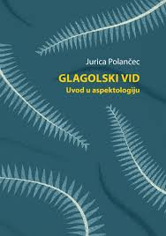

Author Polančec, Jurica

Title **Glagolski vid** : uvod u aspektologiju

Impresum Zagreb : Ibis grafika, 2024.

Description X, 204 str. ; 24 cm.

Note Glosar pojmova: str. 185-189. Bibliografija: str. 191-204; bibliografske bilješke uz tekst.

ISBN 9789533632025 : **EUR 27.40 US$ 32.10**

Subject Gramatika (opća i komparativna) -- Glagolski vid. Hrvatski jezik -- Glagolski vid. Slavenski jezici -- Glagolski vid

UDC 81’367.625 * 811.163.42’367.625

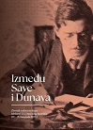

Title **Između Save i Dunava** : Zbornik radova sa skupa Jubilarni XX. Dani Julija Benešića (19. - 21. listopada 2023.)

/ [urednici Anica Bilić ... et al.].

Impresum Ilok : Muzej grada Iloka ; Zagreb : Hrvatska akademija znanosti i umjetnosti, Zavod za lingvistička istraživanja, 2025.

Description 646 str. : ilustr. (djelomice u bojama) ; 30 cm.

Note Bibliografija.

ISBN 9789533476117 : **EUR 47.60 US$ 55.70**

Subject Benešić, Julije -- Zbornici s konferencija. Ilok -- Kulturna povijest -- Zbornici s konferencija

UDC 81Benešić, J. * 821.163.42.09 * 811.163.42(091) * 930.85(497.544Ilok)

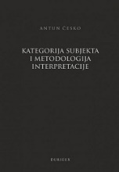

Author Česko, Antun, kroatist

Title **Kategorija subjekta i metodologija interpretacije**

Impresum Zagreb : Durieux, 2025.

Description 150 str. ; 25 cm.

ISBN 9789531885775 : **EUR 22.30 US$ 26.10**

UDC 808.1 * 82.0 * 801.7

Anotation The author's interpretation of about twenty prominent Croatian texts, from analytical expertise to thoughtful synthesis, is the great richness of this book and the model that every Croatian theoretical and literary interpretation should follow. It documents how this can be done, with the interactive effects and symbiosis of phonetics, morphology, lexicology, syntax and stylistics, or in Česk's formulations, "with the interactive effects of individual sounds, syllables, words, larger syntactic units, in the formation of verses and stanzas, poems".

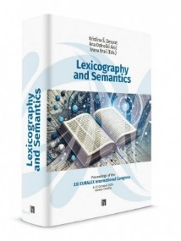Title **Lexicography and Semantics** : proceedings of the XXI EURALEX International Congress, Cavtat, Croatia, 8–12 October 2024

/ Kristina Š. Despot, Ana Ostroški Anić, Ivana Brač (eds.).

Impresum Zagreb : Institut za hrvatski jezik, 2024.

Description 839 str. : ilustr. u bojama, graf. prikazi u bojama ; 24 cm.

Language/s Tekst na engl. i na hrv. jeziku.

ISBN 9789537967772 : **EUR 74.50 US$ 87.20**

Subject Leksikografija -- Zbornici s konferencija. Semantika -- Zbornici s konferencija. Računalna lingvistika -- Zbornici s konferencija

Korpusna lingvistika -- Zbornici s konferencija. Nazivlje -- Zbornici s konferencija

UDC 81’374

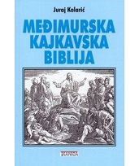Author Kolarić, Juraj

Title **Međimurska kajkavska Biblija**

Impresum Zagreb : Tkanica ; Sesvetski Kraljevec : Grafok, 2023.

Description 280 str. : ilustr., faks. ; 21 cm.

ISBN 9789537999537 : **EUR 29.60 US$ 34.60**

UDC 811.163.42’282 * 272-9(497.521)

Anotation **Međimurska kajkavska Biblija** represents a religious, cultural, linguistic and national phenomenon in the recent history of the Croats from Međimurje. For this reason, its appearance deserves our special attention, and its value and meaning need to be revalued.

In his desire to bring the Međimurje people closer to their homeland Croatia, from which they were politically separated and exposed to aggressive Magyarization, through the "Little Bible", the author deliberately approached the Croatian literary language with his Kajkavian dialect.

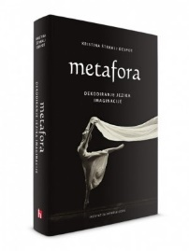

Author Štrkalj Despot, Kristina

Title **Metafora** : dekodiranje jezika imaginacije

Impresum Zagreb : Institut za hrvatski jezik i jezikoslovlje, 2024.

Description XIV, 507 str. : graf. prikazi ; 25 cm.

ISBN 9789538390302 : **EUR 26.60 US$ 31.10**

Subject Metafora * Metafora -- Kognitivno gledište

UDC 81’373.612.2

The series **De imitatione Christi** in three stylizations of the Croatian literary language includes the oldest known Čakavian, Štokavian and Kajkavian translations of the medieval Latin text De imitatione Christi, and is being published in 2024, the year of the 500th anniversary of the death of Marko Marulić, the author of the first known Croatian translation of that work.

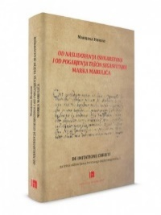The oldest known translation so far written in the Kajkavian stylization of the Croatian literary language, Od nasleduvanja Krištuševog (1710) by an anonymous author, was transcribed and edited by Željka Brlobaš based on the first printed edition.

Author Horvat, Marijana

Title **Od naslidovanʼja Isukarstova i od pogarjenʼja tašćin segasvitnjih Marka Marulića**

Impresum Zagreb : Institut za hrvatski jezik, 2024.

Description 250 str. : table ; 24 cm.

Serie De imitatione Christi na trima stilizacijama hrvatskoga književnog jezika ; knj. 1

Note Predgovor, transkripcija i rječnik uz faksimil. Rječnik: str. 204-219.

ISBN 9789538390241 : **EUR 31.90 US$ 37.30**

UDC 27-42 * 272-1Thomas a Kempis

Anotation The series **De imitatione Christi** in three stylizations of the Croatian literary language includes the oldest known Čakavian, Štokavian and Kajkavian translations of the medieval Latin text De imitatione Christi, and is being published in 2024, the year of the 500th anniversary of the death of Marko Marulić, the author of the first known Croatian translation of that work. For this occasion, Marijana Horvat prepared a new reading of Marulić's work Od naslidovanʼja Isukarstova i od pogarjenʼja tašćin segasvitnjih (1500), written in the Čakavian stylization of the Croatian literary language.

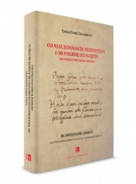

Author Perić Gavrančić, Sanja

Title **Od nasl’jedovan’ja Isukrstova i od pogrde od svijeta (1639.)** : anonimni dubrovački prijevod De imitatione Christi

Impresum Zagreb : Institut za hrvatski jezik, 2024.

Description 539 str. ; 24 cm.

Serie De imitatione Christi na trima stilizacijama hrvatskoga književnog jezika ; knj. 2

Napomena Predgovor: str. 7-36. transkripcija i rječnik uz faksimil

ISBN 9789538390234 : **EUR 42.50 US$ 49.70**

UDC 27-42 * 272-1Thomas a Kempis

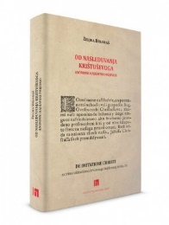

Author Brlobaš, Željka

Title **Od nasleduvanja Krištuševoga** : anonimni kajkavski prijevod De imitatione Christi

: predgovor, transkripcija i rječnik uz faksimil / Željka Brlobaš.

Impresum Zagreb : Institut za hrvatski jezik, 2024.

Description 560 str. ; 24 cm.

Serie De imitatione Christi na trima stilizacijama hrvatskoga književnog jezika ; knj. 3

ISBN 9789538390227 : **EUR 42.50 US$ 49.70**

UDC 27-42 * 272-1Thomas a Kempis

Title **Tekst u središtu p(r)oučavanja jezika** : zbornik radova sTrećeg znanstveno-stručnog skupa Hrvatskog društva sveučilišnih lektora

/ [urednice Ivana Bašić, Anda Bukvić Pažin].

Impresum Zagreb : Hrvatska sveučilišna naklada, 2025.

Description 203 str. : graf. prikazi ; 24 cm.

Note Summaries.

ISBN 9789531695794 : **EUR 14.90 US$ 17.40**

Subject Jezik i jezici -- Zbornici s konferencija. Lingvistika -- Jezik i jezici -- Nastava i učenje -- Visoka učilišta -- Zbornici s konferencija

UDC 81 * 378.091.3:81

Literature. History. Theory

Author Leman, Lucia

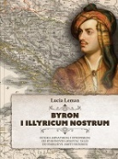Title **Byron i Illyricum nostrum** : suigra hrvatskog i byronskog od Byronovih Oriental tales do Fabrijeve Smrti Vronskog

Impresum Zagreb : Srednja Europa, 2024.

Description 421 str. ; 24 cm.

Note Imensko kazalo. Summary.

ISBN 9789533870380 : **EUR 35.20 US$ 41.20**

UDC 821.111.09Byron, G. G. N. * 821.163.42.09 * 821.163.42.09Krleža, M. * 821.163.42.09Fabrio, N.

Anotation The book tells the story of the Illyrian-British agreement that lasted almost exactly twenty years. The entire British culture of the 19th century, and Byron in particular, was tormented by the so-called Mediterranean longing. Traveling through the Illyrian region in the first decades of the 19th century, Byron canonized in his works the experience of the history and present, the nature and culture of these areas.

Title **Ivana Brlić-Mažuranić u svjetlu kritike svojega vremena**

/ [izabrao i priredio] Ivan Stipić.

Impresum Osijek : Društvo hrvatskih književnika, Ogranak slavonsko-baranjsko-srijemski ; Slavonski Brod : Sveučilište u Slavonskom Brodu, 2024.

Description 252 str. : ilustr. ; 20 cm.

ISBN 9789532784022 : **EUR 23.80 US$ 27.80**

UDC 821.163.42.09Brlić-Mažuranić, I.

Anotation The author, Prof. Ivan Stipić, has selected six literary criticisms that deal with IBM and her early works. A.G.Matoš, A.B.Šimić, Julije Kempf, Dragurin Domjanić and Ulderiko Donadini, in their criticisms written between 1912 and 1917, recognized IBM as a writer of exceptional value. A good book is an audience of all ages, these criticisms said, and this book says it even more strongly, in which Stipić expands his selection to a longer period of time and a larger number of authors.

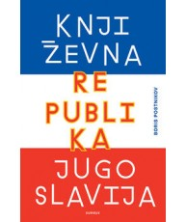

Author Postnikov, Boris

Title **Književna republika Jugoslavija** : od 1989. do 2022.

Impresum Zagreb : Durieux, 2025.

Description 407 str. ; 24 cm.

ISBN 9789531885614 : **EUR 24.60 US$ 28.80**

UDC 821.163.09 * 821.163(091)

Anotation Through a thorough analysis of a considerable number of literary and cultural phenomena that exist after the breakup of Yugoslavia, which symbolically remember and reflect on the common past of Yugoslavia and share the problems and challenges of contemporary capitalism, the author's arguments support the thesis of a post-Yugoslav literary and cultural field that is worth researching and from whose research we can extract important (methodological, social, economic and other) lessons. In doing so, the author does not want to make post-Yugoslav literature a new essentialist category, but rather articulates it as a flexible concept that brings analytical benefits to contemporary literary scholarship.

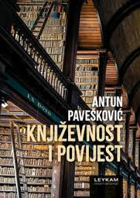

Author Pavešković, Antun

Title **Književnost i povijest**

Impresum Zagreb : Leykam international, 2025.

Description 300 str. ; 22 cm.

ISBN 9789533402024 : **EUR 33.30 US$ 39.00**

UDC 821.163.42.09

Anotation The book **Književnost i povijest** (Literature and History) Literary-Historical Studies on the Relationship between Literary, Cultural and General History consists of four thematically coherent units: "Historiographic Perceptions", "Monographic Aspects", "Gundulić in the Light of Literary Anthropology" and "Ancient and Modern Voices". Using a variety of methodological procedures, the author examines literary and theatrical works in the context of cultural and general history, taking care to ensure that his texts are written in a clear and polished style that reaches the target audience.

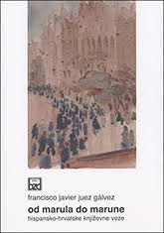

Author Juez Gálvez, Francisco Javier

Title **Od Marula do Marune** : hispansko-hrvatske književne veze

Impresum Split : Književni krug, 2025.

Description 447 str. ; 23 cm.

Note Resumen: De Marulić a Maruna : relaciones literarias hispano-croatas.

ISBN 9789531635639 : **EUR 21.30 US$ 24.90**

UDC 821.163.42.091:821.134.2 * 821.134.2.091:821.163.42

Anotation With this book, Croatian humanities has unified in the Croatian language the insights of a Spanish Slavist, Croatist, and comparatist on topics that directly relate to Croatian literature and the science of literature, and in which Croatian literature and culture are connected to Hispanic as the largest cultural area of ​​the Western circle.

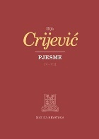

Author Crijević, Ilija

Title **Pjesme** : knjige IV. – VII.

/ s latinskoga prepjevala Zrinka Blažević ; bilješke sastavili Zrinka Blažević i Bojan Marotti ; s latinskim izvornikom usporedio, hrvatski prijevod redigirao i naglaske obilježio Bojan Marotti.

Impresum Zagreb : Matica hrvatska, 2025. (Zagreb : Sveučilišna tiskara)

Description 347 str. ; 24 cm.

ISBN 9789533412887 : **EUR 41.70 US$ 48.80**

UDC 821.163.42-1 * 821.124(497.5)-1=163.42

Anotation Ilija Crijević (Aelius Lampridius Cervinus, Dubrovnik 1463 – Dubrovnik, 15. IX. 1520), a Croatian humanist poet and prose writer, is unanimously considered by literary historians and classical philologists to be among the greatest poets of Latin expression. This is clearly evidenced by the fact that this talented student of the distinguished humanists Tide Acciarini and Pomponius Leto was crowned with a laurel wreath in Rome in 1484, receiving the prestigious title of poeta laureatus.

Crijević's poetic legacy includes 240 poems in seven books (8256 verses). The Croatian edition of Matica Hrvatska will publish a Croatian translation of all poems from Crijević's autograph Vat. lat. 1678 in two volumes, according to the critical edition edited and published by Darko Novaković. The first volume contains a translation of poems from books IV. – VII.

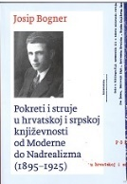

Author Bogner, Josip

Title **Pokreti i struje u hrvatskoj i srpskoj književnosti od moderne do nadrealizma** : (1895-1925)

/ Josip Bogner ; priredila, pogovor, bilješke i komentari Iva Tešić.

Impresum Zagreb : Srpsko kulturno društvo Prosvjeta, 2025.

Description 400 str. : ilustr. ; 21 cm.

ISBN 9789538307485 : **EUR 29.80 US$ 34.90**

Subject Moderna (književnost) – Hrvatska. Moderna (književnost) -- Srbija

UDC 821.163.42(091) * 821.163.41(01) * 821.163.42.02Moderna * 821.163.41.02Moderna

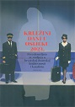Author Krležini dani (34 ; 2023 ; Osijek)

Title **Prvo desetljeće 21. stoljeća u hrvatskoj dramskoj književnosti i kazalištu, dio 2**

/ priredila Martina Petranović.

Impresum Zagreb : Hrvatska akademija znanosti i umjetnosti ; Osijek : Hrvatsko narodno kazalište u Osijeku : Filozofski fakultet Sveučilišta Josipa Jurja Strossmayera u Osijeku, 2024.

Description 522 str. : ilustr. 24 cm.

Note Bibliografija. Summaries. Kazalo.

ISBN 9789533475912 : **EUR 29.90 US$ 34.30**

Subject Hrvatsko kazalište -- 21. st. Hrvatska drama -- 21. st. -- Zbornici s konferencija

UDC 792(497.5) * 821.163.42.09-2

Literature. Poetry

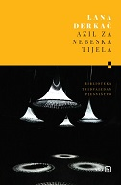

Author Derkač, Lana

Title **Azil za nebeska tijela**

Impresum Zagreb : V.B.Z., 2025.

Description 140 str. ; 20 cm.

Note Stihovi.

ISBN 9789535208020 : **EUR 21.50 US$ 25.20**

UDC 821.163.42-1

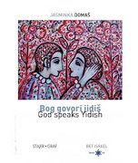Author Domaš, Jasminka

Title **Bog govori jidiš** = **God speaks Yidish**

Impresum Zagreb : Stajer graf : Židovska vjerska zajednica Bet Israel u Hrvatskoj, 2024.

Description 194 str. ; 22 cm.

Note Stihovi.

Language/s Tekst usporedo na hrv. i na engl. jeziku.

ISBN 9789537926274 : **EUR 20.20 US$ 23.60**

UDC 821.163.42-1=111=163.42

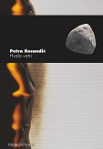

Author Rosandić, Petra

Title **Hvala vatri**

Impresum Zagreb : Durieux, 2025.

Description 64 str. ; 20 cm.

Note Stihovi.

ISBN 9789531885713 : **EUR 13.40 US$ 15.70**

UDC 821.163.42-1

Author Grubišić, Nada

Title **Petoknjižje I.** : daleko od svijeta, daleko od vremena

Impresum Pula : Istarski ogranak Društva hrvatskih književnika, 2024.

Description 261 str. ; 24 cm.

Note Stihovi.

ISBN 9789532783384 : **EUR 31.60 US$ 37.00**

UDC 821.163.42-1

Anotation The Istrian branch of the Croatian Writers' Association has published a comprehensive (355 texts) collection from the legacy of the late poet Nada Grubišić (Pula, 1954 – Zagreb, 2018) entitled **Petoknjižje I**. It is a poetry of conscious femininity, urban, with distinctive metaphors, a fusion of surreal images from erotic to landscape motifs, along the worlds of many civilizations and times that seem to be simultaneous in this poetess. She has few equals in contemporary Croatian poetry...

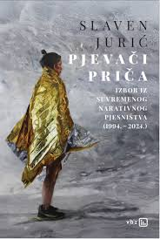Author Jurić, Slaven, komparatist književnosti

Title **Pjevači priča** : izbor iz suvremenog narativnog pjesništva (1994. – 2024.)

Impresum Zagreb : V.B.Z., 2025.

Description 448 str. ; 20 cm.

Note Stihovi.

ISBN 9789535207979 : **EUR 31.70 US$ 37.10**

Subject Hrvatsko pjesništvo -- Zbirke tekstova. Pripovjedno pjesništvo

UDC 821.163.42-1(082)

Literature. Prosa. Novels, short stories. Essays.

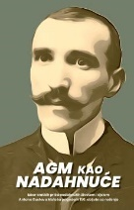

Title **AGM kao nadahnuće** : izbor kratkih priča nadahnutih životom i djelom Antuna Gustava Matoša prigodom 150. obljetnice rođenja

/ [Stjepan Tomaš ... [et al.] ; uredili Mirko Ćurić ; Katarina Čeliković].

Impresum Osijek : Društvo hrvatskih književnika, Ogranak slavonsko-baranjsko-srijemski Subotica : Zavod za kulturu vojvođanskih Hrvata ; Tovarnik : Općina, 2024.

Description 209 str. ; 20 cm.

ISBN 9789532784015 : **EUR 21.40 US$ 25.00**

Subject Matoš, Antun Gustav -- Književne zbirke. Hrvatska kratka priča -- Zbirke tekstova. Hrvatska kratka priča -- Vojvodina -- Zbirke tekstova

UDC 821.163.42-36(082) * 821.163.42(497.11)-36(082) * 821.163.42.09Matoš,

Author Stanković, Aleksandar

Title **Depra**

Impresum Zagreb : Telegram media grupa, 2025.

Description 165 str. ; 21 cm.

ISBN 9789534950142 : **EUR 21.30 US$ 24.50**

Anotastion Famous journalist and presenter Aleksandar Stanković has suffered from depression for years, and now, in this book, he has decided to speak out about his difficult struggle for the first time.

"Depression is when you wait 3 months for 15 minutes to make you feel better. Depression is thinking about how the world would be a better place without you and how you would be happier without the world," he writes. Combining prose and poetry, Aleksandar Stanković has written an impressive, courageous and extremely important book for Croatian society; mental illnesses like depression are still a huge social taboo and a topic that is difficult to talk about.

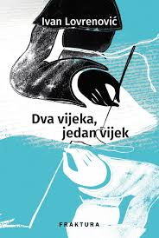Author Lovrenović, Ivan

Title **Dva vijeka, jedan vijek** : ljetopisni triptih

Impresum Zaprešić : Fraktura, 2025.

Description 280 str. ; 21 cm.

ISBN 9789533588155 : **EUR 24.50 US$ 28.70**

Anotation In the invisible chain that the Bosnian friars and their manuscripts connect events and people through time spanning two centuries, empires alternate in bloody wars, crimes, human fractures and suffering. The Sultan's reforms, the surrender of Bosnia to the hands of the Viennese-Pest family, the First and Second World Wars with the omnipotence of the Serbian crown, followed by the communist parties and, in between, the episodes of the wartime terror of the Independent State of Croatia take place on a centuries-old stage, in great times, and the Bosnian horizon in the life and in the text of the three living observers and incorruptible interpreters of circumstances and their companions is low, narrow, closed.

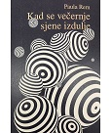

Author Rem, Paula

Title **Kad se večernje sjene izdulje**

Impresum Zagreb : MeandarMedia, 2024.

Description 409 str. ; 20 cm.

ISBN 9789533343501 : **EUR 25.50 US$ 29.80**

Anotation In the post-apocalyptic world of Paula Rem, in the future everydayness of the dystopian novel **Kad se večernje sjene izdulje** (When the Evening Shadows Lengthen), a hyperspace opens up for the undead Capital and its reinterpretation of Existence. When humanity fades, machines and all that exists, which was once called Nature, acquire new statuses. In Paula Rem's novel, set in the year 2200, where the Machinist maintains the Cube, a gigantic building against the omnipresent surrounding Weeds, the values ​​and worthlessness of our modernity are shown, what is disappearing and already missing.

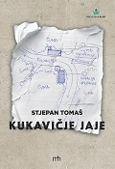

Author Tomaš, Stjepan

Title **Kukavičje jaje**

Impresum Bizovac : Matica hrvatska, Ogranak, 2025.

Description 148 str. ; 21 cm.

ISBN 9789537746650 : **EUR 16.70 US$ 19.50**

Anotation The novel **Kukavičje jaje** (The Cuckoo's Egg) by Stjepan Tomaš is inspired by a contemporary and tragic theme - the discovery and excavation of mass graves, as well as the exhumations and painful identifications of the remains of veterans and civilians after the Homeland War. However, this is only the framework of the life drama of a young woman who has been searching for years for her husband, a HINA war correspondent, who disappeared from the Eastern Slavonian battlefields in September 1991, who had gone to film a column of tanks decorated with flowers, on the way from Belgrade to the Croatian border...

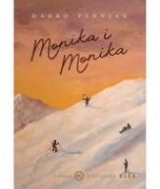

Author Pernjak, Darko

Title **Monika i Monika**

Impresum Zagreb : Mozaik knjiga, 2025.

Description 239 str. ; 21 cm.

ISBN 9789531439343 : **EUR 23.30 US$ 27.30**

Anotation Darko Pernjak's Monika and Monika is an intriguing blend of romance and thriller, following Polish woman Monika on a skiing trip where she confronts her past, new suitors, and her own fears – until she suddenly disappears. Through a tense story of love, identity, and escape, the novel will make you question what freedom is and whether we can truly escape the past and ourselves.

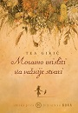

Author Gikić, Tea

Title **Moramo misliti na važnije stvari**

Impresum Zagreb : Mozaik knjiga, 2025.

Description 176 str. ; 20 cm.

ISBN 9789531439466 : **EUR 23.40 US$ 27.40**

Anotation In her new collection of stories, "We Have More Important Things to Think About," this award-winning poet and accomplished storyteller explores the spaces between past and present, closeness and alienation, expectations and disappointment. Each story offers a small psychological study of characters, mostly women, who at crucial moments confront the first signs of change, cracks that reveal truths that may have always been there.

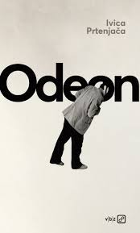

Author Prtenjača, Ivica, književnik

Title **Odeon**

Impresum Zagreb : V.B.Z., 2025.

Description 176 str. ; 20 cm.

ISBN 9789535207993 : **EUR 20.30 US$ 27.30**

Anotation Ivica Prtenjača has long convinced us with his novels that fairy tales are possible, that they can be more real than reality. So here, in a novel set at the height of European decadence, precisely in mythologized Paris, the beauty of the ordinariness of everyday life, empathy and solidarity, in short – the magic of life itself, takes place among complete strangers.

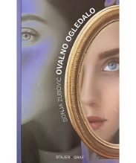

Author Zubović, Sonja

Title **Ovalno ogledalo**

Impresum Zagreb : Stajer graf, 2024.

Description 157 str. ; 23 cm.

ISBN 9789538105470 : **EUR 23.80 US$ 27.80**

Anotation Sonja Zubović in her collection of short stories Ovalno ogledalo deals with human lives and destinies. These are stories with strong points, full of interesting, lively dialogues, but also lyrical passages. The author often highlights as a framework events at the turning point in the lives of her own heroes who change direction, make decisions and step outside the comfort zone.

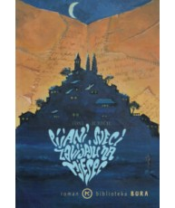Author Juričić, Toni

Title **Pijani sveci zavijaju na mjesec**

Impresum Zagreb : Mozaik knjiga, 2025.

Description 286 str. ; 21 cm.

ISBN 9789531438902 : **EUR 23.30 US$ 27.30**

Anotation When a young writer arrives in a small, picturesque Istrian town, he is convinced that a simple plan awaits him - to finish a manuscript, meet a few interesting people, and enjoy his new surroundings.

However, the idyll quickly turns into chaos. **Pijani sveci zavijaju na mjesec** (Drunken Saints Howl at the Moon) is an incredible combination of imaginative and humorous, fierce and entertaining, sometimes tender and wistful storytelling.

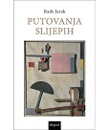

Author Jarak, Rade

Title **Putovanja slijepih** : travanj 2007. – siječanj 2024.

Impresum Zagreb : Disput, 2025.

Description 167 str. ; 21 cm.

ISBN 9789532605044 : **EUR 19.10 US$ 22.30**

Anotation The book brings a compilation of the author's short texts that he wrote down over a fairly long period, from April 2007 to January 2024. These short prose pieces are the fruit of the author's reading of literature and in a way reveal the development of his literary interests. The texts are organized into seven microcycles with ten micro-essays/stories each from these always the same ten thematic frameworks: Ghosts, Travel, Sex, Hunger, Sports, Dreams, War, Art, Madness, Science. It is a collection of those little side things, little spiral novels, that arise in a brief flash of an idea, and in the next few seconds disappear into the whirlpool of oblivion.

Author Ferić, Zoran

Title **Spiderman**

Impresum Zagreb : V.B.Z., 2025.

Description 348 str. ; 20 cm.

ISBN 9789535207986 (meki uvez) **EUR 21.50 US$ 25.20**

Anotation With Spiderman, Ferić returns to the genre with which he entered literature and which made him one of the most important domestic storytellers. For those wondering how much the author has changed in those 25 years, here is a possible answer: There is still black humor and grotesqueness, but in this book the author is gentler, more subtle and seems to love his characters more.

The stories in Spiderman are intriguing, dynamic, imbued with unobtrusive humor, but also disturbing and often poignant. Sometimes they are intricate narrative labyrinths, but their worlds are rich and complex, and reading them is a real adventure.

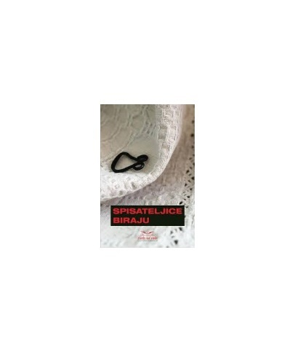

Title **Spisateljice biraju** : (tema: moj najdraži književni lik)

/ anketirala Julijana Matanović.

Impresum Zagreb : Umjetnička organizacija Lađa od vode, 2024.

Description 222 str. ; 20 cm.

ISBN 9789535071969 : **EUR 22.60 US$ 26.40**

Anotation The anthology brings together the texts of twenty-four women writers (including Julijana Matanović) on the topic of the favorite character in literature. This collection is proof that women's togetherness and kindness transcend generational differences, themes, worldviews and genres. In it, characters from literary works are reborn from the pen of our female writers, and they are born anew by those who read them.

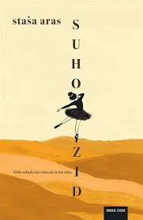Autor Nikolić Aras, Stanislava

Title **Suhozid** : (roman s didaskalijama)

Impresum Zagreb : Hena com, 2025.

Description 216 str. ; 21 cm.

ISBN 9789532595086 : **EUR 21.20 US$ 24.80**

Anotation World War II takes place on a Dalmatian island, and four women and a girl try to live a normal life in unexpected and abnormal circumstances. **Suhozid** (The Dry Wall) describes how life unfolds when one gets used to hunger, waiting, distrust, poverty, crowds, uncertainty and fear, while at the same time conjuring up moments of liveliness, joy and celebration, which, like young shoots, bring light and hope even in the most difficult situations. The story of the lives of these women is complemented by didactic scenes, which is why we sometimes have the impression that we are witnessing a play – as if the war and everything it entails are taking place on some stage, while the inhabitants of the island, affected by its consequences, become mere extras in their own lives.

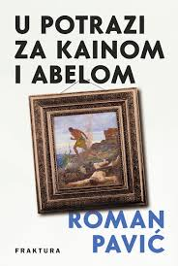

Author Pavić, Roman

Title **U potrazi za Kainom i Abelom**

Impresum Zaprešić : Fraktura, 2025.

Description 288 str. ; 21 cm.

ISBN 9789533588100 : **EUR 23.40 US$ 27.40**

Anotation **U potrazi za Kainom i Abelom** (In Search of Cain and Abel) is a novel about passion for art, about the irresistible attraction of certain images, about history and its influence on each individual. Roman Pavić carefully, meticulously, with a multitude of details, with a touch of humor and tragedy, revives a work of art, an era, but also our modernity, portrays human flaws and values, and as in Medović's masterpiece, death and life, love and passion, fear and hope in all their nuances appear before us.

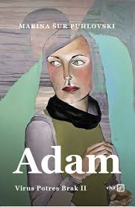

Author Šur Puhlovski, Marina

Title **Virus, potres, brak : Adam**

Impresum Zagreb : V.B.Z., 2025.

Description 400 str. ; 20 cm.

ISBN 9789535207962 : **EUR 21.60 US$ 25.30**

Anotation After the first part of the trilogy Virus, Earthquake, Marriage followed the development of the relationship between the narrator Sofija Kralj and her husband Maks, the focus of the second volume is Adam, Sofija's friend from college. In this novel, Marina Šur Puhlovski demonstrates her writing virtuosity. We get to know Adam not only through the narrator's mouth, who collects her life experiences, but also through the protagonist's diary from the time when love was at its most intense, and through mutual letters, so the register of the text is constantly changing. This turns it into an exciting weave with which the author presents us with a very complex story and shapes one of the most memorable characters in recent Croatian literature.

Arts. General

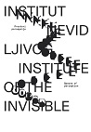Title **29. slavonski biennale** : Institut nevidljivog - prostori percepcije = **29th Slavonian Biennial** : Institute of the invisible - spaces of perception

/ [tekstovi, texts Valentina Radoš, Janka Vukmir] ;; urednik kataloga, editor of the catalogue Dario Vuger]

Impresum Osijek Muzej likovnih umjetnosti, 2024.

Description 143 str. : ilustr. u bojama ; 22 cm

Note Katalog izložbe. –

Language/s Tekst na hrv. jeziku i engl. prijevod.

ISBN 9789538142475 : **EUR 20.20 US$ 23.60**

UDC 7.038.5(497.54)"200"(083.824)

Author Bekar, Dušan, st.

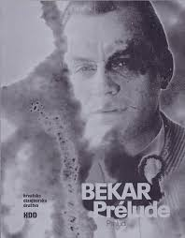Title **Bekar**: **Prélude** = **Bekar**: **Preludij**

/ [texts, tekstovi Ksenija Foretić... [et al.] ; translation, prijevod Robertina Tomić ; editor, urednica Alira Hrabar Bekar].

Impresum Zagreb : Hrvatsko dizajnersko društvo, 2024.

Description 160 str. : ilustr. ; 26 cm.

ISBN 9789538507090 : **EUR 21.30 US$ 24.90**

UDC 7.05Bekar, D., st.

Anotation The book Bekar: Prelude follows the creative odyssey of designer Dušan Bekar, a member of the rich developmental line of Croatian graphic design in the second half of the twentieth century. Raised on the foundations of international modernism, Bekar began his journey in 1949 in Ozeha as an eighteen-year-old, developing over the decades a unique vocabulary made up of illustrations, typography, calligraphy, photography and three-dimensional objects. The author's extensive work, barely scratched by this publication, is presented through some 250 reproduced works on 160 pages.

Author Hušman, Ana

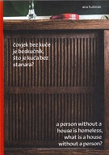Title **Čovjek bez kuće je beskućnik, što je kuća bez stanara?** = **A person without a house is homeless, what is a house without a person?** : [Zbirka Vjenceslava Richtera i Nade Kareš Richter, donacija Gradu Zagrebu : online izložba = Vjenceslav Richter and Nada Kareš Richter Collection, a donation to the City of Zagreb, 25. 11. 2021. - 30. 1. 2022. : online exhibition]

/ [tekstovi, texts Jasna Jakšić, Ivana Meštrov, Vjenceslav Richter ; urednice, editors Ana Hušman ... et al.].

Edition 2. izd. = 2nd ed.

Impresum Zagreb : Muzej suvremene umjetnosti = Museum of Contemporary Art : Studio Pangolin, 2023.

Description 87 str. : ilustr. (pretežno u bojama) ; 24 cm.

Note Katalog izložbe.

Language/s Tekst na hrv. i na engl. jeziku.

ISBN 9789533700205 : **EUR 18.50 US$ 21.60**

Subject Hušman, Ana -- Katalozi izložbi. Zbirka Vjenceslava Richtera i Nade Kareš Richter -- Dom u umjetnosti -- Katalozi izložbi.

UDC Veza 7.038.5Hušman, A. * 7.074Richter

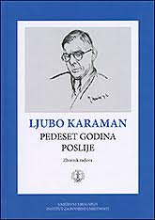Title **Ljubo Karaman** : pedeset godina poslije : zbornik radova s međunarodnog znanstvenog skupa održanog

u Splitu 23. i 24. rujna 2021.

/ uredili Radoslav Tomić, Ivan Basić i Darka Bilić ; [prijevod [sažetaka] na engleski jezik Graham McMaster].

Impresum Split : Književni krug ; Zagreb : Institut za povijest umjetnosti, 2024.

Description 554 str. : ilustr., zemljop. crteži ; 24 cm.

ISBN 9789531635608 **EUR 31.91 US$ 37.30**

UDC 7.072.2Karaman, Lj. * 7.071.3Karaman, Lj.

Anotation The proceedings of the international scientific conference are dedicated to the work of one of the founders of the art history profession in Croatia – Ljubo Karaman (1886 – 1971), who as a scientist, theorist and conservator is still relevant in our profession today, fifty years after his death. Around twenty experts (art historians, historians, archaeologists), participants of the scientific conference, analyzed Ljubo Karaman's contributions to various topics in a scientifically based manner, from early Romanesque sacral architecture, through medieval and Renaissance painting and sculpture, all the way to the art of the Baroque and modern era.

Author Kršić, Dejan

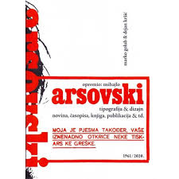Title **Opremio Mihajlo Arsovski** - Tipografija & dizajn novina, časopisa, knjiga, publikacija &td 1961 / 2020.

/ [autori tekstova] Dejan Kršić, Marko Golub.

Impresum Zagreb : HDD [i. e.] Hrvatsko dizajnersko društvo, 2024.

Description 336 str. : ilustr. ; 23 cm.

Language/s Tekst na hrv. i na engl. jeziku.

ISBN 9789538507045 : **EUR 26.60 US$ 31.10**

UDC 7.05Arsovski, M. * 7.05:76(497.5)

Anotation The 336-page book by Dejan Kršić and Marko Golub, for the first time, deals with the design of Mihajlo Arsovski in the field of books and publications in one place and analyzes some of the most beautiful and celebrated editions in the history of Croatian graphic design, which seduce not only with their covers, but also with their overall materiality, choice of paper, color, play with typography, and the dynamics of text and images.

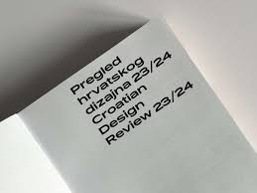

Title **Pregled hrvatskog dizajna 23/24** = **Croatian Design Review 23/24**

/ [tekstovi, texts Monika Čarž ... [et al.] ; urednik, editors Marko Golub ; prevoditelj, translation Marko Golub].

Impresum Zagreb : Hrvatsko dizajnersko društvo, 2025.

Description 542 str. : ilustr. ; 24 cm.

Language/s Tekst usporedo na hrv. i na engl. jeziku.

ISBN 9789538507120 : **EUR 42.50 US$ 49.70**

Subject Hrvatski dizajn -- 21. st. -- Katalozi izložbi. Dizajneri -- 21. st. -- Intervjui

UDC 7.05(497.5)

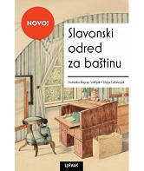Author Najcer Sabljak, Jasminka

Title **Slavonski odred za baštinu** : djelovanje KOMZA-e na području istočne Hrvatske

/ Jasminka Najcer Sablj ; Silvija Lučevnjak.

Impresum Zagreb : Naklada Ljevak, 2025.

Description 184 str. : graf. prikazi ; 24 cm.

ISBN 9789533558578 : **EUR 32.00 US$ 37.40**

Subject Hrvatska (1945-1990). Ministarstvo prosvjete. Komisija za sakupljanje i čuvanje kulturnih spomenika i starina

Kulturna baština -- Zaštita -- Slavonija -- 1945.-1974.

UDC 7.025.3/.4(497.54) * 930.85(497.54)

Anotation The book **Slavonski odred za baštinu** (Slavonian Heritage Detachment), with its rich illustrative material, seeks to familiarize the general public with the activities of KOMZA, so that more attention can be paid to the issue of the provenance of works of art and other nationalized objects from former private collections. The book presents the results of several years of research that resulted in the discovery of material, its publication, restoration and exhibition in permanent museum exhibitions or at temporary exhibitions. The title of the book refers to the famous book and film Heritage Detachment, dedicated to the issues of saving works of art that were alienated by Nazi Germany during World War II. In the area of ​​eastern Croatia, the largest transfer of works of art and objects of artistic craft took place in the post-war period. Many works of art were destroyed, devastated or dislocated, and some are still being searched for today.

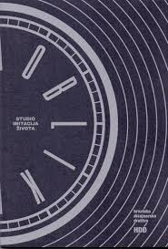Author Golub, Marko, likovni kritičar

Title **Studio Imitacija života**: Oblik vremena : [grafički dizajn 1987. - 1991.] : Galerija HDD, Zagreb, 22. 11. - 30. 12. 2024.

/ [urednik i autor teksta Marko Golub ; fotografije Buga Cvjetanović (postav), Ozren Drobnjak (plakati, portret)].

Impresum Zagreb : Hrvatsko dizajnersko društvo, 2024.

Description 71 str. : ilustr. (pretežno u bojama) ; 20 cm.

Not Katalog izložbe.

Language/s Tekst na hrv. i na engl. jeziku.

ISBN 9789538507144 : **EUR 8.70 US$ 10.20**

UDC 7.05Fritz, D. * 7.05Serdarević, Ž. * 7.05:76(497.5)

Anotation A total of 72 pages of text and color reproductions that give an insight into the early works of Darko Fritz and Željko Serdarević, who strongly marked the visual culture of the late 1980s under the name Studio Imitation of Life in just four years of joint activity. Includes their famous posters and other works

Urbanism. Architecture

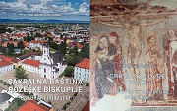Author Škvorčević, Antun

Title **Crkva sv. Lovre u Požegi** = **Church of St Lowrence in Požega**

Impresum Požega : Požeška biskupija, 2024.

Description 118 str. : ilustr. (pretežno u bojama) ; 28 cm.

Language/s Usporedo hrv. tekst i engl. prijevod.

ISBN 9789537647469 : **EUR 30.90 US$ 36.10**

Subject Crkva sv. Lovre (Požega). Crkvena arhitektura -- Požega (Hrvatska). Freske -- Požega (Hrvatska)

UDC 726:27(497.541Požega) * 272-523(497.541Požega) * 75.052(497.541Požega)

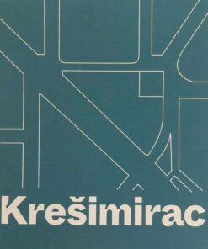

Author Igrec, Dino

Title **Krešimirac**

Impresum Zagreb : Udruga za interdisciplinarna i interkulturalna istraživanja = Association for Interdisciplinary and

Intercultural Research, 2024.

Description 158 str. : ilustr. (djelomice u bojama) ; 26 cm.

ISBN 9789535981626 : **EUR 37.20 US$ 43.50**

Subject Moderna arhitektura – Zagreb. Gradski trgovi – Zagreb. Zagreb -- Trg kralja Petra Krešimira IV -- Zgrade i građevine

UDC 711.61(497.521.2) * 72(497.521.2)

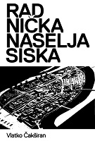

Author Čakširan, Vlatko

Title **Radnička naselja Siska**

Impresum Sisak : Gradski muzej Sisak, 2024.

Description 207 str. : ilustr. ; 24 cm.

ISBN 9789538389191 : **EUR 23.10 US$ 27.00**

Subject Radnička klasa -- Kuće i nastambe – Sisak. Stambena naselja -- Sisak -- 20. st. Stanogradnja -- Sisak -- 20. st.

Urbanizacija -- Sisak -- 20. st. Arhitektura i društvo – Jugoslavija. Sisak -- Zgrade i građevine -- 20. st.

UDC 711.582(497.527Sisak) * 711.4(497.527Sisak) * 72:316(497.1) * 728(497.527Sisak)



Author Repanić-Braun, Mirjana

Title **Sakralna baština Požeške biskupije** : pregled i odabrani primjeri

Impresum Požega : Požeška biskupija, 2024.

Description 251 str. : ilustr. u bojama ; 28 cm.

Language/s Usporedo hrv. tekst i engl. prijevod.

ISBN 9789537647476 : **EUR 30.90 US$ 36.10**

Subject Crkvena arhitektura -- Požega (okolica, Hrvatska). Kršćanska umjetnost -- Požega (okolica, Hrvatska)

UDC 726:27(497.541-37Požega) * 272-523(497.541-37Požega) * 7.046:27(497.541-37Požega)

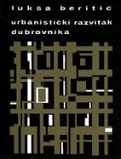Author Beritić, Lukša

Title **Urbanistički razvitak Dubrovnika**

/ [autori popratnih tekstova Maja Nodari, Danko Zelić ].

Impresum Dubrovnik : Društvo prijatelja dubrovačke starine, 2023.

Description 76, LXX str. : ilustr. ; 23 cm + [1] dvostruko presavijen list sa planom Dubrovnika

Language/s Tekst na hrv. i engl. jeziku.

Note Bibliografija o Lukši Beritiću: str. XXI-XXII ; Znanstveni radovi Lukše Beritića: XXIII-XXVI; Resume ; Summary.

ISBN 9789535950257 : **EUR 23,40 US$ 27,40**

Subject Urbanizam -- Dubrovnik

UDC 711.4(497.584Dubrovnik)(091)

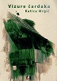Author Mrgić, Katica

Title **Vizure čardaka** : tradicijska graditeljska baština Sisačkog kraja i okolice - Posavina, Pokuplje, Lonjsko polje, Banovina, Pounje, Moslavina, Vukomeričke gorice = **A look at chardaks** : traditional architectural heritage of the area of Sisak and its surroundings - Posavina, Pokuplje, Lonjsko polje, Banovina, Pounje, Moslavina,Vukomeričke gorice

Impresum Sisak : Gradski muzej Sisak, 2024.

Description 210 str. : ilustr. u bojama ; 24 cm.

Language/s Tekst usporedo na hrv. i na engl. jeziku.

ISBN 9789538389207 : **EUR 30.80 US$ 36.00**

UDC 39:72(497.527-37Sisak)

Sculpture and related arts

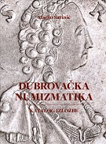

Author Šarinić, Marko

Title **Dubrovačka numizmatika** : katalog izložbe

Impresum Dubrovnik : Društvo prijatelja dubrovačke starine, 2024.

Description XI, 207 str. : ilustr. ; 29 cm.

Note Katalog izložbe otvorene u prostoru na Gundulićevoj poljani, 22. 4. 2024.

ISBN 9789535950295 : **EUR 50,00 US$ 58,50**

Subject Kovani novac -- Dubrovnik -- Katalozi izložbi

UDC 737.1(497.584Dubrovnik)

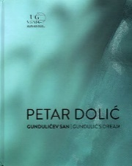

Author: Dolić, Petar

Title **Gundulićev san** : Umjetnička galerija Dubrovnik, 21.9. - 8.12.2024. = **Gundulić's dream** : Museum of modern art

/ autorica teksta, text author Iva Koerbler

Impresum Dubrovnik : Umjetnička galerija, 2024

Description ¸ 103 str. : ilustr. u bojama ; 27 cm

Note Katalog izložbe.

Language/s Tekst na hrv. i na engl. jeziku

ISBN 9789538316340 : **EUR 30.80 US$ 36.00**

UDC 73Dolić, P.(083.824)

Drawings

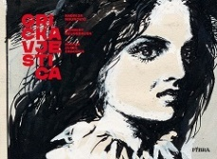Author Maurović, Andrija

/crtež Andrija Maurović; tekst Norbert Neugebauer;

Title **Grička vještica**

Impresum Zagreb : Naklada Fibra, 2024.

Description 348 str., kolor, 30x22 cm

Note Strip

ISBN 9789533218878 : **EUR 47.60 US$ 55.70**

Anotation In the New Year's three-issue issue of Večernji list, dated December 31, 1960, the publication of the comic book adaptation of The Witch of Grička began. The second book in the series, The Countess of Nero, in the hands of two masters of comics, Norbert Neugebauer and Andrija Maurović, once again tickled the imagination of the domestic audience, but it was never printed in the quality that Maurović's talent and drawings deserved. The largest part of the original drawings of The Witch of Grička, 603 banners, have been preserved by the Neugebauer family in the Graphic Collection of the National and University Library in Zagreb. Two more banners have found their way to the Museum of Modern and Contemporary Art in Rijeka, and eight of them are in three private collections. So, out of 632 comic banners, 613 original ones are available. In this book, we bring them to you for the first time in their full glory and with all the scars that life and time have left on them.

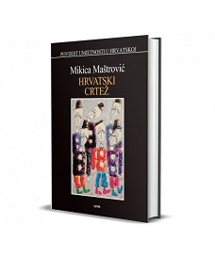Autor Maštrović, Mikica

Title **Hrvatski crtež**

Impresum Zagreb : Naklada Ljevak, 2025.

Description 768 str. : ilustr. (pretežno u bojama) ; 27 cm.

ISBN 9789533558639 : **EUR 83.30 US$ 97.50**

UDC 75(497.5)(091) * 741(497.5)(091)

Anotation Mikica Maštrović's book Croatian Drawing, like her book Croatian Graphics, is undoubtedly a pioneering work, both in its genre and in our art history. It explains and brings the phenomenon of drawing closer to the interested reader and is a real (and so far the only) vademecum through its history. From prehistoric times and drawings on rocks in Croatian caves, through Klović, Medulić and Benković, all the way to the latest generation of authors, it lists the most relevant authors and examples.

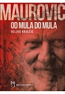Author Krulčić, Veljko

Title **Maurović**: od mula do mula : 555 fragmenata, 244 ilustracije

Impresum Muo : MZ Muo, 2023.

Description 250 str. : ilustr. (pretežno u bojama) ; 24 cm.

ISBN 9789940892012 : **EUR 46.10 US$ 53.90**

UDC 741.52Maurović, A. * 741Maurović, A. * 75Maurović, A.

Anotation The author conceived the book chronologically, starting with the year of Maurović's birth and listing the most significant events related to the work of this legendary comic book artist, painter and illustrator for each year, trying to offer as many contributions as possible that were previously unknown or less known to the general readership. The author does not stop chronologically at the year of Maurović's death, but continues the timeline until 2023, listing all the important events that posthumously marked his fruitful work.

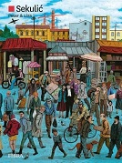

Author Sekulić, Miroslav Struja

Title **Petar & Liza**

Impresum Zagreb; Naklada Fibra, 2024.

Description 168 str. : ilustr. ; 24 cm.

Note Strip

ISBN 9789533219189 : **EUR 29.80 US$ 34.90**

UDC 741.52

Anotation As unpredictable and unusual as life itself, every frame in Miroslav Sekulić-Struja's "Petar and Liza" is a beautiful little canvas - and all of these images together miraculously create an exquisite, emotionally moving and exceptionally poetic portrait of an artist, a love story and, ultimately, an entire generation.

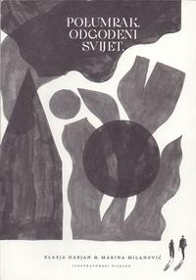Author Habjan, Klasja

Title **Polumrak** : odgođeni svijet : ilustratorski dijalog

/ [autorice pjesama i ilustracija] Klasja Habjan i Marina Milanović ; [urednik i autor predgovora Marko Golub].

Impresum Zagreb : Hrvatsko dizajnersko društvo, 2024.

Description [112] str. : ilustr. ; 24 cm.

ISBN 9789538507083 : **EUR 10.60 US$ 12.40**

UDC 821.163.42-1 * 741Milanović, M.

Anotation A joint collection of poems and illustrations by prominent young illustrators and designers Klasja Habjan and Marina Milanović, realized within the Illustrators' Dialogue project. The illustrations collected in the book were created through a year-long communication – a creative exchange of ideas, images and texts – between the two authors who come from different contexts, did not know each other before and are now working together for the first time.

Paintings

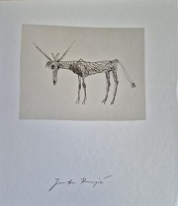Author Runjić, Jadranko

Title **Jadranko Runjić** : posljednja izložba = the last exhibition : Galerija umjetnina, Split, 21. prosinca 2024. - 9. veljače 2025.

= Museum of Fine Arts, 21 December - 9 Februray 2025

/ [tekstovi, essays Saša Runjić, Marija Stipišić Vuković ; fotografije, photographs Robert Matić, Zoran Alajbeg ;]

Impresum Split : Galerija umjetnina = Museum of Fine Arts, 2024

Description 199 str. : ilustr. (pretežno u bojama) ; 27 cm

Language/s Tekst na hrv. i na engl. jeziku.

ISBN 9789538167737 : **EUR 45.40 US$ 53.10**

Subject Runjić, Jadranko -- Katalog izložbe

UDC 75 Runjić, J. (083.824)

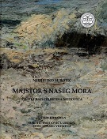

Author Subotić, Nedjeljko

Title **Majstor s našeg mora** : život i rad Celestina Medovića

/ Subotić Nedeljko ; [urednik] Antun Karaman ; [fotografije Miho Skvrce ... et al.].

Impresum Dubrovnik : Društvo prijatelja dubrovačke starine, 2024.

Description 427 str. : ilustr. u bojama ; 28 cm.

ISBN 9789535950288 : **EUR US$**

Subject Medović, Mato Celestin. Slikari -- Hrvatska -- Biografije

UDC 75Medović, M. C.

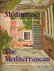Author Körbler, Iva

Title **Mediteran u hrvatskom slikarstvu 20. i 21. stoljeća** = **The Mediterranean in Croatian painting of the 20th and 21st Century** : [Umjetnička galerija Dubrovnik = Museum of modern art Dubrovnik, 19. 7. - 15. 9. 2024.] / [autorica teksta, text author Iva Körbler ; urednica Iva Körbler].

Impresum Dubrovnik : Dubrovačke ljetne igre, 2024.

Description 100 str. : ilustr. u bojama ; 28 cm.

Note Katalog izložbe.

Language/s Tekst na hrv. i engl. jeziku.

ISBN 9789535628484 : **EUR 30.00 US$ 35.10**

Subject Hrvatsko slikarstvo -- 20. st. -- Katalozi izložbi. Hrvatsko slikarstvo -- 21. st. -- Katalozi izložbi.

UDC 75(497.5) * 75.047(497.5)

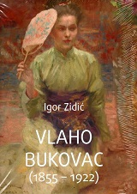

Author Zidić, Igor

Title **Vlaho Bukovac** : (1855 -1922)

Impresum Cavtat : Muzeji i galerije Konavala, Kuća Bukovac, 2024.

Description 920 str. : ilustr. u bojama ; 27 cm.

ISBN 9789537226374 : **EUR 107.00 US$ 125.00**

UDC 75Bukovac, V.

Anotation The monumental monograph **Vlaho Bukovac** by Igor Zidić presents Bukovac as the founder of Croatian Modernism, as the most representative inner voice of the era. After a comprehensive analysis of Bukovac's oeuvre viewed against the background of Croatian and European art of his time, the author concludes that Bukovac was the first modern Croatian artist, especially in terms of the multilingualism of his stylistic idioms and content structures in the same work. Academism, realism, impressionism and symbolism live side by side in Bukovac - each with its own specific artistic expression.

Photography

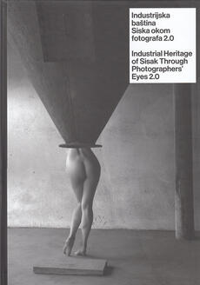

Author Čakširan, Vlatko

Title **Industrijska baština okom fotografa 2.0** = **Industrial Heritage of Sisak through photographers’ eyes 2.0**

/ [autor teksta VlatkoČakširan ; fotografije Stanko Abadžić ... et al. ; prijevod na engleski Ladislava Furlan Zaborac].

Impresum Sisak : Gradski muzej Sisak, 2024.

Description 180 str. : ilustr. ; 30 cm.

ISBN 9789538389177 : **EUR 23.10 US$ 27.00**

Subject Industrijska fotografija -- Sisak -- 21. st. Hrvatska fotografija -- Sisak -- 21. st. Sisak -- 21. st. -- Fotografije

UDC 77.03:338(497.527Sisak)

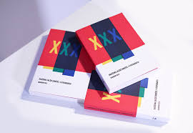Author Jalšić Ernečić, Draženka

Title **O fotografiji / XXX** : odabrani eseji

Impresum Zagreb : ULUPUH - Hrvatska udruga likovnih umjetnika primijenjenih umjetnosti, 2024.

Description 236 str. ; 21 cm.

ISBN 9789533272610 : **EUR 15.50 US$ 18.10**

UDC 77.01

Anotation The book **O fotografiji / XXX** : odabrani eseji (On Photography / XXX : Selected Essays) presents an author's selection of thirty essays on contemporary art photography, written over the past thirty years. Each essay, composed of five paragraphs and a thousand words, focuses on the analysis and reflection of the changes that photography has experienced through different phases of development. The form of these essays, with a clearly defined structure, is specific to domestic art historiography.

Author Buljević, Zvonimir

Title **Zvonimir Buljević** : fotografski klasičar i umjetnički fotograf : Galerija umjetnina, Split, 17. listopada - 1. prosinca 2024. = A photographic Classicist anf Fine Art Photographer : Museum of Fine Arts, 17. October - 1 december 2024

/ [tekst, essay Iris Slade ; prijevod, translation Robertina Tomić ; izbor iz bibliografija, select bibliography Zrinka Buljević, Iris Slade, Katica Vukman ; urednica kataloga, catalogue editor Iris Slade].

Impresum Split : Galerija umjetnina, 2024.

Description 96 str. : ilustr. ; 26 cm.

Napomena Katalog izložbe.

ISBN 9789538167720 : **EUR 20.00 US$ 23.40**

UDC 77Buljević, Z.

Croatian music. History. Theory

Autor Kos, Koraljka

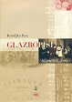Title **Glazbopisi**: ogledi stari i novi : uz 90. rođendan autorice = Text on music : Essays old and new : On the occasion of the 90th Birthday of the author

/ Koraljka Kos ; urednice, editors Vjera Katalinić, Marija Benić Zovko.

Impresum Zagreb : Hrvatska akademija znanosti i umjetnosti, Odsjek za povijest hrvatske glazbe : Hrvatsko muzikološko društvo, 2024.

Description 263 str. : ilustr. (djelomice u bojama), note, faks. ; 25 cm.

Serie Serija Muzikološki zbornici = Series Musicological proceedings ; br. 26

Napomena Summaries ; Zusammenfassungen. Imensko Kazalo.

ISBN 9789536090761 : **EUR 29.80 US$ 34.90**

UDC 78(497.5)

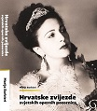

Author Barbieri, Marija

Title **Hrvatske zvijezde svjetskih opernih pozornica**

Impresum Zagreb : Umjetnička organizacija Metropolis, 2024.

Description 329 str. : ilustr. ; 32 cm.

Note Summary. Imensko kazalo.

ISBN 9789534988626 : **EUR 76.90 US$ 90.00**

Subject Operni pjevači -- Hrvatska -- Biografije

UDC 78-051(497.5) * 782(497.5)

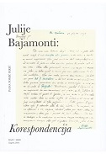Author Tomić Ferić, Ivana

Title **Julije Bajamonti** : (1744. - 1800.) : korespodencija : (izbor): objavljeno u povodu 280. godišnjice rođenja Julija Bajamontija

Impresum Zagreb : Hrvatska akademija znanosti i umjetnosti, Odsjek za povijest hrvatske glazbe : Hrvatsko muzikološko društvo, 2024.

Description 673 str. : ilustr. ; 24 cm.

Language/s Tekst na hrv. na, engl. i na tal. jeziku.

Note Imensko kazalo. Summary.

ISBN 9789536090754 : **EUR 47.60 US$ 55.70**

Subject Bajamonti, Julije – Korespondencija. Skladatelji -- Hrvatska – Korespondencija. Klasicizam u glazbi -- Hrvatska

UDC 78Bajamonti, J.

Theatar. Film. Dance

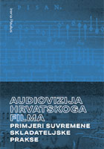

Author Paulus, Irena

Title **Audiovizija hrvatskoga filma** : primjeri suvremene skladateljske prakse

Impresum Zagreb : Hrvatski filmski savez, 2024.

Description 308 str. : ilustr., note ; 24 cm.

ISBN 9789537033774 : **EUR 27.40 US$ 32.10**

UDC 78.05:791(497.5) * 791.63(497.5)

Anotation The book of musicological and filmological studies by Irene Paulus is an overview of film music in Croatia from the 1980s to the present day and a kind of continuation of the author's first book, Music from the Screen. Croatian Film Music from 1942 to 1990, also the first professional publication in the Croatian language that systematically dealt with film music.

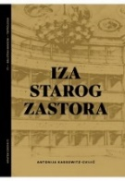

Author Kassowitz-Cvijić, Antonija

Title **Iza starog zastora** : ogledi, portreti i crtice iz zagrebačke kazališne povijesti

Impresum Zagreb : Hrvatski centar ITI, 2024.

Description 498 str. : ilustr. ; 20 cm.

ISBN 9789536343959 : **EUR 31.20 US$ 36.50**

Subject Hrvatsko kazalište -- Zagreb -- 19. st. Hrvatsko kazalište -- Zagreb -- 20. st.

UDC 792(497.521.2)

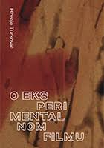

Author Turković, Hrvoje

Title **O eksperimentalnom filmu** : pojam, konteksti, povijesni pregledi, portreti

Impresum Zagreb : Hrvatski filmski savez, 2025.

Description 336 str. : ilustr. (pretežito u bojama) ; 24 cm.

ISBN 9789537033781 : **EUR 29.80 US$ 34.90**

UDC 791.21.037 * 7.038.53:791

Anotation Hrvoje Turković wrote his first article on experimental film in the mid-1960s, at a time when it was not yet known what to call this film genre. For the next sixty years, in addition to his critical and theoretical interests in other film phenomena, he continued to regularly monitor its manifestations and alternations, especially in our country. He was the first in this, and for a very long time also alone. This book brings together in one place Turković's most important theoretical and critical contributions to the understanding of experimental film, tracing in fragments its history in this region.

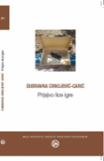

Author Crnojević-Carić, Dubravka

Title **Pr(a)vo lice igre**

Impresum Zagreb : Društvo hrvatskih književnika, 2024.

Description 270 str. ; 18 cm.

ISBN 9789532784060 : **EUR 20.20 US$ 23.60**

Subject Kazališna umjetnost. Igra. Hrvatsko kazalište

UDC 792.01 * 792(497.5)

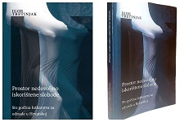Author Tretinjak, Igor

Title **Prostor nedovoljno iskorištene slobode** : sto godina lutkarstva za odrasle u Hrvatskoj

Impresum Zagreb : HDKKT [Hrvatsko društvo kazališnih kritičara i teatrologa], 2024.

Description 240 str. : ilustr. ; 22 cm.

ISBN 9789535036616 : **EUR 29.70 US$ 34.70**

Subject Puppetry -- Croatia

UDC 792.97(497.5)

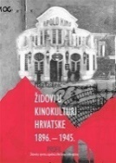Author Vasiljević, Maja

Title **Židovi u kinokulturi Hrvatske 1896. - 1945.**

Impresum Zagreb : Profil knjiga : Židovska vjerska zajednica Bet Israel u Hrvatskoj, 2025.

Description 264 str. ; 23 cm.

Note Bibliografija. Kazalo.

ISBN 9789533861760 : **EUR 24.30 US$ 28.40**

Subject Filmska industrija -- Hrvatska -- 19. st. Filmska industrija -- Hrvatska -- 20. st. Židovi -- Hrvatska -- 19. st. Židovi -- Hrvatska -- 20. st.

UDC 791.6(497.5) * 930.85(497.5=411.16)