Introducing New Books from Croatia 4/2024  ZEBRA komunikacije d.o.o., Dubašnička 12,  10000 Zagreb – Croatia  www.zebrakom,  info@zebrakom.hr,  tel./fax 385 1 3668 993 | 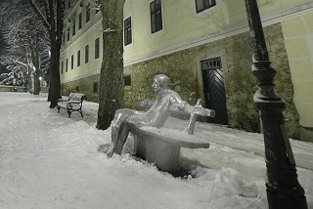  The sculpture "Matoš na klupi" by Ivan Kožarić is located on the Strossmayer Promenade in Zagreb, where it was installed in 1972.

Museums. Social Sciences. Humanities

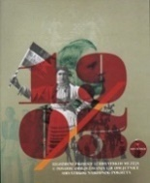
Title 1903. u Hrvatskoj : [izložbeni projekt 13 hrvatskih muzeja u povodu obilježavanja 120. obljetnice Hrvatskog narodnog pokreta] : katalog izložbe
/ [autori tekstova Dražen Ernečić... [et al.] ; uvodna riječ Silvija Limani ; predgovor Vladimir Huzjan ; pogovor Davor Kraš ; urednici Davor Kraš, Silvija Limani].
Impresum Prigorje Brdovečko : Muzej Brdovec [etc.], 2024.
Description 83 str. : ilustr. ; 26 cm.
ISBN 9789535938163 : EUR 18.20 US$ 19.60
Subject Croatia -- History -- 1903 -- Catalogs of exhibitions
UDC 94(497.5)"1527/1918" * 94(497.5)"1903"


Title 300 godina franjevačke crkve u Vukovaru (1723. 2023.) : zbornik radova
/ uredili Dražen Živić, Ivica Jagodić.
Impresum Zagreb : Institut društvenih znanosti Ivo Pilar ; Vukovar : Franjevački samostan Vukovar, 2024.
Description 292 str. : ilustr., zemljop. crteži ; 24 cm.
Note Summaries. Kazalo.
ISBN 9789538404436 : EUR 22.40 US$ 24.20
UDC 272-523(497.544Vukovar) * 272-789.3(497.544Vukovar)-9

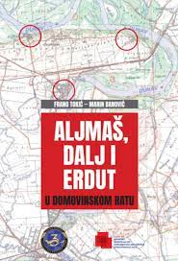
Author Banović, Marin
Title Aljmaš, Dalj i Erdut u Domovinskom ratu
Impresum Zagreb : Hrvatski memorijalno-dokumentacijski centar Domovinskog rata ; Osijek : Udruga veterana 3. gardijske brigade "Kune", 2024.
Description 328 str. : ilustr. ; 24 cm.
ISBN 9789538354250 : EUR 31.60 US$ 34.10
Subject Homeland War (1991-1995) -- Military operations -- Slavonia, Eastern. Homeland War (1991-1995) -- Osijek (surroundings)
UDC 355.44(497.543-37Osijek)

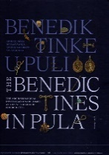
Author Bradara, Tatjana
Title Benediktinke u Puli : arheološko istraživanje grobnica sv. Teodora = Benedictines in Pula : the archaeological investigation of tombs at the st. Theodore church site
Impresum Pula : Arheološki muzej Istre = Archaeological Museum of Istria, 2023
Description 400 str. : ilustr. u bojama ; 31 cm
Napomene Tekst na hrv. i na engl. jeziku. - Bibliografija: str. 386-390. - Bilješke uz tekst.
ISBN 9789538082726 : EUR 90.90 US$ 98.10
UDC 904:72(497.571Pula)"652" * 904:72(497.571Pula)"653"

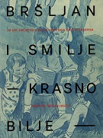
Title Bršljan i Smilje - krasno bilje : uz 150. obljetnicu dvaju hrvatskih dječjih časopisa
/ [autori tekstova Štefka Batinić ... [et al.] ; autori kataloških jedinica Štefka Batinić, Sonja Gaćina Škalamera, Anita Zlomislić].
Impresum Zagreb : Hrvatski školski muzej, 2023. ([Zagreb] : Grafički zavod Hrvatske)
Description 180 str. : ilustr. u bojama ; 26 cm.
Note Katalog izložbe.
ISBN 9789537262303 : EUR 27.40 US$ 29.60
UDC 050-053.5(497.5)(091)

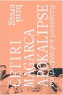
Author Erceg, Heni
Title Četiri magarca apokalipse : razgovori u devedesetima
Impresum Rijeka : Ex libris, 2024.
Description 621 str. : ilustr. ; 23 cm.
ISBN 9789538431180 : EUR 37.20 US$ 40.10
UDC 323(497.5) * 929(497.5)
Anotation The author chose interviews with about sixty intellectuals that she conducted in the period from 1993 to 1997 and published in the then Feral. Most of her interlocutors belonged to the breed of social renegades: writers, scientists, actors, directors, painters, musicians... who, because of their disagreement with the dominant nationalist ideology, were labeled traitors, enemies or suspects, and were relegated to the social margins.

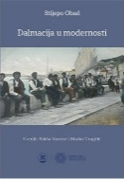
Author Obad, Stijepo
Title Dalmacija u modernosti
Impresum Split : Filozofski fakultet u Splitu ; Zadar : Sveučilište u Zadru, 2024.
Description 365 str. ; 22 cm.
Note Bibliografske bilješke uz tekst. Summaries. Imensko kazalo ; Kazalo geografskih imena.
ISBN 9789533314846 : EUR 29.80 US$ 32.10
Subject Dalmatia -- History -- 1797-1918.
UDC 94(497.5)"1527/1918" * 94(497.58)"1813/1918"

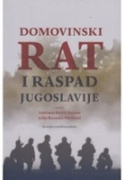
Title Domovinski rat i raspad Jugoslavije
/ uredile Andriana Benčić Kužnar i Julija Barunčić Pletikosić.
Impresum Zagreb : Hrvatska sveučilišna naklada : Učiteljski fakultet, 2024.
Description 214 str. ; 24 cm.
ISBN 9789531695787 : EUR 26.60 US$ 28.70
Subject Homeland War (1991-1995) – Causes --Homeland War (1991-1995) – Diplomacy--Croatia -- International relations –1990-2000.
UDC 323.1(497.5) * 355.48(497.5)

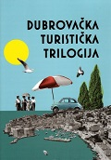
Author Piteša, Aleksandra
Title Dubrovačka turistička trilogija : vodič kroz povijest dubrovačkog turizma za Dubrovčane i turiste
Impresum Dubrovnik : Dubrovački muzeji, 2023. ([Sveti Ivan Zelina] : Tiskara Zelina)
Description 211 str. : ilustr. (pretežno u bojama) ; 25 cm.
ISBN 9789538311208 : EUR 41.70 US$ 45.00
Subject Tourism -- Dubrovnik -- History
UDC 338.48(497.584Dubrovnik)(091)

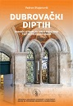
Author Stojanović, Vedran
Title Dubrovački diptih : domaći i strani autori o prostoru pretpotresnoga grada
Impresum Zagreb ; Dubrovnik : Hrvatska akademija znanosti i umjetnosti, Zavod za povijesne znanosti u Dubrovniku, 2024.
Description 280 str. : ilustr. (pretežno u bojama) ; 24 cm.
Note Bibliografija.. Summary. Kazalo
ISBN 9789533475363 : EUR 23.80 US$ 25.70
Subject Književnost -- Povijest i kritika. Književnici -- Boravišta --Dubrovačka Republika -- Kulturna povijest
UDC 94(497.5)"0630/1102" * 930.85(497.584Dubrovnik) * 82.09

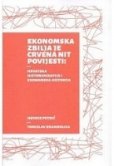
Autor Petrić, Hrvoje, povjesničar
Title Ekonomska zbilja je crvena nit povijesti : hrvatska historiografija i ekonomska historija
Impresum Zagreb : FF press [i. e.] Filozofski fakultet, 2024.
Description 212 str. ; 23 cm.
ISBN 9789533790060 : EUR 10.60 US$ 11.40
Subject Ekonomska povijest -- Hrvatska -- Historiografija
UDC 930(497.5) * 338.1(091)


Author Borić, Marijana
Title Faust Vrančić : a portrait of the Inventor
Impresum Zagreb : Tehnički muzej Nikola Tesla, 2023.
Description 124 str. : ilustr., faks. ; 28 cm.
Note Izv. stv. nasl.: Faust Vrančić : portret izumitelja.
ISBN 9789536568956 : EUR 27.30 US$ 29.50
Subject Vrančić, Faust -- Biografije
UDC 62Vrančić, F. * 001.894Vrančić, F.

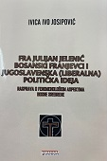
Author Josipović, Ivica Ivo
Title Fra Julijan Jelenić bosanski franjevci i jugoslavenska (liberalna) politička ideja : rasprava o fenomenološkim aspektima Bosne Srebrene
Impresum Zagreb : Tkanica ; Sesvetski Kraljevec : Grafok, 2024.
Description 448 str. : slika autora ; 23 cm.
ISBN 9789537999612 : EUR 29.60 US$ 31.90
Subject Jelenić, Julijan -- Political activity - Bosnia and Herzegovina -- Political history -- 1739-1878.
UDC 323(497.6)(091) * 272-789.3Jelenić, J. * 94(497.6)

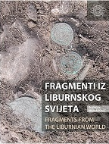
Author Marijanović, Brunislav
Title Fragmenti iz liburnskog svijeta = Fragments from the Liburnian world
Impresum Zadar : Sveučilište u Zadru, 2024.
Description 343 str. : ilustr. u bojama, graf. prikazi ; 28 cm + [1] dvostruko presavijeni list sa planom
Language/s Tekst na hrv. i engl. jeziku.
ISBN 9789533314952 : EUR59.50 US$ 64.20
Subject Cemeteries -- Nin (surroundings) -- Iron Age. Archaeological research -- Nin (surroundings). Liburni -- Material culture.
UDC 903.5(497.581.1-37Nin)"638" * 902.2(497.581.1-37Nin)

Title General Josip Štimac: Na visinama sjećanja : zapisi umirovljenog zapovjednika Hrvatskoga ratnog zrakoplovstva i protuzračne obrane
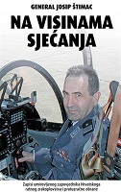
Impresum Zagreb : Večernji list, 2024.
Description 279 str. : ilustr. u bojama ; 23 cm.
ISBN 9789532803877 : EUR 27.30 US$ 29.50
UDC 355Štimac, J.
Anotation The memories of Major General Josip Štimac, a former top military pilot of supersonic fighter jets, who participated in the planning, preparation and implementation of all liberation operations of the Croatian Army during the Homeland War, are very precious. If we add to that the general's great role not only in creating but also in designing the doctrine and development of the Croatian Air Force, and especially his persistent post-war struggle to preserve this important branch of the armed forces, which was threatened with extinction, these records become an indispensable contribution to the research of the Homeland War and its development of the Croatian Air Force.

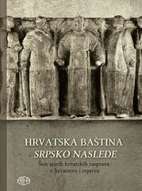
Title Hrvatska baština srpsko nasleđe : šest starih hrvatskih rasprava o hrvatstvu i srpstvu
/ priredio Vladimir Lončarević.
Impresum Zagreb : Alfa, 2024.
Description 262 ; 24 cm.
ISBN 9789533645520 : EUR 26.50 US$ 28.60
Subject Croatian culture. The Croatian question. Croatia -- Relations -- Serbia -- 1868-1919. Serbia -- Relations -- Croatia -- 1804-1918.
UDC 323.1(497.5)(091) * 930.85(497.5)

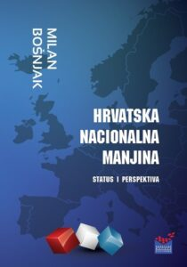
Author Bošnjak, Milan
Title Hrvatska nacionalna manjina - status i perspektiva
Impresum Zagreb : Hrvatska matica iseljenika, 2024.
Description 228 str. ; 24 cm.
ISBN 9789538403057 : EUR 32.70 US$ 35.30
Subject Croats -- Legal status -- Europe, middle. Croats -- Legal status -- Europe, Southeast
UDC 323.15(4=163.42) * 341.234(4=163.42)
Anotation The book by author Milan Bošnjak is an inventive monograph on socio-cultural topics and genre, which is adorned with a completely contemporary narrative about this vital branch of our ethnic corpus. It is a collection of selected essays, articles, studies and occasional records about the Croatian minority from our European neighborhood - derived from the author's direct insights into the social, political and cultural conditions of 12 countries in Central and Southeastern Europe.

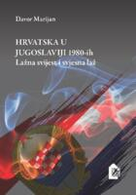
Author Marijan, Davor
Title Hrvatska u Jugoslaviji 80-tih : lažna svijest i svjesna laž
Impresum Zagreb : Hrvatski institut za povijest, 2024.
Description VII, 471 str. ; 25 cm.
ISBN 9789538335471 : EUR 74.50 US$ 80.40
Subject The Croatian question -- Yugoslavia -- 1980-1991. Croatia -- Politics and government -- 1974-1991.
UDC 323.1(497.1=163.42)(091) * 321.74(497.5)

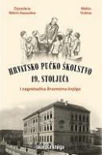
Author Sikirić Assouline, Zvjezdana
Title Hrvatsko pučko školstvo 19. stoljeća : i zagrebačka sramotna knjiga
Impresum Zagreb : Školska knjiga : Filozofski fakultet Sveučilišta u Zagrebu, 2024.
Description 560 str. : ilustr. ; 26 cm.
ISBN 9789530624733 : EUR 46.40 US$ 50.10
Subject Sramotna knjiga. Školska disciplina -- Zagreb -- Povijest -- 19. st. Školstvo -- Zagreb -- 19. st. Školstvo -- Habsburška Monarhija
UDC 373(497.521.2)(091) * 37.091.5(091)

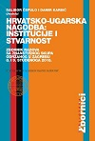
Title Hrvatsko-ugarska nagodba: institucije i stvarnost : zbornik radova sa Znanstvenog skupa održanog u Zagrebu 8. i 9. studenoga 2018.
/ urednici Dalibor Čepulo i Damir Karbić.
Impresum Zagreb : Pravni fakultet : Hrvatska akademija znanosti i umjetnosti, 2024.
Description XXIV, 476 str. ; 24 cm.
Language/s Tekst na hrv. i na engl. jeziku.
ISBN 9789532701852 : EUR 40.50 US$ 43.70
Subject Croatian-Hungarian settlement (1868) -- Conference proceedings. Croatia -- History -- 1868-1918.
UDC 94(497.5)"1868/1918" * 342.23(497.5:439)(091)

Author Beljan Kovačić, Iva
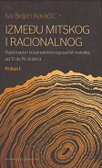
Title Između mitskog i racionalnog : svjetonazori bosanskohercegovačkih katolika od 17. do 19. stoljeća – knj.1
Impresum Zagreb : Hrvatska sveučilišna naklada, 2024.
Description 462 str. ; 25 cm.
ISBN 9789531695305 (Knj. 1) : EUR 37.20 US$ 40.10
UDC 272-722.7(497.6)
Anotation In the book, the author investigates the early modern Bosnian-Herzegovinian (but also Western European) Catholic culture, concentrating primarily on its internal dimension: on the value system, the system of norms and corrections, ideas of God, the world and the human role in the world, the relationship to the body, the concept of identity and hierarchies.
The author observes the culture of Bosnian Catholics in a double lens: on the one hand, she follows its incorporation into the currents of Western European post-Tridentine church culture, and on the other hand, she questions its peculiarities and the context in which it was created. The published first volume of the study (of the two planned) is primarily concentrated on the first of the mentioned tasks.

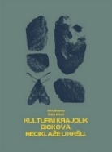
Author Bekavac, Silvia
Title Kulturni krajolik Biokova : reciklaže u kršu
Impresum Zadar : Sveučilište u Zadru ; Javna ustanova "Park prirode Biokovo", 2024.
Description 210 str. : ilustr. u bojama ; 28 cm.
ISBN 9789533314853 : EUR 29.80 US$ 32.10
Subject Cultural landscape – Biokovo. Archaeological findings - Biokovo. Grave archeology – Biokovo
UDC 902.2(234Biokovo) * 903.5(234Biokovo)

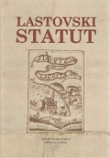
Title Lastovski statut
: [urednik Željko Radić ; uvodne studije napisali Josip Lučić, Antun Cvitanić, Nella Lonza ; prijevod Antun Cvitanić, Nella Lonza].
2. prošireno izd.
Impresum Split : Književni krug ; Lastovo : Općina Lastovo, 2024. (Split : Dalmacija papir)
Description 439 str., [8] str. s tablama ; 24 cm.
Note Sadrži i izvorni tekst Lastovskog statuta i redakciji Frana Radića. Bibliografske bilješke uz tekst. Imensko kazalo. Summary.
ISBN 9789531635578 : EUR26.60 US$ 28.70
UDC 352(210.7Lastovo)(094)
Anotation The book of the Lastovski statut (Lastovo Statute) from 1310 with its changes and additions over the centuries is a unique example of the legal life of one of our small island autonomous communes within another of our communes, later the state of Dubrovnik, within which Lastovo was from the middle of the 13th century. century until the end of the Republic in 1808. Its provisions determined the organization and functioning of the communal government, as well as social relations among the islanders themselves.

Author Blečić Kavur, Martina
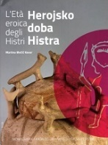
Title L'Eta eroica degli Histri = Herojsko doba Histra
/ autrice del testo Martina Blečić Kavur ; [traduzione italiana, prijevod na talijanski Elis Barbalich-Geromella ; traduzione croata, prijevod na hrvatski Asja Tonc ; fotografie, fotografije Slađana Bukovac ... [et al.]
Impresum Pula : Arheoloski muzej Istre = Archaeological Museum of Istria, 2024
Description: 151 str. : ilustr. u bojama ; 28 cm
Napomene: Tekst na tal. i hrv. jeziku.
Identifikatori: ISBN 9789538082740 : EUR 36.40 US$ 39.30
Subjectnice: Histri -- History
UDC: 903(497.5-3 Istra)"638"(083.824)

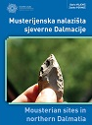
Autor Vujević, Dario
Title Musterijenska nalazišta sjeverne Dalmacije = Mousterian sites in Northern Dalmatia
/ Dario Vujević, Zlatko Perhoč.
Impresum Zadar : Sveučilište, 2024.
Description 310 str. : ilustr. u bojama ; 30 cm.
Language/s Tekst usporedo na hrv. i na engl. jeziku.
ISBN 9789533315034 : EUR 41.70 US$ 45.00
Subject Arheološka nalazišta -- Dalmacija, sjeverna. Prapovijesne kulture – Dalmacija. Musterijenska kultura -- Dalmacija, sjeverna
UDC 903’1(497.58)"632" * 902.2(497.58)

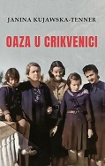
Author Kujawska-Tenner, Janina
Title Oaza u Crikvenici : sudbina kolonije poljskih emigranata u Jugoslaviji tijekom Drugoga svjetskog rata
Impresum Zagreb : Srednja Europa, 2024.
Description 60 str., [8] str. s tablama ; 21 cm.
Note Prijevod djela: Oaza w Crikvenicy : losy kolonii polskich emigrantów w Jugosławii podczas II wojny światowej.
Language/s Tekst na hrv. i na engl. jeziku.
ISBN 9789533870373 : EUR 16.90 US$ 18.20
Subject Poles -- Yugoslavia -- 1941-1945. World War II (1939-1945) -- Refugees – Yugoslavia
UDC 314.15-054.7(497.1=162.1)(091)

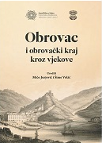
Title Obrovac i obrovački kraj kroz vjekove
/ [urednici Mićo Jurjević, Šime Vrkić].
Impresum Zadar : Sveučilište = University ; Obrovac : Matica Obrovčana, 2024.
Description 330 str. : ilustr. (djelomice u bojama), zemljop. crteži (djelomice u bojama), graf. prikazi u bojama ; 31 cm.
Note Bibliografija uz svaki rad; bibliografske bilješke uz tekst.
ISBN 9789533314815 : EUR 53.60 US$ 57.80
Subject Obrovac (surroundings, Croatia) -- History
UDC 908(497.581.1-37Obrovac)


Author Bubalo, Juraj
Title Od Pola do Malnara : putnici i istraživači u hrvatskoj kulturi od 13. do 20. stoljeća
Impresum Zagreb : Libricon ; Samobor : Meridijani, 2024.
Description 389 str. : ilustr. (djelomice u bojama) ; 25 cm.
ISBN 9789538017254 : EUR41.50 US$ 44.80
UDC 910.4-051(497.5)(091) * 910.4(091) * 821.163.42.09-992 * 821.163.42-992(082)
Anotation Juraj Bubalo in the book "Od Pola do Malnara" brings accounts of seventeen researchers and travelers from Croatian cultural history who, in the period from the developed Middle Ages to the twentieth century, contributed significantly to the study of the world we live in today with their travels, research and works. In addition to well-known names such as Marko Polo and Željko Malnar, mentioned in the title, the book also has a place in the book by various distinguished and great non-European travelers who left a written mark on their activities.

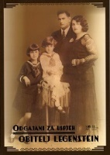
Author Šestak, Ana
Title Odgajani za uspjeh - obitelj Legenstein : izložba povodom 100. obljetnice rođenja Lili Čaki Legenstein : Izložbeni salon Muzeja Međimurja Čakovec, 15. prosinca 2023. - 24. ožujka 2024.
/ [autorica kataloga Ana Šestak ; fotografije Marko Kiš, Silvio Benč].
Impresum Čakovec : Muzej Međimurja, 2023.
Description 90 str. : ilustr. (djelomice u bojama) ; 30 cm.
ISBN 9789536896516 : EUR 18.20 US$ 19.60
Subject Legenstein, obitelj -- Katalozi izložbi. Legenstein, obitelj -- Arhiva
UDC 929.52Legenstein

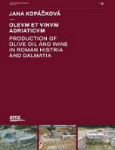
Author Kopáčková, Jana
Title Olevm Et Vinvm Adriaticvm : production of Olive Oil and Wine in Roman Histria and Dalmatia
Impresum Zagreb : Arheološki muzej u Zagrebu, 2024.
Description 403 str. : ilustr. ; 30 cm.
ISBN 9789538143557 : EUR 71.40 US$ 75.00
UDC 904:663.2(398) * 634.8(497.57)(091)
Anotation The book presents the results of many years of scientific research on olive oil and wine in the Roman world and answers the questions of when and by which routes olives and vines came to the eastern Adriatic coast, how they were grown and what methods the Romans used in the production of olive oil and wine. the two main foods of the ancient diet. The results of new research have shown that the production of wine and olive oil in Roman times in Histria and Dalmatia was widespread and occupied a firm position on the economic map of the Roman world.

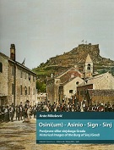
Author Milošević, Ante
Title Osini(um) - Asinio - Sign - Sinj : povijesne slike sinjskoga Grada = historical images of the Sinj fortress (Grad)
Impresum Dubrovnik : CORE ; Split : Muzej hrvatskih arheoloških spomenika, 2024
Description 336 str. : ilustr., zemljop. crteži ; 28 cm
Napomene Tekst na hrv. i na engl. jeziku. - Bibliografija: str. 322-330 i uz tekst.
ISBN 9789536803903 : EUR 83.30 US$ 89.90
Subject Sinj -- Povijest
UDC 94(497.583 Sinj)

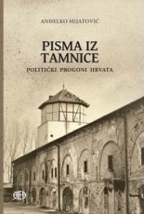
Author Mijatović, Anđelko
Title Pisma iz tamnice : politički progoni Hrvata
Impresum Zagreb : Alfa, 2024.
Description 471 str. : ilustr. ; 25 cm.
ISBN 9789533645056 : EUR 37.10 US$ 40.00
Subject Politički zatvorenici -- Hrvatska – Korespondencija. Politički progoni -- Hrvatska – Povijest. Hrvati -- Žrtve zločina
UDC 323.28-052(497.5)(091)
Anotation The book contains about two hundred letters from about eighty authors over a long period of time, from the XVI to XXI. century. Along with the name of each author, there is a historical essay with personal information and reasons for imprisonment, imprisonment or captivity, and where the letters were taken from. The included letters have a historical-documentary meaning, they bear witness to the associated political circumstances and the fates of their authors, in the majority of famous historical figures who mostly awaited death in dungeons.


Author Rajković Pejić, Ana
Title Plave kute idu na more : svakodnevica radnika u Hrvatskoj tijekom druge polovice 20. stoljeća na primjeru
tvornice "Đuro Đaković"
Impresum Zagreb : Durieux ; Slavonski Brod : Hrvatski institut za povijest, Podružnica za povijest Slavonije, Srijema i Baranje, 2024.
Description 279 str. ; 24 cm.
ISBN 9789531885515 : EUR 24.60 US$ 26.50
UDC 316.334.2:331(497.5)(091) * 316.728-057.2(497.5)(091)
Anotation The book is an important contribution to the social history of Yugoslavia, but also to the history of workers, factories, women's history, and the history of local communities. Based on rich archival materials (from private and local archives to the Croatian State Archives), periodicals (a large number of daily and weekly newspapers and factory sheets), oral history and professional literature, with the use of a multidisciplinary approach, this book is an important contribution to Croatia and European social history of the second half of the 20th century.

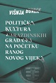
Author Burek, Višnja
Title Politička kultura varaždinskih građana na početku ranog novog vijeka
Impresum Zagreb ; Varaždin : Hrvatska akademija znanosti i umjetnosti, Zavod za znanstveni rad u Varaždinu, 2024.
Description 338 str. : ilustr. ; 24 cm.
Note Bibliografija: str. 307-317; bibliografske bilješke i uz tekst.. Imensko kazalo ; Kazalo mjesta ; Kazalo pojmova.
ISBN 9789533475851 : EUR 35.70 US$ 38.50
Subject Citizenship -- Political activity -- New century. Varaždin -- History -- Social life and customs -- 17th century.
UDC 94(497.5)"1527/1918" * 94(497.523Varaždin)"15/16" * 304(497.523Varaždin)(091)


Author Reill, Dominique Kirchner
Title Riječka kriza : život nakon Habsburške Monarhije
Impresum Zagreb : Naklada Ljevak, 2024.
Description XI, 287 str. : ilustr., zemljop. crteži ; 24 cm.
Note Prijevod djela: The Fiume crisis : life in the wake of the Habsburg empire.
ISBN 9789533558004 : EUR 30.80 US$ 33.20
Subject D'Annunzio, Gabriele -- Political activity. Fascism - Italy. Rijeka -- History -- 1918-1924.
UDC 94(497.5)"1918/1941" * 94(497.561Rijeka)"1919/1921"

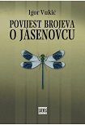
Author Vukić, Igor
Title Povijest brojeva o Jasenovcu
Impresum Zagreb : Naklada Pavičić, 2024.
Description 188 str. ; 21 cm.
ISBN 9789537949273 : EUR 23.80 US$ 25.70
UDC 94(497.5)"1941/1945" * 343.819(497.527Jasenovac)(091)
This is the third book by Igor Vukić (Zagreb, 1966) on the historical topic (from which, unfortunately, the straitjacket has not yet been torn off) of the prison and labor camp in Jasenovac (and Stara Gradiška) from 1941 to 1945. In the third part of the trilogy, History of numbers about Jasenovac, its author deals almost exclusively with the place that numbers had and have in the architecture of the black myth about Jasenovac.
Not only fictional numbers about victims, which dominate Jasenovac, but also real numbers about life on the other side of the camp wall, which are slowly making their way into the light of day.

Author Ivčević, Sanja
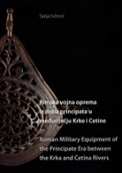
Title Rimska vojna oprema iz doba principata u međuriječju Krke i Cetine = Roman military equipment of the principate era between the Krka and Cetina rivers
/ urednica, editor Jelena Jovanović].
Impresum Split : Arheološki muzej u Splitu, 2024.
Description 349 str. : ilustr., graf. prikazi u bojama ; 30 cm.
Language/s Tekst usporedo na hrv. i engl. jeziku.
ISBN 9789537633486 : EUR 90.90 US$ 98.10
Subject Military equipment -- Roman Empire. Archaeological findings -- Dalmatia -- 27 BC.-284.
UDC 904:623.44(497.58)"652" * 623.445(37) * .66(37)

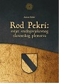
Author Nekić, Antun
Title Rod Pekri : svijet srednjovjekovnog slavonskog plemstva
Impresum Zadar : Sveučilište u Zadru, 2024.
Description 294 str. : ilustr. u bojama ; 24 cm.
ISBN 9789533314976 : EUR 35.70 US$ 38.50
UDC 929.52Tetenj * 929.7(497.54)
Anotation The book is a case study dedicated to the noble family Tetenj (Tétény) or Pekri (Pekry), following its members from the first half of the 13th to the middle of the 15th century in the area of ​​today's northern and eastern Croatia (between the Drava and Sava rivers). The study is part of efforts aimed at a better understanding of the medieval nobility in the territory of the Hungarian-Croatian kingdom, especially the understanding of family structures.

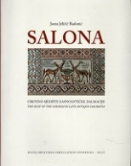
Author: Jeličić Radonić, Jasna
Title: Salona : crkveno sjedište kasnoantičke Dalmacije = the seat of the church in late antique Dalmatia
/ Jasna Jeličić Radonić ; [fotografije i crteži, photographs and drawings Jasna Jelićić Radonić, Miroslav Katić, Tonći Seser
Impresum: Split : Muzej hrvatskih arheoloških spomenika, 2024
Description: 302 str. : ilustr., zemljop. crteži ; 27 CM
Napomene: Bibliografija: str. 277-285 i uz tekst. - Kazala.
ISBN 9789536803897 : EUR 35.70 US$ 38.50
Subjectnice: Church architecture - Dalmatia. Late antique architecture - Dalmatia. Salona -- Archaeological research
UDC: 902/904"653"

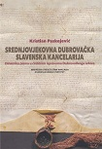
Author Paskojević, Kristian
Title Srednjovjekovna Dubrovačka slavenska kancelarija : dinamika pisma u ćiriličnim ispravama Dubrovačkoga arhiva
Impresum Zagreb : Hrvatska sveučilišna naklada : Staroslavenski institut, 2024. (Sveti Ivan Zelina : Tiskara Zelina)
Description 331 str. : ilustr. ; 25 cm.
ISBN 9789531695503 : EUR 31.90 US$ 34.40
UDC 003.349(497.584Dubrovnik) * 930.2:003.072(497.584Dubrovnik) * 929.653(497.584Dubrovnik)
Anotation The book contributes to deepening the understanding of the cultural position of medieval Dubrovnik and its role within the wider regional context, with special emphasis on the use of the Cyrillic alphabet in Dubrovnik and its correspondence with the Slavic hinterland, and further deepens our understanding of the Cyrillic component in the development of Croatian medieval literacy.

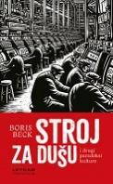
Author Beck, Boris
Title Stroj za dušu i drugi paradoksi kulture
Impresum Zagreb : Leykam international, 2024.
Description 326 str. ; 21 cm.
ISBN 9789533401980 : EUR 29.80 US$ 32.10
Subject Kultura i društvo. Politika i kultura
UDC 008

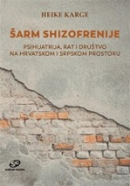
Author Karge, Heike
Title Šarm shizofrenije : psihijatrija, rat i društvo na hrvatskom i srpskom prostoru
Impresum Zagreb : Srednja Europa, 2024.
Description 424 str. : ilustr. ; 24 cm.
Note Prijevod djela: Der Charme der Schizophrenie : Psychiatrie, Krieg und Gesellschaft im kroatisch-serbischen Raum
ISBN 9789533870366 : EUR 42.40 US$ 45.70
UDC 616.89(497.5)(091) * 616.89(497.11)(091) * 355.01:159.9
Anotation

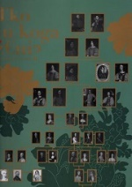
Title Tko tu koga ženi? = Who is marryng whom? : Dvor Trakošćan, 24. travnja 2024. - 15. rujna 2024. = Trakošćan Castle, April 24th 2024 - September 15th 2024
/ [tekstovi, texts by [i] urednica kataloga, catalogue editor Andreja Srednoselec ].
Impresum Trakošćan : Dvor Trakošćan = Trakošćan Castle, 2024.
Description 104 str. : ilustr. u bojama ; 34 cm.
Language/s Tekst usporedo na hrv. i na engl. jeziku.
ISBN 9789539896667 : EUR 27.30 US$ 29.50
Subject Drašković, obitelj -- Genealogija -- Katalozi izložbi. Plemićki brakovi -- Hrvatska -- Novi vijek -- Katalozi izložbi
Plemstvo -- Hrvatska -- Društveni život i običaji -- Katalozi izložbi
UDC 392.54(497.5) * 929.52Drašković * 929.7(497.5)

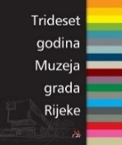
Title Trideset godina Muzeja grada Rijeke
/ [autori Rafaela Ban ... [et al.] ; fotografije Safet Baštrakaj ... [et al.] ; urednica Marija Lazanja Dušević].
Impresum Rijeka : Muzej grada Rijeke, 2024.
Description 197 str. : ilustr. u bojama ; 28 cm.
Note Katalog-spomenica.
ISBN 9789538303265 : EUR 28.60 US$ 30.90
Subject Muzej grada Rijeke -- Povijest
UDC 069:908(497.561Rijeka)

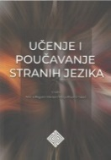
Title Učenje i poučavanje stanih jezika
/ uredile Vesna Bagarić Medve i Višnja Pavičić Takač.
Impresum Osijek : Filozofski fakultet, 2023.
Description 663 str. ; 24 cm.
ISBN 9789533141916 : EUR23.80 US$ 25.70
Subject Jezik i jezici -- Nastava i učenje
UDC 37.091.3:81’243

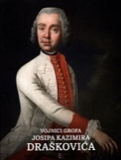
Title Vojnici grofa Josipa Kazimira Draškovića : katalog likovnih djela vojne tematike iz 18. stoljeća u Dvoru Trakošćanu
/ [autori tekstova Vladimir Brnardić ... et al.].
Impresum Trakošćan : Dvor Trakošćan, 2024.
Description 216 str. : ilustr. u bojama ; 28 cm.
ISBN 9789539896681 : EUR 54.50 US$ 58.80
Subject Drašković, Josip Kazimir -- Art collections. Drašković, family - Genealogy. Trakošćan Castle -- Art collections
Officers -- Habsburg Monarchy – Portraits. Croatia, Northwestern -- Military history -- 18th century.
UDC 75.041.5(497.5) * 94(497.5)Drašković, J. K. * 355Drašković, J. K. * 929.52Drašković

Title Vukovar danas : sjećanja, iskustva i realitet življenja
/ uredile Ivana Bendra, Matea Milak, Katarina Perić Pavišić ; [prijevod sažetka Anamarija Miličević i Sandra Cvikić].
Impresum Zagreb : Institut društvenih znanosti Ivo Pilar, 2024.
Description 214 str. : zemljop. crteži, graf. prikazi ; 25 cm.
Note Prema uredničkoj riječi, ovo je zbornik radova sa Znanstveno-stručnog skupa Vukovar devedest prve - trideset i jedna godina poslije, održanog 14. i 15. studenoga 2022. u Vukovaru u organizaciji Instituta društvenih znanosti Ivo Pilar. Summary.
ISBN 9789538404238 : EUR 22.40 US$ 24.20
Subject Domovinski rat (1991.-1995.) -- Razaranja --Vukovar -- Društveni uvjeti -- 21. st. -- Zbornici s konferencija
UDC 308(497.544Vukovar) * 355.018(497.544Vukovar)

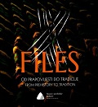
Author Nikolić, Petra
Title X files : od prapovijesti do tradicije = from prehistory to tradition
/ [autori izložbe i teksta, authors of the exhibition and text Petra Nikolić, Dario Bošnjak ; prijevod, translation Ana Ostroški Anić ; fotografije, photos Marin Topić ... [et al.] ; urednice, editors Mirela Hutinec, Mirna Šuljug].
Impresum Vukovar : Muzej vučedolske kulture = Vučedol Culture Museum, 2024.
Description 110 str. : ilustr. (pretežno u bojama) ; 23 cm.
Note Katalog izložbe Muzeja vučedolske kulture, Vukovar.
Language/s Tekst usporedo na hrv. i na engl. jeziku.
ISBN 9789535046370 : EUR 63.60 US$ 68.60
Subject Narodna nošnja -- Baranja (Hrvatska) -- Povijest -- Katalozi izložbi. Vučedolska kultura -- Katalozi izložbi
UDC 903.24(497.543)"634/636" * 391(497.543)

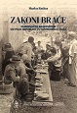
Autor Rašica, Marko, pravnik
Title Zakoni braće : Dubrovačke bratovštine od pada Republike do suvremenog doba / Marko Rašica.
Impresum Zagreb ; Dubrovnik : Hrvatska akademija znanosti i umjetnosti, Zavod za povijesne znanosti u Dubrovniku, 2024.
Description 320 str. : ilustr. (pretežno u bojama) ; 24 cm.
Note Bibliografija. Summary. Kazalo
ISBN 9789533475370 : EUR 23.80 US$ 25.70
Subject Bratovštine -- Dubrovnik – Povijest. Dubrovnik -- Crkvena povijest
UDC 272-78(497.584Dubrovnik)-9

Title Zbornik o Nikoli Andriću : zbornik radova sa znanstvenoga skupa o Nikoli Andriću, Zagreb - Vukovar - Pečuh, 20. - 22. listopada 2022.
/ [glavni urednik Tihomil Maštrović].
Impresum Zagreb : Fakultet hrvatskih studija Sveučilišta u Zagrebu : Fakultet filozofije i religijskih znanosti Sveučilišta u Zagrebu : Filozofski fakultet Sveučilišta u Zagrebu : Hrvatsko filološko društvo ; Osijek : Filozofski fakultet Sveučilišta Josipa Jurja Strossmayera ; Varaždin : Matica hrvatska, Ogranak ; Pula : Sveučilište Jurja Dobrile ; Zadar : Sveučilište u Zadru, 2024.
Description 556 str. : ilustr. ; 24 cm.
ISBN 9789538349621 : EUR 21.20 US$ 22.90
Subject Andrić, Nikola, književnik -- Zbornici s konferencija
UDC 821.163.42.0Andrić, N.

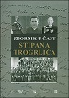
Title Zbornik u čast Stipana Trogrlića
/ uredili Elvis Orbanić i Marko Trogrlić
Impresum Split : Književni krug ; Pazin : Državni arhiv ; Zagreb : Institut društvenih znanosti Ivo Pilar ; Pula : Filozofski fakultet Sveučilišta, 2024.
Description 415 str. : ilustr. ; 24 cm
Note Bibliografske bilješke uz tekst. - Summaries.
ISBN 9789531635561 : EUR 21.20 US$ 22.90
Subject Trogrlić, Stipan -- Život i djelo
UDC 94-05Trogrlić, S.(082)


Author Erceg, Marino
Title Živko Kustić - neustrašivi glas Crkve u Hrvata
Izdanje 2. dopunjeno izd.
Impresum Zagreb : Glas Koncila, 2024.
Description 568 str. : ilustr., faks. ; 25 cm.
ISBN 9789532417425 : EUR 41.70 US$ 45.00
UDC 27-722.5Kustić, Ž.
Anotation The first biography of the unforgettable Greek Catholic priest and longtime editor of Glas Koncil, written by journalist and historian Marino Erceg. Through six large thematic units, the book follows the entire life and work of Don Živko Kustić, from his upbringing in Pag and his unusual entry into the priesthood, through his first parish services in Žumberak to his work in Glas Koncial from the beginning of the sixties.

Linguistics. Philology
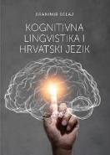
Author Belaj, Branimir
Title Kognitivna lingvistika i hrvatski jezik
Impresum Osijek : Filozofski fakultet, 2023.
Description 387 str. : ilustr. ; 24 cm.
ISBN 9789533141909 : EUR 23.80 US$ 25.70
UDC 811.163.42’23 * 811.163.42’37 * 811.163.42’367
Anotation This book contains fifteen cognitive-linguistic discussions in the field of morphosyntax of the Croatian language, cognitive semantics and normativistics, which were published and prepared for print in domestic and foreign publications from 2005 to 2023.

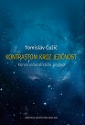
Author Ćužić, Tomislav
Title Kontrastom kroz jezičnost : konstrukturalistički pogled
Impresum Zagreb : Hrvatska sveučilišna naklada, 2024.
Description 283 str. ; 24 cm.
Note Bibliografija: str. 267-281. Summary.
ISBN 9789531695428 : EUR 26.60 US$ 28.70
UDC 811.163.42’37 * 811.163.42’36 * 811.163.42:811.163.41
Anotation The book is primarily intended for linguists, Croatists and South Slavists - scientists, students, professors, lecturers - who are interested in the topics of orthographic and grammatical standardization of the Croatian language, but also in relation to standardization in other South Slavic languages ​​(Serbian, Bosnian, Montenegrin). Individual chapters will be particularly interesting to professors of Croatian as a second language, those who deal with the theory and practice of translation, as well as anyone interested in contrastive linguistics.

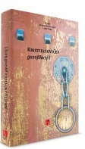
Title Kristijanovićev gazofilacij 1-2
/ Barbara Štebih Golub, Lobel Filipić (ur.).
Impresum Zagreb : Institut za hrvatski jezik i jezikoslovlje, 2024.
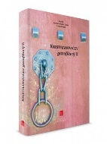
Description 2 sv. (280; 364 str.) ; 25 cm.
Note Bibliografija. Kazalo.
ISBN 9789538390166 (Knj. 1) EUR 27.70 US$ 29.90
9789538390043 (Knj. 2) EUR 27.70 US$ 29.90
UDC 811.163.42Kistijanović, I. * 821.163.42.09Kristijanović, I. * 272-722.5Kristijanović, I.
Anotation Kristijanović's Gazofilicium is the result of a project whose goal was to investigate the life and work of Ignac Kristijanović (1796 – 1884), a prolific religious writer, an important public educator and fighter for the Kajkavian literary language, from the perspective of different scientific disciplines.

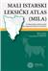
Autor Vuletić, Nikola, lingvist
Title Mali istarski leksički atlas (MILA) : geolingvističke studije iz građe Atlas Linguarum Histriae et Liburniae
Impresum Zadar : Sveučilište, 2024.
Description 382 str. : zemljop. karte u bojama ; 24 cm.
Note Bibliografija: str. 369-382. Kazalo leksičkih tipova.
ISBN 9789533314839 : EUR 35.70 US$ 38.50
Subject Istra -- Jezici -- Atlasi
UDC 81’282(497.57)

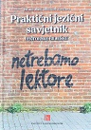
Title Praktični jezični savjetnik: Lektorske bilješke
/ uredili Željko Jozić i Kristian Lewis.
Impresum Zagreb : Institut za hrvatski jezik, 2024.
Description 278 str. ; 21 cm.
ISBN 9789538390173 : EUR 19.10 US$ 20.60
Subject Lektura – Priručnici. Hrvatski jezik -- Pogreške u upotrebi -- Hrvatski jezik -- Pravopis .
UDC 811.163.42’271(035)

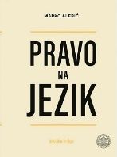
Autor Alerić, Marko
Title Pravo na jezik
Impresum Zagreb : Školska knjiga, 2024.
Description 408 str. : ilustr. ; 25 cm.
ISBN 9789530623422 : EUR 28.60 US$ 30.90
UDC 81’26(075.8) * 811.163.42’26(075.8)
Anotation University monograph The right to language by prof. Ph.D. sc. Marko Alerić unites the fundamental rights of every human being - the right to adopt the native language (immanent grammar) and the right to master the native language (normative grammar). The right to the language is an excellent incentive for learning the Croatian standard language, which the author achieves with a reasoned and scientifically based idea that the right to the language is the right of every individual, as well as a member of the wider social community, and not an imposed obligation that forces and binds.
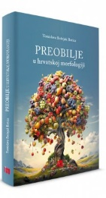

Autor Bošnjak Botica, Tomislava
Title Preobilje u hrvatskoj morfologiji
Impresum Zagreb : Institut za hrvatski jezik, 2024.
Description 148 str. ; 24 cm.
ISBN 9789537967291 : EUR 12.80 US$ 13.80
Subject Hrvatski jezik -- Morfologija
UDC 811.163.42’366

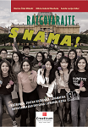
Author Čilaš Mikulić, Marica
Title Razgovarajte s nama! B2 1: vježbenica, zvučna vježbenica i gramatika hrvatskoga kao drugoga i stranoga jezika za razinu B2. 1
Impresum Zagreb : Hrvatska sveučilišna naklada : Croaticum - Centar za hrvatski kao drugi i strani jezik : Filozofski fakultet, 2024.
Description 350 str. : ilustr. ; 24 cm.
ISBN 9789531695602 : EUR 27,30 US$ 29,50
Subject Hrvatski jezik -- Udžbenici za strane govornike. Hrvatski jezik -- Zadaci i vježbe
UDC 811.163.42’243(075.8)

Literature. History. Theory
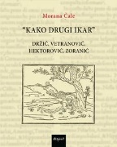
Author Čale, Morana
Title “Kako drugi Ikar” : Držić, Vetranović, Hektorović, Zoranić
Impresum Zagreb : Disput, 2024.
Description 270 str. ; 20 cm.
ISBN 9789532604962 : EUR 19,10 US$ 20.60
Subject Renaissance (literature) – Croatia. Croatian literature -- 16th century. Croatian literature -- Comparative studies
UDC 821.163.42.09

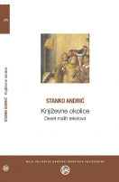
Author Andrić, Stanko
Title Književne okolice : deset malih tekstova
Impresum Zagreb : Društvo hrvatskih književnika, 2024.
Description 122 str. : ilustr. ; 18 cm.
Note Bibliografska bilješka: str. 107-108; biblografske bilješke uz tekst.
ISBN 9789532784039 : EUR 15.50 US$ 16.70
Subject Književnost -- Povijest i kritika
UDC 821.163.42-4

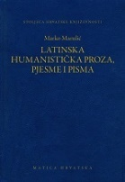
Author Marulić, Marko
Title Latinska humanistička proza, pjesme i pisma
/ priredio Bratislav Lučin ; [tumač imena i izraza i rječnik Dražana Radman i Bratislav Lučin].
Impresum Zagreb : Matica hrvatska, 2024.
Description 551 str. ; 20 cm.
Nakl. cjelina Stoljeća hrvatske književnosti ; knj. 157
Language/s Tekst na hrv. i na lat. jeziku.
ISBN 9789531503624 : EUR 41.70 US$ 45.00
UDC 821.163.42-82=124=163.42(081) * 821.124(497.5)-82=124=163.42(081)
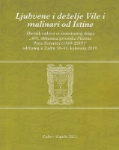

Author Znanstveni skup "Petar Zoranić, Planine (1569-2019)" (2019 ; Zadar)
Title Ljubvene i deželje vile i malinari od istine : Planine Petra Zoranića (1569-2019) : zbornik radova sa znanstvenog skupa "450. obljetnica prvotiska Planina Petra Zoranića (1569-2019)" održanog u Zadru 30-31. kolovoza 2019.
/ urednici Davor Dukić, Ivan Lupić, Divna Mrdeža Antonina.
Impresum Zadar : Sveučilište u Zadru, Odjel za kroatistiku ; Zagreb : Filozofski fakultet, Odjel za kroatistiku, 2023.
Description 384 str. : faks. ; 20 cm.
ISBN 9789533314693 : EUR 35.70 US$ 38.50

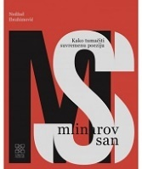
Author Ibrahimović, Nedžad
Title Mlinarov san : kako čitati suvremenu poeziju
Impresum Zagreb : Meandarmedia, 2024.
Description 228 str. : ilustr. ; 21 cm.
ISBN 9789533343372 : EUR 26.60 US$ 28.70
Subject Pjesništvo – Teorija. Književna interpretacija
UDC 82.0-1 * 82.09-1

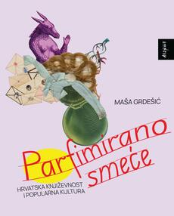
Author Grdešić, Maša
Title Parfimirano smeće : hrvatska književnost i popularna kultura
Impresum Zagreb : Disput, 2024.
Description 275 str. ; 20 cm.
ISBN 9789532604955 : EUR 19.10 US$ 20.60
UDC 821.163.42.09
Anotation The book Parfimirano smeće (Perfumed Trash) by Maša Grdešić explores the relationship between popular and high culture in Croatian literature of the 19th and 20th centuries. In nine chapters divided into three parts, the author shows that it is necessary to approach recent Croatian literature from the perspective of popular culture instead of exclusively from the usual high culture perspective. The author thus deals with popular motifs in the works of canonical writers such as Miroslav Krleža and Ranko Marinković, the political function of popular novels by Marija Jurić Zagorka and the ways in which literature, but also literary theory and history, portray popular genres such as crime and romance and treat passionate female readers of popular literature. – perfumed trash from the title of the book.

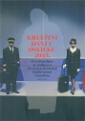
Author Krležini dani (2022 ; Osijek)
Title Prvo desetljeće 21. stoljeća u hrvatskoj dramskoj književnosti i kazalištu, dio 1
/ priredila Martina Petranović.
Impresum Zagreb : Hrvatska akademija znanosti i umjetnosti ; Osijek : Hrvatsko narodno kazalište u Osijeku : Filozofski fakultet Sveučilišta Josipa Jurja Strossmayera u Osijeku, 2023.
Description 546 str. : ilustr. 24 cm.
Note Bibliografija. Summaries. Kazalo.
ISBN 9789533475455 : EUR 29.90 US$ 32.30
Subject Hrvatsko kazalište -- 21. st. Hrvatska drama -- 21. st. -- Zbornici s konferencija
UDC 792(497.5) * 821.163.42.09-2

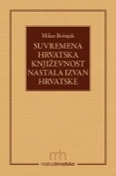
Author Bošnjak, Milan, književnik
Title Suvremena hrvatska književnost nastala izvan Hrvatske : članci i ogledi / Milan Bošnjak.
Impresum Zagreb : Matica hrvatska, 2024.
Description 186 str. ; 18 cm.
ISBN 9789533412573 : EUR 19.00 US$ 20.50
Subject Hrvatska književnost -- Inozemstvo -- Povijest i kritika -- 1990.2010.. Hrvatska emigrantska književnost -- 2010.-2020.
UDC 821.163.42.09

Literature. Poetry
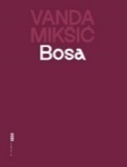
Author Mikšić, Vanda
Title Bosa
Impresum Zagreb : Meandar media, 2024.
Description 143 str. ; 20 cm.
Note Stihovi.
ISBN 9789533343570 : EUR 21.30 US$ 23.00
UDC 821.163.42-1

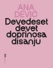
Author Dević, Ana
Title Devedeset devet doprinosa disanju
Impresum Zagreb : Meandar media, 2024.
Description 139 str. ; 20 cm.
Note Stihovi.
ISBN 9789533343556 : EUR 21.30 US$ 23.00
Anotation With her verses, the poet Ana Dević bravely cuts into the melancholy of the past, the vivid colors of girlhood, the inexorability of aging, as well as the many relationships that surround and shape one's own "I". Her poetic language is simultaneous: drinkable, strange, ominous, soft and tremulous, sometimes merciless.
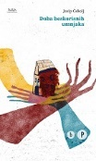
Author Čekolj, Josip
Title Doba beskorisnih umnjaka
Impresum Zagreb : Hrvatsko društvo pisaca, 2024.
Description 120 str. ; 20 cm.
Note Stihovi.
ISBN 9789538152603 : EUR 15.50 US$ 16.70
UDC 821.163.42-1

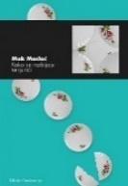
Author Maslać, Mak
Title Kako se razbijaju tanjurići
Impresum Zagreb : Durieux, 2024.
Description 70 str. ; 21 cm.
ISBN 9789531885690 : EUR 13.40 US$ 14.50
UDC 821.163.42-1
Anotation How the plates are broken is a collection of poems in which the author deals with relationships in love and family, queer identity and (children's) sexuality. Maslać pays a lot of attention to the body as a place of euphoria and trauma, and says that this body refuses to be constrained by hetero and cis norms. Using humor, references to pop culture, animals and characters from children's literature, Maslać finds a foothold for creating his own vision of gender identity and succeeds in building a multi-layered text that will push the boundaries of our world.

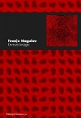
Autor Nagulov, Franjo
Title Krvava knjiga
Impresum Zagreb : Durieux, 2024.
Description 75 str. ; 20 cm.
Note Stihovi.
ISBN 9789531885874 : EUR 13.40 US$ 14.50
Franjo Nagulov's new collection of poetry, Krvava knjiga, is a dark record of the decline of a society. The poems can be read separately or as one long poem, a song about a symbolic mother whose child has no prospects for a dignified life due to social circumstances. Leading us through the nightmarish landscape of today's time, the poet gives a pessimistic diagnosis of society: it is afflicted with various diseases, and its recovery is not yet underway.

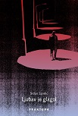
Author Sandić, Srđan
Title Ljubav je glagol
Impresum Zaprešić : Fraktura, 2024.
Description 91 str. ; 21 cm.
Note Stihovi.
ISBN 9789533587677 : EUR 19.10 US$ 20.60
Anotation Srđan Sandić's verses are a healing and sincere mixture of life's pain and everyday joy, the search for the Other, a sung realization of the curse of silence. Ljubav je glagol (Love is a verb), the ground will slip out from under our feet because it believes in feeling and compassion, and above all in the vulnerability of each of us.

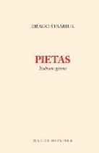
Author Štambuk, Drago
Title Pietas : izabrane pjesme
/ izbor i pogovor Davor Šalat.
Impresum Zagreb : Matica hrvatska, 2024.
Description 470 str. ; 21 cm.
ISBN 9789533412894 : EUR 28.60 US$ 30.90
UDC 821.163.42-1

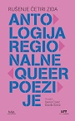
Title Rušenje četiri zida : antologija regionalne queer poezije
/ priredili Denis Ćosić i Đorđe Simić.
Impresum Zagreb : Hrvatsko društvo pisaca, 2024.
Description 184 str. ; 25 cm.
ISBN 9789538152580 : EUR 26.20 US$ 28.30
Subject Queer pjesništvo -- Zbirke tekstova. Pjesništvo -- Balkanska regija -- Zbirke tekstova
UDC 821(497)-1=00(082) * 821(497)-055.3-1(082)

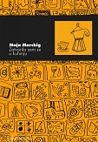
Author Marchig, Maja
Title Zatvorila sam se u kuhinju
Impresum Zagreb : Durieux, 2024.
Description 68 str. ; 21 cm.
Note Stihovi.
ISBN 9789531885683 : EUR 13.40 US$ 14.50
UDC 821.163.42-1

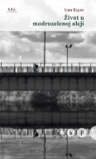
Author Kapec, Ivan
Title Život u modrozelenoj aleji
Impresum Zagreb : Hrvatsko društvo pisaca, 2024.
Description 99 str. ; 20 cm.
Note Stihovi.
ISBN 9789538152573 : EUR 14.30 US$ 15.40
UDC 821.163.42-1

Literature. Prosa. Novels, short stories. Essays.

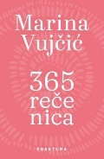
Author Vujčić, Marina
Title 365 rečenica
Impresum Zagreb : Fraktura, 2024.
Description 365 str. ; 19 cm.
ISBN 9789533587844 : EUR 26.60 US$ 28.70
Anotation Among the three hundred and sixty-five sentences, there may be the right one, the only one, the most important one, the one around which the other three hundred and sixty-four are just static, but if there are no such sentences, there will be a written trace of an unusually sentence-like year that you have never experienced before.

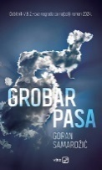
Author Samardžić, Goran
Title Grobar pasa V.B.Z. književna nagrada za najbolji roman godine 2024.
Impresum Zagreb : V. B. Z., 2024.
Description 180 str. ; 23 cm.
ISBN 9789535207528 : EUR 21.30 US$ 23.00
Anotation Grobar pasa (Undertaker of Dogs) is a crumbled prose with rough texture and high dramatic charge, a melange of brutal episodes and jovial exhibitions, fatalistic balancing on the edge of quivering exhilaration and menacing melancholy. Balance of triumphs and losses, because above all, Goran Samardžić's new novel is a self-explanatory and self-ironic letter of a defeated enfant terrible


Author Kordić, Sofija
Title Hipofiza u egzilu
Impresum Zagreb : Naklada Jesenski i Turk : Srpsko narodno vijeće, 2024.
Description 287 str. ; 20 cm.
ISBN 9789533810447 : EUR 21.30 US$ 23.00
Anotation This is not an (anti)war novel about the downfall of Yugoslavia, about Belgrade in the 90s and the war raging on the territory of the former state, but a novel about a generation. To the generation that saw that the only future that exists for them is the one outside the homeland they knew until then.

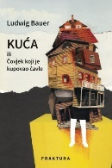
Author Bauer, Ljudevit
Title Kuća ili Čovjek koji je kupovao čavle
Impresum Zaprešić : Fraktura, 2024.
Description 262 str. ; 21 cm.
ISBN 9789533587622 : EUR 24.50 US$ 26.40
Anotation In the novel Kuća ili Čovjek koji je kupovao čavle (The House or the Man Who Bought Nails), Ludwig Bauer painted a fresco about the last decades of socialism. A novel about two lovers who, driven by their obsessions – home or career – gradually drift apart. The novel shows the reverse side of a socialist system that crumbles in the face of its own ambitions, but above all, it is a story about people - their goodness and naivety, greed and fickleness, about whether we can ever understand each other.

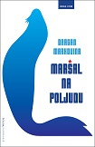
Author Markovina, Dragan
Title Maršal na Poljudu
Impresum Zagreb : Hena com, 2024.
Description 140 str. ; 22 cm.
ISBN 9789532594874 : EUR 21.20 US$ 22.90
Anotation The book Maršal na Poljudu is the second prose fiction work of historian and publicist Dragan Markovina, which this time also gains a novelistic momentum - with the taste of the sea and salt, bitterness but also sweetness, the hedonistic one. In a series of stories about the very recent and already somewhat distant past, Marshal na Poljud tells us a lot, and perhaps above all - about the present.

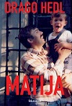
Author Hedl, Drago
Title Matija
Impresum Zagreb : Telegram media grupa, 2024.
Description 360 str. ; 21 cm.
ISBN 9789534950166 : EUR 29.70 US$ 32.00
Anotation The book Matija, the genre closest to a diary, is the tragic story of the renowned Croatian journalist Drago Hedl about the suicide of his son Matija, a doctor of biochemistry and a scientist at the American Yale. Matija Hedl was a successful scientist, employed in America, who decided to leave this world in the fall of 2018. His father Drago wrote an exceptional book, something between Matija's biography and a diary of 37 days of parental agony, how long it took them to transfer the body to Croatia and place the urn in the family tomb.

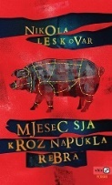
Author Leskovar, Nikola
Title Mjesec sja kroz napukla rebra
Impresum Zagreb : V.B.Z., 2024.
Description 180 str. ; 20 cm.
ISBN 9789535207658 : EUR 23.70 US$ 25.60
Anotation Nikola Leskovar's novel is a dark and poignant study of human evil, false hope and the smoldering power of love that could redeem us all together. Mjesec sja kroz napukla rebra (The Moon Shines Through Cracked Ribs) is a novel with a difference, beyond fashion and handy easy solutions, far from cheap seduction, any flirtation with the genre or condescension to the reader. Then again, it's also an irresistible special text, pure adventure, a funfair carousel that has broken off and is spinning under the cold moonlight.

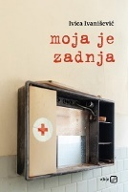
Author Ivanišević, Ivica
Title Moja je zadnja
Impresum Zagreb : V.B.Z., 2024.
Description 142 str. ; 20 cm.
ISBN 9789535207634 : EUR 23.70 US$ 25.60
Anotation The collection of stories with the authoritarian title "Moja je zadnja" by the writer and journalist Ivica Ivanišević from Split is in the grip of the authorities, stabbing horns, and as its basic weapon it chooses humor in its most diverse registers. : satire, parody, irony, the absurdity of the socio-political "world around us" or the ubiquitous Dalmatian squeal and teasing.

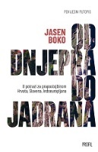
Author Boko, Jasen
Title Od Dnjepra do Jadrana : u potrazi za prapostojbinom Hrvata, Slavena, Indoeuropljana
Impresum Zagreb : Profil knjiga, 2024.
Description 329 str., [28] str. s tablama u bojama : zemljop. crtež ; 23 cm.
ISBN 9789533861319 : EUR 23.70 US$ 25.60
Subject Slavenska civilizacija * Slaveni – Povijest
Anotation In his new travelogue, Jasen Boko investigates where, how and when Croats came to these areas and reveals a broader picture of human migrations since prehistoric times and civilizations that developed and disappeared. In this book, too, Boko clearly advocates tolerance, proving that the nation is social creation, not genetic heritage, and that we are a mixture of all the populations that lived in this area and passed through here.

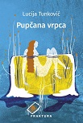
Author Tunković, Lucija
Title Pupčana vrpca
Impresum Zaprešić : Fraktura, 2024.
Description 255 str. ; 21 cm.
ISBN 9789533587868 : EUR 24.50 US$ 26.40
Anotation Lucija Tunković, with her polished style and excellent narrative voice, becomes the author of a generation who brings us all the fears, hopes, happiness and unhappiness of those born in war, who grew up in transition and post-transition, millennials torn between the worlds of their parents and their own, which they fail to build because it is obvious to them are collapsing. Pupčana vrpca (The Umbilical Cord) is a powerful, original piece of prose about the need to break the toxic connection with the past, which is only possible if we truly face it.

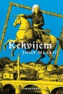
Author Mlakić, Josip
Title Rekvijem
Impresum Zagreb : Fraktura, 2024.
Description 215 str. ; 21 cm.
Note Rječnik manje poznatih riječi i izraza: str. 211-213.
ISBN 9789533587660 : EUR 21.30 US$ 23.00
Anotation Rekvijem mirrors the past and the present, because they cannot do without each other. Josip Mlakić wrote a painful diptych about the times of emigration, about the age when even the most persistent cannot survive. Rekvijem is a great and magnificent novel about Bosnia, about a country that is disappearing, but above all a novel about man's attempts to master and overcome himself and his limitations.

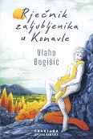
Author Bogišić, Vlaho
Title Rječnik zaljubljenika u Konavle : mali europski roman
Impresum Zagreb : Fraktura, 2024.
Description 224 str. ; 20 cm.
ISBN 9789533587875 : EUR 21.30 US$ 23.00
Anotation The novel-mosaic Dictionary of lovers of Konavle by Vlaho Bogišić is made up of glass panes that reflect a world of incredible beauty and life force, but also of heavy weight and tragedy, characteristic of life on the border. Based on the author's great encyclopedic, cultural and personal experience, with a literary shift, this novel space, from antiquity to the present day, is inhabited by famous and less famous heroes. We find them at the same level of narrative reality - because Konavle, as the Dictionary of Konavle lovers clearly shows, is a magical space where everything is possible.

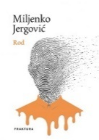
Author Jergović, Miljenko
Title Rod
Impresum Zaprešić : Fraktura, 2024.
Description 980 str. ; 21 cm.
ISBN 9789533587639 : EUR 42.50 US$ 45.90
Anotation Rod Miljenko Jergović's book is composed of several units - novels, documents, narrative sketches, fragments - in which fictional and non-fictional parts alternate and perfectly mix real and imagined. With many autobiographical elements, Jergović in Rod writes a saga about the family of Karel Stubler, his great-grandfather.


Author Matanović, Julijana
Title Stoji ti put
Impresum Koprivnica : Neolit : Artikulacije, 2024.
Description 128 str. ; 20 cm.
ISBN 9789535090953 : EUR 24.90 US$ 26.90
Anotation Three prophetesses, three women and three destinies that merge into one shocking and moving story are the subject of this short novel by Julijana Matanović. It was told in a time when it was normal for a woman to suffer, when there were no such words as rebellion, choice and rights, and when salvation was hidden only in coffee grounds. Although the voices of women's right to equality echo loudly from all sides, the heroines of Julijane Matanović are still forced to live in a man's world where all attempts at rebellion are smashed on their heads.

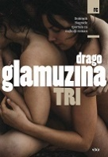
Autor Glamuzina, Drago
Title Tri
Impresum Zagreb : V.B.Z., 2024.
Description 260 str. ; 20 cm.
ISBN 9789535207672 : EUR 23.70 US$ 25.60
Anotation Drago Glamuzina's novel Tri won the tportal award for the best novel in 2009 and was at the top of the Croatian charts that year, and after 15 years, a new edition of that acclaimed novel is being published.
Although it has not been read that way before, Tri is undoubtedly a woman's novel; women are more expressive and dominant in the book, they are the ones who make the moves, move the boundaries, determine the dynamics, adjust the tonality.

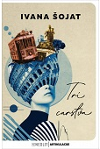
Autor Šojat, Ivana
Title Tri Carstva
Impresum Koprivnica : Neolit : Artikulacije, 2024.
Description 132 str. ; 21 cm.
ISBN 9789535090984 : EUR 26.80 US$ 28.90
Anotation Rome, Istanbul and Vienna, three cities, three empires, three histories, and one story. This book is only a conditional travelogue, it is the result of the sharp eye, open mind and encyclopedic knowledge of Ivana Šojat, who takes us to famous locations, but tells what only she sees, hears and recognizes. And see the influences, the past and the people who used to pass through there.
Three Empires is at the same time a historical handbook and a guide through the history of art, filled with unlimited imagination and a writer's nerve. After this book, you will no longer be a tourist who only looks for the flag or umbrella of the tourist guide.

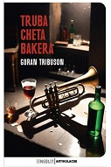
Author Tribuson, Goran
Title Truba Cheta Bakera
Impresum Koprivnica : Neolit : Artikulacije, 2024.
Description 308 str. ; 20 cm.
ISBN 9789535090939 : EUR 28.10 US$ 30.30
Anotation The novel Truba Cheta Bakera (Trumpet by Chet Baker) is a touching tribute to the power of love, but also to the healing power of literature. Anyone who has already read Goran Tribuson knows that his reading cannot be complete without good music, and here, in the background, you will be able to hear the sound of the trumpet of this famous jazz musician.

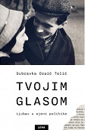
Author Oraić Tolić, Dubravka
Title Tvojim glasom : ljubav u sjeni politike
Impresum Zagreb : Naklada Ljevak, 2024.
Description 336 str. ; 22 cm.
ISBN 9789533558097 : EUR 27.30 US$ 29.50
UDC 821.163.42-94
Anotation Dubravka Oraić Tolić's book Your Voice: Love in the Shadow of Politics belongs to the genre of lyrical autobiographical prose with a strong social and cultural context. The book combines the author's biography and family memoirs, personal destinies and political history, intimate everyday life and the bygone culture of the 20th century in a spatial range from Slavonski Brod to Posušje and Herzegovina, from Borovi and Vukovar to Dugo Selo and Sesvet, from Zagreb and Vienna to Bonn and Zurich.

Arts. General

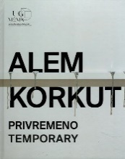
Autor Korkut, Alem
Title Alem Korkut: Privremeno = Temporary : Umjetnička galerija Dubrovnik, 8. lipnja - 14. srpnja 2024. = Museum of Modern art Dubrovnik, June 8 - July 14, 2024
/ [tekst [i] urednica, text [and] editor Rozana Vojvoda ; prijevod, translation Graham McMaster ; fotografije, photographs Marko Ercegović, Alem Korkut, Miho Skvrce].
Impresum Dubrovnik : Umjetnička galerija, 2024.
Description 101 str. : ilustr. u bojama ; 27 cm.
Note Katalog izložbe.
Language/s Tekst na hrv. i engl. jeziku.
ISBN 9789538316319 : EUR 34.50 US$ 37.20

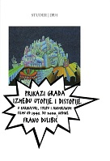
Autor Dulibić, Frano
Title Prikazi grada između utopije i distopije u karikaturi, stripu i animiranom filmu od 1945. do 2020. godine
Impresum Zagreb : Društvo povjesničara umjetnosti Hrvatske, 2024.
Description 160 str. : ilustr. (pretežno u bojama) ; 23 cm.
Note Summary. Imensko kazalo.
ISBN 9789536089536 : EUR 23.80 US$ 25.70
UDC 7.047(497.5)
Anotation Using an interdisciplinary approach, Frano Dulibić investigates the depiction of the city in popular culture from 1945 to 2020 in Croatia. Through cartoons, comics and animated films, the author connects art history, film history, anthropology and sociology. This book offers an intriguing insight into the relationship between man and his urban environment, analyzing how over time the media of popular culture changes and simultaneously shapes our view of ourselves and the world.

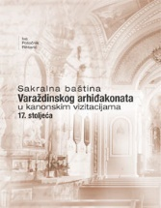
Author Potočnik Rihtarić, Iva
Title Sakralna baština Varaždinskog arhiđakonata u kanonskim vizitacijama 17. stoljeća
Impresum Zagreb ; Varaždin : Hrvatska akademija znanosti i umjetnosti, Zavod za znanstveni rad u Varaždinu, 2024.
Description 209 str. : ilustr. (pretežno u bojama) ; 28 cm.
Note Bibliografija: str. 188-201. Imensko kazalo ; Kazalo svetačkih imena.
ISBN 9789533475561 : EUR 35.70 US$ 38.50
Subject Varaždinska biskupija – Povijest. Kršćanska umjetnost -- Varaždin (okolica). Varaždin (okolica) -- Crkvena povijest
UDC 7.046:27(497.523-37Varaždin) * 272-773(497.523-37Varaždin)

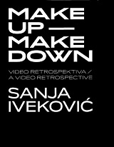
Autor Iveković, Sanja, likovna umjetnica
Title Sanja Iveković: Make up – Make down : video retrospektiva / a video retrospective
/ tekstovi/texts Branka Benčić
Impresum Rijeka, Muzej moderne i suvremen umjetnosti / Museum of modern and contemporary art
Description 233 str. : ilustr. ; 24 cm.
Note Katalog izložbe
Language/s Tekst usporedo na hrv. i na engl. jeziku.
ISBN 9789538107443 : EUR 43.10 US$ 46.50
UDC 7.038.5Iveković, S.

Urbanism. Architecture
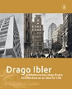
Title Drago Ibler - arhitektura kao ideja života = Drago Ibler - architecture as an idea for life
: međunarodni znanstveni skup u povodu stote obljetnice početka djelovanja arhitekta Drage Iblera : Zagreb, 9. prosinca 2021. = International scientific symposium marking the 100th anniversary of the beginning of architect Drago Ibler’s activity : 9 December 2021, Zagreb
/ [urednica Borka Bobovec ; prijevod Jeremy White, Gorka Radočaj].
Impresum Zagreb : Hrvatska akademija znanosti i umjetnosti, 2024.
Description 403 str. : ilustr. ; 30 cm.
Language/s Tekst na hrv. i na engl. jeziku.
ISBN 9789533475868 : EUR 35.70 US$ 38.50
Subject Ibler, Drago -- Zbornici s konferencija. Moderna et arhitektura -- Hrvatska --Hrvatska arhitektura -- 20. st.
UDC 72Ibler, D. * 72.036/.038(497.5)

Drawing. Applied arts and crafts

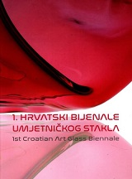
Title 1. hrvatski bijenale umjetničkog stakla = 1st Croatian art glass biennale ; Muzej antičkog stakla u Zadru, 26 siječnja - 26. ožujka 2024. = Museum of Ancient Glass in Zadar, 26th January - 26th March 2024
/ [autor kataloga izložbe, author of the exhibition catalogue Jadranka Belevski ; prijevod na engleski, translation into English Marija Kostić ; urednik, editor Hrvoje Manenica].
Impresum Zadar : Muzej antičkog stakla, 2024. (Zadar : FG grafika)
Description 144 str. ; 28 cm.
Language/s Tekst na hrv. i engl. jeziku.
ISBN 9789538320163 : EUR 34.50 US$ 37.20
Subject Artistic glass processing -- Croatia -- 2020-2030. -- Catalogs of exhibitions
UDC 748(497.5)

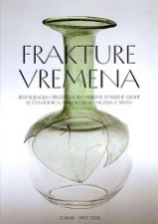
Author Perović, Šime
Title Frakture vremena : restauracija i prezentacija vrijedne staklene građe iz čuvaonica Arheološkog muzeja u Splitu : [katalog = catalogue]
/ [autori tekstova, catalogue texts Šime Perović, Ivana Matković, Ivana Zrinka Bajić Franković ; fotografije, photos Lovre Jelenković ... [et al.] ; prijevod na engleski, translation in English Marija Kostić].
Impresum Zadar: Split : Muzej antičkog stakla: Arheološki muzej ; Split : Arheološki muzej, 2024.
Description 79 str. : ilustr. u bojama ; 24 cm.
Note Katalog izložbe održane od 15. ožujka do 15. rujna 2024. u Muzeju antičkog stakla u Zadru, te 26. rujna do 26. studenoga 2024. u Arheološkom muzeju u Splitu.
ISBN 9789538320170 : EUR 20.70 US$ 22.30
Subject Antique glass -- Conservation and restoration -- Exhibition catalogs. Antique glass -- Dalmatia -- Catalogs of exhibitions
UDC 748.025.3/.4 * 748.032(497.58)

Paintings

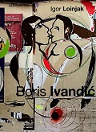
Author Loinjak, Igor
Title Boris Ivandić
/ [tekst] Igor Loinjak ; [kataloški podaci Boris Ivandić, Igor Loinjak, Danijel Zec, urednik Danijel Zec].
Impresum Osijek : Muzej likovnih umjetnosti, 2023.
Description 250 str. : ilustr. u bojama ; 30 cm.
Note Monografija. Bibliografske bilješke uz tekst. Summary.
ISBN 9789538142352 : EUR 59.90 US$ 64.60
UDC 75Ivandić, B.

Author Missia, Frano
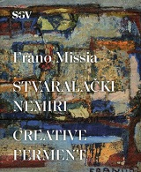
Title Frano Missia: Stvaralački nemiri = Creative ferment : Stara gradska vijećnica, Split, 10. rujna - 3. studenog 20024. = Old City Hall, Split, September 10th - November 3nd 2024
/ [tekst, essay Dalibor Prančević ; fotografije, photographs Zoran Alajbeg ; prijevod, translation Robertina Tomić ; urednica, editor Vesna Bulić Baketić].
Impresum Split : Muzej grada, 2024. (Zagreb : Kerschoffset)
Description 95 str. : ilustr. u bojama ; 26 cm.
Note Katalog izložbe.
Language/s Tekst na hrv. i engl. jeziku.
ISBN 9789538424182 : EUR 10.50 US$ 11.30
UDC 75Missia, F.

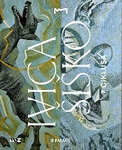
Autor Šiško, Ivica
Title Ivica Šiško: 7 ciklusa
/ [autorice teksta Koraljka Alavanja, Ivana Dražić ; autori fotografije Josip Strmečki (grafike), Nikola Šiško (crteži i slike) ; urednica kataloga Ivana Dražić].
Impresum Zadar : Narodni muzej : Udruga veterana 7. domobranske pukovnije, 2024.
Description 51 str. : ilustr. u bojama ; 24 cm.
Note Katalog izložbe održane u Izložbenim dvoranama Kneževe palače, povodom obilježavanja Dana obrane grada Zadra, 03. 10. 2024. - 27. 11. 2024.
ISBN 9789537477820 : EUR 12.10 US$ 13.10
UDC 75Šiško, I.

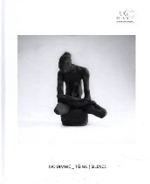
Autor Dimnić, Ivo
Title Ivo Dimnić _ Tišina = Silence : Galerija Dulčić Masle Pulitika=Dulčić Masle Pulitika Gallery, [Dubrovnik], 27. 6. - 11. 8. 2024.
/ tekst, urednica kataloga, text, catalogue editor Petra Golušić ; fotografije, photographs Miho Skvrce ; engleski prijevod, English translation Graham McMaster].
Impresum Dubrovnik : Umjetnička galerija, 2024.
Description 64 str. : ilustr. ; 27 cm.
Note Katalog izložbe.
Language/s Tekst na hrv. i engl. jeziku.
ISBN 9789538316302 : EUR 25.90 US$ 28.00

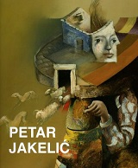
Author Jakelić, Petar
Title Petar Jakelić : retrospektiva : Galerija umjetnina, Split, Croatia, 12. prosinca 2023. - 4. veljače 2024. = retrospective : Museum of Fine Arts, December 12, 2023 - February 4, 2024
/ [predgovor, foreword [i] intervju, interview [i] urednica kataloga, catalogue editor Iris Slade
Impresum Split : Galerija umjetnina = Museum of Fine Arts, 2023. (Zagreb : Sveučilišna tiskara)
Description 200 str. : ilustr. (pretežno u bojama) ; 26 cm.
Language/s Tekst na hrv. i na engl. jeziku.
ISBN 9789538167645 : EUR 23.30 US$ 25.10
UDC 75Jakelić, P. * 76Jakelić, P.

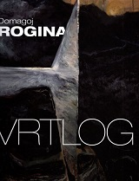
Author Rogina, Domagoj
Title Vrtlog = Vortex : Galerija umjetnina, Palača Sermage, Varaždin, 11. 10. - 24. 12. 2023.
/ [autorica teksta u katalogu, essay Elizabeta Igrec ; fotografije, photos Andrej Švoger ; urednica, editor Elizabeta Igrec].
Impresum Varaždin : Gradski muzej, 2023.
Description 69 str. . : ilustr. u bojama ; 28 cm.
Note Katalog izložbe.
Language/s Tekst na hrv. i engl. jeziku.
ISBN 9789538280436 : EUR 25.90 US$ 27.90
UDC 75Rogina, D.

Graphic art
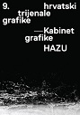
Title 9. hrvatski trijenale grafike : Galerija Klovićevi , 7. svibnja – 16. lipnja 2024.
/ [tekstovi Vesna Kedmenec Križić, Ana Petković Basletić, Ružica Pepelko].
Impresum Zagreb : Hrvatska akademija znanosti i umjetnosti, Kabinet grafike, 2024.
Description 128 str. : ilustr. u bojama ; 30 cm.
Note Katalog izložbe.
ISBN 9789533475929 : EUR 11.90 US$ 12.80
UDC 76(497.5) * 76Krasić, I.

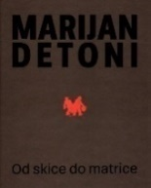
Author Detoni, Marijan
Title Marijan Detoni : Od skice do matrice
/ [autori tekstova Mihaela Cik, Antonia Došen, Miran Šabić ; fotografi Vedran Benović, Srećko Budek, Miran Šabić ; urednica Antonia Došen].
Impresum Zagreb : Muzej za umjetnost i obrt, 2023.
Description 80 str. : ilustr. ; 24 cm.
ISBN 9789537641993 : EUR 17.90 US$ 19.30
UDC 76Detoni, M.

Photography
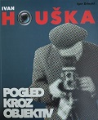
Author Zrinski, Igor
Title Ivan Houška : Pogled kroz objektiv : fotomonografija
Impresum Sveti Ivan Zelina, Muzej Sveti Ivan Zelina, 2024
Description 191 str.: ilustr.; 29 cm
Notes Bibliograf. bilj. uz tekst.- Bibliografija
Subject Houška, Ivan
ISBN 9789538052132 : EUR 51.70 US$ 55.80

Croatian music. History. Theory


Author Marić, Domagoj
Title Dora Pejačević : životi i svjetovi
Impresum Zagreb : Školska knjiga, 2023.
Description 328 str. : ilustr. ; 24 cm.
Note Bibliografija. Kazalo
ISBN 9789530623361 : EUR 53.30 US$ 57.50
UDC 78Pejačević, D.

Theatar. Film. Dance

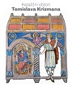
Author Petranović, Martina
Title Kazališni obzori Tomislava Krizmana
Impresum Zagreb : Hrvatska akademija znanosti i umjetnosti : ULUPUH - Hrvatska udruga likovnih umjetnika primijenjenih umjetnosti, 2024.
Description 236 str. : ilustr. (pretežno u bojama) ; 24 cm.
ISBN 9789533272573 : EUR 53.60 US$ 57.80
Subject Krizman, Tomislav. Kazališna scenografija -- Hrvatska -- 20. st. Kostimografija -- Hrvatska -- 20. st.
UDC 792Krizman, T. * 75Krizman, T. * 792.021(497.5)

