Introducing New Books from Croatia 3/2024  ZEBRA komunikacije d.o.o., Dubašnička 12,  10000 Zagreb – Croatia  www.zebrakom,  info@zebrakom.hr,  tel./fax 385 1 3668 993 | 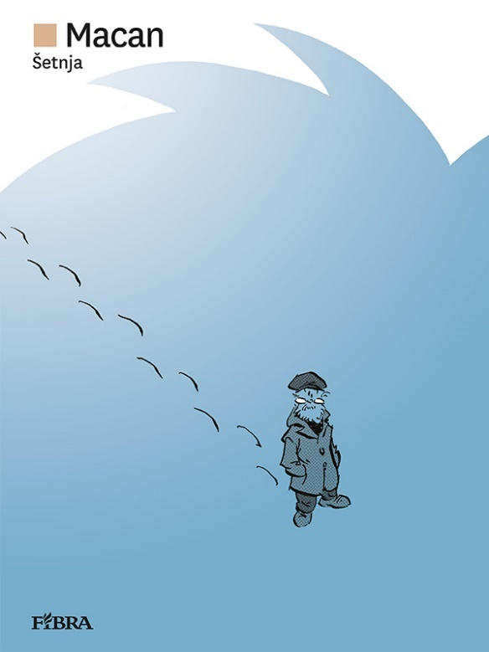  Is there life after death?  Certainly. We live even after someone dies

Museums. Social Sciences. Humanities

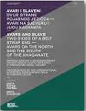
Title Avari i Slaveni : dvije strane pojasnog jezičca - Avari na sjeveru i jugu Kaganata : zbornik radova s međunarodnog znanstvenog skupa održanog u Vinkovcima 2020. godine = Avars and Slavs : Two Sides of the Belt Strap End - Avars on the North and the South of the Khaganate : proceedings of the international scientific conference held in Vinkovci 2020
/ urednici, editors Anita Rapan Papeša, Anita Dugonjić.
Impresum Zagreb : Arheološki muzej u Zagrebu = Arceheological museum in Zagreb ; Vinkovci : Gradski muzej Vinkovci = Municipal Museum Vinkovci, 2022.
Description 408 str. : ilustr. u bojama ; 24 cm.
ISBN 9789538143588 : EUR 46.50 US$ 53.20
Subject Avari -- Materijalna kultura -- Zbornici s konferencija. Avari -- Društveni život i običaji -- Zbornici s konferencija
Arheološki nalazi -- Europa, srednja -- Rani srednji vijek -- Zbornici s konferencija
UDC 904(398) * 902(4) * 94(=351.12) * 39(=351.12)

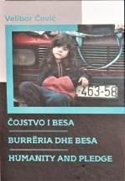
Author Čović, Velibor
Title Burrëria dhe besa = Čojstvo i besa = Humanity and pledge
Izdanje 2. izmijenjeno i dopunjeno izd.
Impresum Zagreb : Zajednica Albanaca grada Zagreba i Zagrebačke županije, 2023.
Description 199 str. : ilustr. u bojama ; 25 cm.
Language/s Tekst na alb., crnog. i na engl. jeziku.
ISBN 9789535011842 : EUR 33.30 US$ 38.10
Subject Rat na Kosovu (1998.-1999.) – Izbjeglice. Rat na Kosovu (1998.-1999.) – Svjedočanstva.
UDC 364-56(497.16) * 314.15-054.74(497.115=18)(091)

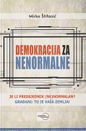
Author Štifanić, Mirko
Title Demokracija za nenormalne : Je li Predsjednik (ne)normalan? Građani: To je vaša zemlja!
Impresum Zagreb : Despot Infinitus, 2024.
Description 264 str. ; 21 cm.
ISBN 9789533661674 : EUR 22,60 US$ 25.80
Subject Demokracija – Hrvatska. Hrvatska -- Politika i vlast -- 2020.-2025.
UDC 321.7(497.5)
Anotation

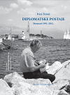
Author Tomić, Ivica, inženjer prometa
Title Diplomatske postaje : memoari 1991–2012.
Impresum Zagreb : Hrvatska sveučilišna naklada, 2024.
Description 559 str. : ilustr. ; 25 cm.
ISBN 9789531695459 : EUR 37.20 US$ 42.60
Anotation Ivica Tomić's book is an original and documented presentation of the relations of the Republic of Croatia with relevant countries, but also a broader presentation of political, economic and cultural cooperation in these countries and our bilateral relations. The author refers to specific events, of which he was personally a participant to a large extent, which he argues with facts, and gives an account of situations and an opinion on important aspects, both bilateral and overall relations and conditions in the countries and regions in which he worked.

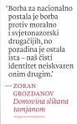
Author Grozdanov, Zoran
Title Domovina slikana tamjanom : teologija nacionalnog identiteta
Impresum Rijeka : Ex libris, 2023.
Description 184 str. ; 20 cm.
ISBN 9789538431135 : EUR 16.00 US$ 18.30
Subject Kršćanstvo i politika – Hrvatska. Religija i politika – Hrvatska. Politička teologija
UDC 27-84(497.5) * 322(497.5)


Title Dr. Franjo Tuđman – život i naslijeđe : zbornik radova sa znanstvenog skupa Dr. Franjo Tuđman - život i naslijeđe, održanog u organizaciji Hrvatskog instituta za povijest, Instituta društvenih znanosti Ivo Pilar, Matice hrvatske, Hrvatskog državnog arhiva i Hrvatskog memorijalno-dokumentacijskog centra Domovinskog rata 5. i 6. svibnja u Matici hrvatskoj u Zagrebu
/ uredili Domagoj Knežević, Ivan Hrstić.
Impresum Zagreb : Matica hrvatska : Hrvatski institut za povijest : Institut društvenih znanosti Ivo Pilar : Hrvatski memorijalno-dokumentacijski centar Domovinskog rata, 2024.
Description 341 str. ; 25 cm.
ISBN 9789533412771: EUR 36.80 US$ 42.10

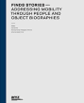
Title Finds Stories - Addressing Mobility through People and Object Biographies : Archaeological Museum in Zagreb, [12. 4. - 2. [i. e. 16.] 9. 2023.
/ editors Ivan Drnić, Konstantinos Prokopios Trimmis, Kristina Brkić Drnić ; [authors of the texts Kristina Brkić Drnić ... [et al.] ; photographs Ivan Drnić ... [et al.] ; drawings Miljenka Galić, Kristina Brkić Drnić].
Impresum Zagreb : Archaeological Museum in Zagreb, 2023.
Description 131 str. : ilustr. u bojama ; 28 cm.
Note Katalog izložbe.
Pogrešan ISBN 9789538143632 : EUR 23.30 US$ 26.70
Subject Migration -- Balkan region -- History. Archaeological findings - Croatia. Archaeological findings -- Greece
UDC 904:314.15(497) * 314.15(497)

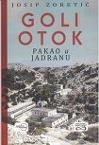
Author Zoretić, Josip
Title Goli otok : pakao u Jadranu
Impresum Zagreb : Despot infinitus, 2024.
Description 180 str. : ilustr., faks. ; 24 cm.
ISBN 9789533661704 : EUR 16.90 US$ 19.30
Subject Zoretić, Josip – Detention. Goli otok (concentration camp) - History. Concentration camps -- Yugoslavia -- 1945-1974.
Political persecution -- Yugoslavia -- 1945-1974.
UDC 323.28(497.1)(091) * 343.819(210.7Goli otok)(091) * 929Zoretić, J.

Author Krizmanić, Attilio
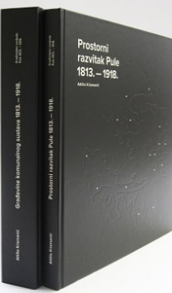
Title Građevine komunalnog sustava 1813. - 1918.
Impresum Pula = Pola : Povijesni i pomorski muzej Istre = Museo storico e navale dell'Istria, 2023
Description 529 str. : ilustr. (djelomice u bojama), graf. prikazi ; 28 x 31 cm
ISBN 9789537695262 : EUR 75.00 US$ 85,90
UDC 338.465(497.571Pula)"1813/1918"

Autor: Krizmanić, Attilio
Title: Prostorni razvitak Pule 1813. - 1918. : od obnove i promjene urbanog tkiva do transformacije identiteta u okviru unaprjeđenja obrambenog sustava
Impresum: Pula = Pola : Povijesni i pomorski muzej Istre = Museo storico e navale dell'Istria, 2023
Description: 199 str. : ilustr. (pretežno u bojama) ; 28 x 31 cm
ISBN 9789537695217 : EUR 41.70 US$ 47.70
UDC: 711.4(497.5Pula)"1813/1918"
Anotation The Historical and Maritime Museum of Istria - Museo storico e navale dell'Istria is the holder of the exhibition and publishing project Architectural heritage of Pula 1813 - 1918, the aim of which is to present the extremely rich architectural heritage of the city of Pula from the period of the Habsburg Monarchy and Austria- of the Hungarian Monarchy, systematically research the existing architectural heritage and archival documentation, catalog the objects and present the results of the research.
The first two books within the project are Spatial Development of Pula 1813 – 1918 and Buildings of the Communal System 1813 – 1918, authored by Ph.D. Attilio Krizmanić, which talk about the spatial development of Pula and the history of buildings of the municipal system of the city, which has so far been scarcely researched and studied.

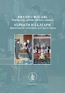
Author Znanstveni skup Hrvati i Bugari. Diplomacija, politika, kultura i znanost (2022 ; Zagreb)
Title Hrvati i Bugari : diplomacija, politika, kultura i znanost = H’rvati i B’lgari : diplomacija, politika, kultura i nauka : zbornik radova sa znanstvenog skupa održanog povodom 30. obljetnice uspostave diplomatskih odnosa između Republike Bugarske i Republike Hrvatske, te 25. obljetnice uspostave znanstvene suradnje između Bugarske akademije znanosti i Hrvatske akademije znanosti i umjetnosti (Zagreb, 28.-30. rujna 2022.)
/ [uredili Damir Karbić i Tihana Luetić].
Impresum Zagreb : Hrvatska akademija znanosti i umjetnosti, Razred za društvene znanosti, Odsjek za povijesne znanosti Zavoda za povijesne i društvene znanosti, 2024.
Description 482 str. ; 24 cm.
Language/s Tekst na hrvatskom i na bugarskom jeziku.
ISBN 9789533475332 : EUR 23.80 US$ 27.20
Subject Hrvatska -- Odnosi -- Bugarska -- Zbornici s konferencija. Bugarska -- Odnosi -- Hrvatska -- Zbornici s konferencija
UDC 94(497.5:497.2) * 930.85(497.5:497.2) * 327(497.5:497.2)(091)

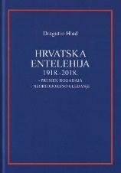
Author Hlad, Dragutin
Title Hrvatska entelehija : 1918. - 2018. : presjek događaja : neortodoksno gledanje
Impresum Zagreb : Feniks knjiga, 2023.
Description 503 str. ; 25 cm.
Language/s Tekst na hrv., engl. i na srp. jeziku.
Lat. i ćir.
ISBN 9789537710149 : EUR 50.00 US$ 57.20
Subject Hrvatsko pitanje. Hrvatska -- Povijest -- 1918.-1945. Hrvatska -- Politika i vlast -- 1945.-2000.
Hrvatska -- Politika i vlast -- 1990.-2000. Hrvatska -- Politika i vlast -- 21. st.
UDC 323.1(=163.42)(091) * 94(497.5)"1918/2018"

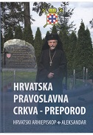
Author Ivanov, Aleksandar Radoev
Title Hrvatska pravoslavna crkva : preporod
Impresum Zagreb : vlast. nakl., 2024.
Description 359 str. : ilustr. u bojama ; 24 cm.
Note Bibliografija: str. 353-354.
ISBN 9789535954699 : EUR 45.00 US$ 51.50
Subject Hrvatska pravoslavna crkva – Povijest. Pravoslavlje. Crkva i država -- Hrvatska -- 20. st.
UDC 271.22(497.5)-9 * 322(497.5)(091)

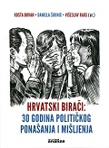
Title Hrvatski birači : 30 godina političkog ponašanja i mišljenja
/ Kosta Bovan, Daniela Širinić i Višeslav Raos (ur.).
Impresum Zagreb : Fakultet političkih znanosti, 2024.
Description 355 str. : graf. prikazi ; 23 cm.
ISBN 9789538174216 : EUR 47.60 US$ 54.60
Subject Demokracija – Hrvatska. Politički izbori – Hrvatska. Hrvatska -- Politika i vlast -- 1990.-2000. Hrvatska -- Politika i vlast -- 21. st.
UDC 324(497.5) * 324-051(497.5)

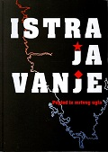
Author Ćurić, Mate
Title Istrajavanje : (pogled iz mrtvog ugla)
Impresum Pazin : Matica hrvatska ; Pula : IO DHK, 2023
Description: 272 str. : ilustr. ; 21 cm
Napomene: U prigodi osamdesete obljenice Proglasa i Pazinskih odluka o prisjedinjenju Istre s domovinom.
ISBN 9789536476633 : EUR 23.30 US$ 26.70
UDC: 005.571-32
Anotation These are texts about the recent history of Istria, especially those concerning the events, witnesses and actors of the so-called of the September events surrounding the unification with the motherland, Croatia. They were published during the last four decades of the author's journalistic career in Glas Istra, where he was also employed in various forms - feuilletons, columns, comments, interviews with the most relevant actors of that era, connected with the adoption of the September decisions in 1943.

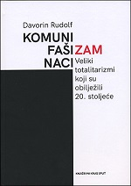
Author Rudolf, Davorin, st.
Title Komunizam, fašizam i nacizam : veliki totalitarizmi koji su obilježili 20. stoljeće : s osvrtom na jugoslavenske totalitarizme i totalitarizam Nezavisne Države Hrvatske
Impresum Split : Književni krug, 2023.
Description 843 str. : ilustr. ; 24 cm.
ISBN 9789531635462 : EUR 25.50 US$ 29.20
UDC 321.64"19"
Anotation This book is dedicated to the evil of war, the origins, features, terror and goals of the three great totalitarianisms of the 20th century, especially totalitarianisms in the Croatian territories. In a special way, she talks about the sources of our internal bloody conflicts, as well as the determination and naivety of politicians who flirted and closely cooperated with the leaders of great totalitarian regimes and created copies of foreign dictatorships. The purpose of this reading is to remind the reader of the core, practice, forms and methods of brutal and violent totalitarian governments that caused terrible troubles and evils to people whose part of life fell into the period of the 20th century. The totalitarianisms of three powerful superpowers: the Soviet Union, Italy and Germany and the effects of their dictatorial regimes are discussed. And the possibility of repeating them.

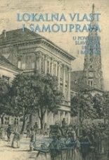
Title: Lokalna vlast i samouprava u povijesti Slavonije, Srijema i Baranje : zbornik radova znanstvenog skupa s međunarodnim sudjelovanjem održanog u Osijeku 22.-23. rujna 2022.
/ uredili Ana Rajković Pejić, Domagoj Tomas
Impresum Slavonski Brod : Hrvatski institut za povijest-Podružnica za povijest Slavonije, Srijema i Baranje ; Osijek : Zagreb : Filozofski fakultet, 2024
Description: 478 str. : ilustr. u bojama ; 24 cm
Napomene: Bibliografija. - Summaries.
ISBN 9789538102424 : EUR 20.00 US$ 22.90
Subjectnice: Lokalna samouprava -- Hrvatska -- Povijest
UDC: 352(497.54)(091)

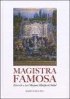
Title Magistra famosa : Zbornik u čast Mirjani Matijević Sokol
/ uredili Ivan Botica ... [et al.]
Impresum Split : Književni krug, 2024- .
Description 903 str. : ilustr., graf. prikazi. ; 24 cm
Napomene: Tekst na hrv. i na engl. jeziku. - Bibliografija iza svakog poglavlja i uz tekst. - Summaries.
ISBN 9789531635486 : EUR 28.70 US$ 32.90
UDC 32-05 Matijević Sokol, M.(082)

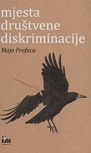
Author Profaca, Maja
Title Mjesta društvene diskriminacije
Impresum Zagreb : Meandarmedia, 2024.
Description 96 str. ; 20 cm.
ISBN 9789533343389 : EUR 17.00 US$ 19.50
Subject Anti-discrimination law. Women -- Victims of violence -- Philosophical point of view. Women -- Victims of violence -- Media coverage. Gender discrimination. Stereotypes. Mass media - Influence. Female artists -- Political aspects
UDC 305-055.2 * 342.726-055.2 * 316.647.8-055.1/.3

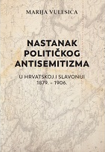
Author Vulesica, Marija
Title Nastanak političkog antisemitizma u Hrvatskoj i Slavoniji 1879. – 1906.
/ Marija Vulesica ; [preveli Ivana Cvijović Javorina i Marko Javorina].
Impresum Zagreb : Srednja Europa, 2024.
Description 266 str. ; 24 cm.
Note Prijevod djela: Die Formierung des politischen Antisemitismus in den Kronländern Kroatien-Slawonien 1879–1906.
ISBN 9789533870168 : EUR36.20 US$ 41.40
UDC 323.12(497.5=411.16)(091) * 94(497.5=411.16)
Anotation The development and shaping of political anti-Semitism in Croatia and Slavonia at the turn of the 19th and 20th centuries is presented chronologically. After the introduction, the first chapter presents the historical context and, above all, the active parties, their political lines, their protagonists and their press. After the description of the parties, a brief overview of the history of the Jews in Croatia and Slavonia is given. Although anti-Semitism is not primarily understood as part of Jewish history, it has affected European Jews to varying degrees. The history of Croatian Jews is mostly unknown to the reading (professional) audience outside of Croatia. It is not outlined here only for that reason, but also to clarify the Croatian-Jewish (i.e. Christian-Jewish) context.

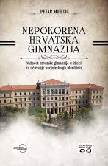
Author Miletić, Petar, povjesničar
Title Nepokorena hrvatska gimnazija : važnost riječke gimnazije za očuvanje nacionalnoga identiteta
Impresum Zagreb : Despot infinitus, 2024.
Description 292 str. : ilustr. u bojama ; 24 cm.
ISBN 9789533661902 : EUR 28.30 US$ 32.40
UDC 373.5(497.561Rijeka)(091) * 373.5.016:811.163.42(091) * 323.11(497.561Rijeka)
Anotation This book is the first comprehensive work on the Croatian high school in Rijeka from the perspective of its role and meaning in the preservation of Croatian national identity in the second half of the 19th century, when it was seriously threatened by the systematic Hungarianization and Italianization of the city of Rijeka. In addition to its primary, educational activity, the gymnasium also led a political struggle for the preservation of Croatian linguistic and national identity, thus becoming the most important Croatian institution in the city and a kind of symbol of national resistance. Because of this, it experienced media and vandal attacks and, in the end, was forced to move from Rijeka, but it managed to educate generations of Croatian patriots and national revivalists, so this school is partly to blame for the fact that Rijeka and Istria are now parts of the Republic of Croatia.
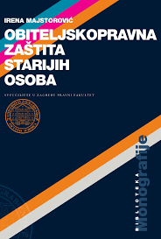

Author Majstorović, Irena
Title Obiteljskopravna zaštita starijih osoba
Impresum Zagreb : Pravni fakultet, 2024.
Description 137 str. ; 24 cm.
ISBN 9789532701821: EUR 27.80 US$ 31.80
Subject Starije osobe -- Obiteljski odnosi. Prava starijih osoba
UDC 364.65-053.9:34 * 343.6-053.9

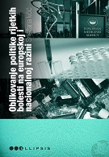
Author Ivčić, Snježana
Title Oblikovanje politike rijetkih bolesti na europskoj i nacionalnoj razini
Impresum Zagreb : Durieux, 2024.
Description 235 str. ; 24 cm.
ISBN 9789531885522 : EUR 22.30 US$ 25.50
Subject Zdravstvena politika – Europa. Javno zdravstvo – Europa. Rijetke bolesti -- Politički aspekti -- Europa
UDC 614.2:32(4) * 616-036.25(4)
Anotation

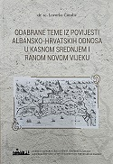
Author Čoralić, Lovorka
Title Odabrane teme iz povijesti albansko-hrvatskih odnosa u kasnom srednjem i ranom novom vijeku
Impresum Zagreb : Zajednica Albanaca grada Zagreba i Zagrebačke županije = Bashkësia Shqiptare e qytetit të Zagrebit dhe Prefekturës së Zagrebit, Hrvatski institut za povijest, 2023.
Description 422 str. : ilustr. u bojama, graf. prikazi ; 25 cm.
Note Imensko kazalo ; Kazalo zemljopisnih pojmova. Summary.
ISBN 9783952587416 : EUR 50.00 US$ 57.20
Subject Hrvatska -- Odnosi -- Albanija – Povijest. Albanija -- Odnosi -- Hrvatska -- Povijest
UDC 94(497.5:496.5)

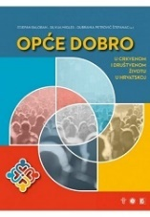
Author Znanstveni simpozij Opće dobro u crkvenom i društvenom životu u Hrvatskoj (2022 ; Zagreb)
Title Opće dobro u crkvenom i društvenom životu u Hrvatskoj
/ (uredili) Stjepan Baloban, Silvija Migles, Dubravka Petrović Štefanac.
Impresum Zagreb : Kršćanska sadašnjost : Centar za promicanje socijalnog nauka Crkve : Katolički bogoslovni fakultet, 2023.
Description 374 str. : ilustr., graf. prikazi ; 28 cm.
ISBN 9789531118187 : EUR 30.80 US$ 35.30
UDC 27-42 * 304(497.5)
Anotation


Author Kovačić, Tomislav, vojni časnik
Title Operacija Una : igra karata i magla rata na Uni i Savi u rujnu 1995. godine
Impresum Zagreb : Despot infinitus, 2024.
Description 236 str. : ilustr. ; 24 cm.
ISBN 9789533661865 : EUR 28.30 US$ 32.40
UDC 355.4(497.528.3)
Anotation In the Croatian public, there are still many unknowns as to why and how the clash between the Croatian Army and the Army of the Republika Srpska (VRS) took place in Operation "Una" on the banks of the Una and Sava rivers on September 18 and 19, 1995. Carrying out a tactically and operationally very complex operation of an unprepared forcible crossing of rivers, the engaged forces of the Croatian Army, after initial success, withdrew to their initial combat positions already on the second day of the operation. The most serious consequence of the "Una" operation is 50 dead or missing Croatian soldiers, which is the main motive for elucidating the contradictory and until now mostly partially and differently presented circumstances in which it was initiated, prepared and conducted.

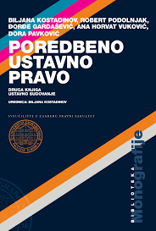
Title Poredbeno ustavno pravo : Ustavno sudovanje : druga knjiga
/ Biljana Kostadinov ... [et al.] ; urednica Biljana Kostadinov.
Impresum Zagreb : Pravni fakultet, 2024.
Description VIII, 302 str. ; 24 cm.
Note Ostali zastupljeni autori: Robert Podolnjak, Đorđe Gardašević, Ana Horvat Vuković, Dora Pavković.
ISBN 9789532701814 : EUR 34.70 US$ 39.70
Subject Ustavno pravo. Poredbeno pravo
UDC 342.4:340.5

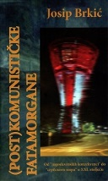
Author Brkić, Josip, prevoditelj
Title (Post)komunističke fatamorgane : (od “jugoslavenskih konzekvenci” do “cербского мира” u XXI. stoljeću)
Impresum Zaprešić : Matica hrvatska, Ogranak, 2023.
Description 227 str. ; 20 cm.
ISBN 9789538407123 : EUR 26.50 US$ 30.30
Subject Postkomunizam – Hrvatska. Hrvatska -- Politika i vlast -- 1990.-2000. Hrvatska -- Politika i vlast -- 21. st.
UDC 323.1(497.5) * 321.7(497.5)

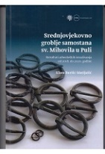
Author Buršić-Matijašić, Klara
Title Srednjovjekovno groblje samostana sv. Mihovila u Puli : rezultati arheološkog istraživanja od 2018. do 2020. godine
Impresum: Pula : Sveučilište Jurja Dobrile, Filozofski fakultet, 2023
Description: 290 str. : ilustr. u bojama, zemljop. crtezi u bojama ; 29 cm
Napomene: Str. 7-8: Uvod / Klara Buršić-Matijašić. - Bibliografija: str. 271-283. - Summary.
ISBN 9789533770369 : EUR 42.50 US$ 48.70
Subjectnice: Pula -- Arheološka istraživanja
UDC: 904:726.8](497.571Pula)"653"

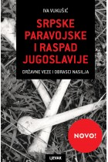
Author Vukušić, Iva
Title Srpske paravojske i raspad Jugoslavije : državne veze i obrasci nasilja
/ Iva Vukušić ; s engleskog preveo Damir Biličić.
Impresum Zagreb : Naklada Ljevak, 2024.
Description 280 str. ; 23 cm.
Note Prijevod djela: Serbian paramilitaries and the breakup of Yugoslavia.
ISBN 9789533557991 : EUR 29.60 US$ 33.90
Subject Paravojne postrojbe -- Srbija -- 1991.-1995. Rat u Jugoslaviji (1991.-1999.) -- Srpske vojne postrojbe
UDC 355.317(497.1=163.41)

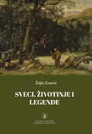
Author Cvetnić, Željko
Title Sveci, životinje i legende
Impresum Zagreb : Hrvatska akademija znanosti i umjetnosti, 2024.
Description X, 213 str. : ilustr. u bojama ; 23 cm.
ISBN 9789533475615 : EUR 23.80 US$ 27.20
Subject Kršćanski sveci zaštitnici. Životinje -- Legende
UDC 27-36 * 2-264 * 59:27
Anotation The book describes the saints who came from the Roman Catholic Church, and many of them were martyrs from the beginning of Christianity and before the church split (1054). It is almost impossible to list or describe all the saints who had any contact with animals. Animals were their companion, help or sign. It took a lot of effort to choose the most important, interesting or famous saints, and it was not easy to find the different animals that accompany them and describe them by species.

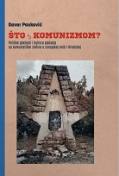
Autor Pauković, Davor
Title Što s komunizmom? : Politike povijesti i kultura sjećanja na komunističke zločine u Europskoj uniji i Hrvatskoj
Impresum Zagreb : Srednja Europa, 2024.
Description 246 str. ; 24 cm.
ISBN 9789533870182 : EUR 29.80 US$ 34.10
Subject Kolektivno pamćenje -- Hrvatska -- 1945.-1990. Kolektivno pamćenje -- Europa -- 1945.-1990.
Politički zločini -- Hrvatska -- 1945.-1990. Politički zločini -- Europa -- 1945.-1990.
UDC 323.28:329.15(497.5)(091) * 323.28:329.15(4)(091) * 316.72:93(497.5)


Author Dragojević, Rade
Title Šuvar : politička biografija
Impresum Zagreb : Srednja Europa, 2024.
Description 440 str. : ilustr. ; 24 cm.
ISBN 9789533870175 : EUR 31.90 US$ 36.50
UDC 32Šuvar, S.
Anotation Stipe Šuvar, a convinced communist originally from Dalmatian Zagora, was for a number of years the Minister of Education and Culture and a university professor of sociology in Zagreb, and at the end of the socialist period he was the head of the Union of Communists of Yugoslavia in Belgrade and for a short time he was the Croatian representative in the Presidency of the SFRY . Since the 1990s, he has been in the opposition as the founder and leader of the Socialist Workers' Party and the author of several journalistic works about contemporary Croatia.

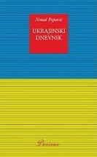
Author Popović, Nenad
Title Ukrajinski dnevnik
Impresum Zagreb : Durieux, 2024.
Description 215 str. ; 20 cm.
ISBN 9789531885744 : EUR 17.70 US$ 20.30
UDC 355.4(470:477)
Anotation In 2023, Ukrajinski dnevnik was awarded the literary prize Fantôm slobode, awarded by the literary, cultural and political portals Le Fantôme de la liberté (Paris), Forum.tm (Zagreb), Radio Gornji grad (Zagreb), the magazine Europski glasnik (Zagreb), as well as the Ukrainian monthly La Parole ukrainienne/Ukaіns'ke slovo/Ukrainsko slovo (Paris), which has been published in France since 1933.

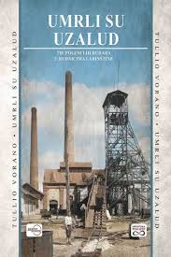
Author Vorano, Tullio
Title Umrli su uzalud : 718 poginulih rudara u rudnicima Labinštine
Impresum Zagreb : Despot Infinitus, 2024.
Description 337 str. : ilustr., zemljop. crteži ; 28 cm.
ISBN 9789533661872 : EUR 34.00 US$ 38.90
UDC 622.86(497.571-37Labin) * 622(497.571)(091)
Anotation It is estimated that during the continuous operation of the mines in Labinština, from 1785 to 1999, a total of about 40,000,000 tons of coal were produced, with at least 718 miners killed. A huge price was paid for the production achieved because the value of human life is immeasurable.

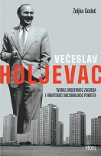
Author Godeč, Željka
Title Većeslav Holjevac : tvorac modernog Zagreba i hrvatskog nacionalnog pokreta
Impresum Zagreb : Profil knjiga, 2024.
Description 430 str. : ilustr. ; 23 cm.
ISBN 9789533861449 : EUR 27.80 US$ 31.80
Subject Holjevac, Većeslav. Političari -- Hrvatska -- 20. st. -- Biografije
UDC 32Holjevac, V.

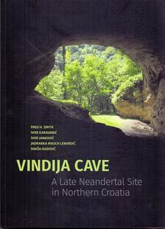
Title Vindija Cave : a late neandertal site in northern Croatia
/ Ivor Karavanić... [et al.]
Impresum Zagreb : Faculty of Humanities and Social Sciences, 2024.
Description 167 str. : ilustr. ; 28 cm.
Note Bibliografija.
ISBN 9789533791890 : EUR 21.30 US$ 24.40
Subject Kameno oruđe -- Vindija (špilja) – Prapovijest. Arheološka nalazišta -- Varaždin (okolica).
Neandertalac -- Istraživanje -- Varaždin (okolica). Arheozoologija -- Varaždin (okolica). Vindija (špilja)
UDC 903:572(497.523-37Varaždin)"632" * 903.21(497.523-37Varaždin)"632" * 56:591(497.523-37Varaždin)"632"

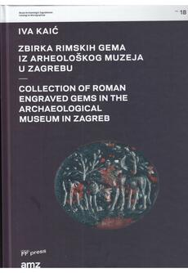
Author Kaić, Iva
Title Zbirka rimskih gema iz Arheoloskog muzeja u Zagrebu = Collection of roman engraved gems in the Archaeological museum in Zagreb
Impresum Zagreb : Arheološki muzej u Zagrebu : FF press [i. e.] Filozofski fakultet : Arheološki zavod Odsjeka za arheologiju, 2024.
Description 327 str. : 31 cm.
Language/s Tekst usporedo na hrv. i na engl. jeziku.
ISBN 9789531757997 : EUR 95.70 US$ 109.60
Subject Arheološki muzej (Zagreb). Zbirka rimskih gema – Katalozi. Geme -- Hrvatska -- Katalog
UDC 069.5:736(37) * 736.2(37)

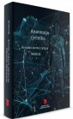
Linguistics. Philology

Title Anatomija rječnika : Hrvatski mrežni rječnik – Mrežnik
/ urednici Lana Hudeček, Milica Mihaljević, Željko Jozi.
Impresum Zagreb : Institut za hrvatski jezik i jezikoslovlje, 2024.
Description 656 str. ; 23 cm.
ISBN 9789538390128 : EUR 29.80 US$ 34.10
Subject Hrvatski mrežni rječnik Mrežnik. Hrvatski jezik – Leksikografija. Elektronički rječnici
UDC 811.163.42’374

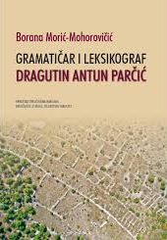
Author Morić-Mohorovičić, Borana
Title Gramatičar i leksikograf Dragutin Antun Parčić
Impresum Zagreb : Hrvatska sveučilišna naklada ; Rijeka : Sveučilište u Rijeci, Filozofski fakultet., 2024.
Description 181 str. ; 24 cm.
ISBN 9789531695510 : EUR 20,20 US$ 23.10
Subject Parčić, Dragutin Antun. Grammatica della lingua slava (Illirica). Hrvatski jezik -- Gramatika -- 19. st.
Hrvatski jezik -- Leksikografija -- Povijest
UDC 811.163.42Parčić, A. D. * 811.163.42’36(091)

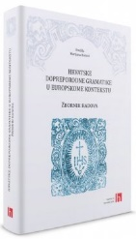
Title Hrvatske dopreporodne gramatike u europskome kontekstu : zbornik radova
/ urednica Marijana Horvat
Impresum Zagreb : Institut za hrvatski jezik i jezikoslovlje, 2024.
Description 436 str. ; 25 cm.
ISBN 9789538390289 : EUR 27.70 US$ 31.70
Subject Hrvatski jezik -- Gramatika -- Povijest -- Zbornici s konferencija.
UDC 811.163.42’36(091)

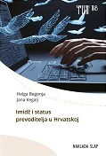
Author Begonja, Helga
Title Imidž i status prevoditelja u Hrvatskoj
Impresum Jastrebarsko : Naklada Slap, 2024.
Description 224 str. : graf. prikazi ; 25 cm.
ISBN 9789531919982 : EUR 36.70 US$ 42.00
UDC 81’25(497.5)
Anotation ...This monograph has a special place in the present moment, in which there is often a false impression of the disappearance of the translation profession in the future due to the emergence of artificial intelligence and the rise of digital translation tools. This aspect is proven by empirical research conducted using a mixed method of collecting quantitative and qualitative data on the population of translators in the Republic of Croatia. The results of this research contribute to guidelines towards a stronger professionalization of the translation profession, which is changing its direction from an "ordinary" translator to a mediator and interpretive communicator.

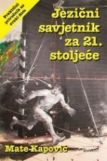
Author Kapović, Mate
Title Jezični savjetnik za 21. stoljeće : Praktični priručnik za svaki dom
Impresum Zagreb : Sandorf, 2024
Description 220 str. ; 24 cm.
ISBN 9789533515014 : EUR 17.00 US$ 19.50
UDC 811.163.42’271
Anotation This book gives you answers to these and similar popular questions about the language in a modern and scientifically based way, with numerous examples, a description of the real language in Croatia and references to local pop culture.

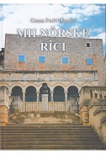
Author Ferić-Depolo, Grana
Title Milnôrske rîci : (da hi se ne zõbi)
Impresum Split : Naklada Bošković, 2022.
Description 225 str. : ilustr. u bojama, note ; 21 cm.
ISBN 9789532637083 : EUR 22.70 US$ 26.00
Subject Čakavsko narječje -- Milna (Brač) -- Rječnici
UDC 811.163.42’282.2(497.583Milna)(038)
Anotation


Author Crnić Novosel, Mirjana
Title Mirakuli Slavne Deve Marije (Senj, 1508.) : latinička transliteracija sa studijom i popratnim tekstovima
/ priredile Mirjana Crnić Novosel, Ivana Eterović.
Impresum Zagreb : Institut za hrvatski jezik i jezikoslovlje, 2024.
Description 97 str., [159] str. ; 25 cm.
ISBN 9789538390142 : EUR 16.00 US$ 18.30
UDC 27-312 * 811.163.42’01 * 003.349.1(497.5)
Anotation

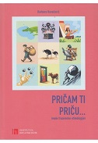
Author Kovačević, Barbara
Title Pričam ti priču... : (male frazemske etimologije) / Barbara Kovačević.
Impresum Zagreb : Institut za hrvatski jezik, 2024.
Description 260 str. ; 25 cm.
ISBN 9789538390180 : EUR 16.00 US$ 18.30
UDC 811.163.42’373.7 * 811.163.42’373.6
Anotation These are texts dealing with phraseological etymology, i.e. the origin and motivation of Croatian idioms. In them, on the one hand, the origin of a group of idioms whose components can be semantically grouped (e.g. animalistic, somatic, phytonymic, sports) is considered, and sometimes, on the other hand, the common source of individual idioms is taken as a criterion (e.g. idioms that derive their origin from fables, from the Bible or from mythology).

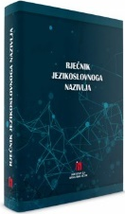
Title Rječnik jezikoslovnoga nazivlja
/ [urednice Milica Mihaljević, Lana Hudeček].
Impresum Zagreb : Institut za hrvatski jezik i jezikoslovlje, 2024.
Description 632 str. ; 25 cm.
ISBN 9789538390111 : EUR 29.80 US$ 34.10
Subject Lingvistika -- Rječnici
UDC 81(038)=163.42

Author Begonja, Helga
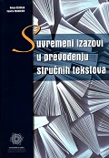
Title Suvremeni izazovi u prevođenju stručnih tekstova
Impresum Zadar : Sveučilište u Zadru, 2024.
Description 207 str. : graf. prikazi ; 24 cm.
ISBN 9789533314754 : EUR 23.30 US$ 26.70
UDC 81’25
Anotation The collection of works contains eight contributions dedicated to the translation activity and the application of translation models and procedures in professional translation and that specialty in that area, in the contemporary context. The publication contributes to the presentation of contemporary challenges in professional translation texts in Croatian translational practice, and presents papers in which translation of professional texts researches in different areas of human activities and in contrasting the Croatian language with English, German, Italian and Russian

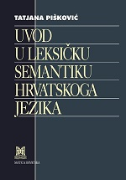
Author Pišković, Tatjana
Title Uvod u leksičku semantiku hrvatskoga jezika
Impresum Zagreb : Matica hrvatska, 2024.
Description 615 str. ; 25 cm.
ISBN 9789533412580 : EUR 58.00 US$ 66.40
Subject Hrvatski jezik – Semantika. Semantika
UDC 811.163.42’37 * 81’37

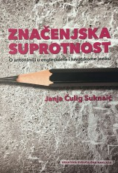

Author Čulig Suknaić, Janja
Title Značenjska suprotnost : o antonimiji u engleskome i hrvatskome jeziku
Impresum Zagreb : Hrvatska sveučilišna naklada, 2024.
Description 293 str. ; 24 cm.
Note Bibliografija: str. 270-275; bibliografske bilješke. Summary.
ISBN 9789531695435 : EUR 26.60 US$ 30.40
UDC 811.111’373.42 * 811.163.42’373.42 * 81’373.42

Literature. History. Theory
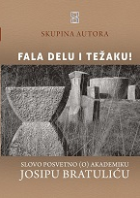
Title "Fala delu i težaku" : slovo posvetno (o) akademiku Josipu Bratuliću
/ knjigu uredio Boris Domagoj Biletić
Impresum Pula : Istarski ogranak Društva Hrvatskih književnika ; Žminj : Čakavski sabor, 2024
Description 262 str. : ilustr. ; 24 cm
Napomene Paralelni istovjetni Title na glagoljici. - Najkraće o autorima tekstova: str. 255-258. - Bibliografske bilješke uz tekst. -
ISBN 9789532783353 : EUR 34.90 US$ 40.00
Subject Bratulić, Josip – Zbornik. Hrvatska književnost. Hrvatski jezik -- Zbornici
UDC: 821.163.42Bratulić J.(082) * 821.163.42(091)Bratulić J.(082) * 811.163.42-05 Bratulić, J.(082)

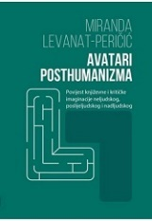
Author Levanat-Peričić, Miranda
Title Avatari posthumanizma : povijest književne i kritičke imaginacije neljudskog, poslijeljudskog i nad ljudskog
Impresum Zadar : Sveučilište ; Zagreb : FF press, 2024.
Description 355 str. ; 24 cm.
ISBN 9789533314891 : EUR 21.30 US$ 24.40
Subject Hrvatska književnost -- Povijest i kritika. Književnost -- Povijest i kritika. Transhumanizam u književnosti
Čudovišta u književnosti. Distopija u književnosti. Utopija u književnosti. Apokalipsa u književnosti
UDC 821.163.42.09 * 82.09 * 82.0 * 1:572

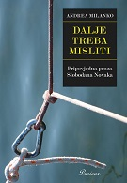
Author Milanko, Andrea
Title Dalje treba misliti : pripovjedna proza Slobodana Novaka
Impresum Zagreb : Durieux, 2024.
Description 173 str. ; 20 cm.
Note Bibliografija: str. 153-161; bibliografske bilješke uz tekst. Imensko kazalo.
ISBN 9789531885621 : EUR 17.90 US$ 20.50
Subject Novak, Slobodan, književnik – Proza. Novak, Slobodan, književnik – Romani. Pripovijedanje (književna teorija)
UDC 821.163.42.09Novak, S. * 82.0-3

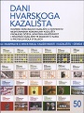
Title Dani Hvarskoga kazališta – knjiga 50 : Hvarsko komunalno kazalište u kontekstu mediteranskih komunalnih kazališta ; Promjene očišta: Hrvatska književnost i hrvatsko kazalište te znanost o njima u proteklih pola stoljeća
Impresum Zagreb : Hrvatska akademija znanosti i umjetnosti ; Split : Književni krug, 2024.
Description 547 str. ; 20 cm
Napomene Bibliografija. - Summaries.
ISBN 9789531635516 : EUR 10.60 US$ 12.10
UDC 821.163.42.09-2(082) * 792.2(497.5)(082)

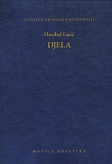
Author Lucić, Hanibal
Title Djela
/ priredio Ivan Lupić ; talijanske tekstove preveo Borna Treska ; [tumač imena i izraza i Rječnik Nataša Debogović i Ivan Lupić].
Impresum Zagreb : Matica hrvatska, 2023.
Description 311 str. : ilustr. ; 20 cm.
Nakl. cjelina Stoljeća hrvatske književnosti ; knj. 155
Note Rječnik: str. 286-311. Imensko i pojmovno kazalo.
ISBN 9789531503594 : EUR 32.40 US$ 37.10
Dijalektalno pjesništvo. Epistolarno pjesništvo. Dramska književnost
UDC 821.163.42-82(081) * 821.163.42-1’282 * 821.163.42-2

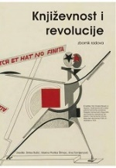
Title Književnost i revolucije : zbornik radova
/ uredile Zrinka Božić, Marina Protrka Štimec i Ana Tomljenović.
Impresum Zagreb : FF press [i. e.] Filozofski fakultet, Odsjek za kroatistiku, Odsjek za komparativnu književnost, 2024.
Description 456 str. ; 21 cm.
Language/s Tekst na hrv., na srp. i na engl. jeziku.
ISBN 9789533790916 : EUR 21.30 US$ 24.40
Subject Revolucije u književnosti
UDC 82.09

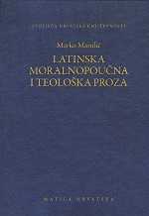
Author Marulić, Marko
Title Latinska moralnopoučna i teološka proza
/ Marko Marulić ; priredio Bratislav Lučin ; [tumač imena i izraza i rječnik Dražana Radman].
Impresum Zagreb : Matica hrvatska, 2024.
Description 415 str. : ilustr. ; 20 cm.
Language/s Tekst na hrv. i na lat. jeziku.
ISBN 9789531503617 : EUR 34.90 US$ 37.10
UDC 821.163.42-97 *-821.124(497.5)-97=124=163.42

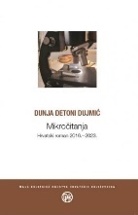
Author Detoni-Dujmić, Dunja
Title Mikročitanja : hrvatski roman 2016. - 2023.
Impresum Zagreb : Društvo hrvatskih književnika, 2024.
Description 330 str. ; 18 cm.
ISBN 9789532783988 : EUR 22.60 US$ 25.90
Subject Hrvatski roman -- 2010.-2020. Hrvatski roman -- 2020.-2025.
UDC 821.163.42.09-31 * 821.163.42-4

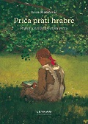

Author Matičević, Ivica
Title Priča prati hrabre : pogled u noviju hrvatsku prozu
Impresum Zagreb : Leykam international, 2024.
Description 232 str. : ; 22 cm.
ISBN 9789533401812 : EUR 26.70 US$ 30.60
Subject Hrvatska proza -- 2010.-2020.
UDC 821.163.42.09-3

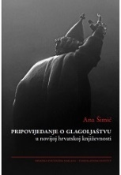
Author Šimić, Ana, lingvistkinja
Title Pripovijedanje o glagoljaštvu u novijoj hrvatskoj književnosti
Impresum Zagreb : Hrvatska sveučilišna naklada : Staroslavenski institut, 2024.
Description 307 str. ; 25 cm.
ISBN 9789531695398 : EUR 29.80 US$ 34.10
Subject Hrvatska književnost -- 20. st. Hrvatska književnost -- 21. st. Glagoljaštvo -- U književnosti
UDC 821.163.42.09 * 003.349.1(497.5)

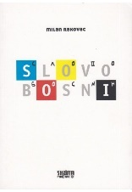
Autor Rakovac, Milan
Title Slovo Bosni
Impresum Opatija : ShuraPublikacije, 2023.
Description 135 str. ; 21 cm.
ISBN 9789538203503 : EUR 23.30 US$ 26.70
UDC 821.163.42(497.6)-82(082) * 821.163.4(497.6)-82(082)
Anotation Among Rakovčev's various manuscripts in the making, a book about Bosnia and Herzegovina stood out. The book is unfinished, but here it is revealed in its imperfection and incompleteness before us. It is at the same time an act of translation and introduction: an attempt to translate one's own experience of the people, space and history of Bosnia and Herzegovina, but also the experience of one's own reading of BiH literature into a universal cultural memory that could serve as an introduction to BiH for younger people and those who are yet to come. the multiverse.


Author: Znanstveni skup Vesna Parun, stijena koju ispiru kiše (2022 ; Split)
Title: Vesna Parun, stijena koju ispiru kiše : zbornik radova sa znanstvenog skupa održanog u Splitu 26. rujna 2022. / uredio Krešimir Bagić
Impresum: Split : Književni krug, 2024
Description: 216 str. ; 24 cm
ISBN 9789531635547 : EUR 19.10 US$ 21.90
UDC: 821.163.42Parun, V.(082)


Author Medić, Igor, profesor hrvatskog jezika
Title Zavedeni jezikom : Oscar Wilde i hrvatski književni modernisti
Impresum Zagreb : Durieux, 2024.
Description 289 str. ; 24 cm.
ISBN 9789531885546 : EUR 22.30 US$ 25.50
UDC 821.163.42.09 * 821.111.09Wilde, O. * 82.0
Anotation The book is an exhaustive, meticulous and comprehensive comparative and literary theoretical reading of both the problems, ideas and concepts of Wild's aestheticism, as well as Croatian literature that is related to it. The author did an exceptional philological and literary historical work, and a great contribution was made not only to the study of individual works of Croatian writers, but also to the study of Croatian literary modernism as a whole.


Author Lovrenčić, Sanja
Title Žrtvovanje čarolije u svijetu Ivane Brlić Mažuranić
Impresum Zagreb : Mala zvona, 2024.
Description 148 str. ; 21 cm.
ISBN 9789538313943 : EUR 20.20 US$ 23.10
UDC 821.163.42.09Brlić-Mažuranić, I. * 821.163.42-94
Anotation The essays collected in this book reveal the sources and meanders of Sanja Lovrenčić's long-term search for the authentic character of Ivana Brlić Mažuranić.

Literature. Poetry
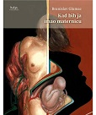
Author Glumac, Branislav
Title Kad bih ja imao maternicu
Impresum Zagreb : HDP [i. e.] Hrvatsko društvo pisaca, 2024.
Description 132 str. ; 20 cm.
Note Stihovi.
ISBN 9789538152566 : EUR 16.70 US$ 19.10
UDC 821.163.42-1

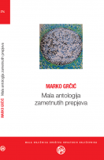
Title Mala antologija zametnutih prepjeva
/ [prepjevao i priredio] Marko Grčić.
Impresum Zagreb : Društvo hrvatskih književnika, 2024.
Description 277 str. ; 18 cm.
ISBN 9789532784008 : EUR 20.90 US$ 23.90
Subject Pjesništvo -- Zbirke tekstova. Pjesma u prozi -- Zbirke tekstova
UDC 821-1=00(082) * 821-16=00(082)
Anotation

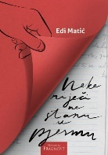
Author Matić, Edi
Title Neke riječi ne stanu u pjesmu
Impresum Split : Naklada Fragment, 2024.
Description 73 str. ; 21 cm.
Note Stihovi.
ISBN 9789538301377 : EUR 18.60 US$ 21.30
UDC 821.163.42-1

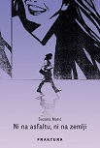
Author Matić, Suzana
Title Ni na asfaltu, ni na zemlji
Impresum Zaprešić : Fraktura, 2024.
Description 160 str. : ilustr. ; 22 cm.
Note Stihovi. Lirske pjesme
ISBN 9789533587592 : EUR 21.30 US$ 24.40
UDC 821.163.42-1

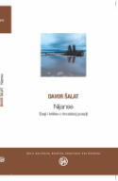
Author Šalat, Davor
Title Nijanse : eseji i kritike o hrvatskoj poeziji
Impresum Zagreb : Društvo hrvatskih književnika, 2024.
Description 332 str. ; 18 cm.
ISBN 9789532783858 : EUR 22.10 US$ 25.30
Subject Hrvatsko pjesništvo -- 2000.-2010. Hrvatsko pjesništvo -- 2010.-2020. Hrvatsko pjesništvo -- Prikazi knjiga
UDC 821.163.42.09-1 * 821.163.42-4

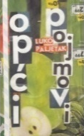
Author Paljetak, Luko
Title Opći pojmovi : pjesme
/ Luko Paljetak ; [pogovor Miljenko Jergović].
Impresum Split : Naklada Bošković, 2023.
Description 98 str. ; 21 cm.
ISBN 9789532637465 : EUR 16.90 US$ 19.30
UDC 821.163.42-1

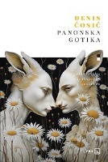
Author Ćosić, Denis
Title Panonska gotika
Impresum Zagreb : V.B.Z., 2024.
Description 72 str. ; 21 cm.
Note Stihovi.
ISBN 9789535207290 : EUR 18.50 US$ 21.20
UDC 821.163.42-1

Literature. Novels, short stories. Essays.
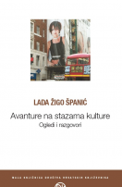
Author Žigo, Lada
Title Avanture na stazama kulture : ogledi i razgovori
Impresum Zagreb : Društvo hrvatskih književnika, 2024.
Description 302 str. ; 18 cm.
ISBN 9789532784046 : EUR 20.90 US$ 23.90
Subject Hrvatski književnici -- Intervjui
UDC 821.163.42-4 * 821.163.42

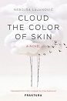
Author Lujanović, Nebojša
Title Cloud the color of skin : a novel
/ Nebojša Lujanović ; translated from the Croatian by Ena Selimović.
Impresum Zaprešić : Fraktura, 2024.
Description 381 str. ; 21 cm.
Note Prijevod djela: Oblak boje kože.
ISBN 9789533587240 : EUR 26.60 US$ 30.50
Anotation Weaving between Zagreb and Bosnia, between past and present, between a Roma ghetto in the heart of Zagreb and the lesser-known ghettos of the Roma Holocaust (or Porajmos), and between an imagined better life and the blaring trumpets of war in reality, Nebojša Lujanović’s Cloud the Color of Skin tells a story of guilt and justice, victimhood and violence, peacetime and war—and the Roma in the midst of it all.

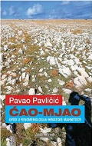
Author Pavličić, Pavao
Title Ćao-mjao : uvod u fenomenologiju hrvatske mahnitosti
Impresum Zagreb : Umjetnička organizacija Lađa od vode, 2024.
Description 167 str. ; 20 cm.
ISBN 9789535071952 : EUR 18.60 US$ 21.30
UDC 821.163.42-4
Anotation The book Ćao-mjao belongs not only among the sharpest critically, but also among Pavličić's most important essay books in general. At the same time, it undoubtedly belongs to the top of the new millennium Croatian critical essay writing in general, not only because of the topic it opens up, but also because of the specific style in which it was written. Namely, books like this rarely appear: it is extremely critical but also decent, sharp and benevolent, comprehensive and concrete, multi-layered and readable. Such books can only be written by writers and minds of the highest caliber, but also on the condition that they want good for their culture and homeland.

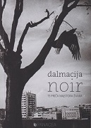
Title Dalmacija noir : [15 priča majstora žanra]
/ [izabrala Iva Pejković ; fotografije Aleksandar Bonačić ... et al.].
Impresum Zadar : Panacea, 2023.
Description 199 str. : ilustr. ; 21 cm.
ISBN 9789534800126 : EUR 20.90 US$ 23.90
Anotation Dalmatia is not only the blue of the sky and the sea, the glare of the sun and the beaches, the hedonism of food and wine with the intoxicating scents of the Mediterranean and the sound of crickets and seagulls. Dalmatia also has its dark side, its noir, which fifteen writers used in this collection to write their stories in a genre that also brings to light the Dalmatian black chronicle.
They will take us to dark portuns, cemeteries, unlit shacks, burning olive groves and all kinds of scenes of possible tragic epilogues; will introduce us to self-destructive, lost, terrified individuals, executioners and victims, atypical inspectors and typical Dalmatians caught in a world of lies, fraud, crime, anxiety and unfortunate circumstances.

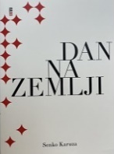
Author Karuza, Senko
Title Dan na Zemlji
Impresum Zagreb : Meandar media, 2024.
Description 127 str. ; 20 cm.
ISBN 9789533343440 : EUR 21.30 US$ 24.40
Anotation A collection of short stories presented at the Festival of European Short Stories in Zadar. This is a book about our inner enemies. This book is very important to me, says Karuza about his new collection, which, after his "Guide to the Island", comes as a kind of guide to Zagreb, the city where the author spent his student days.

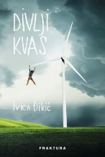
Author Đikić, Ivica
Title Divlji kvas
Impresum Zagreb : Fraktura, 2024.
Description 175 str. ; 21 cm.
ISBN 9789533587363 : EUR 21.30 US$ 24.40
Anotation Ivica Đikić in Divlji kvas masterfully, with a lot of humor and bitterness, revives the atmosphere of a provincial town where everyone knows everyone, and where the past and the present cannot be separated. This novel is a gallery of the characters of our lives: just like in reality, there are no right and wrong, everyone has the burden of their own and general history such that they cannot get rid of it and start new lives, but must wait for the wind to blow that will move them in this or that direction.

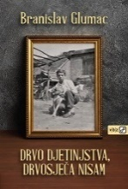
Author Glumac, Branislav
Title Drvo djetinjstva, drvosječa nisam : (1938. - 1952.)
Impresum Zagreb : V.B.Z., 2024.
Description 156 str. : ilustr. ; 21 cm.
ISBN 9789535206842 : EUR 23.10 US$ 26.40
Anotation After Cjediljka za perfekt, Branislav Glumac added another autobiographical book to his large oeuvre of almost forty titles. And while in Cjediljka he writes about his life from 1957 to 2010, in the book Drvo djetinjstva, drvosječa nisam, the actor goes back even deeper into the past, into his childhood. Well, if in Krleža we read about childhood in Agram, here we are talking about childhood in Virovitica, which we follow from the first memories until the author's 14 years.

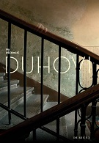
Author Ušćumlić, Iva
Title Duhovi : roman
Impresum Zagreb : Durieux, 2024.
Description 205 str. ; 20 cm.
ISBN 9789531885768 : EUR 17.90 US$ 20.50
Anotation The first novel of the favorite Croatian writer Iva Ušćumlić Duhovi, first published in 2013, shows a mature author who knows how to develop a plot and plastic, psychologically convincing characters whose traumas are transmitted from generation to generation without fail, more thoroughly than a multiplication table. The ghosts of Iva Ušćumlić will lead you to live the lives recorded on these pages and to ask yourself if some hidden things can be avoided and how.

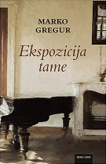
Author Gregur, Marko
Title Ekspozicija tame : roman
Impresum Zagreb : Hena com, 2024.
Description 239 str. ; 22 cm.
ISBN 9789532594775 : EUR 21.20 US$ 24.30
Anotation Narrated from the perspective of a blind man, who is at the same time its focal point, the novel Ekspozicija tame (Exposure of Darkness) takes place in the imaginary Podravina village of Viru, where the rich merchant family of Aviro ended up as a result of migration. Their house is the center of intellectual life, more elegant and civil than others, the breath of Vienna, so it is not surprising that a blind boy from a poor, illiterate family thinned out and damaged by the Great War wants and longs to be like them, one of them, all his life.

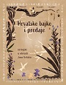
Title Hrvatske bajke i predaje : 55 bajki u obradi Joze Vrkića
/ [pripremila Nada Vrkić ; ilustracije Iris Jambrek].
Impresum Zagreb : Srednja Europa, 2024.
Description 227 str. : ilustr. u bojama ; 27 cm.
Note Leksikon mitskih bića: str. 163-198. Rječnik manje poznatih riječi: 199-224; i uz tekst.
ISBN 9789533870151 : EUR 31.90 US$ 36.50
UDC 821.163.42-93-34:39 * 398.21(=163.42)

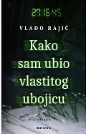
Author Rajić, Vlado
Title Kako sam ubio vlastitog ubojicu
Impresum Zagreb : Beletra, 2024.
Description 359 str. ; 21 cm.
Note Str. [357]-359: Uz roman Kako sam ubio vlastitog ubojicu ili kako ubija Vlado Rajić / Božica Brkan.
ISBN 9789538209765 : EUR 20.20 US$ 23.10
Anotation The thriller "How I Killed My Murderer" is a challenge in which author combines his legal profession and his profession as a journalist. In preparation for writing a novel about organ smuggling, he conducted thorough research so that all autopsy protocols, anatomical details, and descriptions of the halls of the pathology department are authentic. In the novel, Rajić proves himself as a writing craftsman who is not afraid of literary challenges. He expresses with ease and in the novel he achieves an atmosphere of uncertainty and fear that keeps the reader's attention from beginning to end.


Author Vujčić, Borna
Title Kao da nema sutra : roman
Impresum Zagreb : V. B. Z., 2024.
Description 252 str. ; 23 cm.
ISBN 9789535207245 : EUR 20.80 US$ 23.80
Anotation In the novel Kao da nema sutra (As if there is no tomorrow), we are led by the members of the unusual Fleminov family, each from their own, seemingly incompatible, perspective. The eldest son, a humanitarian, is benevolent to his own detriment, the father is driven by nostalgia for military service while a new conflict is on the horizon, the mother as a nurse is directly exposed to the apocalypse, the younger son just wants to find a new place to camp and roll another joint, and an eighteen-year-old daughter in the vortex of mental illness hopes for a better tomorrow. Like, in the end, all of us. But what if tomorrow doesn't come?

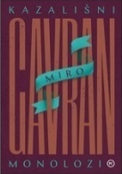
Author Gavran, Miro
Title Kazališni monolozi : (osamdeset kazališnih monologa)
Impresum Zagreb : Mozaik knjiga, 2024.
Description 289 str. ; 24 cm.
ISBN 9789531437196 : EUR 24.60 US$ 28.20
Anotation In this unusual book, the author collected eighty monologues from his theatrical texts created in the past four decades. Reading monologues similar to short stories, you will go through the rich comedic and dramatic oeuvre in the theater of the most performed Croatian writer, whose works have been staged on all continents, and his plays have been seen by more than four million viewers.

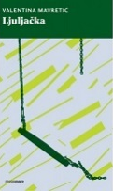
Author Mavretić, Valentina
Title Ljuljačka
Impresum Zagreb : Naklada OceanMore, 2024.
Description 133 str. ; 21 cm.
ISBN 9789533321837 : EUR 17.90 US$ 20.50
Anotation How millennials view the world and navigate it is revealed in this collection of stories by Valentina Mavretić. In personal experiences and events, the social environment and the present day, family relationships are discussed honestly and subtly, and the time before the nineties is cautiously explored.

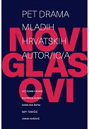
Title Novi glasovi : pet drama mladih hrvatskih autor/ic/a
/ Vid Adam Hribar ... [et al.] ; [urednica Željka Turčinović].
Impresum Zagreb : Hrvatski centar ITI, 2024.
Description 317 str. ; 20 cm.
Note Ostali zastupljeni autori: Beatrica Kurbel, Nikolina Rafaj, Espi Tomičić, Ivana Vuković.
ISBN 9789536343935 : EUR 23.80 US$ 27.20
UDC 821.163.42-2(082)

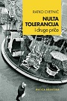
Author Cvetnić, Ratko
Title Nulta tolerancija i druge priče
Impresum Zagreb : Matica hrvatska, 2024.
Description 134 str. ; 21 cm.
ISBN 9789533412740 : EUR 23.30 US$ 26.70
Anotation In sixteen stories, Cvetnić brings to life a vivid gallery of characters: yuppies, businessmen, lawyers, journalists, politicians, but also "little people": sexually frustrated pensioners, disillusioned communist dissidents and lonely high school professors, who, taken together, give a layered picture of Croatian society and its protagonist.

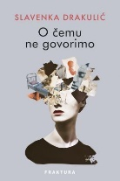
Author Drakulić, Slavenka
Title O čemu ne govorimo
Impresum Zaprešić : Fraktura, 2024.
Description 168 str. ; 21 cm.
ISBN 9789533587516 : EUR 21.30 US$ 24.40
Anotation Slavenka Drakulić tells about marital relationships that disintegrate over time and turn into petty reproaches and permanent ill will, about newly discovered passion in mature years, about our imprisonment in the body, about the fact that all our thoughts, all our creativity, all our aspirations and desires, all our psychophysical progress depends on the very thin skin that holds our body together. The stories O čemu ne govorimo (We Don't Talk About) will shake you to the core, take you on an emotional merry-go-round and make you ask yourself difficult questions - even the most difficult one, your own duration in time.

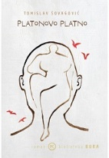
Author Šovagović, Tomislav
Title Platonovo platno : [roman]
Impresum Zagreb : Mozaik knjiga, 2024.
Description 124 str. ; 21 cm.
ISBN 9789531437608 : EUR 21.30 US$ 24.40
Anotation Tomislav Šovagović wrote a great novel in one single sentence! That furious sentence full of love, jealousy, passion and depression is a broken haiku miniatures, and already after the first few pages the reader will find himself thinking and breathing in the rhythm set by the writer and with pleasure surrender to his masterful leadership.

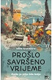
Author Ivanišević, Ivica
Title Prošlo savršeno vrijeme : zašto je prije bilo bolje
Impresum Zagreb : Media bar, 2024.
Description 258 str. ; 21 cm.
ISBN 9789538357213 : EUR 23.30 US$ 26.70
Anotation his short, deadly accurate, witty and slightly nostalgic notes, Ivica Ivanišević reminds us of what even escapes our memory today. Because technology has brought us many good things, but it has also taken something away from us - the art of joy, for example.


Author Jurak, Dragan
Title Sveto pismo
Impresum Zagreb : V. B. Z., 2024.
Description 216 str. : ilustr. ; 20 cm.
ISBN 9789535207443 : EUR 23.10 US$ 26.40
Anotation The novel-essay with the intriguing title Sveto pismo (Holy Scripture) begins precisely with the letter: with the discovery of ancient clay tablets that need to be deciphered, and thus open the door to a lost world, which slowly intertwines and permeates our own. The two streams, fictional and essayistic, flow comparatively and mathematically balanced, similar to a DNA double helix, but, as usual in Dragan Jurak's books, it is often difficult to tell them apart.

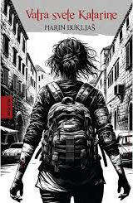
Author Bukljaš, Marin
Title Vatra svete Katarine : roman
Impresum Zagreb : Hena com, 2024.
Description 295 str. ; 22 cm.
ISBN 9789532594799 : EUR 22.20 US$ 25.40
Anotation Vatra svete Katarine is a novel of high tension, full of betrayals, adventures, defeats and sex as external manifestations of what Marin Bukljaš actually writes about - an intimate search for oneself, which is always a ride on a long, unpredictable, dangerous road.


Author Kozina, Luca
Title Vidjet ćeš kad odrasteš
Impresum Zaprešić : Fraktura, 2024.
Description 163 str. ; 21 cm.
ISBN 9789533587264 : EUR 21.30 US$ 24.40
Anotation With the collection of stories Vidjet ćeš kad odrasteš (You'll see when you grow up), Luca Kozina confronts us, narrating from a child's perspective, with the violent and hypocritical society we live in, which closes its eyes to the problems of children and young people, even though there is constant talk about caring for them. Aware that in almost every childhood there is a hidden little hell to which the environment closes its eyes, Luca Kozina unpretentiously and convincingly exposes that hell, giving an authentic portrayal of children's helplessness, fear, but also hope.

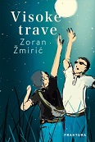
Author Žmirić, Zoran
Title Visoke trave
Impresum Zagreb : Fraktura, 2024.
Description 466 str. ; 23 cm.
ISBN 9789533587325 : EUR 26.60 US$ 30.50
Anotation Visoke trave (The tall grasses) by Zoran Žmirić are an ode to friendships that should last forever, a book about a generation whose dreams were forcibly stolen, but which never stopped saving them, so even today they live in the collective memory in some places, on some new basketball courts where new kids start their novels that life will write for them.

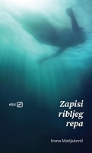
Author Matijašević, Irena, književnica
Title Zapisi ribljeg repa
Impresum Zagreb : V.B.Z., 2024.
Description 132 str. ; 23 cm.
ISBN 9789535207320 : EUR 20.80 US$ 23.80
Anotation In her new book of prose writings, Irena Matijašević combines love speech and a kind of introspective fairy tale. As soon as he convinces us that we are witnessing the breakdown of a love relationship anchored in realistic storytelling, we suddenly fall, with Alice, monks and other enigmatic characters, into an inverted world of lyrical fantasy. From fragments of love speech, essay and commentary inserts, metatextual discourses about what a character, author, narration is, a complete narrative is woven about being in the world and time, about freedom, about love, about beauty, about aging, about meaning, about creation. .

Arts. General

Author Golub, Marko, likovni kritičar

Title ĐKĆ X : deset događaja = the ten events : [HDD galerija, Zagreb, 26.4. - 15.5.2024.]
/ [tekst] Marko Golub : [urednici Zoran Đukić i Marko Golub].
Impresum Zagreb : Hrvatsko dizajnersko društvo, 2024.
Description 112 str. : ilustr. (pretežno u bojama) ; 20 cm.
Note Katalog izložbe.
Language/s Tekst na hrv. i na engl. jeziku.
ISBN 9789538507076 : EUR 8.00 US$ 9.00
Subject Đukić, Zoran, grafički dizajner -- Katalozi izložbi. Studio đkć (Zagreb) – Katalozi. Hrvatski dizajn -- 21. st. -- Katalozi izložbi
UDC 7.05Studio đkć * 7.05Đukić, Z. * 7.05(497.5)

Author Franceschi, Branko
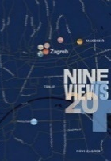
Title Dawor Preis, Nine Views 20+
/ [tekstovi, essays Branko Franceschi, Vanja Babić, Željko Marciuš ; fotografije, photographs Alan Čaplar, Dawor Preis ; prijevod na engleski, translation into English Graham McMaster, Robertina Tomić].
Impresum Zagreb : Nacionalni muzej moderne umjetnosti = National Museum of Modern Art, 2024.
Description 100 str. : ilustr. ; 24 cm.
ISBN 9789533481685 : EUR 43.30 US$ 49.60
Subject Preis, Davor. Devet pogleda
Kožarić, Ivan. Prizemljeno Sunce. Instalacije (umjetnost) -- Hrvatska
UDC 7.038.5Preis, D. * 7.038.5Kožarić, I. * 7.038.55(497.5)

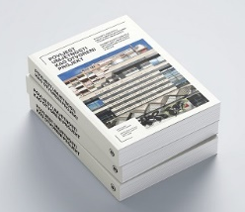
Title: Povijest umjetnosti kao otvoreni projekt : (koncepti, projekti i oblici tumačenja likovnih i vizualnih umjetnosti) : zbornik radova Odsjeka za povijest umjetnosti Filozofskog fakulteta u Splitu = Art history as an open project : (concept, projects, and ways of interpreting fine and visual arts) : proceedings of the department of art history of the faculty of humanities and social sciences in Split
/ urednik, editor Silva Kalčić ; [engl., prijevod i lektura, translation and proofreading Marina Schumann]
Impresum Split : Sveučilište u Splitu, Filozofski fakultet, 2024
Description 469 str. : ilustr. ; 24 cm
ISBN 9789533521077 : EUR 34.90 US$ 40.00
Napomene Tekst na hrv. i na engl. jeziku. - Bibliografija iza svakog rada. - Abstracts.
Subject Povijest umjetnosti -- Hrvatska -- Zbornici
UDC: 7.01(497.583)(062)

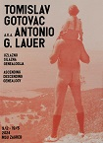
Author Gotovac, Tomislav
Title Tomislav Gotovac a.k.a. Antonio G. Lauer : uzlazno-silazna genealogija = Ascending descending genealogy : [Muzej suvremene umjetnosti, Zagreb., 9. 2. – 19. 5. 2024. = Museum of contemporary art, Zagreb, 9th Febvruary - 19th May 2024] / [tekst, text Pierre Bal-Blanc ... [et al.] ; urednica, editor Vesna Meštrić].
Impresum Zagreb : Muzej suvremene umjetnosti, 2024.
Description 84 str. : ilustr. u bojama ; 29 cm.
Note Katalog izložbe.
Language/s Tekst usporedo na hrv. i na engl. jeziku.
ISBN 9789533700335 : EUR 41.70 US$ 47.70
UDC 7.038.5Gotovac, T.

Urbanism. Architecture
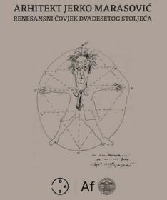
Title Arhitekt Jerko Marasović : renesansni čovjek dvadesetog stoljeća
/ [uredništvo Ivan Bošković... et al.].
Impresum Split : Društvo arhitekata Splita ; Zagreb : Arhitektonski fakultet Sveučilišta u Zagrebu, 2024.
Description 417 str. : ilustr. ; 24 cm.
ISBN 9789535743156 : EUR 76,90 US$ 86,10
Subject Marasović, Jerko. Marasović, Jerko – Suvremenici. Arhitekti -- Hrvatska -- Biografije
UDC ¸ 72Marasović, J.

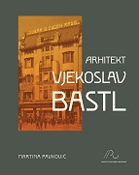
Author Pavković, Martina, povjesničarka umjetnosti
Title Arhitekt Vjekoslav Bastl
Impresum Zagreb : Institut za povijest umjetnosti, 2024.
Description 400 str. : ilustr. u bojama ; 24 cm.
Note Arhivski i dokumentacijski izvori: str. 366-367. Summary. Imensko kazalo.
ISBN 9789533730431 : EUR 53.60 US$ 61.40
Subject Bastl, Vjekoslav. Secesijska arhitektura – Zagreb. Neoklasicizam (arhitektura) – Hrvatska. Moderna arhitektura -- Hrvatska
Zagreb -- Zgrade i građevine -- 20. st.
UDC 72Bastl, V. * 72.035.93(497.512.2)

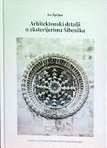
Author Šprljan, Ivo
Title Arhitektonski detalji u eksterijerima Šibenika
Impresum Šibenik : Društvo za očuvanje šibenske baštine Juraj Dalmatinac, 2023.
Description 302 str. : ilustr. (pretežno u bojama) ; 30 cm.
ISBN 9789535022909 : EUR 41.70 US$ 47.70
Subject Arhitektonski elementi. Arhitektonske dekoracije i ornamenti -- Šibenik – Povijest. Hrvatska arhitektura -- Šibenik
Šibenik -- Zgrade i građevine -- Konzervacija i restauracija
UDC 72.04(497.581.2Šibenik)(091) * 72.025.3/.4(497.581.2Šibenik)

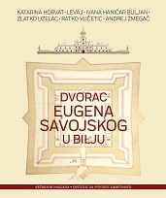
Title Dvorac Eugena Savojskog u Bilju
/ Ivana Haničar Buljan ... [et al.] ; [fotografije Paolo Mofardin].
Impresum Zagreb : ArTresor naklada : Institut za povijest umjetnosti, 2024.
Description 130 str. : ilustr. u bojama ; 30 cm.
ISBN 9789537875862 : EUR 42.90 US$ 49.10
Subject Dvorac Ars Eugenium (Bilje). Burgovi -- Baranja (Hrvatska). Burgovi -- Konzervacija i restauracija -- Hrvatska
Barokna arhitektura -- Baranja (Hrvatska)
UDC 725.1:623.1(497.543Bilje) * 72.034.7(497.543Bilje)
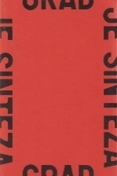

Author Šimpraga, Saša
Title Grad je sinteza : razgovori o Zagrebu
Impresum Zagreb : Udruga za promicanje vizualnih umjetnosti i kulturnu djelatnost Vizkultura, 2023.
Description 509 str. : ilustr. u bojama ; 23 cm.
ISBN 9789534837115 : EUR 58.30 US$ 66.70
UDC 711.4(497.521.2) * 711.417(497.521.2)
Anotation It is a book that gathers interviews that space analyst and publicist Saša Šimpraga conducted over a number of years with numerous experts in the field of urban planning in Zagreb: architects, urban planners, landscape architects, art historians, conservators and other colleagues relevant to (public) space and city planning.

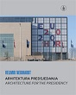
Title Velimir Neidhardt : arhitektura predsjedanja = Architecture for the presidency
/ urednica Borka Bobovec ; [prijevod Graham McMaster ; fotografije Damir Fabijanić].
Impresum Zagreb : Hrvatska akademija znanosti i umjetnosti, 2024.
Description 107 str. : ilustr., u bojama ; 31 cm.
Language/s Tekst usporedo na hrv. i na engl. jeziku.
ISBN 9789533475585 : EUR 29.80 US$ 34.10
Subject Neidhardt, Velimir. Nacionalna i sveučilišna knjižnica (Zagreb) -- Zgrade
Nacionalna i sveučilišna knjižnica (Zagreb). Kongresni centar – Zgrade. Zgrade knjižnica -- Zagreb
UDC 727:02(497.521.2) * 027.54(497.521.2)

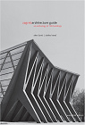
Author Karač, Zlatko
Title Zagreb Architecture Guide : an anthology of 100 buildings
Impresum Zagreb : UPI-2M plus : Arhitektonski fakultet Sveučilišta, 2024.
Description 317 str. : ilustr. (djelomice u boji) ; 24 cm.
Note Izv. stv. nasl.: Antologijski arhitektonski vodič Zagreba : 100 izabranih zgrada
ISBN 9789537703745 : EUR 26.60 US$ 30.50
UDC 72(497.521.2)(036)
Anotation The English edition of the guide, translated by Graham McMaster, represents the first overview of centuries of Zagreb’s architecture, presented by the most important buildings from the Middle Ages to the present day, now available for international readers. The anthology is edited by Zlatko Karac and Alen Zunic, guided by the idea of equal representation of architecture of all periods, starting from the early Romanesque cathedral of the late 11th century all the way to the Episcopal Conference building from 2011. With the concept of broad historical overview this guide offers a comprehensive image of the architecture of the city in addition to all the necessary information.

Drawings
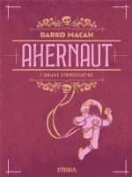
Author Macan, Darko, književnik
Title Ahernaut : i druge stripovijetke
Impresum Zagreb : Naklada Fibra, 2023.
Description 315 str. : ilustr. ; 25 cm.
Note Strip.
ISBN 9789533216881 : EUR 20.20 US$ 23.10
UDC 741.52(497.5)

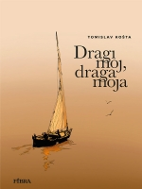
Author Košta, Tomislav, slikar
Title Dragi moj, draga moja
Impresum Zagreb : Naklada Fibra, 2024.
Description 55 str. : ilustr. ; 29 cm.
Note Strip. Obiteljski stripovi
ISBN 9789533218618 : EUR 11.90 US$ 13.60
UDC 741.52(497.5)


Title Godišnjak hrvatskog stripa 2022.
/ priredio Darko Macan.
Impresum Zagreb : Naklada Fibra, 2022.
Description 127 str. : ilustr. (pretežno u bojama) ; 29 cm.
Note Stripovi
ISBN 9789533216621 : EUR 19.70 US$ 22.60
UDC 741.52(497.5)

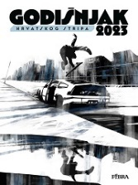
Title Godišnjak hrvatskog stripa 2023.
/ priredio Darko Macan.
Impresum Zagreb : Naklada Fibra, 2023.
Description 144 str. : ilustr. (pretežno u bojama) ; 29 cm.
Note Stripovi
ISBN 9789533217673 : EUR 23.80 US$ 27.30
UDC 741.52(497.5)

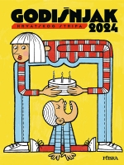
Title Godišnjak hrvatskog stripa 2024.
/ priredio Darko Macan.
Impresum Zagreb : Naklada Fibra, 2023.
Description 144 str. : ilustr. (pretežno u bojama) ; 29 cm.
Note Stripovi
ISBN 9789533217673 : EUR 26.20 US$ 30.00
UDC 741.52(497.5)

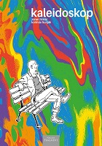
Author Žmirić, Zoran
Title Kaleidoskop
Impresum Split : Naklada Fragment, 2024.
Description 152 str. : ilustr. u bojama ; 21 cm.
Note Strip.
ISBN 9789538301391: EUR 24.50 US$ 28.00
UDC 741.52(497.5)

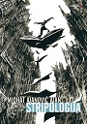
Author Ajanović, Midhat
Title Stripologija
Impresum Bizovac : Matica hrvatska, Ogranak, 2024.
Description 207 str. : ilustr. ; 24 cm.
Note Bibliografija iza svakog poglavlja.
ISBN 9789537746643 : EUR 17.40 US$ 19.90
UDC 741.52.01

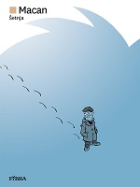
Author Macan, Darko, književnik
Title Šetnja
Impresum Zagreb : Naklada Fibra, 2024.
Description 53 str. : ilustr. u bojama ; 29 cm.
Note Strip.
ISBN 9789533218564 : EUR 14.30 US$ 16.40
UDC 741.52(497.5)

Paintings

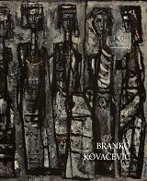
Author Kovačević, Branko, slikar
Title Branko Kovačević : (1911. - 1988.) : iz dubrovačkih zbirki = from Dubrovnik collections : Umjetnička galerija Dubrovnik = Museum of Modern Art Dubrovnik, 14. 12. 2023. - 24. 3. 2024. / [autorica teksta, text author Rozana Vojvoda [i] urednica, editor Rozana Vojvoda ; fotografije, photographs Miho Skvrce ... [et al.] ; prijevod, translation Graham McMaster].
Impresum Dubrovnik : Umjetnička galerija Dubrovnik = Museum of Modern Art Dubrovnik, 2023.
Description 131 str. : ilustr. u bojama ; 26 cm.
Note Katalog izložbe.
Language/s Tekst na hrv. i na engl. jeziku.
ISBN 9789538316296 : EUR 38.50 US$ 44.10
UDC 75Kovačević, B.

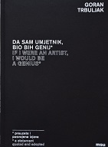
Author Trbuljak, Goran
Title Da sam umjetnik, bio bih genij = Muzej suvremene umjetnosti Zagreb, 2. srpnja – 8. rujna 2024.
/ [urednica Radmila Iva Janković ; tekstovi, texts Ivana Bago ... et al.].
Impresum Zagreb : Muzej suvremene umjetnosti ;, 2024.
Description 176 str. : ilustr. u bojama ; 24 cm.
Language/s Tekst usporedo na hrv. i na engl. jeziku.
ISBN 9789533700359 : EUR 61.70 US$ 70,60
UDC 75Trbuljak, G.

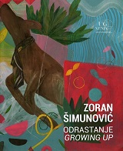
Author Šimunović, Zoran
Title Odrastanje = Growing up : Umjetnička galerija Dubrovnik = Museum of Modern Art Dubrovnik, 8. 11. - 10. 12. 2023.
/ [autor teksta u katalogu, author of text in catalogue Branko Franceschi ; urednik kataloga, catalogue editor Zoran Šimunović, Branko Franceschi].
Impresum Dubrovnik : Umjetnička galerija Dubrovnik = Museum of Modern Art Dubrovnik, 2023.
Description 51 str. : ilustr. u bojama ; 26 cm.
Language/s Tekst na hrv. i na engl. jeziku.
ISBN 9789538316289 : EUR 18.50 US$ 21.20
UDC 75Šimunović, Z.

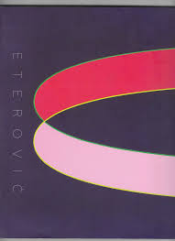
Author Eterović, Joško
Title Secundum minimum : Muzej moderne i suvremene umjetnosti = Museum of Modern and Contemporary Art, Rijeka, Nacionalni muzej moderne umjetnosti = National Museum of Modern Art, Zagreb, 26. 3. 2024. − 22. 5. 2024.
/ [tekst, essay Branko Franceschi ; uvodnik, introduction Branka Benčić ; urednici, editors Branko Franceschi, Diana Zrilić].
Impresum Zagreb : Nacionalni muzej moderne umjetnosti ; Rijeka : Muzej moderne i suvremene umjetnosti, 2024.
Description 104 str. : ilustr. u bojama ; 24 cm.
Language/s Tekst usporedo na hrv. i na engl. jeziku.
ISBN 9789538107474 : EUR 27.30 US$ 31,10
UDC 75Eterović, J.

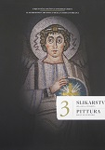
Author Matejčić, Ivan
Title Slikarstvo : od 4. do 15. stoljeća = Pittura : dal IV al XV secolo
/ Ivan Matejčić, Nikolina Maraković, Željko Bistrović ;
Impresum Pula = Pola : Pomorski i povijesni muzej Istre = Museo storico e navale dell'Istria [etc.], 2023
Description 392 str. : ilustr. u bojama ; 24 x 29 cm
Note Tekst na hrv. i tal. jeziku. - Bibliografija: str. 378-387. - Kazalo.
ISBN 9789537695224 : EUR 100.00 US$ 114.50
Subject Istra -- Slikarstvo -- 4.-15. st.
UDC 75(497.571)"04/14"

Photography
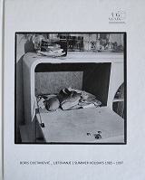
Author Cvjetanović, Boris
Title Društvo = Society
/ [tekst, text Leonida Kovač, Branka Slijepčević ; urednik, editor Boris Greiner].
Impresum Zagreb : Petikat, 2022.
Description 279 str. : ilustr. ; 27 cm.
Language/s Tekst usporedo na hrv. i na engl. jeziku.
ISBN 9789536946549 : EUR 42.50 US$ 48.70
UDC 77Cvjetanović, B.

Croatian music. History. Theory
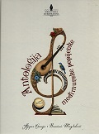
Author Hranjec, Stjepan
Title Antologija međimurske popijevke
/ [odabrali i priredili] Stjepan Hranjec, Branimir Magdalenić.
Impresum Čakovec : Ogranak Matice hrvatske u Čakovcu, 2024.
Description 556 str. : ilustr., sadrži i note ; 24 cm.
ISBN 9789538488092 : EUR 31.90 US$ 36.50
Subject Hrvatske popijevke – Međimurje. Pučko pjevanje -- Međimurje
UDC 784.4(497.524) * 821.163.42-1:39 * 398.8(497.524)

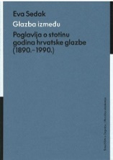
Author Sedak, Eva
Title Glazba između : Poglavlja o stotinu godina hrvatske glazbe : (1890.- 1990.)
/ Eva Sedak ; uredio, preveo i komentarom popratio Dalibor Davidović.
Impresum Zagreb : Muzička akademija, 2024.
Description 900 str. ; 25 cm.
ISBN 9789538252075 : EUR 100.00 US$ 114.50
Subject Sedak, Eva. Hrvatska glazba – Historiografija. Hrvatska glazba -- 19. st. Hrvatska glazba -- 20. st.
UDC 78(497.5) * 78.072Sedak, E.


Author Drach, Saša
Title Vladimir Kranjčević : do posljednjeg zbora: [život i djelo]
Impresum Zagreb : Sandorf, 2024.
Description 519 str. : ilustr. ; 23 cm.
Note Bibliografija: str. 497-500; bibliografske bilješke uz tekst. Imensko kazalo.
ISBN 9789533514079 : EUR 35.10 US$ 40.20
Subject Kranjčević, Vladimir – Biografije. Dirigenti -- Hrvatska – Biografije. Pijanisti – Hrvatska. Glazbeni pedagozi -- Hrvatska -- Biografije
UDC 78Kranjčević, V. * 78.06Kranjčević, V.

Theatar. Film. Dance

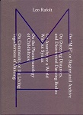
Author Rafolt, Leo
Title M /F
Impresum Zagreb : Oaza Book ; Pula : Castropola , 2023.
Description 266 str. : ilustr. u bojama ; 23 cm.
ISBN 9789538369193: EUR 41.70 US$ 47.70
UDC 7.038.5Ferlin, M. * 792.8Ferlin, M.
Anotation The book, that is, the professional publication On "M/F", or Staging an/d Archive is a collection of theoretically analytical texts by Leo Rafolt, which gathers the performance works of choreographer, director and performer Matija Ferlin, from the first solo Sad Sam in 2004, to recent interdisciplinary projects from 2023


Author Govedić, Nataša
Title Oscar Wilde izlazi iz zatvora : ili vaša omiljena umjetnost zove se kritika
Impresum Zagreb : Hrvatsko društvo kazališnih kritičara i teatrologa, 2022.
Description 573 str. ; 21 cm.
Bib./Saž./Kaz. Bibliografija: str. 534-549. Subjectno kazalo ; Imensko kazalo.
ISBN 9789535036609 : EUR 39.30 US$ 45.00
Subject Kritika. Kazališna kritika
UDC 792.01

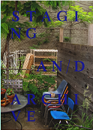
Title Staging an/d Archive
/ [authors and editorial board Matija Ferlin ... et al. ; illustration, photography Andi Bančić ... [et al.]].
Impresum Zagreb : Oaza Book ; Pula : Castropola, 2023.
Description [398] str. : ilustr. u bojama ; 23 cm.
ISBN 9789538369209 : EUR 59.50 US$ 68.10
UDC 7.038.5Ferlin, M. * 792.8Ferlin, M.
Antion A two-part edition that reflects the last twenty years of activity of the author, dance artist and choreographer Matija Ferlin


Author Banović, Snježana
Title Vila lutaka : prilozi za povijest hrvatskoga kazališta i kulture kroz sudbine trinaest i više zaboravljenih i zanemarenih scenskih umjetnica : (1855. – 1975.)
Impresum Zagreb : Hrvatski centar ITI, 2024.
Description 198 str. : ilustr. ; 20 cm.
ISBN 9789536343942 : EUR 23.80 US$ 27.20
Subject Glumice -- Hrvatska – Biografije. Plesačice -- Hrvatska – Biografije. Glazbenice -- Hrvatska -- Biografije
UDC 792-051(497.5) * 791.63-051(497.5) * 78-051(497.5)

