Introducing New Books from Croatia 5/2023  ZEBRA komunikacije d.o.o., Dubašnička 12,  10000 Zagreb – Croatia  www.zebrakom,  info@zebrakom.hr,  tel./fax 385 1 3668 993 | 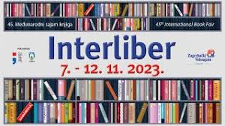  The story that we have been writing and reading again and again for 45 years with great pleasure - Interliber, this year takes place from November 7 to 12.  Interliber is the largest literary event in Croatia and a platform for the promotion of books, writers, reading, science and knowledge that brings together the most important publishers and bookstores. Being a part of this event has long become a pleasure and prestige for all stakeholders who participate in this extremely important activity, because there really is no better place for promotion in the literary business.

Social Sciences. Humanities

Autor Šulj, Tomislav
Title Bojna Frankopan : prvi hrvatski komandosi
Impresum Zagreb : Udruga Bojna Frankopan : Hrvatski memorijalno-dokumentacijski centar Domovinskog rata, 2023.
Description

Museums. Social Sciences. Humanities

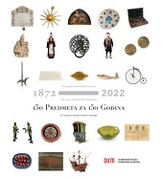
Title 150 Subjecta za 150 godina : iz fundusa Dubrovačkih muzeja : 150 godina Dubrovačkih muzeja = 150 years Dubrovnik Museums : 1872 - 2022
/ [urednice Ana Kaznačić Skurić, Ivona Michl ; autori kataloških jedinica Đivo Bašić ... [et al.] ; fotografije Katarina Radonić ... et al.].
Impresum Dubrovnik : Dubrovački muzeji, 2022.
Description 183 str. : ilustr. u bojama ; 29 cm
ISBN 9789538311123 : EUR 46,50 US$ 52,10
UDC 069(497.584Dubrovnik)
Anotation The catalog of the exhibition "150 objects for 150 years" was issued to mark the 150th anniversary of the founding of the Dubrovnik Museums. For the publication, 150 objects from the museum's rich holdings were selected, which was no easy task for the curators, because today the Dubrovnik museums have a fund of outstanding cultural-historical and artistic value of about fifty thousand objects, arranged in various collections, created in the time span from the early Neolithic until the end of the 20th century.

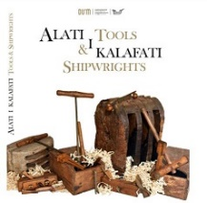
Author Dunatov, Ljerka
Title Alati i kalafati = Tools & Shipwrights : [Etnografski muzej, Dubrovnik], Žitnica Rupe 15. 12. 2020. - 1. 6. 2021.
Impresum Dubrovnik : Dubrovački muzeji, 2022.
Description 128 str. : ilustr. u bojama ; 28 cm.
Note Katalog izložbe.
Language/s Tekst usporedo na hrv. i na engl. jeziku.
Bib./Saž./Kaz. Bibliografija i mrežni izvori ; Bibliography and interner sources: str. 127-128; bibliografske bilješke uz tekst.
ISBN 9789538311017 : EUR 23,30 US$ 26,00
Subject Pomorski muzej (Dubrovnik). Zbirka brodogradilišnog alata – Katalozi. Brodogradnja -- Dubrovačka Republika -- Katalozi izložbi
UDC 629.5(497.584Dubrovnik)(091) * 069.5:629.5

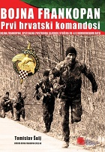
Author Šulj, Tomislav
Title Bojna Frankopan
Impresum Zagreb : Udruga Bojna Frankopan : Hrvatski memorijalno-dokumentacijski centar Domovinskog rata, 2023.
Description 487 str. : ilustr. u bojama ; 30 cm.
Note Bibliografija: str. 484-487; bibliografske bilješke. Imensko i pojmovno kazalo. Summary.
ISBN 9789534964002 : EUR 58,10 US$ 65,10
Subject Hrvatska. Hrvatska vojska. Bojna Frankopan – Povijest. Specijalne postrojbe -- Hrvatska -- 1991.-1995.
Domovinski rat (1991.-1995.) -- Hrvatske vojne postrojbe
UDC 355.316(497.5)(091)

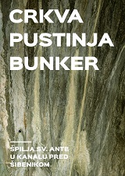
Title Crkva, pustinja, bunker : špilja sv. Ante u kanalu pred Šibenikom
/ [autori] Emil Podrug ... [et al.] ; [crteži Jelena Jović ... [et al.] ; fotografije Josip Belamarić [et al.] ; prijevod sažetka na engleski jezik Joško Tošić ; urednici Emil Podrug, Josip Pavić].
Impresum Šibenik : Muzej grada Šibenika : Javna ustanova Priroda Šibensko-kninske županije : Javna ustanova u kulturi Tvrđava kulture Šibenik, 2023.
Description 163 str. : ilustr. (pretežno u bojama), zemljop. crteži, faks. ; 24 cm.
Note Bibliografija: str. 149-163; bibliografske bilješke uz tekst. Summary.
ISBN 9789536844791 : EUR 25,00 US$ 28,00
Subject Crkva sv. Ante (Šibenik). Arheološka nalazišta – Šibenik. Sakralna arhitektura – Šibenik. Kulturna baština -- Šibenik
UDC 902.2(497.581.2Šibenik) * 726:27(497.581.2Šibenik) * 930.85(497.581.2Šibenik)

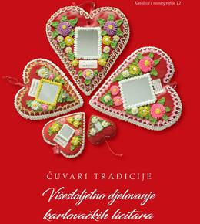
Author Mihalić, Jana
Title Čuvari tradicije : višestoljetno djelovanje karlovačkih licitara
Impresum Karlovac : Gradski muzej Karlovac, 2022.
Description 160 str. : ilustr. u bojama ; 30 cm.
ISBN 9789537510985 : EUR 32,10 US$ 36,00
UDC 39:638.1(497.529Karlovac)(091) * 39:665.14(497.529Karlovac)(091)
Anotacija The monograph is dedicated to the ancient art of making honey cakes and wax products, which are carried out by medicine men and candle makers, better known as licitari. The monograph is divided into three parts. In the first part, the historical development of this activity is presented, and the Karlovac medics and candlemakers are presented. The second unit is dedicated to medicine, and the third to candle making.

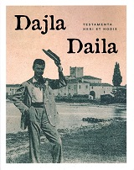
Title Dajla - Daila : testamenta heri et hodie : Muzej - Muzeo Lapidarium
/ uredili, a cura di [predgovori, prefazione] Jerica Ziherl, Marijan Bradanović
Impresum Novigrad - Cittanova : Muzej-Museo Lapidarium, 2023
Description 195 str. : ilustr. ; 27 cm.
Note Katalog izložbe održane 2. lipnja - 2. srpnja 2023. u Muzeju Lapidarium.
Language/s Tekst na hrv. i tal. jeziku.
ISBN 9789537608446 : EUR 48,40 US$ 54,20
Subject Benediktinci -- Dajla -- Katalozi izložbi. Kulturna baština -- Dajla -- Katalozi izložbi. Dajla -- Kulturna povijest -- Katalozi izložbi
UDC 930.85(497.571Dajla) * 272-789.2(497.571Dajla)

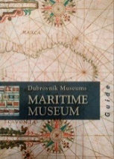
Author Kaznačić Skurić, Ana
Title Dubrovnik Museums: Maritime Museum : guide
Izdanje 3rd enlarged ed.
Impresum Dubrovnik : Dubrovački muzeji = Dubrovnik Museums, 2023.
Description 152 str. : ilustr. u bojama ; 21 cm.
ISBN 9789538311161 : EUR 19,60 US$ 21,90
UDC 069:656.61(497.584Dubrovnik)(036) * 069(497.584Dubrovnik)(036)
Anotation In chronological order, it shows the development of Dubrovnik's seafaring, from ancient times to the present day. This richly illustrated publication is intended for everyone who wants to find in one place the most important information about the Maritime Museum and its history, about the Museum building which is a protected cultural monument, the museum collections and to get to know Dubrovnik's maritime heritage. The guide actually provides for the first time an insight into the Museum's rich holdings, which today number over 5,000 objects systematized in fifteen collections, of which slightly more than 700 are exhibited in a permanent exhibition open in the fortress of St. Ivan in the city port in 1986.

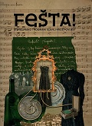
Title Fešta! : što su i kako Trogirani slavili kroz povijest : izložba u povodu proslave 60. obljetnice osnutka Muzeja grada Trogira : Muzej grada Trogira, Galerija Cate Dujšin Ribar, 10. srpnja - 27. rujna 2023.
/ [autorice tekstova kataloga, kataloških jedinica, bibliografije, stručne koncepcije i likovnog postava izložbe Aleksandra Bilić Petričević ... [et al.] ; fotografije Maja Maljković Zelalija ... et al.].
Impresum Trogir : Muzej grada, 2023.
Description 115 str. : ilustr. (pretežno u bojama) ; 29 cm.
Note Katalog izložbe.
ISBN 9789537677367 : EUR 32,30 US$ 36,10
Subject Praznici -- Trogir -- Povijest -- Katalozi izložbi. Blagdani -- Trogir -- Povijest -- Katalozi izložbi
Trogir -- Društveni život i običaji -- Katalozi izložbi
UDC 394(497.583Trogir)

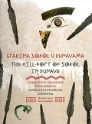
Author Katić, Miroslav, arheolog
Title Gradina Sokol u Dunavama : konavoska povijesna proskozorja = The Hill-fort of Sokol in Dunave : Konavle's
historical dawning
/ Miroslav Katić, Niko Kapetanić ; [urednica = editor Antonia Rusković Radonić
Impresum Dubrovnik : Društvo prijatelja dubrovačke starine ; Split : Muzej hrvatskih arheoloških spomenika ; [Gruda] : Muzeji i galerije Konavala, 2023
Description 167 str. : 1ilustr. ; 24 cm
Notes Usporedo hrv. tekst i engl. prijevod. - Bibliografija.
ISBN 9789536803828 : EUR 29,10 US$ 32,60
Subject Arheološki nalazi – Konavle. Arheološki nalazi -- Utvrda Sokol grad (Konavle)
UDC 904:738](497.584-3Konavle)"637/654"

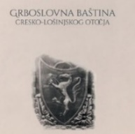
Author Ćus-Rukonić, Jasminka
Title Grboslovna baština cresko-lošinjskog otočja
Impresum Cres : Creski muzej, 2023.
Description 247 str. : ilustr. u bojama ; 29 cm.
Note Bibliografija: str. 221-226. Summary.
ISBN 9789538287084 : EUR 40,50 US$ 45,40
Subject Grbovi -- Cres (otok). Grbovi -- Lošinj
UDC 929.6(210.7Cres) * 929.6(210.7Lošinj)

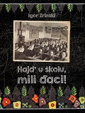
Author Zrinski, Igor
Title Hajd’ u školu, mili đaci!
Impresum Sveti Ivan Zelina : Muzej Sveti Ivan Zelina, 2022.
Description 143 str. : ilustr. ; 28 cm.
ISBN 9789538052118 : EUR 32,30 US$ 36,10
UDC 373(497.521)(091)
Anotation According to the available sources, the author in this professional paper provides a historical account of the development of education in the area of ​​Sv. Ivan Zelina. The main source of data are the canonical visitations, Materials for the history of education by Antun Cuvaj, the Croatian State Archives and school monuments.
The presentation begins with the very beginnings of some, conditionally speaking, forms of schools in the Middle Ages, and ends with a presentation of schooling up to the middle of the 20th century.

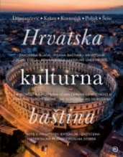
Title Hrvatska kulturna baština
/ [autori tekstova] Ivana Drenjančević ... [et al.] ; [autori fotografija Zvonimir Atletić ... et al.].
Impresum Zagreb : Mozaik knjiga, 2023.
Description 352 str. : ilustr. u bojama ; 30 cm.
ISBN 9789531435185 : EUR 59,00 US$ 66,10
UDC 930.85(497.5)
Anotation The book gives a brief overview of the most representative cultural assets that spread the word about our country all over the world. It is divided into ten chapters, in which the authors tried to include all the most precious things that we can find in Croatian history, painting, sculpture, architecture, literature, music, archeology and ethnology.
Picturesque castles, mighty fortresses, unconquered walls and magical summer houses, valuable books and stone inscriptions that bear witness to the thousand-year cultural presence in these areas, inspiring traditional construction and stunning examples of contemporary architecture, masterpieces of painters, sculptors and composers...

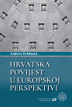
Autor Feldman, Andrea
Title Hrvatska povijest u europskoj perspektivi
Impresum Zagreb : Učiteljski fakultet, 2023.
Description 209 str. ; 24 cm.
ISBN 9789533800004 : EUR 37,20 US$ 41,70
Subject Povijest -- Nastava i učenje -- Hrvatska -- Udžbenici
UDC 37.091.3:94(497.5)(075.8) * 94(497.5)(075.8)

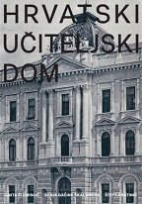
Autor Zlomislić, Anita
Title Hrvatski učiteljski dom
/ Anita Zlomislić, Sonja Gaćina Škalamera, Štefka Batinić ; [prijevod sažetka Graham McMaster ; fotografije Fredy Fijačko ... et al.].
Impresum Zagreb : Hrvatski školski muzej, 2023.
Description 200 str. : ilustr. u bojama ; 30 cm.
Bib./Saž./Kaz. Bibliografija. Summary
ISBN 9789537262297 : EUR 32,30 US$ 36,10
Subject Hrvatski učiteljski dom (Zagreb) – Izložbe. Hrvatski školski muzej (Zagreb) – Izložbe. Školstvo -- Hrvatska -- Izložbe
UDC 069:37(497.5) * 727(497.521.2 * 37.018(497.5)

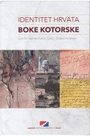
Title Identitet Hrvata Boke kotorske
/ uredili Vanda Babić Galić i Željko Holjevac.
Impresum Zagreb : Institut društvenih znanosti Ivo Pilar , 2023.
Description 258 str. : ; 25 cm.
Bib./Saž./Kaz. Bibliografija. Summary.
ISBN 9789538404139 : EUR 22,80 US$ 25,60
Subject Hrvati -- Boka kotorska -- Etnički identitet -- Zbornici s konferencija
UDC 323.15(497.16=163.42)

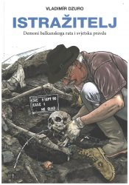
Author Dzuro, Vladimír
Title Istražitelj : demoni balkanskoga rata i svjetska pravda
Impresum Zagreb : Hrvatski institut za povijest ; Vinkovci : Ogranak Matice hrvatske u Vinkovcima ; Slavonski Brod : Podružnica za povijest Slavonije, Srijema i Baranje Hrvatskog instituta za povijest u Slavonskom Brodu ; Zagreb : Hrvatski memorijalno-dokumenacijski centar Domovinskog rata, 2023.
Description 341 str. : ilustr. u bojama, graf. prikazi ; 24 cm.
Note Prijevod djela: Vyšetřovatel : démoni balkánské války a světská spravedlnost.
ISBN 9789538335389 : EUR 37,60 US$ 42,10
UDC 341.64(492):341.322(497.1) * 341.322.5(497.1) * 343.9Dzuro, Vladimír
Anotation The book Istražitelj : demoni balkanskoga rata i svjetska pravda is a memoir of the Czech criminalist Vladimír Dzura about his participation in the work of the International of the Criminal Court for the former Yugoslavia (ICTY) in The Hague, which was actually founded for the purpose of punishing perpetrators of war crimes in Croatia and Bosnia and Herzegovina. He is the author investigated the crimes committed by Serbian forces in Croatia, which is above all Mediterranean and Central European country, which defines it geographically, geopolitically and culturally sense, and in Bosnia and Herzegovina, during the war from 1991 to 1995.

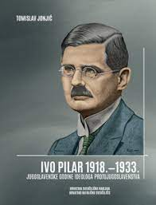
Author Jonjić, Tomislav
Title Ivo Pilar 1918.-1933. : jugoslavenske godine ideologa protujugoslavenstva
Impresum Zagreb : Hrvatska sveučilišna naklada : Hrvatsko katoličko sveučilište, 2023.
Description 669 str. : ilustr. ; 27 cm.
ISBN 9789531695107 : EUR 43,00 US$ 48,20
UDC 94(497.5)Pilar, I. * 32Pilar, I.
Anotation The book deals with the Yugoslav period of activity of Ivo Pilar and is a continuation of Jonjić's book Ivo Pilar – writer, politician and ideologue (1898-1918), published by the author in 2020, which deals with the previous period of Pilar's activity in the Austro-Hungarian Monarchy. With the publication of the book Ivo Pilar 1918-1933: the Yugoslav years of the ideologue of anti-Yugoslavism, we get a rounded picture of Pilar's activities at the border between two epochs, in two countries and two cultural circles. Her publication enabled us to find constants and changes in Pilar's views, created in new political circumstances.

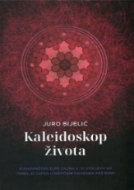
Author Bijelić, Juro
Title Kaleidoskop života : stanovništvo župe Čazma u 19. stoljeću na temelju zapisa u matičnim knjigama krštenih
/ Juro Bijelić ; [kazalo izradio Hrvoje Fürnstein].
Impresum Bjelovar : Državni arhiv u Bjelovaru, 2023.
Description 320 str. : ilustr., graf. prikazi ; 24 cm.
ISBN 9789535993674 : EUR 33,30 US$ 37,30
Subject Matice krštenih -- Čazma (okolica). Matične knjige -- Čazma (okolica). Čazma (okolica) -- Stanovništvo -- Arhivski izvori
UDC 314.1(497.526-37Čazma)(093) * 929.532(497.526-37Čazma)

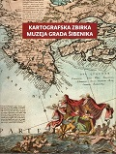
Author Brakus, Bruno
Title: Kartografska zbirka Muzeja grada Šibenika
/ [Bruno Brakus ; fotografije Tomislav Šmider, Dragan Zrnčević]
Impresum: Šibenik : Muzej grada Šibenika, 2022
Description: 323 str. : zemljop. karte u bojama ; 28 cm
ISBN 9789536844784 : EUR 37,50 US$ 42,00
Subjectnice: Muzej grada Šibenika -- Kartografska zbirka. Kartografske zbirke -- Hrvatska
UDC: 069.5:528](497.581.2Šibenik)(083.82)

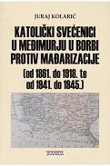
Author Kolarić, Juraj
Title Katolički svećenici u Međimurju u borbi protiv mađarizacije (od 1861. do 1918. te od 1941. do 1945.) : doprinos katoličkoga svećenstva očuvanju hrvatske kulturne baštine i nacionalnoga identiteta Međimurja (od 1094. do 1918/19.) u povodu 100. obljetnice oslobođenja Međimurja od mađarske okupacije
Impresum Zagreb : Tkanica ; Sesvetski Kraljevec : Grafok, 2023.
Description 264 str. : ilustr. ; 21 cm.
ISBN 9789537999599 : EUR 23,10 US$ 25,90
Subject Katolička crkva – Kler-- Svećenici --Crkva i država – Međimurje. Međimurje -- Povijest -- 1790.-1945.
UDC 94(497.5)"1527/1918" * 272-722.53(497.524)

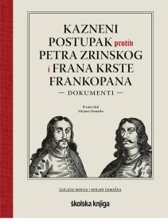
Title Kazneni postupak protiv Petra Zrinskog i Frana Krste Frankopana : dokumenti
/ prema zamisli Mirjana Damaške priredile i prevele Ivana Horbec (njemački), Maja Matasović (latinski) i Nella Lonza (talijanski) ; uredila Nella Lonza ; uvodne studije napisao Mirjan Damaška.
Impresum Zagreb : Zaklada Marija i Mirjan Damaška : Školska knjiga, 2023.
Description 582 str. : ilustr., faks. ; 27 cm.
ISBN 9789530623668 : EUR 61,60 US$ 69,00
UDC 343.32(497.5:436)(091) * 94(497.5)Zrinski, P. * 94(497.5)Frankopan, F. K. * 929.73Zrinski, P. * 929.73Frankopan
Anotation This unique book, the first of its kind, deals with the original texts of one of the most important criminal proceedings in Croatian history, translated using the most modern scientific methods. Therefore, it is an indispensable source of all future research on this and related topics, but interesting not only to scientists and students, but also to a wider audience, who for the first time can see the course of the entire procedure, not through retelling of events but through original documentation, and with excellent essay studies. prof. Mirjan Damaška.

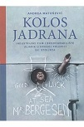
Author Matošević, Andrea
Title Kolos Jadrana : industrijski film i brodogradilište Uljanik u drugoj polovici XX. stoljeća
Impresum Zagreb : Srednja Europa, 2023.
Description 224 str. : ilustr. ; 24 cm.
ISBN 9789533870021 : EUR 28,00 US$ 31,30
Subject Uljanik (Pula) – Povijest * Industrijski film – Hrvatska * Industrijski film -- Jugoslavija
UDC 629.5(497.571Pula)(091) * 791.229(497.5)
Anotation The monograph Kolos Jadrana is an original and updated contribution and provides an innovative understanding of the role of shipbuilding and industrial film in the construction of local and global imaginaries of economic development and historical modernity throughout the twentieth century. In accordance with the editorial decisions and the focus of the authors of the analyzed films, ships become signifiers of different political and cultural messages.

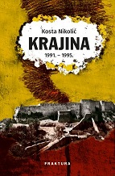
Author Nikolić, Kosta
Title Krajina : 1991. – 1995.
Impresum Zaprešić : Fraktura ; Zagreb : Srpsko narodno vijeće, 2023.
Description 728str. ; 24 cm.
ISBN 9789533586540 : EUR 37,60 US$ 42,10
Subject Srbi -- Hrvatska -- 1990.-1995. Domovinski rat (1991.-1995.) -- Okupirana područja.
Domovinski rat (1991.-1995.) -- Vojne operacije
UDC 323.26(497.5=163.41) * 94(497.5)"199" * 355.4(497.5)
Anotation Kosta Nikolić's book Krajina 1991 - 1995 brings to the Croatian public a new and different approach to the tragic events of the early nineties of the last century. The nature of the rebellion of Serbian nationalists in Croatia, who founded and for some time maintained a separate political entity, as well as the nature of the new order in independent Croatia forced both opposing sides to exclusivity. Krajina 1991 - 1995 by Kosta Nikolić is a balanced, documented account of a tragedy, and above all, an occasion for a calm, sympathetic and conciliatory dialogue.

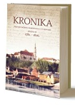
Title Kronika Franjevačkog samostana u Vukovaru, knj. 2: (1781. - 1826.)
/ transkripcija, kritičko izdanje i prijevod Petar Ušković Croata ; stručna redakcija prijevoda Šime Demo ; [autor kazala i popisa Ivica Jagodić ; transkripcija i prijevod s njemačkoga i predstandardnog hrvatskog jezika Henrik Ivan Damjanović ... et al.].
Impresum Vukovar : Državni arhiv : Franjevački samostan Vukovar, 2022.
Description LIII, 843 str. : faks.
Note Summary ; Zusammenfassung.
ISBN 9789537980337 : EUR 42,50 US$ 47,60
Subject Franjevački samostan sv. Filipa i Jakova (Vukovar) – Povijest. Vukovar -- Crkvena povijest
UDC 272-789.3(497.544Vukovar)-9 * 272-523(497.544Vukovar)-9

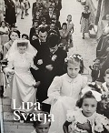
Author Prusina, Branka
Title Lipa svatja : (uspomene na vjenčanja s lošinjskog otočja)
/ [autorica teksta i urednica Branka Prusina].
Impresum Mali Lošinj : Lošinjski muzej, 2023.
Description 100 str. : ilustr. ; 27 cm.
ISBN 9789537902421 : EUR 32,30 US$ 36,10
Subject Wedding customs and ceremonies - Lošinj - Wedding customs and ceremonies -- Cres-Lošinj Islands
UDC 392.5(210.7Lošinj)

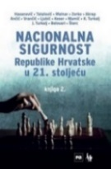
Title Nacionalna sigurnost Republike Hrvatske u 21. stoljeću : knjiga 2.
/ [Aziz] Hasanović ... et al.].
Impresum Zagreb : Naklada Jesenski i Turk : Fakultet političkih znanosti Sveučilišta u Zagrebu : Institut za sigurnosne politike, 2023.
Description 309 str. : ilustr., graf. prikazi ; 24 cm.
ISBN 9789533810140 : EUR 31,20 US$ 34,90
Subject Nacionalna sigurnost -- Hrvatska -- 21. st.
UDC 355.02(497.5) * 351.86(497.5)

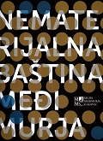
Author Kovač, Janja
Title Nematerijalna baština Međimurja = Intangible geritage treasury of Međimurje
Impresum Čakovec : Muzej Međimurja, 2022.
Description 124 str. : ilustr. u bojama ; 29 cm.
Language/s Tekst na hrv. i na engl. jeziku
ISBN 9789536896455 : EUR 33,20 US$ 37,20
Subject Nematerijalna kulturna baština – Međimurje. Folklor -- Međimurje
UDC 39(497.524)

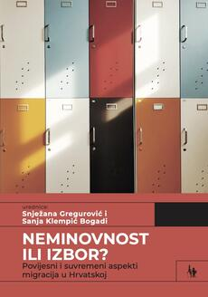
Title Neminovnost ili izbor? : povijesni i suvremeni aspekti migracija u Hrvatskoj
/ urednice Snježana Gregurović i Sanja Klempić Bogadi.
Impresum Zagreb : Naklada Jesenski i Turk : Institut za migracije i narodnosti, 2023.
Description 202 str. : graf. prikazi ; 23 cm.
ISBN 9789532229806 : EUR 24,00 US$ 25,80
UDC 314.15(497.5) * 316:314(497.5)
Anotation This book aims to offer an explanation as to why similar migration patterns in today's Republic of Croatia persist or occur cyclically in the past 130 years despite fundamental transformations of political systems as well as changes in the economic, cultural, educational, ideological and institutional framework. Although in recent times migrations in Croatia, both emigration and immigration, are often the result of a choice based on the individual decision of the migrants, it has been shown that they are still more often inevitable, i.e. conditioned by the socio-economic context and political events.

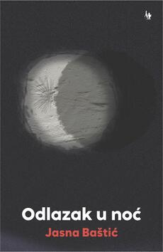
Author Baštić, Jasna
Title Odlazak u noć
Impresum Zagreb : Naklada Jesenski i Turk, 2023.
Description 208 str. ; 21 cm.
ISBN 9789533810317 : EUR 20,40 US$ 22,90
UDC 355Zakošek, Z. * 159.97-058.65-057.36 * 821.163.42-94
Anotation This book offers a lot of knowledge about the psychological and sociological aspects of the Homeland War, and especially about the veteran population that copes with the consequences of the war in the form of post-traumatic stress disorder. Furthermore, the contribution of this work is also evident in the fact that the interlocutor (co-author) held a high officer's post during the war, and such confessions are rare in the literature on PTSD, especially on one of the most problematic aspects of PTSD, which refers to dealing with guilt.

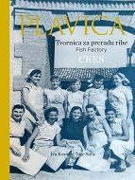
Author Kosmos, Iva
Title Plavica : tvornica za preradu ribe, Cres = fish factory : [Creski muzej, 12. 5. do 20. 8. 2023. = The Cres Museum, May 12 to
August 20, 2023]
Impresum Cres : Creski muzej ; Ljubljana : ZRC SAZU Institut za studije kulture i sjećanja, 2023.
Description 93 str. : ilustr. (djelomice u bojama) ; 28 cm.
Language/s Tekst na hrv. i na engl. jeziku.
ISBN 9789538287091 : EUR 13,50 US$ 15,10
Subject Tvornica za preradbu ribe Plavica (Cres) – Povijest. Cres (otok) -- Društveni život i običaji
UDC 39(210.7Cres) * 636.2(210.7Cres)(091)

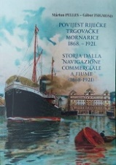
Author Pelles, Marton; Zsigmon, Gabor
Title Povijest riječke trgovačke mornarice 1868.-1921. = Storia dalla navigazione comerciale a Fiume
Impresum Rijeka: Muzej grada Rijeke ; Budimpešta: Mađarski tehnički i prometni muzej, 2022.
Description 272 str. ; ilustrirano, 30 cm.
Language/s hrvatski i talijanski
ISBN 978615644908 : EUR 35,30 US$ 39,50
Anotation The book sheds light on an important part of Rijeka's maritime history, which enabled the economic rise of the city during the Austro-Hungarian Monarchy, more precisely after the Croatian-Hungarian settlement in 1868. Her focus is on the economic results of Rijeka's maritime trade, with particular emphasis on the importance of the city's industry, which was created in a tight symbiosis with shipping. At the beginning of the 20th century, the increased traffic through the port of Rijeka would bring it to tenth place among European ports. At work, there was a synergistic stimulus to the simultaneous development of Croatia and Hungary, often thanks to attracted foreign capital investments.

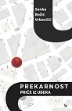
Author Božić-Vrbančić, Senka
Title Prekarnost : priče iz Ubera
Impresum Zagreb : Naklada Jesenski i Turk, 2023.
Description 159 str. ; 20 cm.
ISBN 9789533810089 : EUR 16,10 US$ 18,10
UDC 39:33(497.521.2) * 331.5(497.521.2)
Anotation In order to understand some important trends of the present, and even some deep principles, you do not need to devote yourself to philosophical texts - it is enough to take a taxi often. This is exactly what a university professor of anthropology did, who, after breaking her foot and the medical complications that followed, drove herself to therapy every day. In the process, she chatted with Uber drivers, precarious workers whose work is organized by an algorithm, i.e. Uber's application. Following her conversations, fragments that she later recorded, a wide range of life opens up before us

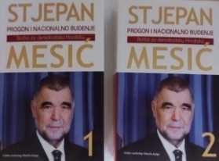
Author Mesić, Stjepan
Title Progon i nacionalno buđenje 1-2 : borba za demokratsku Hrvatsku
/ priredio i uredio Franjo Maletić.
Impresum Zagreb : Golden marketing-Tehnička knjiga, 2023.
Description 2 sv.(1-439; 443-780 str.) : ilustr. u bojama ; 25 cm.
ISBN 9789532124927 (cjelina) : EUR 69,80 US$ 78,10
Subject Mesić, Stjepan – Autobiografija. Političari -- Hrvatska – Autobiografije. Hrvatsko pitanje -- Jugoslavija -- 1945.-1991.
UDC 32Mesić, S. * 323.1(497.1=163.42)
Anotation "Therefore, I believe that the time has come to truly speak out - it is the result of my inner reflections: to answer and remove some of the wrong interpretations, conclusions, assessments and leave the readers free to evaluate for themselves what is true, but also the fact that Croatian society is crying out for some of the key answers from newer awareness.
I base my knowledge partly on personal experience and personal observations, and partly on the records of my contemporaries. I believe that all this is just a part of the unknown intricate structure of the events of the nineties of the last century." From the foreword: Stjepan Mesić

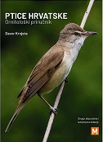
Autor Krnjeta, Davor
Naslov Ptice Hrvatske : ornitološki priručnik
Izdanje Drugo, dopunjeno i izmijenjeno izd.
Impresum Samobor : Meridijani, 2023.
Materijalni opis 383 str. : ilustr. u bojama ; 19 cm.
Napomena Imensko kazalo. Summary.
ISBN 9789532392715 : EUR 35,70 US$ 39,60
Predmet Ptice -- Hrvatska -- Priručnici -- Klasifikacija
UDK 598.2(497.5)(035)

Author Milaković, Gordana
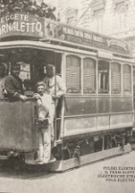
Title Pulski električni tramvaj = Il tram elettrico Polese = Elektrische Strassenbahn Pula = Pula electri.
/ [autori kataloga, autori del catalogo, autoren des katalogs, catalogue authors] Gordana Milaković, Katarina Pocedić, Gracijano Kešac ; urednice, editori, redakteure, editors Gordana Milaković, Katarina Pocedić].
Impresum Pula : Povijesni i pomorski muzej Istre, 2022.
Description 257 str. : ilustr. ; (djelomice u bojama) ; 19 X 25 cm.
Note Katalog izložbe
Language/s Tekst na više jezika.
ISBN 9789537695163 : EUR 25,70 US$ 28,80
Subject Tramvajski promet -- Pula (Hrvatska) -- Povijest -- Katalozi izložbi. Pula (Hrvatska) -- Na razglednicama -- Katalozi izložbi
UDC 656.34(497.571Pula) * 676.813(497.571Pula)

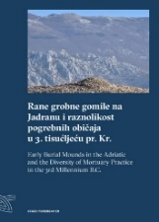
Author Forenbaher, Stašo
Title Rane grobne gomile na Jadranu i raznolikost pogrebnih običaja u 3. tisućljeću pr. Kr. = Early Burial Mounds in the Adriatic and the Diversity of Mortuary Practice in the 3rd Millennium B.C.
Impresum Zagreb : Institut za arheologiju, 2023.
Description 200 str. : ilustr. u bojama, zemljop. crteži u bojama, graf. prikazi u boji ; 29 cm.
Language/s Tekst usporedo na hrv. i na engl. jeziku.
ISBN 9789536064670 : EUR 23,30 US$ 26,00
Subject Pogrebni običaji i obredi -- Jadranska regija -- Bakreno doba. Gomile -- Jadranska regija -- Bakreno doba
UDC 903.5(210.5)(262.3)"636"

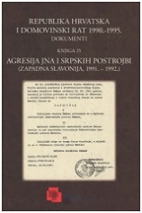
Title Republika Hrvatska i Domovinski rat 1990. - 1995., Knj. 25
Agresija JNA i srpskih postrojbi : (zapadna Slavonija : 1991. – 1992.)
/ [urednici Julija Barunčić Pletikosić, Petar Mijić].
Impresum Zagreb : Hrvatski memorijalno-dokumentacijski centar Domovinskog rata ; Slavonski Brod : Hrvatski institut za povijest, Podružnica za povijest Slavonije, Baranje i Srijema, 2023.
Description 364 str.
Serie Republika Hrvatska i Domovinski rat 1990. - 1995., Knj. 25
ISBN 9789538354212 : EUR 24,10 US$ 27,00
Subject Domovinski rat (1991.-1995.) -- Vojne operacije -- Slavonija, zapadna -- Arhivski izvori
UDC 355.48(497.541)(093)

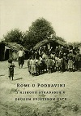
Title Romi u Podravini i njihovo stradanje u Drugom svjetskom ratu
/ [urednici Robert Čimin, Danijel Vojak].
Impresum Koprivnica : Muzej grada Koprivnice ; Zagreb : Institut društvenih znanosti Ivo Pilar, 2023.
Description 176 str. : ilustr. ; 24 cm.
ISBN 9789538138881 : EUR 48,40 US$ 54,20
Subject Romi -- Žrtve zločina -- Podravina -- 1941.-1945. -- Zbornici s konferencija
Genocid -- Nezavisna Država Hrvatska -- Zbornici s konferencija
UDC 323.12(497.525=214.58)(091) * 341.48(497.525=214.58)(091)

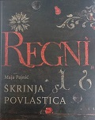
Author Pajnić, Maja
Title Škrinja povlastica
Impresum Zagreb : Hrvatski državni arhiv, 2023.
Description 504 str. : ilustr. u bojama ; 29 cm.
Notes Bibliografija: str. 481-487. Imensko kazalo. Summary ; Zusammenfassung.
ISBN 9789538461071 : EUR 43,00 US$ 48,20
UDC 930.253(497.5)
Anotation At the end of the 19th century, two great men of that era, Emilij Laszowski and Ivan Bojničić, wrote that the Škrinja povlastica (Privilege Chest), together with its documents, was the greatest treasure of the Archive, and its contents were of the greatest importance for domestic history. The value of these documents is also evidenced by the fact that Vjekoslav Klaić was inspired by the information found in their contents and discreetly wove them into his monumental work History of the Croats, without mentioning the Ark of Privileges.

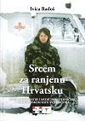
Autor Radoš, Ivica, publicist
Title Srcem za ranjenu Hrvatsku : medicinske sestre i medicinski tehničari u Domovinskom ratu - svjedočenja
Impresum Zagreb : Hrvatski strukovni sindikat medicinskih sestara - medicinskih tehničara : Naklada Bošković, 2022.
Description 432 str. ; 24 cm.
ISBN 9789532637120 EUR 32,40 US$ 36,30
Subject Domovinski rat (1991.-1995.) -- Medicinska skrb – Svjedočanstva. Zdravstveni djelatnici -- Hrvatska -- 1991.-1995.
UDC 614.253.5(497.5) * 355.48(497.5)
Anotation On more than 400 pages, there are testimonies of those who, in the most difficult moments of the struggle for the freedom and independence of Croatia, gave their all to the defense of the homeland. Nurses and technicians incorporated themselves, their vocation and knowledge into the foundations of Croatia's freedom, and their testimonies are permanently recorded in this book.

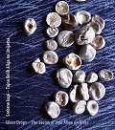
Autor: Karniš Vidovič, Iskra
Title: Srebrne kapi - Tajna Velih aliga na Unijama = Silver Drops - The Secret of Vele Alige on Unije
Impresum: Mali Lošinj : Lošinjski muzej, 2023
Description: 68 str. : ilustr. ; 24 cm
Napomene: Tekst usporedo na hrv. i na engl. jeziku. - Katalog izložbe.
ISBN 9789537902469 : EUR 32,30 US$ 36,10
Subject Unije (otok) -- Povijest
UDC: 94(497.572)"1945"(083.824)
Anotation Author duo Iskra Karniš Vidovič and Davor Karniš created the atmosphere of January 1945, when Unije had 639 inhabitants (today there are ten times less). Then, while returning from a landing operation on Ista, three torpedo boats of the German Navy ran aground on the Union.

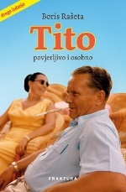
Author Rašeta, Boris
Title Tito : povjerljivo i osobno
Impresum Zaprešić : Fraktura ; Zagreb : 24sata, 2023.
Description 693 str. ; 24 cm.
ISBN 9789533586175 : EUR 37,60 US$ 42,10
UDC 32Tito, J. B.
Anotation Josip Broz Tito is without a doubt the most important historical figure who was born in our region. Theater amateur, locksmith, soldier, award-winning swordsman, prisoner of war, Red Army soldier, political worker, illegal, terrorist, secretary of the Communist Party, leader of the uprising, marshal, president, world traveler, bon vivant... all this and much more was Josip Broz, a man with many names and faces, but always with a clear vision: that he will be successful. From a boy from the Sutla to a statesman whose funeral was attended by the largest number of delegations and state representatives.

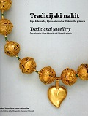
Author Margaretić, Barbara
Title Tradicijski nakit: Župa dubrovačka, Rijeka dubrovačka i Dubrovačko primorje : iz fundusa Etnografskog Muzeja u Dubrovniku = Traditional Jewellery: Župa dubrovačka, Rijeka dubrovačka and Dubrovačko primorje
Impresum Dubrovnik : Dubrovački muzeji, 2023.
Description 95 str. : ilustr. u bojama ; 28 cm.
Note Katalog zbirke.
Language/s Tekst usporedo na hrv. i engl. jeziku.
ISBN 9789538311185 : EUR 24,70 US$ 27,70
Subject Etnografski muzej "Rupe" (Dubrovnik) -- Zbirke – Katalozi. Tradicijski nakit -- Dubrovnik (okolica)
UDC 069.51:391.7(497.584-37Dubrovnik) * 391.7(497.584-37Dubrovnik) * 739.2(497.584-37Dubrovnik)


Autor Bertoša, Miroslav
Title Trošenje života : Gdje li je život što ga izgubih živeći?
Impresum Zagreb : Hrvatska sveučilišna naklada, 2023.
Description 494 str. ; 21 cm.
ISBN 9789531695473 : EUR 37,60 US$ 42,10
UDC 930Bertoša, M. * 821.163.42-94
Anotation In the center of the text are the author's diary notes from 1984, which he returns to after 36 years with the intention of retrospectively presenting impressions, knowledge, changes in life's maturation, social and political changes, and new horizons in historiography. From his diary, Miroslav Bertoša recounts events from his place of residence (the city of Pula), Istria, Croatia and Yugoslavia, but he also describes his stays in Ljubljana, Zagreb, Trieste, Bologna, Loreto, especially in Venice, where he regularly spent several weeks researching in the State Archives there and in Paris . From the diary, as the backbone of the book, some episodes from private life stand out, especially those characteristic of the way of life at that time, but in the foreground are essayistic, journalistic and historiographical accounts of the author's efforts to fit his everyday life into the methodological approaches of the changed reality.

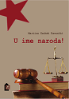
Author Grahek Ravančić, Martina
Title U ime naroda! : djelovanje sudova za zaštitu nacionalne časti Hrvata i Srba u Hrvatskoj 1945. godine
Impresum Zagreb : Hrvatski institut za povijest, 2023.
Description 197 str. : ilustr., graf. prikazi ; 25 cm.
Bib./Saž./Kaz. Bibliografija. Kazala.
ISBN 9789538335402 : EUR 24,70 US$ 27,70
Subject Politički progoni -- Jugoslavija -- 1945.-1974. Pravosuđe -- Hrvatska -- 1945.-1974.
UDC 323.28(497.1)(091) * 342.56(497.5)

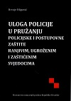
AuHtor Filipović, Hrvoje, pravnik
Title Uloga policije u pružanju policijske i postupovne zaštite ranjivim, ugroženim i zaštićenim svjedocima
Impresum Zagreb : Ministarstvo unutarnjih poslova Republike Hrvatske, Policijska akademija, 2021.
Description XIV, 352 str. : graf. prikazi ; 24 cm.
Notes Bibliografija: str. 313-335. Imensko kazalo ; Predmetno kazalo.
ISBN 9789531613248 : EUR 50,70 US$ 56,70
Predmet Svjedoci – Zaštita. Policijsko postupanje
UDK 351.74:343.2 * 343.143

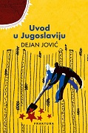
Author Jović, Dejan
Title Uvod u Jugoslaviju
Impresum Zaprešić : Fraktura ; Zagreb : SKD Prosvjeta, 2023.
Description 496 str. ; 24 cm.
ISBN 9789533586212 : EUR 32,20 US$ 36,10
UDC 321.74(497.1) * 327(497.1)
Anotation Uvod u Jugoslaviju (The introduction to Yugoslavia) is a kind of reset of previous interpretations, let's hope and a reset of perceptions of an important chapter of Croatian (clearly, not only Croatian) history. This book, written above all for the new generations, born after the breakup of Yugoslavia, explains what Yugoslavia was and wanted to be - what it succeeded in and what it failed to do. She also offers a convincing answer to the question - why she broke up. This opens up space for new research, based on archival material as well as on solid and convincing scientific research methodology.

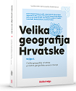
Title Velika geografija Hrvatske - knjiga 2.: Fizička geografija Hrvatske, prirodno-geografska osnova razvoja
/ Damir Magaš... [et al.].
Impresum Zadar : Sveučilište u Zadru, Odjel za geografiju Zagreb : Školska knjiga.
Description 728 str. : ilustr. u bojama, zemljop. karte u bojama.
Skup Velika geografija Hrvatske, knj. 2
Bib./Saž./Kaz. Kazala.
ISBN 9789530622692 : EUR 94,20 US$ 105,50
Subject Fizička geografija. Hrvatska -- Geografija
UDC 911.2(497.5)

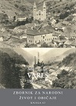
Author Žuljić, Mijo
Title Vareš : 1897. - 1911.
/ priredili Jakša Primorac, Mirjana Crnić Novosel i Mario Katić.
Impresum Zagreb : Hrvatska akademija znanosti i umjetnosti ; 2023.
Description 788 str. : ilustr. ; 25 cm.
Nakl. cjelina Zbornik za narodni život i običaje, knj. 63
Bib./Saž./Kaz. Summary.
ISBN 9789533472768 : EUR 40,70 US$ 45,60
Subject Vareš -- Društveni život i običaji
UDC 39(497.6)

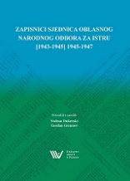
Title Zapisnici sjednica Oblasnog narodnog odbora za Istru : [1943-1945] 1945-1947
/ priredili i uredili Vedran Dukovski, Gordan Grzunov.
Impresum Pazin : Državni arhiv u Pazinu, 2023.
Description 784 str. ; 25 cm.
ISBN 9789537640514 : EUR 17,40 US$ 19,50
Subject Oblast Istra. Narodnooslobodilački odbor. – Arhiva. Narodnooslobodilački rat u Jugoslaviji (1941.-1945.) -- Istra -- Arhivski izvori. Istra -- Povijest -- 1943.-1945. -- Arhivski izvori. Istra -- Politika i vlast -- 1945.-1974. -- Arhivski izvori
UDC 94(497.5)"1941/1945" * 94(497.571)"1943/1947"(093) * 321.011(497.571)(093)

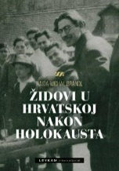
Autor Brandl, Naida Michal
Title Židovi u Hrvatskoj nakon Holokausta
Impresum Zagreb : Leykam international, 2023.
Description 438 str. : ilustr. ; 24 cm.
ISBN 9789533401546 : EUR 36,70 US$ 41,10
UDC 323.15(497.5=411.16)(091)
Anotation This is the first scientific monograph that deals with the hitherto unexplained fate of Jews who survived the Second World War and the Holocaust, and which examines their experience of life in communist Yugoslavia and their departure to Israel during the last four aliyahs. The book is intended for those interested in the fate of Jews in Croatia/Yugoslavia in the period after the end of the Second World War, but also for those who want to know more about the complex relationship between Jews and Croats, especially the communists after the war.

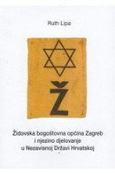
Autor Lipa, Ruth
Title Židovska bogoštovna općina Zagreb i njezino djelovanje u Nezavisnoj Državi Hrvatskoj
/ Ruth Lipa ; priredila Jasminka Domaš ; prevela s hebrejskog Sonja Makek.
Impresum Zagreb : Skaner Studio : Židovska vjerska zajednica Bet Israel u Hrvatskoj, 2023.
Description 142 str. ; 21 cm.
ISBN 9789537926205 : EUR 18,60 US$ 20,80
Subject Židovi -- Zagreb -- Povijest -- 1941.-1945. Židovi -- Humanitarna pomoć -- Zagreb -- 1941.-1945.
Drugi svjetski rat (1939.-1945.) -- Izbjeglice -- Hrvatska
UDC 94(497.5)"1941/1945" * 323.14(497.521.2=411.16)(091)

Linguistics. Philology

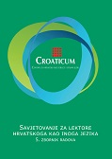
Title Croaticum : savjetovanje za lektore hrvatskoga kao inoga jezika : 5. zbornik radova
/ uredili Marica Čilaš Mikulić, Milvia Gulešić Machata, Darko Matovac.
Impresum Zagreb : FF press [i. e.] Filozofski fakultet, Odsjek za kroatistiku, 2023.
Description 184 str. : ilustr. ; 24 cm.
ISBN 9789533790091: EUR 14,00 US$ 15,70
Subject Hrvatski jezik -- Nastava i učenje -- Strani govornici -- Zbornici s konferencija
UDC 811.163.42’243

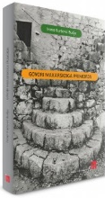
Author Kurtović Budja, Ivana
Title Govori Makarskoga primorja
Impresum Zagreb : Institut za hrvatski jezik i jezikoslovlje, 2023.
Description XIII, 217 str. : ilustr. ; 25 cm.
Bib./Saž./Kaz. Bibliografija. Abstract
ISBN 9789538390081 : EUR 21,50 US$ 24,10
Subject Hrvatski jezik -- Narječja -- Makarsko primorje. Štokavsko narječje -- Makarsko primorje
UDC 811.163.42’282.3(497.583)

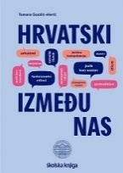
Autor Gazdić-Alerić, Tamara
Title Hrvatski između nas
Impresum Zagreb : Školska knjiga : Učiteljski fakultet, 2023.
Description 244 str. : ilustr. ; 24 cm.
ISBN 9789530312043 : EUR 19,60 US$ 22,00
UDC 811.163.42(075.8) * 811.163.42’26(075.8) * 811.163.42’271(075.8)
Anotation Croatian between us talks about the complex topic of learning the Croatian standard language with the aim of developing the linguistic and communicative competence of its speakers. The author first places the learning of the standard language in a broad linguistic context and in the narrower context of learning the Croatian standard language, its idioms and functional styles.
Tamara Gazdić-Alerić has comprehensively dealt with numerous language issues which, although there is a lot of literature on them, are rarely presented in this way.


Autor Znanstveno-stručni skup Jezici i svjetovi (2 ; 2021 ; Zagreb)
Title Jezici i svjetovi : zbornik radova Drugog znanstveno-stručnog skupa Hrvatskog društva sveučilišnih lektora održanog 25. i 26. veljače 2021. u Zagrebu
/ [urednici Ivančica Banković-Mandić, Marko Majerović, Marina Zubak Pivarski].
Impresum Zagreb : Hrvatska sveučilišna naklada : Hrvatsko društvo sveučilišnih lektora, 2023.
Description 236 str. ; 24 cm.
Bib./Saž./Kaz. Bibliografija iza svakog rada. Summaries
ISBN 9789531695299 : EUR 15,70 US$ 17,40
Subject Jezik i jezici -- Nastava i učenje -- Zbornici s konferencija. Frazeologija -- Zbornici s konferencija
UDC 81’243 * 81’373.7 * 37.091.3:81

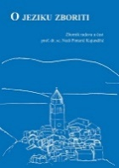
Title O jeziku zboriti : zbornik radova u čast prof. dr. sc. Nedi Pintarić Kujundžić
/ [urednici Ivana Vidović Bolt, Ivana Čagalj, Miroslav Hrdlička].
Impresum Zagreb : FF press [i. e.] Filozofski fakultet, 2023.
Description 462 str. ; 17 cm.
ISBN 9789533790961 : EUR 25,60 US$ 28,70
Subject Pintarić, Neda. Jezik i jezici. Lingvistika
UDC 81Pintarić Kujundžić, N. * 81

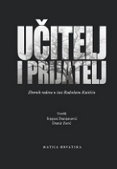
Title Učitelj i prijatelj : zbornik radova u čast Radoslavu Katičiću
/ uredili Stjepan Damjanović, Damir Zorić.
Impresum Zagreb : Matica hrvatska, 2023.
Description 476 str. : ilustr. ; 24 cm.
ISBN 9789533412382 : EUR 45,30 US$ 50,80
UDC 81Katičić, R. * 811.16
Anotation The collection contains 26 scientific papers and essays. Most of the discussions are scientific works from different areas of linguistics, to the development of which Radoslav Katičić contributed greatly, and the other part of the discussions are precious contributions of essay reviews on different segments of Katičić's professional biography. It is primarily about historical-philological topics (Croatian, Slavic, Indo-European, Indological) and ethnological.

Literature. History. Theory
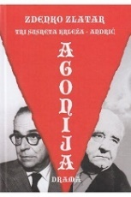
Author Zlatar, Zdenko
Title Agonija : tri susreta Krleža - Andrić
Impresum Zagreb : Izvori, 2023.
Description 160 str. ; 21 cm.
ISBN 9789532034745 : EUR 23,30 US$ 26,00
UDC 821.163.42-2
Anotation Agonija is a drama about the conflict between Miroslav Krleža and Ivo Andrić, the two greatest writers of the former Yugoslavia. The conflict between Andrić and Krleža contains the entire history of the relationship between politics and poetics during both the first - monarchist - and the second - socialist - Yugoslavia. And the Nobel committee also gets involved in this conflict. Namely. in 1958, the Union of Writers of Yugoslavia nominated Miroslav Krleža together with Ivo Andrić for the Nobel Prize. But only one of them can get it...

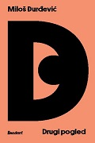
Author Đurđević, Miloš
Title Drugi pogled : o suvremenoj poeziji i povezanim temama
Impresum Zagreb : Sandorf, 2023.
Description 259 str. ; 21 cm.
ISBN 9789533514819 : EUR 20,40 US$ 22,90
Subject Hrvatsko pjesništvo -- Povijest i kritika. Pjesništvo -- Povijest i kritika. Pjesništvo -- Zbirke tekstova
UDC 821.163.42.09-1 * 82.09-1
Anotation Miloš Đurđević studiously and expertly deals with the poetic imaginary of contemporary Croatian literature, this time choosing a series of names that belong to voices beyond the dominant lyrical orientations. At the same time, he approaches the selected poets as a refined connoisseur of their oeuvre, the relationship between the text and media-mediated reality, and the task that, in the end, poetry strives to preserve in this age of technical visualization of the world as a pledge of true telling.

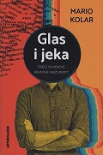
Autor Kolar, Mario
Title Glas i jeka : odjeci suvremene hrvatske književnosti
Impresum Koprivnica : Umjetnička organizacija Artikulacije, 2023.
Description 397 str. ; 21 cm.
ISBN 9789538465031 : EUR 19,80 US$ 22,10
UDC 821.163.42.09
Anotation This book clearly shows how contemporary Croatian literature resonates. In it, university professor and literary critic Mario Kolar collected about fifty criticisms, presentations, reviews, reviews, essays, prefaces, afterwords and other - as he calls them - echoes of domestic literary and Croatian production of the last decade.

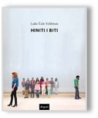
Author Čale Feldman, Lada
Title Hiniti i biti
Impresum Zagreb : Disput, 2023.
Description 308 str. ; 20 cm.
ISBN 9789532604559 : EUR 18,30 US$ 20,50
UDC 821.163.42-4 * 792.2
Anotation The book entitled Hiniti i biti is divided into three units that gather around the phenomenon of acting, i.e. mask and pretense, transformation and reshaping - as an ambiguity that not only connects text and performance but also reveals itself as a key metaphor for theoretical considerations of the problem of gender difference. It is precisely the feminist perspective, which we find in conjunction with psychoanalytical or deconstructionist criticism, that allows the author a privileged approach to researching the phenomenon of acting as an existential, cognitive, ethical, political and aesthetic problem.

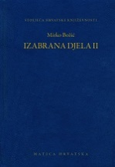
Autor Božić, Mirko
Title Izabrana djela II
/ priredio Ivan Bošković.
Impresum Zagreb : Matica hrvatska, 2023.
Description 381 str. : ilustr. ; 20 cm.
Nakl. cjelina Stoljeća hrvatske književnosti ; knj. 154
ISBN 9789531503587 : EUR 28,90 US$ 32,40
UDC 821.163.42-82(081) * 821.163.42-2

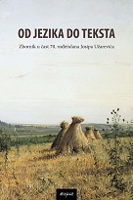
Title Od jezika do teksta : zbornik u čast 70. rođendana Josipa Užarevića
/ uredile Danijela Lugarić Vukas i Jasmina Vojvodić.
Impresum Zagreb : Disput, 2023.
Description 498 str. ; 20 cm.
Language/s Tekst na hrv., rus. i engl. jeziku.
ISBN 9789532604764 : EUR 26,90 US$ 30,10
UDC 821.163.42.09 * 821.161.1.09
Anotation The anthology consists of original, creative and inventive texts in which the authors, along with stating the views of other researchers, sovereignly present their interpretations, critical reviews, presentations and judgments. I emphasize the relevance of the theoretical assumptions of the collection for future research.

Literature. Poetry
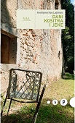
Author Kos-Lajtman, Andrijana
Title Dani kositra i jeke
Impresum Zagreb : HDP [i. e.] Hrvatsko društvo pisaca, 2023.
Description 113 str. ; 20 cm.
Note Stihovi.
ISBN 9789538152481 : EUR 15,10 US$ 16,90
UDC 821.163.42-1

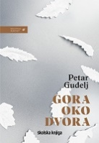
Author Gudelj, Petar
Title Gora oko dvora : lirski dnevnik
Impresum Zagreb : Školska knjiga, 2023.
Description 395 str. ; 21 cm.
Note Stihovi.
ISBN 9789530623576 : EUR 21,80 US$ 24,10
UDC 821.163.42-16
Anotation Gora oko dvora, a sort of continuation of the biography and poems Za svojim pjesmama and lyrical diary Dva ili tri ljeta, dvije ili tri zime, is an amazing book of daily / diary entries of one of the greatest living Croatian poets. It is a hybrid reading, potentially defined as poetry in prose, as a diary, as a memoir, and as narrative prose with lyrical elements.

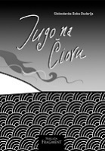
Author Đuderija, Slobodanka Boba
Title Jugo na Čiovu
Impresum Split : Naklada Fragment, 2023.
Description 80 str. ; 21 cm.
Note Stihovi.
ISBN 9789538301339 : EUR 18,60 US$ 20,80
UDC 821.163.42-1

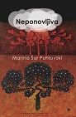
Author Šur Puhlovski, Marina
Title Neponovljiva
Impresum Zagreb : Naklada Jesenski i Turk, 2023.
Description 136 str. ; 24 cm.
Note Stihovi
ISBN 9789533810331 : EUR 14,00 US$ 15,70
UDC 821.163.42-1

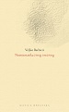
Author Barbieri, Veljko
Title Numizmatika živog i neživog
/ pogovor Boris Domagoj Biletić.
Impresum Zagreb : Matica hrvatska, 2023.
Description 108 str. ; 19 cm.
ISBN 9789533412566 : EUR 14,50 US$ 16,30
UDC 821.163.42-16
Anotation Numizmatika živog i neživog is the final part of Veljko Barbieri's poetic trilogy, which began with the titles Sto koraka po šumi (2009) and Sto šesnaest valova (2016), previously published in Matica Hrvatska.
In the new collection of poems in prose, Barbieri writes condensed meditative dedications to the Mediterranean landscape and its archetypal signs: olives, sea, storm, goat, bread. In his poetic vision, the Mediterranean is a space where ancient and Christian, mythological and religious intertwine and co-exist, creating a landscape that is both real and imaginary at the same time.

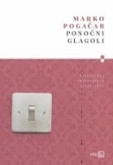
Author Pogačar, Marko
Title Ponoćni glagoli
Impresum Zagreb : V.B.Z., 2023.
Description 72 str. ; 20 cm.
Note Stihovi.
ISBN 9789535206552 : EUR 17,70 US$ 19,80
UDC 821.163.42-1

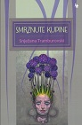
Author Tramburovski, Snježana
Title Smrznute kupine
Impresum Zagreb : Naklada Jesenski i Turk, 2023.
Description 152 str. ; 24 cm.
Note Stihovi
ISBN 9789533810324 : EUR 14,00 US$ 15,70
UDC 821.163.42-1

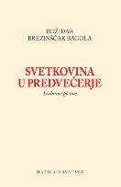
Autor Brezinščak-Bagola, Božidar
Title Svetkovina u predvečerje : izabrane pjesme
/ priredio Božidar Petrač.
Impresum Zagreb : Matica hrvatska, 2023.
Description 267 str. ; 21 cm.
ISBN 9789533412559 : EUR 26,60 US$ 29,80
UDC 821.163.42-1
Anotation Božidar Brezinščak Bagola wrote his poetic oeuvre over a period of more than half a century, creating an authentic, experienced and comprehensive poetic work that, even though it was outside the basic currents of contemporary Croatian poetry, had an enviable critical reception in Croatian literature as well. Bagola's poetics is fundamentally intimate and confessional, deeply immersed in nature and native landscape, and characterized by a vitalistic and optimistic sense of life.

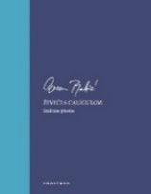
Author Babić, Goran, književnik
Title Živeći s Caligulom : izabrane pjesme
Impresum Zaprešić : Fraktura, 2023.
Description 288 str. ; 21 cm.
Note Stihovi.
ISBN 9789533586267 : EUR 17,20 US$ 19,30
UDC 821.163.42-1

Literature. Novels, short stories
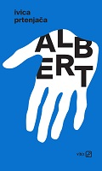
Author Prtenjača, Ivica
Title Albert
Impresum Zagreb : V.B.Z., 2023.
Description 176 str. ; 20 cm.
ISBN 9789535206644 : EUR 18,80 US$ 21,00
Anotation Albert is a literary powerful book, poetic, dramatic and deeply happy. In it, Prtenjača confronts us again and again with our gaps and superficialities, but also offers bright solutions. They are not where they keep telling us they are. The main character of this novel is a quiet rebel, similar to the walker from Brdo (The Hill), Andrej from Plivač (The Swimmer) or the co-painter from Tiho rušenje (Silent Demolition). In this series of unforgettable characters, Albert is the closest to the dream of happiness, that powerful moment in the morning, while the eyelids are still down, and the sun has already spilled over everyone and everything.

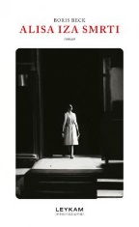
Author Beck, Boris
Title Alisa iza smrti
Impresum Zagreb : Leykam international, 2023.
Description 156 str. ; 21 cm.
ISBN 9789533401768 : EUR 17,40 US$ 19,50
Anotation The short novel "Alisa iza smrti" is focused again on love relationships that acquire a special drama and fate in a war situation. The story follows two scouts stationed at an observation post along the front, with whom, with a large dose of realism, we get to know the authentic circumstances of life on the battlefield, but also a little bit of the network of relationships between people, both defenders and enemies, whose intertwined ties go back to the past, and whose long-term and pent-up conflicts erupt in full force. Written in a superb style, with incredible turns, literature in the best light!

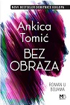
Author Tomić, Ankica
Title Bez obraza : roman u bojama
Impresum Zagreb : Media bar, 2023.
Description 306 str. ; 23 cm.
ISBN 9789538357176 : EUR 23,10 US$ 25,90
Anotation In her new novel, Ankica Tomić masterfully delves into the most important human relationships, those that define our lives. But in family relationships, in motherhood and in female friendship, nothing is ever just black and white. That is why this is a "novel in colors", colors that are sometimes bright and warm, and sometimes dark, threatening and dangerous.

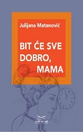
Author Matanović, Julijana
Title Bit će sve dobro, mama : (knjiga priča)
Impresum Zagreb : Umjetnička organizacija Lađa od vode, 2023.
Description 126 str. : ilustr. u bojama ; 20 cm.
ISBN 9789535071914 : EUR 13,90 US$ 15,60
Anotation The collection of stories by Julijana Matanović Bit će sve dobro, mama (It will be all right, mom) is made up of five stories accompanied by a preface and an afterword, which can also be read as a story.
All the stories in the collection are full of details, solitudes, never-said questions and many silences. And precisely what is kept silent is often the key place on which the characters stumble, unable to untangle the knots of life that hold them back.

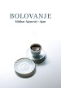
Autor Ajanović, Midhat- Ajan
Title Bolovanje
Impresum Zagreb : Ibis grafika, 2023.
Description 262 str. ; 21 cm.
ISBN 9789533631233 : EUR 18,60 US$ 20,80
Anotation In the novel Bolovanje (Illness), which tells about the loss of a loved one, parts of the novel are intertwined with the form of a diary, from which we learn important events from the life of the author and his sick wife. This novel, a confession by which the author tried to overcome the most difficult moments in his life and find a reason to continue living, describes the last months of his wife's life.

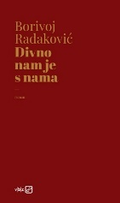
Author Radaković, Borivoj
Title Divno nam je s nama
Impresum Zagreb : V.B.Z., 2023.
Description 164 str. ; 20 cm.
ISBN 9789535206675 : EUR 18,80 US$ 21,00
Anotation In Borivoj Radaković's new novel, two heroines, Vanja and Mirna, decide to completely change their lives due to violence in the family, on the street, at the workplace and in society in general. With joy and love, they step into the unknown and discover the beauty of day and night, the streets and, above all, their own beauty. In a tender love story full of ecstasy and ecstasy, they want to live together; they plan trips and a future in which they will realize their fantasies and gain security. The only question is how much we are able to consciously change our own life and influence it.

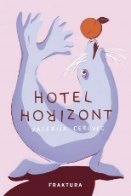
Author Cerovec, Valerija
Title Hotel Horizont
Impresum Zaprešić : Fraktura, 2023.
Description 200 str. ; 21 cm.
ISBN 9789533586373 : EUR 21,50 US$ 24,10
Anotation In her literary debut, Valerija Cerovec puts her heroes in impossible, absurd situations in meticulously designed interiors and exteriors. Hotel Horizont is a sharp satire on today's way of life, on reality shows, to our desire to look prettier, to present ourselves as better than we are, to follow fake influencers and live deeply unhappy lives.

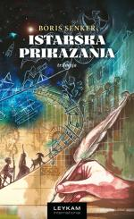
Author Senker, Boris
Title Istarska prikazanja : trilogija
Impresum Zagreb : Leykam international, 2023.
Description 208 str. : ilustr. ; 21 cm.
ISBN 9789533401751 : EUR 23,30 US$ 26,00
Žanr/Oblik Mirakuli i misteriji. Moraliteti
Anotation The Istrian stories in a series of short scenes linked by the conference follow the thousands of years of life in the Istrian area, from the appearance of the first people and their accidental discovery of the biska "to the last chorus", i.e. the totalitarian regime, in the 20th century. The common feature of the three "shows" is their brevity scene, dynamism, multilingualism and the mixing of verse and prose.


Author Tomaš, Marko
Title Knjiga za Maju
Impresum Zagreb : V. B Z., 2023.
Description 184 str. ; 20 cm.
ISBN 9789535206651 : EUR 18,80 US$ 21,00
Anotation Knjiga za Maju (The book for Maja) brings a completely intimate story, but also the story of an entire generation, torn apart by the legacy of the past and the imposed expectations of society. It is a story about many displacements and one return - above all about love, the love of fate, written without any pathos, placed only in the glittering freckles of one face. With his second novel, and perhaps his most personal work to date, Tomaš once again confirmed that he is an exceptional prose author with an already recognizable poetic sensibility for language.

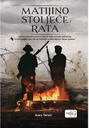
Author Šimić, Ivan, publicist
Title Matijino stoljeće rata
Impresum Zagreb : Despot Infinitus, 2023.
Description 326 str. ; 21 cm.
ISBN 9789533661490 : EUR 16,60 US$ 18,50
Anotation Matija's Century of War is an epic, so Croatian story about the 20th century, written in a superior narrative and style, which you will not read, but swallow! By intertwining fiction and real events, not caring about literary-theoretical laws and rigid genre molds, about which according to his own admission he knows little or nothing anyway, the obviously well-informed author brings testimonies about people and events in a really wide temporal and spatial scope, thus tragic fate convincingly places the titular heroines in the historical context that actually decisively determined that fate. To that extent, this book is simultaneously a Chronique du xxe siècle, as the subtitle suggests, but also a moving story about a woman who survived as many as three wars, losing in each of them one of her closest relatives.

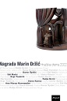
Title Nagrada Marin Držić : Hrvatska drama 2022.
Impresum Zagreb : Disput, 2023.
Description 247 str. ; 21 cm.
ISBN 9789532604696 : EUR 14,00 US$ 15,70
Anotation Dramski zbornik Nagrada Marin Držić. Hrvatska drama 2022. sadrži šest dramskih djela nagrađenih na natječaju Ministarstva kulture i medija Republike Hrvatske “Marin Držić” za 2022. godinu.
Prvonagrađena drama je Žena himna Davora Špišića.
Drugu nagradu ravnopravno dijele dramski tekst Vulnera urbis, vulnera orbis (Rane grada, rane svijeta) Edija Matića i Ples na broju 60 Espija Tomičića
Treću nagradu ravnopravno dijele Katja Grcić, Hana Konsa i Ana Maras Harmander.

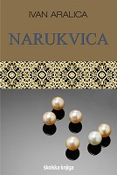
Autor Aralica, Ivan
Title Narukvica
Impresum Zagreb : Školska knjiga, 2023.
Description 692 str. ; 21 cm.
Nakl. cjelina Djela Ivana Aralice ; sv. 40
ISBN 9789530623569 : EUR 33,70 US$ 37,80
Anotation Although it is not a historical novel, Narukvica cuts into almost all important events and themes of the author's national and native history from the Second World War to the Homeland War and the aftermath: conflicts during the Second World War, Partisan-Chetnik crimes, the relationship between Zadar and the hinterland during the Italian administration of the city before war and during the war, political persecution and Croatian emigration, the Croatian Spring and its collapse, the Serbian rebellion and the Homeland War, post-war privatization...


Author Adamović, Julijana
Title Oče, ako jesi
Impresum Zaprešić : Fraktura, 2023.
Description 264 str. ; 21 cm.
ISBN 9789533586472 : EUR 23,60 US$ 26,50
Anotation Julijana Adamović wrote a magnificent novel about Pannonia - a black land that gives birth and buries. Oče ako jesi is an atypical family saga, a great novel about women and men, about political officials, about ordinary people, but above all about sons who are left without fathers and look for them all their lives instead of going their own, different way.

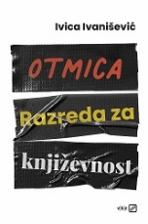
Author Ivanišević, Ivica
Title Otmica Razreda za književnost
Impresum Zagreb : V.B.Z., 2023.
Description 192 str. ; 20 cm.
ISBN 9789535206569 : EUR 18,80 US$ 21,00
Anotation Ivica Ivanišević wrote a peppery satire about the bloody image of our culture, but also of the entire society, narrated fluently, with his characteristic ease, with a lot of self-irony and humor.

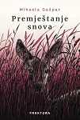
Autor Gašpar, Mihaela
Title Premještanje snova
Impresum Zaprešić : Fraktura, 2023.
Description 232 str. ; 21 cm.
ISBN 9789533586489 : EUR 23,60 US$ 26,50
Anotation Three women and three wives. Three lives and three lies. All three women had dreams that didn't happen
achieved, each was betrayed by the one they loved, the one who was supposed to be their support. Each of them suffered the most in the home, and their men were protected by relatives, friends, society... Mihaela Gašpar gives voice to those who do not speak, to those who are ashamed of their bruises and wounds, to those who fear for their lives and to those who only meet their ex-husbands in public places. The voice of those who have been let down by their loved ones. Moving dreams moves us into the "invisible" world next to us, the world to which we ourselves (un)consciously belong and which we must change.

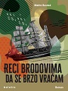
Author Rundek, Melita
Title Reci brodovima da se brzo vraćam
Impresum Zagreb : Beletra, 2023.
Description 159 str. ; 20 cm.
ISBN 9789538209604 : EUR 15,00 US$ 16,90
Anotation Reci brodovima da se brzo vraćam (Tell the ships that I'll be back soon), the second novel for adults by Melita Rundek, a favorite children's writer, deals with the relations between neighbors in a building on Zagreb's Peščenica at the beginning of the war in the 1990s.
Melita Rundek describes the war from a woman's point of view and in the novel achieves a cathartic feeling of sadness due to stopped lives and lost loves. Although the background is a reconstructed wartime reality in Zagreb and Croatia, the novel does not aim for politicization or conflict, but from the female discourse repeats the thesis that love, realized or unrealized, intimate, human, personal, is the only possible way out.

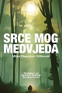
Author Majerović-Stilinović, Milan
Title Srce mog medvjeda
Impresum Zagreb : Libricon, 2023.
Description 211 str. ; 20 cm.
ISBN 9789538017216 : EUR 20,80 US$ 23,30
Anotation After the acclaimed collection "stories on the go Što sam naučio na planini (What I learned on the mountain), Milan Majerović-Stilinović tackled a genre so rare in our country by writing a novel inspired by the mountain. At the center of the story is Marko Turk, a "peculiar forest hermit" whose lair was probably stumbled upon by all those who climbed Veliki Risnjak on one of the paths from Crni Lug. After telling the story of his life, Majerović-Stilinović wrote an ode to the wilderness of Gorski kotar, but also to its natives and their way of life in the middle and end of the 19th century.

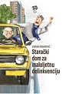
Author Srdarević, Goran
Title Starački dom za maloljetnu delinkvenciju
Impresum Zagreb : Naklada Ceres, 2023.
Description 176 str. ; 21 cm.
ISBN 9789532671070 : EUR 18,50 US$ 20,70
Anotation The novel is about ordinary people who have spent their entire lives fighting for survival, sacrificing for their families, raising children, always putting themselves last. Now that that struggle is behind them, and their grown children were born in the same hatch of life that they went through, they found themselves in a nursing home. No, instead of enjoying a peaceful old age, they refuse to submit to the outrage of their surroundings, starting with the owner and manager of the nursing home called Idila and ending with their children and grandchildren, they decide to spend the little time they have left in this world the way they think they deserve. . . Although it is a comedy, the novel through humor actually talks about a serious and somewhat contradictory topic, which awaits each of us with time.

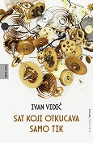
Author Vidić, Ivan, književnik
Title Sat koji otkucava samo tik
Impresum Zagreb : Hena com, 2023.
Description 344 str. ; 22 cm.
ISBN 9789532594522 : EUR 22,50 US$ 25,20
Anotation Sat koji otkucava samo tik (The clock is only ticking) is a novel about love, betrayal, revenge and crime. About the moment when the irrational dominates the situation, reason is lost in the face of feelings, anger and uncontrolled actions. When private madness becomes an "unconscious social revolution", there is no longer any difference between seriousness and farce, humor and horror, in that strange time in which it barely ticks and only - tick!

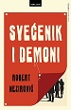
Autor Nezirović, Robert
Title Svećenik i demoni
Impresum Zagreb : Hena com, 2023.
Description 240 str. ; 21 cm.
ISBN 9789532594560 : EUR 21,40 US$ 24,00
Anotation Robert Nezirović's novel "Priest and Demons" is energetic and dynamic as the genre requires, no who done it is not in the foreground here, although, don't worry, you will find out in the end.
Through the destinies of the characters, Nezirović scans various layers of society, and in this one can clearly feel the criticism towards deviations, immorality, and corruption. The characters are not just figures that depict society, but are carefully characterized with their inner and outer demons that come to light when we least expect it.

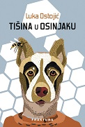
Author Ostojić, Luka
Title Tišina u osinjaku
Impresum Zaprešić : Fraktura, 2023.
Description 192 str. ; 21 cm.
ISBN 9789533586335 : EUR 21,50 US$ 24,10
Anotation The book of short stories, Tišina u osinjak by Luka Ostojić is a book that leads to dangerous, uncertain places. Welcome, then, to complicated love relationships, strange marriages and large families - places you know, but which by some miracle you have never seen before.
Clever, moving, humorous and seductively drinkable, Luka Ostojić's Silence in the Aspen is one of the wittiest domestic books you will read, but the good fun in it will have to be paid for with reflection, and with a little chill. By reading and asking: is the wasp really quiet, or do we just need to wait a little longer?

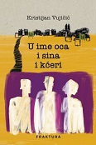
Author Vujičić, Kristijan
Title U ime oca i sina i kćeri
Impresum Zaprešić : Fraktura, 2023.
Description 296 str. ; 21 cm.
ISBN 9789533586342 : EUR 23,60 US$ 26,50
Anotation U ime oca i sina i kćeri (In the name of father and son and daughter) is a novel that takes us through the big and small mistakes of ordinary lives in an incredibly intimate and emotional way. Combining an intimate confession, philosophy and poetic reflections, this novel reminds us why it is important to love, to sin and in the end – to persevere in tenderness until the last moment. Kristijan Vujičić shows us that it is never too late to listen to the heart, follow our dreams, and that the loss of loved ones can sometimes be the driving force behind change.

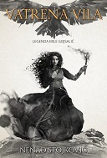
Author Stojković, Nenad, književnik
Title Vatrena vila : legenda Mile Gojsalić
Impresum Split : Naklada Bošković, 2022.
Description 340 str. ; 21 cm.
ISBN 9789532637168 : EUR 29,20 US$ 32,70
Anotation The novel shows in a new light the story of Mila Gojsalić, one of our greatest heroines, the life of the Polish Republic and the legacy of the famous Frankopans as the southern and northern wings of the Croatian Adriatic, faced with seemingly impossible balances of power in the fight against the vast Ottoman Empire. An adventure, picaresque and romance novel tailored to connect a modern audience with its incredible heritage.
Literary award Knez Trpimir for the best unpublished Croatian historical novel

Arts. General

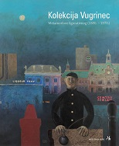
Autor: Makarun, Ema
Title: Kolekcija Vugrinec : metamorforze figurativnog (1880. - 1970.) : Muzej grada Rijeke, 14. rujna - 8. studenoga 2023.
/ [autori tekstova Ema Makarun, Zvonko Maković]
Impresum Rijeka: Muzej grada Rijeke, 2023
Description: 152 str. : ilustr. ; 28 cm
Napomene: Katalog izložbe.
ISBN 9789538303234 : EUR 23,30 US$ 26,00
UDC: 7.036/.038(083.824) * 7.074Vugrinec D.(083.824)

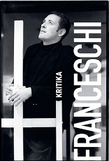
Autor Franceschi, Branko
Title Likovna kritika
Impresum Zagreb : Durieux : Hrvatska sekcija AICA, 2023.
Description 470 str. ; 21 cm.
ISBN 9789531885638 : EUR 22,60 US$ 25,30
UDC 7.036/.038(497.5) * 7.036/.038(100)
Anotation Branko Franceschi is one of the most agile and productive figures in curatorial and critical practice in Croatia at the moment, an author who has been working continuously, with undiminished intensity, as a curator and critic for more than 30 years now, and from the end of the eighties until today, his activity has significantly marked the Croatian contemporary art scene, from whatever position he performed.

Urbanism. Architecture
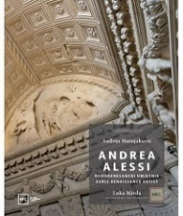
Autor Mutnjaković, Andrija
Title Andrea Alessi : ranorenesansni umjetnik = Early Renaissance Artist
Impresum Zagreb : Hrvatski fotografski centar : L. Mjeda, 2022.
Description 500 str. : ilustr. u bojama ; 31 cm.
Language/s Tekst usporedo na hrv. i na engl. jeziku.
ISBN 9789534801062 : EUR 86,20 US$ 96,50
UDC 72Aleši, A. * 73Aleši, A. * 7.034
Anotation Architect and sculptor Andrea Alessi (Andrija Aleši) belongs to the golden age of Croatian architecture, when, in the middle of the 15th century, architects Lucijan Vranjanin, Juraj Dalmatinac, Andrija Aleši and Nikola Florentinac created protagonist works of the early Renaissance in Dalmatia and Italy. Aleši is of Albanian origin, he was born in Durrës, and as a young man he studied stonemasonry in Zadar. He stayed in Dalmatia and distinguished himself by designing public and private palaces in Split, Rab and Trogir, the baptistery in Trogir, the relief of St. Jeronima and the chapel on Marjan and the chapel of St. John in Trogir and...

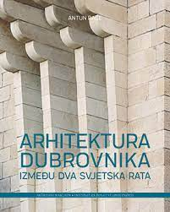
Author Baće, Antun
Title Arhitektura Dubrovnika između dva svjetska rata
Impresum Zagreb : ArTresor naklada : Institut za povijest umjetnosti, 2023. (Sveta Nedelja : Printera)
Description 611 str. : ilustr. (djelomice u bojama) ; 30 cm + Pregledna karta kataloških jedinica ([1] presavijeni list)
Note Summary: The architecture of Dubrovnik between the two world wars.
ISBN 9789537875985: EUR 69,80 US$ 78,10
Subject Hrvatska arhitektura -- Dubrovnik – Povijest. Hrvatska arhitektura -- Dubrovnik -- Povijest -- 1918.-1941.
Hrvatska arhitektura -- Dubrovnik -- Povijest -- 20. st Arhitekti -- Dubrovnik -- 20. st. Dubrovnik -- Zgrade i građevine -- Povijest
UDC 72(497.584Dubrovnik)(091)

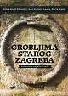
Autor Rajić Šikanjić, Petra
Title Grobljima starog Zagreba : znanstveno-popularni vodič
Impresum Zagreb : Medicinska naklada : 2023.
Description 198 str. : ilustr. ; 27 cm.
ISBN 9789533681214 : EUR 23,00 US$ 25,70
Subject Groblja – Zagreb. Zagreb -- Povijest
UDC 718(497.521.2) * 726.8(497.521.2) * 94(497.521.2)

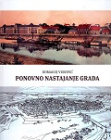
Author Vuković, Domagoj
Title Ponovno nastajanje grada
Impresum Petrinja : Matica hrvatska, Ogranak, 2022.
Description 195 str. : ilustr. (pretežno u bojama) ; 28 cm.
Note Summary. Imensko kazalo ; Kazalo mjesta.
ISBN 9789536668823 : EUR 29,10 US$ 32,60
Subject Urbanizam -- Sisak – Povijest. Hrvatska arhitektura -- Sisak – Povijest. Sisak -- Povijest
UDC 94(497.5)".../0630" * 94(497.527Sisak)"-00/+19" * 711.4(497.527Sisak)(091) * 72(497.527Sisak)(091)

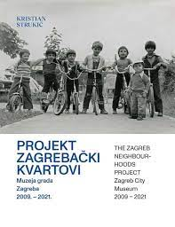
Author Strukić, Kristian
Title Projekt Zagrebački kvartovi Muzeja grada Zagreba 2009. - 2021. = The Zagreb neighbourhoods project Zagreb City Museum 2009 – 2021
/ [autor i voditelj projekta, author and project manager Kristian Strukić ; urednica, editor Milena Bušić].
Impresum Zagreb : Muzej grada Zagreba = Zagreb City Museum, 2023.
Description 164 str. : ilustr. (djelomice u bojama) ; 29 cm.
Language/s Tekst usporedo na hrv. i na engl. jeziku.
ISBN 9789538496011 : EUR 19,30 US$ 21,70
Subject Zagrebački kvartovi (projekt) -- Katalozi izložbi. Urbanizam -- Zagreb -- Katalozi izložbi. Zagreb -- Povijest -- Katalozi izložbi
UDC 711.5(497.521.5) * 316.334.56(497.521.2) * 94(497.521.2)

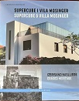
Author Ivanković, Vedran, arhitekt
Title Supercube i Vila Mosinger : izbrisano naslijeđe = Supercube & Villa Mosinger : erased heritage
/ Vedran Ivanković ; [prijevod na engleski jezik Andy Jelčić].
Impresum Zagreb : ArTresor naklada, 2023.
Description 115 str. : ilustr. (djelomice u bojama) ; 26 cm.
Language/s Tekst usporedo na hrv. i na engl. jeziku.
ISBN 9789538012563 : EUR 26,70 US$ 29,90
Subject Šterk, Vladimir. Vila Mosinger. Ladanjska arhitektura – Zagreb. Moderna arhitektura -- Zagreb
UDC 728.84(497.521.2) * 72.036(497.521.2) * 72Šterk, V.

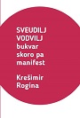
Author Rogina, Krešimir
Title Sveudilj vodvilj : bukvar skoro pa manifest
Impresum Zagreb : Meandarmedia, 2023.
Description 172 str. ; 18 cm.
ISBN 9789533343297 : EUR 16,10 US$ 18,10
Subject Hrvatska arhitektura -- 21. st.
UDC 72(497.5)

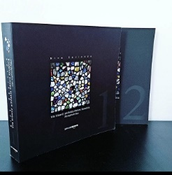
Author Gazivoda, Nina
Title Vila Vrbanić arhitekta Viktora Kovačića 1-2 : das englische Haus
Impresum Zagreb : UPI-2M plus, 2023.
Description 2 sv. (1018 str.) : ilustr. (djelomice u bojama) ; 22 cm.
ISBN 9789537703684 (Cjelina) : EUR 95,70 US$ 107,20
UDC 72Kovačić, V. * 728.84(497.521.2) * 72.036/.038(497.521.2)
Anotation The research, valorization and established value of Viktor Kovačić's architectural achievement in the integrally designed Villa Vrbanić in Zagreb contributes to the knowledge of Kovačić's influential oeuvre in modern Croatian architecture, and the identified influences and interaction with English architecture at the turn of the 19th and 20th centuries adds to the established value. and the European context.

Sculpture

Author Meštrović, Ivan, kipar
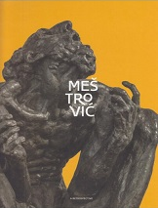
Title Ivan Meštrović : exhibition commemorating the 140th anniversary of birth : Klovićevi Dvori Gallery, Zagreb, 22 November 2023 - 3 March 2024 = Ivan Meštrović : izložba povodom 140. obljetnice rođenja : Galerija Klovićevi dvori, Zagreb 22. studenoga 2023. - 3. ožujka 2024.
/ [texts Petra Vugrinec, Barbara Vujanović ; editors Iva Sudec Andreis, Petra Vugrinec, Barbara Vujanović].
Impresum Zagreb : Klovićevi dvori Gallery ; Split : Ivan Meštrović Museums, 2023.
Description 340 str. : ilustr. u bojama ; 28 cm.
Note Katalog izložbe.
Language/s Tekst usporedo na engl. i na hrv. jeziku.
ISBN 9789532711509 : EUR 46,50 US$ 52,10
Subject Meštrović, Ivan, kipar -- Katalozi izložbi. Meštrović, Ivan, kipar -- Kronologija
UDC 73Meštrović, I.

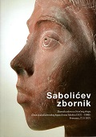
Author Stručni skup "Život i rad akademskog kipara Ivana Sabolića (1921-1986)" (2021 ; Peteranec)
Title Sabolićev zbornik : zbornik radova sa stručnog skupa »Život i rad akademskog kipara Ivana Sabolića (1921 – 1986)", Peteranec, 17. 9. 2021.
/ [urednik Robert Čimin].
Impresum Koprivnica : Muzej grada Koprivnice, 2023.
Description 144 str. : ilustr. ; 24 cm.
ISBN 9789538138942 : EUR 48,40 US$ 54,20
Subject Sabolić, Ivan, kipar -- Zbornici s konferencija. Hrvatsko kiparstvo -- 20. st. -- Zbornici s konferencija
UDC 73Sabolić, I.

Drawing. Applied arts and crafts


Author Marks, Aleksandar
Title Aleksandar Marks
/ [urednica Maja Cepetić Rogić ; prijevod sažetaka na engleski jezik Tena Bukna izrada kazala Marina Junger].
Impresum Čazma : Centar za kulturu Čazma, 2022.
Description 148 str. : ilustr. (pretežito u bojama) ; 28 cm.
ISBN 9789538083112 : EUR 27,80 US$ 31,10
UDC 741Marks, A. * 791.228Marks, A.
Anotation The work of Aleksander Marks is extremely significant in terms of the earliest animation in our area. He was the main cartoonist of the first Croatian cartoon in color, "Red Riding Hood", in 1954. He worked in different cartoon studios, and since 1956 and the founding of the Zagreb Film Cartoon Studio, he has been employed there until his retirement. He is the originator of the distinctly modern artistry of cartoons, which gave rise to the term Zagreb School of Cartoons. Although an award-winning author of an animated film in the country and abroad, in today's broader social discourse, Marks remains unknown and unrecognized, even in the local community.

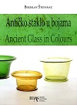
Author Štefanac, Berislav
Title Antičko staklo u bojama = Ancient glass in colours
/ Berislav Štefanac ; [urednik, editor Hrvoje Manenica
Impresum Zadar : Muzej antičkog stakla = The Museum of Ancient Glass, 2022.
Description 96 str. : ilustr. u bojama, zemljop. crteži u bojama ; 28 cm.
Note Katalog izložbe održane u Muzeju antičkog stakla, Zadar, od 12. listopada do 25. studenoga 2022.
Language/s Usporedo hrv. tekst i engl. prijevod.
ISBN 9789538320088 : EUR 21,40 US$ 24,00
Subject Antičko staklo – Dalmacija. Bojano staklo -- Dalmacija -- Stari vijek
UDC 748.032(497.58)

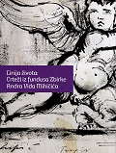
Author Mihičić, Andro Vid
Title Linija života : crteži iz fundusa Zbirke Andra Vida Mihičića = Line of life : Drawings from the holdings of the Andro Vid Mihičić Collection : [Lošinjski muzej, palača Fritzi, 28. lipnja - 01. rujna 2023.]
Impresum Mali Lošinj : Lošinjski muzej, 2023
Description 128 str. : ilustr. (pretežno u bojama) ; 28 cm
Note Katalog izložbe. - Tekst na hrv. i na engl. jeziku.
ISBN 9789537902445 : EUR 29,00 US$ 32,50
Subject Mihičić, Andro Vid -- Život i djelo
UDC 7.021.22Mihičić, A. V.(083.824) * 7.072Mihičić, A.V.

Paintings
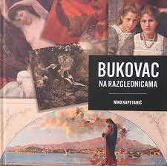
Author Kapetanić, Niko
Title Bukovac na razglednicama
Impresum Cavtat : Muzeji i galerije Konavala, 2022.
Description 196 str. : ilustr. u bojama ; 24 cm.
ISBN 9789537226398 : EUR 30,90 US$ 34,60
Subject Bukovac, Vlaho -- Na razglednicama
UDC 75Bukovac, V. * 676.813

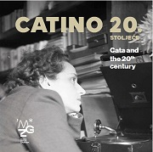
Title Catino 20. stoljeće = Cata and the 20th century : [Muzej grada Zagreba listopad 2023. – veljača 2024.]
/ [tekst, text Leonida Kovač, Martina Kokolari, Vesna Vukelić Horvatić ; prijevod, translation Marina Schuman].
Impresum Zagreb : Muzej grada Zagreba, 2023.
Description 156 str. : ilustr. ; 23 cm.
Note Katalog izložbe.
Language/s Tekst usporedo na hrv. i na engl. jeziku.
ISBN 9789538496035 : EUR 24,20 US$ 27,10
Subject Dujšin-Ribar, Cata -- Katalozi izložbi
UDC 75Dujšin-Ribar, C. * 821.163.42.09Dujšin-Ribar, C.

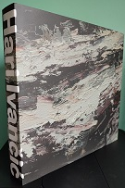
Author Ivančić, Hari
Title Hari Ivančić
/ [autorica teksta, text by Ivana Mance Cipek ; urednici, editors Hari Ivančić, Ketrin Milićević Mijošek
Impresum Pula = Pola : Muzej suvremene umjetnosti Istre = Museo d'arte contemporanea dell'Istria = Museum of contemporary art of Istria, 2022
Description 346 str. : ilustr. u bojama ; 29 cm
Napomene Katalog izložbe. - Tekst na hrv. i na engl. jeziku.
ISBN 9789538194139 : EUR 104,80 US$ 117,40
UDC: 75 Ivančić, H.(083.824)

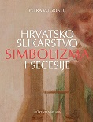
Autor Vugrinec, Petra
Naslov Hrvatsko slikarstvo simbolizma i secesije
Impresum Zagreb : ArTresor naklada : Galerija Klovićevi dvori, 2023.
Materijalni opis 495 str. : ilustr. u bojama ; 29 cm.
Notes Summary. Imensko kazalo.
ISBN 9789538012662 : EUR 66,70 US$ 74,70
Predmet Simbolizam (likovne umjetnosti) – Hrvatska. Secesija – Hrvatska. Hrvatsko slikarstvo -- 1890.-1900.
Hrvatsko slikarstvo -- 1990.-1910. Hrvatsko slikarstvo -- 1910.-1920.
UDK 75.036.4(497.5) * 75.035.93(497.5)


Title Ivan Rabuzin i simbolika prirode u umjetnosti 20. i 21. stoljeća : [zbornik radova s virtualnog simpozija povodom 100. obljetnice rođenja Ivana Rabuzina (Ključ, kod Novog Marofa, 27. ožujka 1921. - Varaždin, 18. prosinca 2008.) održanog 25. i 26. ožujka 2021.] = Ivan Rabuzin and Nature Symbolism in the Art of the 20th and the 21st Century : [proceedings of the virtual symposium marking the centenary of the birth of Ivan Rabuzin (Ključ by Novi Marof, March 27, 1921 - Varaždin, December 18, 2008) held on March 25 and 26, 2021]
/ urednici, editors Svjetlana Sumpor, Ivana Mance Cipek, Petar Prelog
Impresum Zagreb : Hrvatski muzej naivne umjetnosti : Institut za povijest umjetnosti, 2023.
Description 360 str. : ilustr. u bojama ; 24 cm.
Language/s Tekst usporedo na hrv. i na engl. jeziku.
ISBN 9789533730325 : EUR 29,10 US$ 32,60
Subject Rabuzin, Ivan -- Zbornici s konferencija. Likovne umjetnosti -- 20. st. -- Teme i motivi.
UDC 75Rabuzin, I. * 7.047 * 7.036/.038

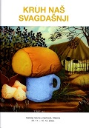
Autor Kušenić, Helena
Title Kruh naš svagdašnji : Galerija naivne umjetnosti, Hlebine, 25. 11. - 15. 12. 2022.
Impresum Koprivnica : Muzej grada Koprivnice, 2022.
Description 55 str. : ilustr. (pretežno u bojama) ; 24 cm.
Note Katalog izložbe.
ISBN 9789538138843 : EUR 16,10 US$ 18,10
Subject Naivno slikarstvo -- Hrvatska -- 2010.-2020. -- Katalozi izložbi. Naivno slikarstvo -- Hrvatska -- 2020.-2030. -- Katalozi izložbi
UDC 75.031.4(497.5) * 73.031.4(497.5)

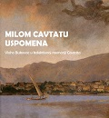
Title Milom Cavtatu uspomena : Vlaho Bukovac u kolektivnoj memoriji Cavtata : Kuća Bukovac, 29. listopada - 31. ožujak 2023. / [autor izložbe Helena Puhara ; autori tekstova Jelena Beželj ... et al.].
Impresum Cavtat : Muzeji i galeriji Konavala, 2022. ([Sveti Ivan Zelina] : Tiskara Zelina)
Description 127 str. : ilustr. u bojama ; 23 cm.
Note Katalog izložbe otvorene povodom 100. obljetnice smrti Vlaha Bukovca.
ISBN 9789537226411 : EUR 23,30 US$ 26,00
Subject Bukovac, Vlaho -- Katalozi izložbi. Cavtat -- U umjetnosti -- Katalozi izložbi
UDC 75Bukovac, V.

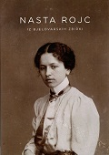
Author Rojc, Nasta
Title Nasta Rojc: Iz bjelovarskih zbirki : Gradski muzej Bjelovar, siječanj 2023.
/ [tekst i urednica Ana Drveni].
Impresum Bjelovar : Gradski muzej Bjelovar, 2023.
Description 63 str. : ilustr. u bojama ; 30 cm.
Note Katalog izložbe.
ISBN 9789537236373 : EUR 12,30 US$ 13,60
Subject Rojc, Nasta -- Katalozi izložbi. Rojc, Nasta -- Interpretacije i kritike. Rojc, Nasta -- Fotografske zbirke -- Katalozi izložbi
UDC 069.5:75Rojc, N. * 75Rojc, N.

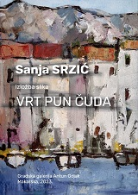
Author Srzić, Sanja
Title Vrt pun čuda : izložba slika : [Gradska galerija Olomouc, 30. studeni 2022. - 21. siječnja 2023. = Galerie mĕsta Olomouce = Olomouc City Gallery, November 30 - January 21, 2023]
/ [predgovor, foreword [i, and] urednik, editor Josip Karamatić
Impresum Makarska : Gradska galerija Antun Gojak, 2023.
Description 82 str. : ilustr. u bojama ; 30 cm.
Note Katalog izložbe.
Language/s Tekst na hrv. i engl. jeziku.
ISBN 9789537519209 : EUR 16,10 US$ 18,10
UDC 75Srzić, S.

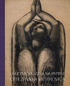
Author Meštrović, Ivan
Title Umjetnička vizija na papiru: crteži Ivana Meštrovića : izložba povodom 140. obljetnice rođenja Ivana Meštrovića : Galerija Meštrović, Split, 30. ožujka - 28. svibnja 2023.
/ [tekst i kataloška obrada Zorana Jurić Šabić ; autor fotografije Zoran Alajbeg].
Impresum Split : Muzeji Ivana Meštrovića, 2023.
Description 102 str. : ilustr. ; 26 cm.
Note Katalog spomen-izložbe.
ISBN 9789537396824 : EUR 16,10 US$ 18,10
Subject Meštrović, Ivan, kipar -- Katalozi izložbi
UDC 75Meštrović, I.

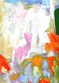
Author Trostmann, Josip
Title Vatrena paleta Pinove jeseni : retrospektivna izložba : Umjetnička galerija Dubrovnik = The Fiery Palette of Pino's Autumn : A Retrospective exhibition : Museum of Modern Art Dubrovnik
/ Josip Trostmann ; [autorica tekst, author of the text Andrea Batinić
Impresum Dubrovnik : Umjetnička galerija, 2023.
Description 197 str. : ilustr. u bojama ; 32 cm
Note Katalog izložbe
Language/s Tekst na hrv. i na engl. jeziku.
ISBN 9789538316234 : EUR 34,70 US$ 38,90
UDC 75Trostmann, J.(083.824)

Graphics
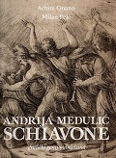
Title Andrija Medulić Schiavone : grafički genij manirizma : [IX. dani grafike, 7. rujna - 3. prosinca 2023.]
/ [autori tekstova Chiara Callegar ... et al.] ; urednici Achim Gnann, Milan Pelc ; [prijevod s talijanskog i njemačkog Milan Pelc]
Impresum Osijek : Muzej likovnih umjetnosti, 2023
Description 308 str. : ilustr. u bojama ; 30 cm
ISBN 9789538142420 : EUR 48,40 US$ 54,20
Subject Medulić, Andrija -- Katalog izložbe. Medulić, Andrija -- Život i djelo
UDC 76Medulić, A.(083.824) * 76(497.543Osijke)(083.824)

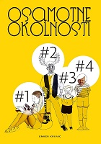
Autor Krivac, Enver
Title Osamotne okolnosti : grafičko-literarni magazin
Impresum Zagreb : V. B. Z., 2023.
Description 236 str. : ilustr. u bojama ; 25 cm.
ISBN 9789535206330 : EUR 38,90 US$ 43,60
UDC 76Krivac, E.
Anotation Osamotne okolnosti is something completely different: a fused graphic-literary magazine in which the author, the cheekily multi-talented Enver Krivac, drew and wrote four issues of the newspaper, combined them into an art book that, with contemporary art, stifled correctness and calculations, has absolutely nothing connections. This is a compendium of art that we already forgot existed, let's say those of American underground comics with all their provocations of a formal and substantive nature, anarcho-liberal outbursts and (auto)irony.

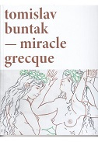
Author Buntak, Tomislav
Title Tomislav Buntak - Miracle Grecque : 15. lipnja - 23. srpnja 2023. = June 15th – July 23rd 2023 : grafička mapa = graphic portfolio : edicija Biškupić = edition Biškupić
/ [autori tekstova, text authors Željko Marcijuš, Luko Paljetak, Tomislav Buntak ;
Impresum Zagreb : Galerija Klovićevi dvori, 2023.
Description 124 str. : ilustr. u bojama ; 28 cm.
ISBN 9789537072650 : EUR 17,40 US$ 19,50
Subject Buntak, Tomislav -- Katalozi izložbi
UDC 76Buntak. T. * 75Buntak, T.

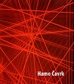
Author Čavrk, Hamo
Title Dolazak - Carta incognita
/ autorica teksta i urednica kataloga Marijana Dlačić ; fotografije Branko Babić ... et al.]
Impresum Mali Lošinj : Lošinjski muzej, 2023
Description: 74 str. : ilustr. ; 23 cm
Note Katalog izložbe.
ISBN 9789537902438 : EUR 24,20 US$ 27,10
UDC: 76Čavrk, H.(083.824)

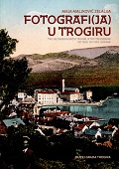
Photography

Autor Maljković Zelalija, Maja
Title Fotografi(ja) u Trogiru : tko je ovjekovječio Trogir, a tko Trogirane od 1850. do 1950. godine.
Impresum Trogir : Muzej grada Trogira, 2022. (Trogir : Grafički studio Mario)
Description 99 str. : ilustr. ; 25 cm.
ISBN 9789537677312 : EUR 32,30 US$ 36,10
Subject Hrvatska fotografija -- Trogir -- 19. st. Hrvatska fotografija -- Trogir -- 20. st. Fotografi -- Trogir
UDC 77(497.583Trogir) * 7-051(497.5)

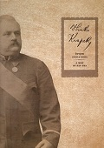
Author Kočevar, Sanda
Title Hinko Krapek : čovjek svoga doba = a man of his era
Impresum Karlovac : Muzeji grada Karlovca, 2023.
Description 255 str. : ilustr. u bojama ; 31 cm.
Language/s Tekst usporedo na hrv. i na engl. jeziku.
ISBN 9789538468018 : EUR 24,20 US$ 27,10
UDC 77Krapek, H.
Anotation The monographic presentation of Hink Krapek's life and works brings together information from archival material, museum material and documentation, newspaper articles, and other forms of printed material from the time, as well as various scientific and professional texts, which contributes to the unification of knowledge from different sources and the audience's familiarity with Hink Krapek, as well as the context of his activity. At the same time, it positions Karlovac as one of the important centers in the history of photography in the 19th century.

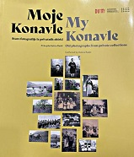
Author Margaretić, Barbara ; Kovačić, Ljiljana
Title Moje Konavle: stare fotografije iz privatnih zbirki = My Konavle: old photographs from private collections
Impresum Dubrovnik : Dubrovački muzeji, 2022.
Description 250 str. : ilustr. ; 28 cm.
Note Katalog izložbe.
Language/s Tekst na hrv. i engl. jeziku.
ISBN 9789538311000 : EUR 45,90 US$ 51,40
Anotation On the 250 pages of the catalog, segments of the traditional way of life are documented through eight thematic units, starting with
family photos, individual portraits, widely recognizable traditional clothing, photos of children, photos of everyday life such as agricultural work, photos of
cultural monuments, traditional architecture, public and church events. The photo catalog contains the title, place and time of creation, the author of the
photo, and the name of the person or participant and their year of birth and death. The time period covered is from the last decades of the 19th century,
when the oldest photographs date to the 60s of the 20th century, and most of them were created between the two world wars.

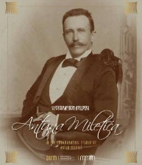
Author Filipović, Marina, fotografkinja
Title U fotografskom atelijeru Antuna Miletića = In the photographic studio of Antun
/ [uredništvo editorial board Ana Kaznačić Škurić, Domagoj Perkić, Lucija Vuković].
Impresum Dubrovnik : Dubrovački muzeji, 2022. ([Sveti Ivan Zelina] : Tiskara Zelina)
Description 243 str. : ilustr. ; 28 cm.
Note Katalog izložbe.
Language/s Tekst kataloga na hrv. i engl. jeziku.
ISBN 9789538311055 : EUR 36,60 US$ 41,00
UDC 77Miletić, A. * 77.041(497.5)
Anotation Antun Miletić from Dubrovnik is one of the most important studio photographers who worked from the late 1880s until 1925.
The first part of the catalog presents the life and professional activity of Antun Miletić. Also, new knowledge about Miletić's extremely rich socio-cultural
and political activity was presented. In the second part of the catalog, over 380 photographs are described, most of which are from the holdings of
Dubrovnik museums, and some of which are on loan from private owners and collectors.

Film. Theatar
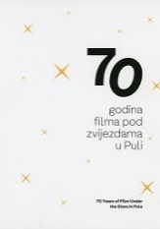
Title: 70 godina filma pod zvijezdama u Puli = 70 years of film under the stars in Pula
/ [urednice, editors Sanela Pliško, Lana Skuljan Bilić ; autori tekstova, authors Darko Dukovski ... [et al.] ;
prijevod na engleski jezik, english translation Nina Grković, Ljiljana Kragulj]
Impresum Pula : Pulski filmski festival, 2023
Description 292 str. : ilustr. u bojama ; 27 cm
Language/s Tekst usporedo na hrv. i na engl. jeziku
ISBN 9789535964773 : EUR 64,50 US$ 72,30
Subject Filmski festivali -- Pula -- Povijest
UDC 791.65.079(497.571Pula)(091)

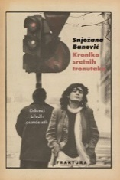
Author Banović, Snježana
Title Kronika sretnih trenutaka : odlomci iz ludih Osamdesetih
Impresum Zaprešić : Fraktura, 2023.
Description 320 str. ; 21 cm.
ISBN 9789533586243 : EUR 21,50 US$ 24,10
Subject Banović, Snježana – Autobiografija. Popularna kultura – Zagreb. New wave – Hrvatska. Teatrologinje -- Hrvatska -- Autobiografije
UDC 792.072Banović, S. * 316.723(497.521.2)
Anotation The eighties of the twentieth century became mythical - music, the feeling of freedom, the loosening of rigid socialism, technological progress, faith in a better future, but above all popular culture created a time that was different and unique. Snježana Banović was born in a happy moment to live in Zagreb in those years, a city that "emerges from a dream", where "music comes from the basement and the roof"... and to be one of the active and important protagonists of the new wave scene, and later also of the cultural and theater scene .

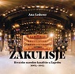
Author Lederer, Ana
Title Zakulisje : Hrvatsko narodno kazalište u Zagrebu : 2005.-2013.
Impresum Zagreb : Hrvatska akademija znanosti i umjetnosti, 2023.
Description 405 str. : ilustr. u bojama ; cm.
Bib./Saž./Kaz. Bibliografija. Kazalo
ISBN 9789533474489 : EUR 40,70 US$ 45,60
Subject Hrvatsko narodno kazalište (Zagreb) – Povijest. Hrvatsko kazalište -- Zagreb -- 21. st. Hrvatsko kazalište -- 2000.-2020.
UDC 792(497.521.2)

Sports
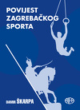
Autor Škarpa, Damir
Title Povijest zagrebačkog sporta : (1363.- 1941.)
Impresum Zagreb : Alfa, 2023.
Description 140 str. : ilustr. ; 23 cm.
Note Bibliografija: str. 136-138.
ISBN 9789533645063 : EUR 19,20 US$ 21,60
Subject Sport -- Zagreb -- Povijest
UDC 796(497.521.2)

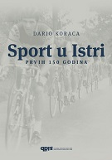
Author Koraca, Dario
Title Sport u Istri : prvih 150 godina
Impresum Pula : Povijesni i pomorski muzej Istre, 2022.
Description 443 str. : ilustr. (pretežno u bojama) ; 29 cm.
ISBN 9789537695170 : EUR 48,40 US$ 54,20
Subject Sport -- Pula (Hrvatska) -- Povijest
Žanr/Oblik Fotomonografije
UDC 796(497.571Pula)(091)

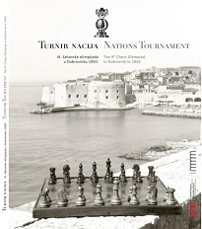
Author Marunčić, Tonko
Title Turnir nacija : IX. šahovska olimpijada u Dubrovniku 1950 = Nations tournament : the 9th Chess Olympiad in Dubrovnik in 1950 : Knežev dvor = Rector Palace, 20. 8. - 15. 11. 2020.
Impresum Dubrovnik : Dubrovački muzeji, 2022.
Description 149 str. : ilustr. (pretežno u bojama), faks. ; 28 cm.
Note Katalog izložbe.
Language/s Tekst kataloga usporedo na hrv. i engl. jeziku.
ISBN 9789538311116 : EUR 36,60 US$ 41,00
UDC 794.1.09(497.584Dubrovnik)(091) * 656.835:794.1
Anotation The central part of the catalog contains texts about candidacy, preparations and the course of the IX. of the Chess Olympiad, where the Yugoslav FNR national team won the podium. Finally, the original chess pieces from that Olympiad, as well as its later versions, are described. In addition to nine thematic units, the catalog contains 181 photographs and 156 professionally processed catalog units. IX. the 1950 Chess Olympiad had an exceptional sporting, touristic and cultural contribution to the development of Dubrovnik in the second half of the 20th century.

