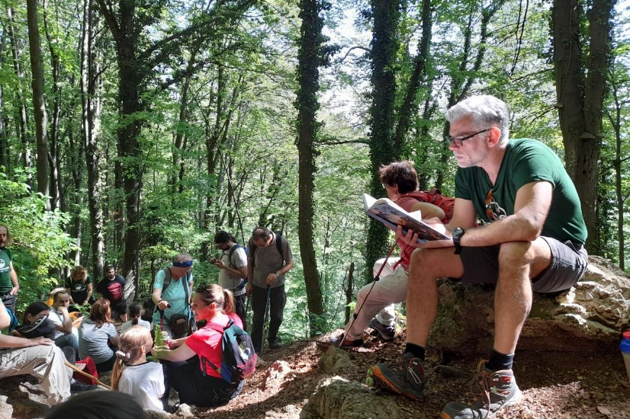



Introducing New Books from Croatia 3/2023

ZEBRA komunikacije d.o.o., Dubašnička 12,
10000 Zagreb – Croatia
www.zebrakom.hr
info@zebrakom.hr, tel./fax 385 1 3668 993

Social Sciences. Humanities.
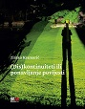
Author Kramarić, Zlatko, filolog
Title (Dis)kontinuiteti ili ponavljanje povijesti
Impresum Zagreb : Meandarmedia, 2023.
Description 224 str. ; 20 cm.
ISBN 9789533343259 : EUR 22,60 US$ 25,10
Subject National identity -- Balkan region. Collective memory -- Political aspects -- Balkan region
Historiography -- Political aspects
UDC 323.1(497) * 316.347(497) * 316.72:93(497)
Anotation The book deals with current and acute topics, processes and dilemmas of the Croatian ideological-political and cultural context, where (inevitably) significant aspects and conflicting experiences from the common ex- and post-Yugoslav history are included, as well as numerous examples of mutual cultural contacts and fruitful intersections (first of all, with the Macedonian situation and the so-called Macedonian "question", which is not strange, considering that the author of the book is a prominent Macedonian by his subspecialist vocation).

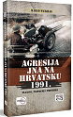
Author Werhas, Mario
Title Agresija JNA na Hrvatsku 1991. : planovi, pripreme i provedba
Impresum Zagreb : Despot Infinitus, 2023.
Description 212 str. : ilustr. ; 23 cm.
ISBN 9789533660899 : EUR 23,10 US$ 25,60
Subject Jugoslavija (1942-1992). Jugoslavenska narodna armija. Domovinski rat (1991.-1995.) -- Jugoslavenske vojne postrojbe
UDC 355.31(497.1)(091) * 355.48(497.5)
Anotation Today in Croatian historiography, there are a handful of books and articles (popular, professional and scientific) that deal with various aspects of the Homeland War (military operations, memories of participants, war crimes... etc.), but rarely does any of the above provide an overview of the main events from the decisive 1991. years. This is precisely why the fundamental purpose of this book is to provide a synthesis of the main events through the prism of the Yugoslav People's Army on the one hand, and the Croatian Defense Forces on the other (the basic and special police of the Ministry of the Interior of the Republic of Croatia, the National Guard Corps, and then the Croatian Army and National Protection units). .

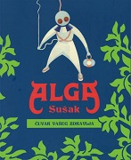
Author Pintur, Marin
Title Alga Sušak - čuvar vašeg zdravlja : [izložba : Muzej grada Rijeke, od 28. veljače - 31. svibnja 2023.]
/ [Autori izložbe i kataloga Marin Pintur, Kristina Pandža, Rafaela Ban ; fotografije Doris Fatur].
Impresum Rijeka : Muzej grada Rijeke, 2023.
Description 163 str. : ilustr. (pretežno u bojama), faks. ; 26 cm.
Note Katalog izložbe.
ISBN 9789539828361 : EUR 24,40 US$ 27,10
Subject Alga (Rijeka) -- Povijest – Izložbe. Farmaceutska industrija -- Rijeka -- Povijest – Izložbe. Rijeka -- Sušak -- Povijest -- Izložbe
UDC 661.12(497.561Rijeka)(091) * 615(497.561Rijeka)(091)

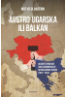
Author Globačnik, Matko
Title Austro-Ugarska ili Balkan : gledište hrvatske socijaldemokracije na Balkanske ratove (1912.-1914.)
Impresum Zagreb : Plejada, 2023.
Description 151 str. : ilustr. ; 23 cm.
Note Imensko kazalo.
ISBN 9789537782900 : EUR 34,80 US$ 38,60
Subject Socijaldemokracija -- Hrvatska -- 1868.-1918. Balkanski ratovi (1912.-1913.) -- Hrvatsko javno mnijenje
UDC 329.14(497.5)(091) * 94(497.5)"1912/1914" * 355.48(497):316.653(497.5)
Anotation The book analyzes the "foreign policy" of Croatian social democracy during the Balkan wars, i.e. at the time of the most intense relations between Croatian social democrats (V. Korać, V. Bukšeg, J. Demetrović and others) and their comrades from the Balkan countries (D. Tucović, D. Lapčević, D. Blagoev, J. Sakazov and others) before the First World War. The research on relations between socialists was carried out using an innovative methodology and on the basis of unused sources, such as the minutes of the Main Committee of the Social Democratic Party of Croatia and Slavonia, and was placed in the context of discussions on the national question of the South Slavs led by the most relevant European socialist theoreticians (K. Kautsky, H. Wendel , O. Bauer, K. Renner, etc.).

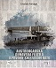
Author Freivogel, Zvonimir
Title Austrougarska Dunavska flotila u Prvome svjetskom ratu
Impresum Zagreb : Despot Infinitus, 2023.
Description 180 str. : ilustr. ; 28 cm.
ISBN 9789533661148 : EUR 34,80 US$ 38,60
UDC 359(436+439)(091) * 623.82(436+439)(091)
Anotation Austria-Hungary was also known as the Danube Monarchy because the Danube River, as an important traffic route, connected several countries of the Monarchy to each other, as well as to the Black Sea. The river also served as a border with some less stable neighbors, and during the Turkish presence in the Balkans, the Austrian Empire had a strong Danube flotilla with warships with sails and rudders. In the second half of the 19th century, the construction of the imperial and royal Danube flotillas equipped with steam-powered warships began. During World War I, Austria-Hungary operated ten monitors on the Danube, along with dozens of patrol boats, armed steamers and auxiliary warships. The history and fate of all these vessels are listed here, together with the history of their development,

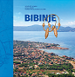
Title Bibinje
/ urednici Ante Bralić, Ante Gverić ; [prijevod sažetaka na engleski jezik Boris Blažina].
Impresum Zadar : Sveučilište u Zadru, 2022.
Description 655 str. : ilustr., zemljop. karte u bojama, graf prikazi, note ; 30 cm.
Note Predgovor urednika: str. [6-7]
Bibliografija iza svakog poglavlja i uz tekst. Summaries.
ISBN 9789533313597 : EUR 48,60 US$ 53,90
Subject Bibinje
UDC 908(497.581.1Bibinje)

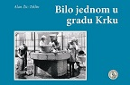
Author Žic-Teklin, Alan
Title Bilo jednom u gradu Krku
Impresum Rijeka : Pandora gong, 2023.
Description 224 str. : ilustr. ; 17 X 24 cm.
Note Bibliografija
ISBN 9789534814161 : EUR 37,10 US$ 41,20
Subject Krk (grad) -- Zgrade i građevine – Fotografije. Krk (grad) -- Društveni život i običaji -- 20. st.
UDC 930.85(497.561Krk) * 39(497.561Krk) * 728.3(497.561Krk)

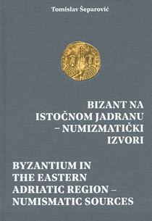
Author Šeparović, Tomislav
Title Bizant na istočnom Jadranu : numizmatički izvori = Byzantium in the eastern Adriatic region : numismatic sources
Impresum Split : Muzej hrvatskih arheoloških spomenika, 2021.
Description 276 str. : ilustr. u bojama, table ; 24 cm.
Nakl. cjelina Katalozi i monografije / Arheološki muzej, Split ; 2
Language/s Tekst usporedo na hrv. i na engl. jeziku.
Note. Bibliografija: str. 241-253; bibliografske bilješke. Imensko kazalo.
ISBN 9789536803774 : EUR 32,40 US$ 36,00
Subject Bizantski novac -- Dalmacija – Katalozi. Numizmatika. Dalmacija -- Bizantske starine
UDC 904:737(497.58)"653" * 737.1(497.58)

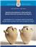
Author Radić Rossi, Irena
Title Brodolom rimskog trgovačkog broda kod rta Glavata na Mljetu = Shipwreck of a Roman merchantman near Cape Glavat on the island of Mljet
/ Irena Radić Rossi, Igor Borzić ; [prijevod na engleski jezik, translation into English Edo Bosnar, Tanja Tomaš].
Impresum Zadar : Sveučilište u Zadru, 2022.
Description 195 str. : ilustr. (pretežno u bojama), zemljop. crteži (pretežno u bojama) ; 28 cm.
Language/s Tekst usporedo na hrv. i engl. jeziku.
ISBN 9789533313542 : EUR 32,40 US$ 36,00
Subject Podvodna arheologija – Mljet. Hidroarheološki nalazi -- Mljet -- 27. pr. Kr.-284. Amfore -- Rimsko Carstvo
Rimsko staklo -- Dalmacija, južna. Brodske olupine -- Mljet -- Stari vijek
UDC 902.03(210.7Mljet) * 904:629.5(210.7Mljet)"652" * 738(37)

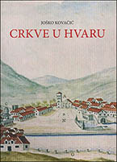
Author Kovačić, Joško
Title Crkve u Hvaru
Impresum Split : Književni krug ; Hvar : Gradska knjižnica i čitaonica : Hvarska biskupija, 2023
Description 731 str. : ilustr. ; 24 cm
ISBN 9789531635332 : EUR 35,50 US$ 39,40
Subject Crkve – Hvar. Hvar -- Crkvena povijest
UDC 27-523(497.5 Hvar)
Anotation Joško Kovačić prepared this capital work, a book in which all the churches in Hvar were treated on the basis of research, archival data and literature, for about thirty years and constantly supplemented the material with new knowledge. The book not only provides church history and art history, but also numerous important information about Hvar's cultural heritage, presenting, for example, the history of the city districts where certain churches are located, or entire smaller settlements developed around them. For the first time, the names of numerous protagonists - clients, builders, artists - are presented, lists of Hvar's bishops and princes are brought, and thus the life of Hvar is brought to life almost plastically.

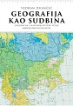
Author Duančić, Vedran
Title Geografija kao sudbina : geografija i nacionalističke vizije međuratne Jugoslavije
/ Vedran Duančić ; prevela Mirjana Markovinović.
Impresum Zagreb : Srednja Europa, 2023.
Description XIII, 228 str. : zemljop. karte ; 24 cm.
Note Prijevod djela: Geography and nationalist visions of interwar Yugoslavia.
ISBN 9789538281877 : EUR 36,60 US$ 40,60
Subject Geografija -- Politički aspekti -- Jugoslavija -- 1918.-1941. Geopolitika -- Jugoslavija -- 1918.-1941.
Socijalna geografija -- Jugoslavija -- 1918.-1941.
UDC 911.3:32(497.1) * 94(497.1)

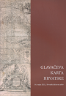
Author Znanstveni skup Glavačeva karta Hrvatske (2021 ; Zagreb)
Title Glavačeva karta Hrvatske / zbornik radova sa znanstvenog skupa održanog 16. rujna 2021. u Hrvatskom državnom arhiv
/ urednica Emilia Domazet.
Impresum Zagreb : Hrvatski državni arhiv, 2023.
Description 143 str. : ilustr., graf. prikazi ; 24 cm.
ISBN 9789538461064 : EUR 13,70 US$ 15,20
Subject Zemljopisne karte -- Hrvatska -- 17. st. – Kongresi. Kartografska građa -- Hrvatska -- 17. st. -- Kongresi
UDC 912.43(497.5)
Anotation The collection presents seven works that talk about the oldest map of Croatia, the map of Stjepan Glavač from 1673, from different points of view. Glavač is one of the oldest Croatian cartographers of the 17th century who, acting under the strong influence of European science and culture, strongly promoted Croatian national interests. Today, a unique copy of this map is kept in the Metropolitan Library of the Zagreb Archdiocese.

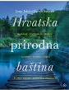
Author Jukić, Josip
Title Hrvatska prirodna baština
Impresum Zagreb : Mozaik knjiga, 2023.
Description 352 str. : ilustr. u bojama ; 30 cm.
Note Monografija.
ISBN 9789531434294 : EUR 53,70 US$ 59,60
Subject Prirodna baština -- Hrvatska
UDC 502(497.5)
Anotation A necklace made of more than a thousand islands and islets, magical waterfalls, mystical lakes, picturesque rivers, mysterious caves, sung mountains, preserved flora and fauna... We could enumerate the beauties and string epithets endlessly. That's why in this book the authors Josip Jukić and Goran Šafarek selected the best of the best and prepared this magnificent green-blue puzzle for all readers. A puzzle interspersed with superb photographs that will certainly be enjoyed by some future generations.

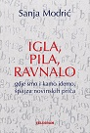
Author Modrić, Sanja, novinarka
Title Igla, pila, ravnalo : gdje smo i kamo idemo : zbirka novinskih priča
Impresum Zagreb : Telegram media grupa, 2023.
Description 314 str. ; 22 cm.
ISBN 9789534950135 : EUR 24,40 US$ 27,10
UDC 323(497.5)(046)
Anotation The first book by Sanja Modrić, one of the best and most famous Croatian journalists, winner of the Croatian Journalists' Association awards for Journalist of the Year and Lifetime Achievement. A book of Sanja Modrić's best columns, newspaper stories about where we are and where we are going. '

Author Jardas, Ivo
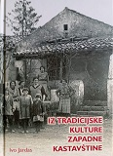
Title Iz tradicijske kulture zapadne kastavštine
/ Ivo Jardas ; [suradnici Milovan Matetić ... [et al.] ; akcentuacija rječnika Jasna Gržinić ; fotografije Ivo Jardas].
Impresum Kastav : Udruga Čakavski senjali, 2022.
Description 173, [2] str. s tablama : ilustr. ; 25 cm.
Note Ostali zastupljeni suradnici: Miljenko Ujčić, Vesna Matetić, Roberto Žigulić, Arsen Jardas, Cvjetana Miletić.
Ča je ča [Rječnik]: str. 155-165.
ISBN 9789534813645 : EUR 21,00 US$ 23,30
Subject Jardas, Ivo. Kastav (okolica) -- Društveni život i običaji
UDC 39(497.561-37Kastav)

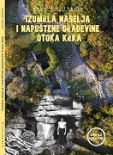
Author Žic-Teklin, Alan
Title Izumrla naselja i napuštene građevine otoka Krka
Impresum Rijeka : Pandora, 2020
Description 208 str. : ilustr. (pretežno u bojama) ; 21 cm
Note Bibliografske bilješke uz tekst.
ISBN 9789534814130 : EUR 22,40 US$ 24,90
Subject Krk (otok) – Povijest. Krk (otok) -- Historiografija
UDC 94(497.57Krk) * 908(497.57Krk)

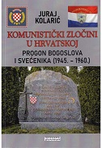
Author Kolarić, Juraj
Title Komunistički zločini u Hrvatskoj : progon bogoslova i svećenika : (1945.-1960.)
Impresum Zagreb : Tkanica ; Sesvetski Kraljevec : Grafok, 2023.
Description 456 str. : ilustr. ; 21 cm.
ISBN 9789537999520 : EUR 30,40 US$ 33.70
Subject Politički progoni -- Hrvatska -- 1945.-1974. Svećenici -- Žrtve zločina -- Hrvatska -- 1945.-1974.
Križni put (1945.)
UDC 323.28(497.5)(091) * 355.257.7(497.1=163.42) * 272-722.53(497.5)


Title Konavoski kaleidoskop : konavoski vez u interpretaciji suvremenih vezilja : Zavičajni muzej Konavala, Čilipi 6. 12. 2022. – 31. 4. 2023
/ [tekst Antonia Rusković Radonić].
Impresum Gruda : Muzeji i galerije Konavala, 2023.
Description 65 str. : ilustr. u bojama ; 21 cm.
Note Katalog izložbe.
ISBN 9789537226435 : EUR 14,60 US$ 16,20
Subject Tradicijski vezovi -- Konavle -- Izložbe
UDC 39:746(497.584-3Konavle) * 746.3(497.584-3Konavle)


Author Zavičajni muzej Konavala (Čilipi)
Title Konavoski vez iz etnografske zbirke Zavičajnog muzeja Konavala
/ [Autor teksta Antonia Rusković Radonić ; fotografije Ljubo Gamulin, Ana Bratoš].
Impresum Gruda : Muzeji i galerije Konavala, 2023.
Description 356 str. : ilustr. u bojama ; 25 cm.
Note Bibliografija
ISBN 9789537226381 : EUR 36,60 US$ 40,60
Subject Zavičajni muzej Konavala (Čilipi). Etnografska zbirka. Tradicijski vezovi -- Konavle
UDC 069.51:391.9(497.584-3Konavle * 39:746(497.584-3Konavle) * 746.3(497.584-3Konavle)


Author Frančula, Rudolf
Title Moje polemike
Impresum Zagreb : Despot Infinitus, 2023.
Description 340 str. ; 23 cm.
Note. Bibliografija.
ISBN 9789533661247 : EUR 28,90 US$ 32,10
Subject Frančula, Rudolf -- Politička aktivnost. Istra -- Politika i vlast. Hrvatska -- Politika i vlast
UDC 32Frančula, R. * 323(497.571)

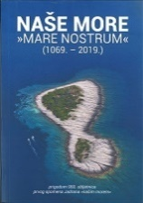
Title Naše more "mare nostrum" : (1069. - 2019.) : znanstveni skup prigodom 950. obljetnice prvog spomena Jadrana "našim morem" (2019 ; Split)
/ [urednica Danka Radić
Impresum Split : Hrvatski pomorski muzej, 2022.
Description 676 str. : ilustr. ; 24 cm.
ISBN 9789537742232 : EUR 27,10 US$ 30,10
Subject Pomorstvo -- Jadransko more -- Povijest – Kongresi. Morsko ribarstvo -- Jadransko more -- Povijest -- Kongresi
Kulturni identitet -- Hrvatska – Kongresi. Hrvatska -- Pomorska povijest – Kongresi. Dalmacija -- Povijest -- Kongresi
Jadranska regija -- Pomorska povijest -- Kongresi
UDC 656.61(210.5)(262.3)(091) * 639.2(262.3)(091) * 316.72(497.5) * 94(497.58)"10/20"

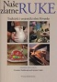
Title Naše zlatne ruke : Tradicijski i umjetnički obrti Hrvatske = Hands of gold : Croatian Traditional And Artistic Crafts : u povodu 170. obljetnice osnutka Hrvatske obrtničke komore = In celebration of 170th anniversary of the founding of the Croatian Chamber of Trades and Crafts
/ urednica Petra Somek ; Autorski tim Dragutin Feletar ... [et al.] ; fotografije Saša Pjanić, Jurica Galić Juka i Romeo Ibrišević ; prijevodi na engleski Ivana Gradečak].
Impresum Zagreb : Hrvatska obrtnička komora ; Samobor : Meridijani, 2022.
Description 287 str. : ilustr. u bojama ; 30 cm.
Language/s Tekst na hrv. i na engl. jeziku.
ISBN 9789532392746 : EUR35,70 US$ 39,60
Subject Tradicijski obrti – Hrvatska. Primijenjena umjetnost -- Hrvatska
UDC 39:67/68(497.5) * 745/749(497.5)
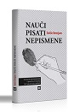

Author Senjan, Saša
Title Nauči pisati nepismene : kampanje opismenjavanja u sjevernoj Hrvatskoj [od 1945. do 1952. godine]
Impresum Samobor : Meridijani, 2023.
Description 383 str. : ilustr. ; 28 cm.
ISBN 9789532392692 : EUR 25,80 US$ 28,60
UDC 37.014(497.5-17)(091) * 316.42(497.5-17) * 94(497.5-17)"1945/1974"
Anotation The book describes one of the most important events of post-war socialist Yugoslavia - the literacy of the population. The Communist Party of Yugoslavia set an ambitious plan to solve the problem of illiteracy within five years and to direct society and the economy towards a brighter future. Widespread illiteracy was a first-class problem, but also a challenge for the new government, because not a single government managed to solve this problem until the end of the Second World War. The party saw in the removal of this age-old problem a great benefit for its legitimacy, but also a foundation for carrying out the transformation of society and the economy.


Author Filipi, Mario
Title Nikola Tesla ispod paučine
Impresum Samobor : Zminjak, 2022.
Description 509 str. : ilustr., faks., zemljop. crteži u bojama ; 25 cm.
Note Str. 15-17: Predgovor / Josip Pečarić.. Bibliografija: str. 504-508.
ISBN 9789534994900 : EUR 48,80 US$ 54,20
UDC 621.3Tesla, N.
Anotastion The book talks about the great scientist as a person in society, about his physical and psychological characteristics, about his attitude towards other people, especially towards friends, colleagues, towards "little" people, fellow scientists and women, about his attitude towards religion and God, towards money, prizes, social honors and much more.
The book also contains a comprehensive historical account of the development of Croats and nearby peoples, as well as a detailed description of social, administrative, political and ecclesiastical circumstances in the era when he lived. The book also contains numerous documents that touch on the "eternal" topic of the scientist's ethnicity and nationality, some of which are surprising, and perhaps even shocking.

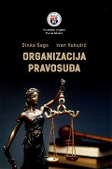
Author Šago, Dinka
Title Organizacija pravosuđa
Impresum Split : Pravni fakultet, 2021.
Description XVII, 545 str. ; 25 cm.
ISBN 9789538116360 : EUR 33,20 US$ 36,80
UDC 342.56(497.5)
Anotation The monograph deals with the organization of the judiciary in the Republic of Croatia and Europe. For the sake of a clearer analysis, the material is divided into chapters related to the organization of the courts and judicial authority in the Republic of Croatia, the Attorney General, the Center for Social Welfare and the Center for Special Guardianship, the Attorney General's Office, the State Attorney's Office, the Notary Public, and the Organizational Procedural Law of the European Union and the Council of Europe . Within each chapter, problematic issues of individual institutions are analyzed.

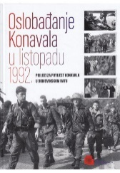
Author Marijan, Davor
Title Oslobađanje Konavala u listopadu 1992. : (prilozi za povijest Konavala u Domovinskom ratu)
/ [Autor poglavlja Davor Marijan i Jakša Raguž ; suradnici - odabir fotografija Ana Holjevac Tuković, Petar Mijić].
Impresum Zagreb : Hrvatski memorijalno-dokumentacijski centar Domovinskog rata, 2022.
Description 135 str. : ilustr. (djelomice u bojama) ; 30 cm.
Note Bibliografija: str. 133-135; bibliografske bilješke.
ISBN 9789538354151 : EUR 24,30 US$ 27,00
Subject Domovinski rat (1991.-1995.) -- Vojne operacije -- Dubrovnik (okolica)
UDC 355.4(497.584-37Dubrovnik)

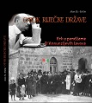
Author Žic-Teklin, Alan
Title Otok riječke države : Krk u pandžama D’Annunzijevih lavova
Impresum Rijeka : Pandora gong, 2021.
Description 272 str. : ilustr. ; 24 cm.
ISBN 9789534814147 : EUR 22,40 US$ 24,90
Subject Krk (otok) -- Povijest -- 1918.-1941.
UDC 94(497.5)"1918/1941" * 94(497.572)"1918/1941"
Anotation Historical notes and testimonies of the inhabitants of the island of Krk about the turbulent period from the end of 1920 to the beginning of 1921, when the Italian dictator and poet Gabriele d'Annunzio ruled or tried to rule the island of Krk.

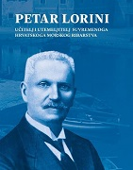
Author Lorini, Petar
Title Petar Lorini : učitelj i utemeljitelj suvremenoga hrvatskoga morskog ribarstva
/ [urednik Josip Faričić ; prijevod sažetka na engleski jezik Sandra Mlađenović].
Impresum Zadar : Sveučilište u Zadru, 2022.
Description 163 str. : ilustr., graf. prikazi u bojama, faks. ; 24 cm.
Note Arhivska građa i bibliografija o Petru Loriniju: str. 12. Bibliografija iza svakog rada ; bibliografske bilješke uz tekst.
ISBN 9789533313887 : EUR 19,40 US$ 21,50
Subject Lorini, Petar. Morsko ribarstvo -- Hrvatska -- 19. st.
UDC 63Lorini, P. * 639.22(497.5)(091)

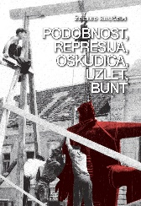
Author Krušelj, Željko
Title Podobnost, represija, oskudica, uzlet, bunt : Koprivnica u socijalističkom razdoblju u očima
lokalnih medija (1945. – 1990.)
Impresum Koprivnica : Muzej grada Koprivnice, 2022.
Description 287 str. : ilustr. ; 24 cm.
ISBN 9789538138850 : EUR 39,80 US$ 44,20
UDC 308(497.525.1Koprivnica)(091) * 070(497.525.1Koprivnica)(091) * 94(497.525.1Koprivnica)"1945/1990"
Anotation The book is based on research of archival materials of political, executive and judicial bodies of the city and district of Koprivnica from the second half of 1945 until 1990, as well as a detailed reading of local newspapers (Glas Podravine i Prigorje, Koprivnički tjednik) that were published over a period of several decades. The author focused on analyzing and documenting the living and working conditions of ordinary citizens of Koprivnica and its surroundings.

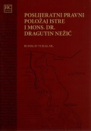
Author Vukas, Budislav
Title Poslijeratni pravni položaj Istre i mons. dr. Dragutin Nežić
/ Budislav Vukas ; (urednici) Ilija Jakovljević, Ivan Milotić.
Impresum Pazin : "Josip Turčinović" ; Rijeka : Pravni fakultet ; Poreč : Biskupija ; Pula : Biskupija, 2022.
Description XVI, 157 str. ; 24 cm.
Note Str. VII-IX: Predgovor / Dražen Kutleša.
. Bibliografija: str. 130-144; bibliografske bilješke i uz tekst. Summary ; Zusammenfassung ; Riassunto.
ISBN 9789538031861 : EUR 20,20 US$ 22,40
Subject Istra -- Pravna povijest. Istra -- Državnopravni status -- 20. st.
UDC 341.1(497.571)(091)

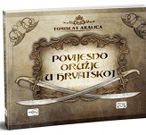
Author Aralica, Tomislav
Title Povijesno oružje u Hrvatskoj
Impresum Zagreb : Despot Infinitus, 2023.
Description 236 str. : ilustr. ; 24 cm.
ISBN 9789533660936 : EUR 34,80 US$ 38,60
UDC 623.44(497.5)(091)
Anotation The topics covered in the book are only a fraction of the great splendor of Croatian historical weapons and military history. It is an indispensable part of Croatian national history, culture and being, because we are a nation formed in wars, we lived in wars and survived them. The author dedicates this book to the idea of ​​forming a museum of Croatian military history that would include topics such as the Avar Khaganate, the emergence of the early medieval Croatian state and its noble military elite and military power, the alliance with the Hungarians, the Mongol invasion, the fight against the Venetian Republic in the Middle

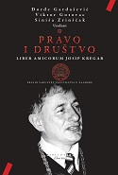
Title Pravo i društvo : liber amicorum Josip Kregar
/ Đorđe Gardašević, Viktor Gotovac, Siniša Zrinščak, urednici.
Impresum Zagreb : Pravni fakultet Sveučilišta u Zagrebu, 2022.
Description 672 str. ; 24 cm.
Note Bibliografija iza svakog rada. Sumaries.
ISBN 9789532701593 : EUR 55,00 US$ 61,10
UDC 347.9(497.5) * 340.13 * 316.334.4
Anotation Proceedings Pravo i društvo : liber amicorum Josip Kregar (Law and Society. Liber amicorum Josip Kregar), published in memory of the late prof. Ph.D. Josip Kregar, brings twenty-four texts by Croatian and foreign authors in the scientific fields of law, sociology and political science. The works deal with a whole range of topics that are relevant to the moment in which we live, from the question of the role and development of democracy, the judiciary, the development of certain legal institutes, human rights to the question of abortion, corruption, mass crimes, nationalism or the role of the public intellectual in society.

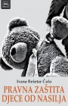
Author Rešetar Čulo, Ivana
Title Pravna zaštita djece od nasilja
Impresum Zagreb : TIM press, 2023.
Description 335 str. ; 24 cm.
ISBN 9789533690186 : EUR 30,50 US$ 33,90
Subject Children's rights - Protection. Children -- Victims of violence -- Legal regulation
UDC 364.632-053.2(094) * 343.62
Anotation This scientific monograph is a comprehensive analysis of the legal protection of children against violence in contemporary international, regional and national law of the Republic of Croatia. The author systematically analyzes the existing legal framework for the protection of children from violence at the international, regional and national level, in order to, bearing in mind all the complexity of violence against children, present the content of the child's right to protection from all forms of violence, as well as the prerequisites for the establishment of an integrated, national system for the protection of children from violence.

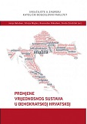
Title Promjene vrijednosnog sustava u demokratskoj Hrvatskoj
/ urednici Josip Baloban ... [et al.].
Impresum Zagreb : Katolički bogoslovni fakultet Sveučilišta u Zagrebu : Kršćanska sadašnjost, 2023.
Description 414 str. : graf. prikazi (djelomice u boji), ilustr. ; 25 cm.
Note Zastupljeni Autori: Krunoslav Nikodem, Siniša Zrinščak, Josip Baloban, Josip Ježovita, Branko Murić, Tonči Matulić, Ivan Balabanić, Josip Šimunović, Gordan Črpić, Marijana Kompes, Lucija Mihaljević, Stjepan Baloban, Silvija Migles, Mateja Čehulić.
ISBN 9789531117579: EUR 41,50 US$ 46,10
Subject Vrijednosni sustav – Hrvatska. Religija i politika – Hrvatska. Religija i politika -- Europa
UDC 316.64(497.5) * 322(4) * 322(497.5)

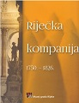
Title Riječka kompanija : 1750. - 1826.
/ [urednik Ervin Dubrović]
Impresum Rijeka : Muzej grada Rijeke, 2022
Description 200 str. : meki uvez, ilustracije ; 23 cm
ISBN 9789538303197 : EUR 30,50 US$ 33,90
UDC 347.72(497.561Rijeka)"1750/1826"
Anotation The monograph "Rijeka Company 1750 – 1826" is dedicated to a company that changed its name several times during its activity, the most famous being the Trieste-Rijeka Privileged Trading Company. In the history of Rijeka, she is mostly remembered as the founder of the Sugar Refinery. For its time, the refinery was a huge industrial plant that changed the face of the city. He became the starting point of the industrialization of the city on the Rječina, operating in three city locations

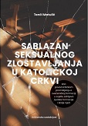
Author Matulić, Tonči
Title Sablazan seksualnog zlostavljanja u Katoličkoj Crkvi : kao povod kritičkom promišljanju o svećeničkoj formaciji
u svjetlu zahtjeva ljudske formacije i Božje riječi
Impresum Zagreb : Kršćanska sadašnjost, 2022.
Description 142 str. ; 20 cm.
ISBN 9789531117050 : EUR 18,30 US$ 20,30
Subject Katolička crkva -- Kler -- Seksualno ponašanje. Seksualno zlostavljanje djece u Crkvi. Celibat
UDC 272-447

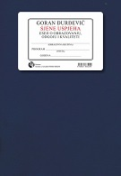
Author Đurđević, Goran, povjesničar
Title Sjene uspjeha : eseji o obrazovanju, odgoju i kvaliteti
Impresum Zagreb : Durieux, 2023.
Description 282 str. ; 21 cm.
ISBN 9789531885249 : EUR 18,10 US$ 20,10
Subject Školstvo – Hrvatska. Reforma obrazovanja – Hrvatska. Socijalne vještine -- Nastava i učenje
Kritičko mišljenje u djece. Popularna kultura -- Nastava i učenje
UDC 37.018(497.5)

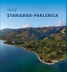
Author Znanstveni skup Starigrad Paklenica ; 23. do 25. travnja 2018. ; Starigrad-Paklenica
Title Starigrad - Paklenica
/ urednici Ante Uglešić, Zoran Šikić, Marijana Tomić ; [prijevod sažetaka na engleski Sandra Mlađenović].
Impresum Zadar : Sveučilište u Zadru, 2022.
Description 523 str. : ilustr. u bojama, graf. prikazi u bojama ; 30 cm.
Note Bibliografija iza svakog poglavlja. Summaries.
ISBN 9789533313658 : EUR 48,60 US$ 53,90
Subject Starigrad
UDC 908(497.581.1Starigrad)


Author Stryjek, Tomasz
Title Suvremena Hvatska i Srbija prema vlastitoj povijesti
/ Tomasz Stryjek ; prevela Magdalena Najbar-Agičić.
Impresum Zagreb : Srednja Europa, 2023.
Description XXII, 492 str. : ilustr. ; 23 cm.
Note Prijevod djela: Współczesna Serbia i Chorwacja wobec własnej historii.
ISBN 9789538281822 : EUR 40,90 US$ 45,40
Subject Historiografija – Hrvatska. Historiografija -- Srbija
Kolektivno pamćenje -- Politički aspekti – Hrvatska. Kolektivno pamćenje -- Politički aspekti – Srbija
Hrvatska -- Odnosi -- Srbija -- 20. st. Srbija -- Odnosi -- Hrvatska -- 20. st.
UDC 930(497.5) * 930(497.11) * 94(497.5:497.11) * 32:316.64(497.5) * 32:316.64(497.11)

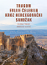
Author Pinjuh, Dijana
Title Tragom Evlije Čelebija kroz Hercegovački sandžak
Impresum Zagreb : Srednja Europa, 2023.
Description 326 str. : ilustr. u bojama ; 24 cm.
ISBN 9789538281853 : EUR 30,10 US$ 33,40
Subject Evliya Çelebi, Hafız Mehmet Zıllî -- Putovanja
Subject Hercegovina -- Opisi i putovanja -- 17. st. Osmanlijsko Carstvo -- Balkanska regija -- Opisi i putovanja -- 17. st.
UDC 94(560)Evliya Çelebi, H. M. Z. * 910.4Evliya Çelebi, H. M. Z.

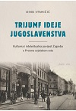
Author Staničić, Dino
Title Trijumf ideje jugoslavenstva : kulturna i intelektualna povijest Zagreba u Prvome svjetskom ratu
Impresum Zagreb : Plejada, 2023.
Description 248 str. : ilustr. ; 23 cm.
ISBN 9789537782917 : EUR 26,90 US$ 29,90
UDC 94(497.5)"1527/1918" * 94(497.521.2)"1914/1918" * 930.85(497.521.2)
Anotation Analyzing the development of literature and art in Zagreb during the First World War, the author explains the continuities and discontinuities between the wartime and the "beautiful epoch" (French: la belle epoque) which immediately preceded the war and witnessed significant literary and artistic achievements in Croatia. At the center of the analysis is the articulation of the idea of ​​Yugoslavism among the intellectuals and artists of wartime Zagreb, but also the continuation of the conflict between the "old" and the "young" in literature, which has not yet been clearly observed and exhaustively treated in historiography.

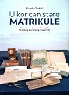
Author Teklić, Branka
Title U korican stare matrikule : zbirka pisane dokumentarne građe Hrvatskoga pomorskog muzeja Split
/ [Autorica kataloga] Branka Teklić ; [prijevod na engleski jezik Tomislav Denegri ; fotografije Mario Javorčić ... et al.].
Impresum Split : Hrvatski pomorski muzej, 2022.
Description 191 str. : ilustr. (pretežno u bojama), faks. ; 29 cm.
Note Summary.
ISBN 9789537742249 : EUR 20,00 US$ 22,20
Subject Hrvatski pomorski muzej (Split). Zbirka pisane dokumentarne građe – Katalozi. Brodarstvo -- Hrvatska -- Povijesni izvori
UDC 069.5:656.61(497.5) * 656.61(497.5)

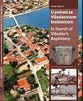
Author Uglešić, Ante, arheolog
Title U potrazi za Višeslavovom krstionicom = In search of Višeslav’s Baptistery
Impresum Split : Muzej hrvatskih arheoloških spomenika, 2022.
Description 120 str. : ilustr. u bojama ; 28 cm.
Language/s Tekst usporedo na hrv. i na engl. jeziku.
ISBN 9789536803804 : EUR 32,40 US$ 36,00
Subject Arheološka istraživanja – Nin. Arheološki nalazi -- Nin -- Rani srednji vijek. Srednjovjekovna arheologija -- Hrvatska
Višeslavova krstionica
UDC 904:726(497.581.1Nin)"652" * 902.2(497.581.1Nin) * 726:27(497.581.1Nin)

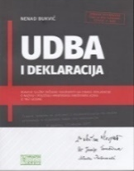
Author Bukvić, Nenad
Title UDBA i Deklaracija : reakcije Službe državne sigurnosti na objavu Deklaracije o nazivu i položaju hrvatskoga književnog jezika iz 1967. godine
Impresum Zagreb : Hrvatski državni arhiv, 2022.
Description 342 str. : ilustr. ; 26 cm.
ISBN 9789537659998 : EUR 18,20 US$ 20,20
Subject Jugoslavija (1942-1992). Ministarstvo unutrašnjih poslova. UDBA -- Arhiva
Subject Hrvatsko pitanje -- Jugoslavija -- 1945.-1974. -- Arhivski izvori. Hrvatska -- Politika i vlast -- 1945.-1974. -- Arhivski izvori
UDC 323.1(497.1=163.42)(093) * 355.40(497.1)(093)

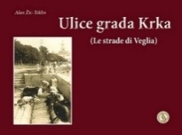
Author Žic-Teklin, Alan
Title Ulice grada Krka (Le strade di Veglia)
Impresum Rijeka : Pandora gong, 2022.
Description 256 str. : ilustr. ; 17 X 24 cm.
Note Bibliografija: str. 256.
ISBN 9789534814154 : EUR 29,80 US$ 33,10
Subject Krk (grad) -- Zgrade i građevine – Fotografije. Krk (grad) -- Društveni život i običaji -- 20. st.
UDC 930.85(497.561Krk) * 39(497.561Krk) * 728.3(497.561Krk)

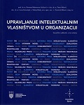
Title Upravljanje intelektualnim vlasništvom u organizaciji
/ Romana Matanovac Vučković ... [et al.].
Impresum Zagreb : Hrvatska gospodarska komora ; Varaždin : Sveučilište Sjever, 2023.
Description 184 str. : graf. prikazi ; 24 cm.
Note. Bibliografija
ISBN 9789537622954 : EUR 23,60 US$ 29,00
Subject Intelektualno vlasništvo – Hrvatska. Autorsko pravo -- Hrvatska
UDC 347.77(497.5)

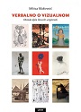
Author Maštrović, Mikica
Title Verbalno o vizualnom : obrada djela likovnih umjetnosti
Impresum Zagreb : Naklada Ljevak, 2023.
Description 277 str. : ilustr. (pretežno u bojama) ; 24 cm.
ISBN 9789533556529 : EUR 43,80 US$ 48,60
Anotation The development of information technologies enabled new ways of museum business and a new paradigm of access to the necessary information. The intention of publishing the book Verbalno o vizualnom by Mikica Maštrović is to make it easier for everyone, primarily curators, who have visual material in their collections, to process it formally and substantively, so that it can be remotely accessible to all users. All the examples used are works by authors significant for Croatian culture, so it is also a kind of overview of Croatian visual art.

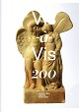
Author Čargo, Boris
Title Vis-à-Vis 200 : arheološka baština otoka Visa ; [Galerija Klovićevi dvori, Zagreb, 11. 5. – 2. 7. 2023.]
/ [Autori tekstova Boris Čargo, Jelena Jovanović, Maja Bonačić Mandinić].
Impresum Zagreb : Galerija Klovićevi dvori, 2023.
Description 180 str. : ilustr. ; 28 cm.
Note Katalog izložbe.
ISBN 9789532711479 : EUR 18,30 US$ 17,50
Subject Kulturna baština -- Vis (otok) – Izložbe. Arheološka istraživanja -- Vis (otok) -- Izložbe
Arheološki nalazi -- Vis (otok) – Izložbe. Vis (otok) -- Kulturna povijest -- Izložbe
UDC 902/908(210.7Vis) * 930.85(210.7Vis)
Anotation In the light of the latest discoveries and the completed restoration and conservation works, the little-visible, but extremely significant Croatian heritage of the town and island of Vis is presented in a modern and attractive museological way. The anniversary exhibition presents more than 750 selected, most representative monuments of the Archaeological Museum in Split found on the island/city of Vis (ancient Issa), one of the most significant and largest archaeological sites in Croatia.

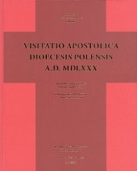
Title Visitatio apostolica dioecesis polensis episcopi Augustini Valerii A. D. MDLXXX = Apostolska vizitacija pulske biskupije biskupa Augustina Valiera 1580. godine = Visita apostolica alla diocesi di Pola del vescovo Agostino Valier nell’anno 1580
/ redegit, priredila, a cura di Milena Joksimović ; [izrada kazala, creazione di indici, indices Maja Tabak ; izrada karata, creazione di mappe, mappae David Ivić, Ivan Jurković].
Impresum Pisini = Pazin = Pisino : Državni arhiv = Archivio di Stato = Archivium publicum ; Parenti = Poreč = Parenzo : Porečka i Pulska biskupija = Diocesi di Parenzo e Pola = Dioecesis Parentina et Polensis ; Polae = Pula = Pola : Arheološki muzej Istre = Museo archeologico dell’Istria = Museum archaeologicum Histriae, 2023.
Description 865 str. : ilustr. (pretežno u bojama), zemljop. crteži (djelomice u bojama), faks. ; 31 cm.
Jezik/Pismo Tekst usporedo na tal. i na hrv. jeziku.
Bib./Saž./Kaz. Bibliografija: str. 853-862; bibliografske bilješke uz tekst.
Subjectno kazalo ; Kazalo toponima ; Kazalo crkava, kapela, ubožnica, bratovština i oltara ; Kazalo osoba.
ISBN 9789537640484 : EUR 73,20 US$ 81,20

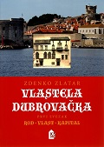
Author Zlatar, Zdenko
Title Vlastela dubrovačka 1-2 : od Šiška do Vladislava Menčetića : kvantitativna studija
Sv.1 : Rod, vlast, kapital.
Impresum Zagreb : Hrvatski institut za povijest, 2022.
Description 352 str. ; 24 cm.
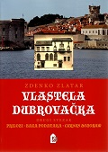
ISBN 9789538335303

Sv. 2 : Prilozi, baza podataka, cursus honorum.
Impresum Zagreb : Hrvatski institut za povijest, 2022.
Description 355 str. ; 24 cm.
ISBN 9789538335310
Subject Plemstvo -- Dubrovačka Republika -- Novi vijek
UDC 929.7(497.584Dubrovnik) * 94(497.584Dubrovnik)"1457/1666"
ISBN 9789538335297 (1-2) : EUR 28,60 US$ 31,80

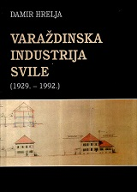
Author Hrelja, Damir
Title Varaždinska industrija svile : (1929. - 1992.)
Impresum Varaždin : Državni arhiv u Varaždinu, 2023.
Description 170 str. : ilustr. ; 22 cm.
Bib./Saž./Kaz. Bibliografija
ISBN 9789536075584 : EUR 14,60 US$ 16,20
Subject Industrija svile -- Varaždin – Povijest. Svilarstvo -- Hrvatska -- Povijest
UDC 338.45:677.37(497.523Varaždin)(091) * 677.37(497.5)(091)

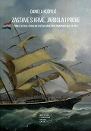
Author Kušpilić, Daniela
Title Zastave s krme, jarbola i prove : zbirka zastava i signalnih zastava Hrvatskog pomorskog muzeja Split
/ [Autorica kataloga] Daniela Kušpilić ; [prijevod (sažetka) na engleski jezik Tomislav Denegri ; fotografije Mario Javorčić, Zoran Alajbeg, Kristina Soldić].
Impresum Split : Hrvatski pomorski muzej, 2023.
Description 172 str. : ilustr. u bojama ; 24 cm.
Note Bibliografija: str. 165-167. Summary.
ISBN 9789535205838 EUR 14,30 US$ 15,90
UDC 929.929

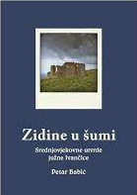
Author Babić, Petar, povjesničar
Title Zidine u šumi : srednjovjekovne utvrde južne Ivančice
Impresum Varaždin : Državni arhiv u Varaždinu, 2022.
Description 184 str. : ilustr. ; 22 cm.
Bib./Saž./Kaz. Bibliografija
ISBN 9789536075577 : EUR 12,20 US$ 13,50
Subject Burgovi – Ivančica. Fortifikacijska arhitektura -- Hrvatsko zagorje. Hrvatsko zagorje -- Povijest -- Srednji vijek
UDC 94(497.5)"1102/1527" * 94(497.522)"12/15" * 728.81(497.522) * 725.1:623.1(497.522)

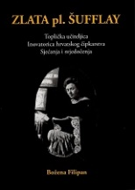
Author Filipan, Božena
Title Zlata pl. Šufflay : toplička učiteljica : inovator hrvatskog čipkarstva : sjećanja i svjedočenja / Božena Filipan.
Impresum Varaždin : Državni arhiv u Varaždinu ; Varaždinske Toplice : Matica hrvatska, Ogranak, 2022. (Varaždinske Toplice : "Tonimir")
Description 183 str. : ilustr. ; 21 cm.
ISBN 9789536075553: EUR 23,20 US$ 25.70
Subject Šufflay, Zlata – Biografije. Šufflay, obitelj – Genealogija
Čipka i čipkarstvo -- Varaždinske Toplice. Varaždinske Toplice -- Društveni život i običaji
UDC 39Šufflay, Z. * 39:746(497.523Varaždinske Toplice) * 929.52Šufflay

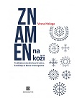
Author Haluga, Vesna
Title Znamen na koži : tradicijska tetovaža žena Hrvatica, katolkinja iz Bosne i Hercegovine
Impresum Zagreb : Naklada Nediljko Dominović, 2023.
Description 206 str. : ilustr. u bojama ; 24 cm.
Note. Bibliografija. Summary
ISBN 9789537954857 : EUR 36.50 US$ 40.50
Subject Tattooing -- Bosnia and Herzegovina -- Social aspects. Catholic women -- Bosnia and Herzegovina -- Social life and customs
UDC 391.9(497.6) * 316.774-028.22


Author Bitunjac, Martina
Title Žene i ustaški pokret : uključenost, sudjelovanje, nepravda
/ Martina Bitunjac ; preveli Ivana Cvijović Javorina i Marko Javorina.
Impresum Zagreb : Srednja Europa, 2023.
Description X, 240 str. ; 24 cm.
Note Prijevod djela: Verwicklung. Beteiligung. Unrecht. Frauen und die Ustaša-Bewegung
ISBN 9789538281884 : EUR 28,00 US$ 31,10
Subject Ustaški pokret (1929.-1945.) Drugi svjetski rat (1939.-1945.) -- Sudjelovanje -- Žene -- Hrvatska
Žene -- Hrvatska -- Društveni uvjeti. Hrvatska -- Povijest -- 1941.-1945.
UDC 94(497.5)"1941/1945" * 355-055.2(497.5) * 329.17/.18(497.5)(091)

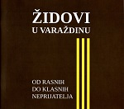
Author Hrelja, Damir
Title Židovi u Varaždinu : od rasnih do klasnih neprijatelja
Impresum Varaždin : Državni arhiv u Varaždinu, 2021.
Description 52 str. : ilustr. ; 22 cm.
ISBN 9789536075515 : EUR 7,20 US$ 8,00
Subject Židovi -- Žrtve zločina -- Varaždin -- 1941.-1945. – Izložbe. Židovi -- Žrtve zločina -- Varaždin -- 1945.-1974. -- Izložbe
UDC 323.28-052(497.523Varaždin=411.16)(091

Linguistics. Philology
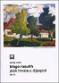
Author Vulić, Sanja
Title Blago rasutih Dio 2 : jezik Hrvata u dijaspori
Impresum Split : Književni krug, 2022.
Description 203 str. : ilustr., faks. (pretežno u bojama), 24 cm
ISBN 9789531635318 : EUR 19,30 US$ 21,40
Subject Hrvatski jezik – Inozemstvo. Hrvatsko iseljeništvo -- Jezik
UDC 811.163.42(100=163.42)
Anotation The author, dialectologist and language historian deals with the Croatian diaspora as a whole from a linguistic point of view, which has not been done until now. She researched numerous literature related to the emigration of Croats to other continents and Europe, as well as literature related to autochthonous minority communities in Central, Southern and Southeastern Europe. She analyzed the language of each immigrant and minority community in a historical context.

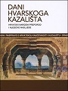
Title Dani Hvarskoga kazališta – knjiga 49
: hrvatski narodni preporod i njegovo nasljeđe
/ [uredništvo knjige Boris Senker, Lucija Ljubić, Vinka Glunčić-Bužančić].
Impressum Zagreb : Hrvatska akademija znanosti i umjetnosti, Split : Književni krug, 2023.
Description 524 str. ; 20 cm.
Serie Dani Hvarskog kazališta - 49
Note Summaries.
ISBN 9789531635349 : EUR 10,80 US$ 12,00

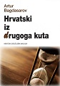
Author Bagdasarov, Artur Rafaelovič
Title Hrvatski iz drugoga kuta
Impresum Zagreb : Hrvatska sveučilišna naklada, 2023.
Description 193 str. ; 24 cm.
ISBN 9789531694919 : EUR 15,00 US$ 16,60
Subject Hrvatski jezik
UDC 811.163.42 * 811.163.42:811.163.41
Anotation Hrvatski iz drugoga kuta by Dr. Artur Bagdasarov contains various linguistic works published in the magazines Filologija, Jezik, Kolo, Kroatologija, on the portal of the Croatian Cultural Council and other Croatian media from 2014 to 2022, as well as unpublished texts. The texts include topics in the field of lexicology, lexicography, spelling, language policy in the period of the second Yugoslavia, texts on the general or commonly used similarities and differences between the Croatian and Serbian languages, a text on the professional difference at the level of military terminology, and a text on the peculiarities of teaching and methodology during the comparative study of related languages . At the end of the book there is a list of literature, a note about the author and a note about the texts published in this book. Some works are discussions or language tips.

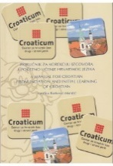
Author Banković-Mandić, Ivančica
Title Priručnik za korekciju izgovora i početno učenje hrvatskog jezika = A Manual for croatian pronunciation and initial learning of croatian
Impresum Zagreb : FF press [i. e.] Filozofski fakultet, 2023.
Description 88 str. : ilustr. ; 24 cm.
Language/s Tekst na hrv. i na engl. jeziku.
ISBN 9789531759298 : EUR 10,70 US$ 11,90
Subject Hrvatski jezik -- Fonetika -- Priručnici
UDC 811.163.42(035) * 81’34(035)

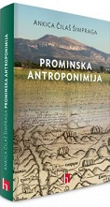
Author Čilaš Šimpraga, Ankica
Title Prominska antroponimija
Impresum Zagreb : Institut za hrvatski jezik i jezikoslovlje, 2023.
Description 222 str. : ilustr. (pretežno u bojama), graf. prikazi u bojama, zemljop. crteži u bojama, faks. ; 25 cm.
ISBN 9789537967642 : EUR 26,90 US$ 29,90
UDC 81’373.23(497.581.2-2Promina)
Anotation Promina, a parish of eleven villages, located southwest of Knin in the area between Promina mountain, the Krka river and Miljevac, has not yet been treated onomastically. As this area, which has been continuously inhabited since the Neolithic, was characterized by a large depopulation in the 20th century, it was necessary to start anthroponomastic and toponomastic research so that a large number of anthroponyms would not irreversibly fall into oblivion with the departure of the inhabitants. One of the goals of this work was to record and from an onomastic point of view anthroponyms as linguistic monuments that reflect the material and spiritual culture of that region, which Croatian onomastics have not dealt with so far.
Promin speech belongs to the Novoštokavian Ikavian or Western dialect. On the basis of anthroponymy, the main phonological and morphological features of that speech are presented.

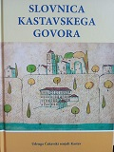
Author Grbac, Smiljan
Title Slovnica kastavskega govora
Impresum Kastav : Udruga Čakavski senjali, 2021.
Description 197 str. ; 21 cm.
ISBN 9789534813638 : EUR 19,70 US$ 21,90
UDC 811.163.42’282(497.561Kastav)
Anotation A two-hundred-page work that describes the features of Kastava Čakavica through its morphology, syntax, phonetics and accents, along with examples of short stories that combine the theoretical and practical part of preserving the Kastava language heritage.
In addition to a dictionary, maps of the Kastava speaking area, and notes on the history of expression in the Kastav language, "Slovnica" in its eight parts deals with and explores the cultural and historical topic of Kastav, whose speech is also interesting to numerous foreign researchers of Slavic languages ​​and dialects due to its archaic nature.
After the dictionary, Dictionary of the Kastaf language by Cvjetana Miletić, published in 2019, the Kastaf dialect received an adequate grammatical treatment, which is a step forward towards obtaining the status of intangible cultural heritage.

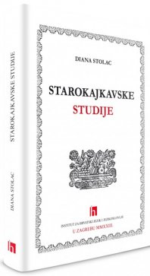
Author Stolac, Diana
Title Starokajkavske studije
Impresum Zagreb : Institut za hrvatski jezik i jezikoslovlje, 2023.
Description 208 str. ; 25 cm.
ISBN 9789537967734 : EUR 19,30 US$ 21,40
Subject Kajkavsko narječje -- Povijest
UDC 811.163.42’282(091)
Anotation This book offers texts on the literary Kajkavian language. Introductory, it talks about the standardization processes in the Kajkavian Croatian literary language, its polyfunctionality and with a separate topic related to the name of the language as an identity sign not only for Kajkavian but also for other historical Croatian literary languages.
The following is an overview of the written Kajkavian language through the centuries, starting with an introductory text on Hungarian-Croatian lexical contacts. The transition from the 16th to the 19th century shows different themes, authors, and linguistic approaches to their works.
In the third unit, dictionaries are presented through the linguistic topic, and grammars through the declension of nouns.
And only now could it be the turn of syntactic and syntactic stylistic topics. We hope that readers will see the beauty and flexibility of the language of the old Kajkavian authors, led by Tituš Brezovacki.

Literature. History. Theory

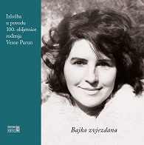
Title Bajka zvjezdana: izložba povodom 100 godina rođenja Vesne Parun : katalog : Hrvatski državni arhiv, [Zagreb], 12. listopada - 16. prosinca 2022.
/ [Autori kataloga Marijan Bosnar, Melina Lučić].
Impresum Zagreb : Hrvatski državni arhiv, 2022.
Description 95 str. : ilustr. u bojama ; 23 cm.
Note Katalog izložbe.
ISBN 9789538461026 : EUR 14,60 US$ 16,20
Subject Parun, Vesna -- Izložbe
UDC 821.163.42.09Parun, V. * 81’25Parun, V.

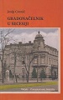
Author Cvenić, Josip, književnik
Title Gradonačelnik u secesiji : magle su bile sve gušće : cinema-novel
Impresum Osijek : Ogranak Matice hrvatske Osijek, 2022.
Description 212 str. ; 20 cm.
Note Str. 203-206: O Vjekoslavu Henglu / Erika Žilić Vincetić.
Životopis: str. 207-209.
ISBN 9789532421477 : EUR 22,40 US$ 24,90
UDC 821.163.42-31

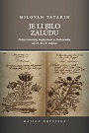
Author Tatarin, Milovan
Title Je li bilo zalúdu : prilozi hrvatskoj književnosti u Dubrovniku od 16. do 19. stoljeća
Impresum Zagreb : Matica hrvatska, 2023.
Description 1357 str. ; 23 cm.
ISBN 9789533412092 : EUR 56,00 US$ 62,20
Subject Hrvatska književnost -- Dubrovnik -- Povijest i kritika
UDC 821.163.42(497.584Dubrovnik)
Anotation The new book by the historian of older Croatian literature and university professor Milovan Tatarin brings together twenty-one studies devoted to Croatian literature in Dubrovnik from the 16th to the 19th century, most of which are being published in this edition for the first time. Milovan Tatarin's book makes a significant scientific contribution in three philological segments: in a textologically expert critical edition of the texts of Dubrovnik's early modern literature, in a detailed poetic description of its individual genres, and in reliable and relevant literary-historical factography.

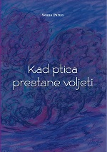
Title Kad ptica prestane voljeti : (izbor iz posljednjih rukopisnih memoara Vesne Parun)
/ priredili Denis Derk i Marina Selnik ; [ilustracije Vesna Parun].
Impresum Zagreb : Hrvatski državni arhiv, 2022. (Zagreb : Kerschoffset)
Description 166 str. : ilustr. ; 21 cm.
Note Str. 7-9: Predgovor / Denis Derk.
Bibliografija: str. 161.
ISBN 9789538461033 : EUR 18,20 US$ 20,20
Subject Parun, Vesna – Autobiografije. Hrvatske književnice -- Autobiografije
UDC 821.163.42-94 * 821.163.42.09Parun, V.

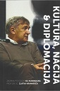
Title Kultura, nacija & diplomacija : zbornik povodom 65. rođendana prof. dr. sc. Zlatka Kramarića
/ [urednice Kristina Peternai Andrić, Tatjana Ileš].
Impresum Osijek : Filozofski fakultet ; Akademija za umjetnost i kulturu Sveučilišta J.J. Strossmayera, 2022.
Description 239 str. ; 24 cm.
Language/s Tekstovi na hrv. i na engl. jeziku.
Lat. i ćir.
ISBN 9789533141589 : EUR 16,20 US$ 18,00
Subject Kramarić, Zlatko, filolog -- Politička aktivnost. Kramarić, Zlatko, filolog – Obljetnice
Makedonska književnost -- Povijest i kritika. Književnost -- Povijest i kritika. Književnost i politika
UDC 32Kramarić, Z. * 821.163.42.0Kramarić, Z.

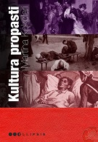
Author Kokolari, Martina
Title Kultura propasti : hrvatski književni dekadenti fin de sièclea
Impresum Zagreb : Durieux, 2023.
Description 287 str. ; 24 cm.
Note Bibliografija: str. 269-280; bibliografske bilješke uz tekst. Imensko kazalo.
ISBN 9789531885218 : EUR 24,70 US$ 27,40
Subject Hrvatska književnost -- 19. st. Hrvatska književnost -- 20. st. Dekadencija u književnosti
UDC 821.163.42.09

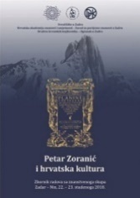
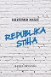
Author Bagić, Krešimir
Title Republika stiha
Impresum Zagreb : Matica hrvatska, 2023.
Description 375 str. ; 21 cm.
ISBN 9789533412511 : EUR 24,30 US$ 27,00
Subject Hrvatsko pjesništvo -- 2015.-2020.
UDC 821.163.42.09-1
Anotation Krešimir Bagić, poet, stylist and critic, collected more than 50 critical essays dedicated to contemporary Croatian poetry in the book Republika stiha.
In the new book, Bagić once again confirms himself as a knowledgeable theoretician, a reader who does not miss any detail of the text, and a writer who writes harmoniously and clearly and openly expresses his critical evaluations.

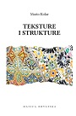
Author Kolar, Mario
Title Teksture i strukture : rasprave i ogledi iz novije hrvatske književnosti.
Impresum Zagreb : Matica hrvatska, 2023.
Description 297 str. ; 22 cm.
ISBN 9789533412078 : EUR 29,10 US$ 32,30
Subject Hrvatska književnost -- Povijest i kritika. Hrvatska dijalektalna književnost -- Povijest i kritika
UDC 821.163.42.09 * 821.163.42.09’282
Anotation Historian of Croatian literature and literary critic Mario Kolar, in his new book Teksture i strukture, gathered twelve studies dedicated to modern and contemporary Croatian writers. In his research, the author pays equal attention to Croatian classics (Fran Galović, Slavko Kolar, Antun Šoljan) and popular literature (Marija Jurić Zagorka), and he is equally interested in the literary canon and less researched and even completely neglected authors, works and phenomena.

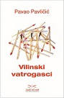
Author Pavličić, Pavao
Title Vilinski vatrogasci
Impresum Zagreb : Umjetnička organizacija Lađa od vode, 2023.
Description 142 str. ; 20 cm.
Note Pogovor: str. 131-138.
ISBN 9789534911488 : EUR 15,80 US$ 17,50
Anotation The text recounts the memories of the first reading and fascination with the novel "Fairy firemen" in Sirius magazine, along with considerations about reading, genres and personal poetics - author's and reader's.

Literature. Poetry
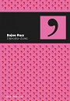
Author
Title Djevojka-Zarez
Impresum Zagreb : Durieux, 2023.
Description 67 str. ; 21 cm.
Note Stihovi.
Bilješka o autorici: str. 63.
ISBN 9789531885362 : EUR 13,50 US$ 15,00
UDC 821.163.42-1

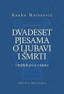
Author Matasović, Ranko
Title Dvadeset pjesama o ljubavi i smrti : (i kratkih priča o njima)
Impresum Zagreb : Matica hrvatska, 2023.
Description 93 str. ; 23 cm.
Note Stihovi i eseji o njima.
ISBN 9789533412504 : EUR 14,50 US$ 16,10
UDC 821-1=163.42=00(082)
Anotation Dvadeset pjesama o ljubavi i smrti (Twenty poems about love and death : and short stories about them) is a personal anthology in which the author chose the poems that, according to his own words, seem to be the strongest, most expressive and most valuable from the almost endless corpus of Western lyrics and translated them into Croatian. The circle of included poets ranges from Sapfa and Katul to Villon and Hölderlin to Trakl and Marina Cvetaeva and a number of poets of the 20th century.
The short stories written by the author for each song are particularly interesting to read. In them, the author's erudition and historical awareness come to the fore, as well as his literary skill, as Matasović imaginatively revives imagined biographical situations from the lives of poets, shows possible circumstances of the creation of poems or develops his own story on a theme from a poetic template.

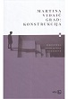
Author Vidaić, Martina
Title Grad: konstrukcija
Impresum Zagreb : V.B.Z., 2023.
Description 72 str. ; 21 cm.
Note Stihovi.
ISBN 9789535205982 : EUR 18,50 US$ 20,50
UDC 821.163.42-1

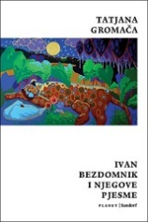
Author Gromača, Tatjana
Title Ivan Bezdomnik i njegove pjesme
Impresum Zagreb : Sandorf, 2023.
Description 84 str. ; 17 cm.
ISBN 9789533514642 EUR 10,70 US$ 11,90
Anotation Tatjana Gromača appeared on the Croatian literary scene at the turn of the millennium with her poetic debut "Something wrong?" and opened the way for a new generation of real-life poets whose strong influence in Croatian and regional literature is still our legacy today
And now, twenty-three years later, as is the case with great and unobtrusive poets, Gromača returns to poetic writing (from which she never left) without fanfare, modestly, yet powerfully and recognizable, in everyday language and directly, collection Ivan Bezdomnik i njegove pjesme

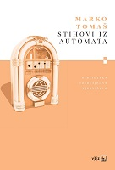
Author Tomaš, Marko
Title Stihovi iz automata
Impresum Zagreb : V.B.Z., 2023.
Description 136 str. ; 21 cm.
Note Stihovi.
ISBN 9789535205906 : EUR 18,50 US$ 20,50
UDC 821.163.4(497.6)-1

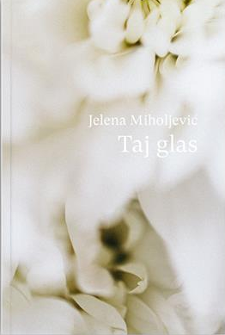
Author Miholjević, Jelena
Title Taj glas
Impresum Zagreb : Petrine knjige, 2023.
Description 185 str. ; 19 cm.
Note Stihovi.
Str. 173-185: Grad/glas Jelene Miholjević: Simfonijska lirika velegrada / Nataša Govedić
ISBN 9789538423598 : EUR 17,20 US$ 19,10
UDC 821.163.42-1

Literature. Novels, short stories

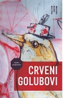
Author Lovrenčić, Sanja
Title Crveni golubovi
Impresum Zagreb : Mala zvona, 2022.
Description 208, 79 str. ; 20 cm.
Note Sadrži i stihove. Sadržaj: Crveni Golubovi: pjesmarica.
ISBN 9789538313592 : EUR 23.20 US$ 25.70
Anotation Sanja Lovrenčić's new novel, Crveni golubovi, is a double book: the prose text, which oscillates on the edge of fantasy, deals with the burning issues of the modern world, is complemented by Pjesmarica, a collection of poetic fragments that the author wrote as sketches for individual fragments of the novel. The action of the story, which is presented in two different ways, begins with the narrator's arrival on an unnamed island...

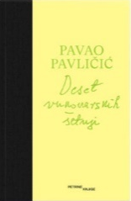
Author Pavličić, Pavao
Title Deset vukovarskih šetnji
Impresum Zagreb : Petrine knjige, 2023.
Description 82 str. ; 22 cm.
ISBN 9789538423567 : EUR 15,00 US$ 16,50
Anotation Pavao Pavličić takes us from east to west of Vukovar, telling us about the streets, buildings, churches and customs that can be seen there, but also about those that are no longer there and that remain only in the memories of witnesses and records like this one. The text is written in the genre of a tourist guide, but photos and maps are not included, we leave them to the reader, his imagination and a personal visit to this city. In addition to information, Pavličić also brings smells, colors, memories and secrets that he shares with us in this small but unforgettable book.

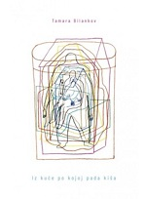
Author Bilankov, Tamara
Title Iz kuće po kojoj pada kiša
Impresum Zagreb : Naklada Jesenski i Turk, 2023.
Description 103 str. : ilustr. ; 20 cm.
ISBN 9789533810010 : EUR 14,00 US$ 15,50
Anotation The first collection of stories by the writer and interdisciplinary artist Tamara Bilankov Iz kuće po kojoj pada kiša (From the house where it rains), richly seasoned with drawings by Ivana Pipal, is one of the most unusual and fresh in our literature. Tamara Bilankov's stories are mostly sci-fi - there are also fantastic and realistic stories and mutated fables - which mostly reckon with new technologies as old nature, and write about societies in which radical changes have already taken place.

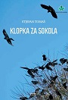
Author Tomaš, Stjepan
Title Klopka za sokola
Impresum Bizovac : Matica hrvatska, Ogranak Bizovac, 2023.
Description 153 str. ; 21 cm.
ISBN 9789537746551 : EUR 17,10 US$ 19,00
Anotation Using the allegory of Tomaš in this novel, he investigates the court process against a man who, in our divided reality, fought for Croatian independence, in very specific, difficult, opaque and dramatic historical circumstances, who is suspected of a war crime during the Homeland War, in a process that was undoubtedly political, and to a large extent staged, so the significant motto at the beginning of the novel, Nietzsche's words: 'Truth is a matter of (un)friendship.'

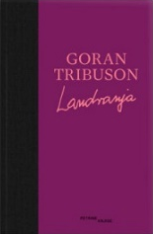
Author Tribuson, Goran
Title Landranja
Impresum Zagreb : Petrine knjige, 2023.
Description 160 str. ; 22 cm.
ISBN 9789538423550 : EUR 17,20 US$ 19,10
Anotation Goran Tribuson's Landranja is an anti-walking story. His hero has everything he needs indoors: books, movies and music. But when they inspire him, he has to go out, he has to go to the places where his literary heroes lived, where his favorite movies were filmed, and a good concert is also welcome. Tribuson's character belongs to a better past, to a time when there was little and even less was needed for happiness.

Author Beleš, Igor
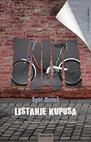
Title Listanje kupusa
Impresum Zagreb : Hena com, 2023.
Description 376 str. ; 22 cm.
ISBN 9789532594171 : EUR 23,50 US$ 26,10
Anotation In 1991, five eleven-year-olds, inseparable members of the An group, set out to investigate the mystery of the disappearance of children and some families from their settlement in Borovo, which changes from day to day, and more rapidly, from day to night, in the nights in which they are heard more and more often shots, detonations... However, their friendship is above all, so even the fact that they find out that they suddenly became Serbs or Croats means nothing to them, while it becomes crucial in the world of adults. Listanje kupusa (Leafing through the Cabbage) is one of the first more beautiful, then more painful and tense, and all in all more poignant and humane novels written in recent years.
It is a novel for adults and for those who, because of the war, never managed to grow up, or, on the other hand, managed to do so, but truncated, crookedly, without being guilty of it.

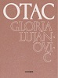
Author Lujanović, Gloria
Title Otac : poema
Impresum Zagreb : Naklada OceanMore, 2023.
Description 132 str. ; 21 cm.
ISBN 9789533321608 : EUR 13,40 US$ 14,90
Anotation This is a book about the war and what happened after the war. This is a book about a constituent nation and one of its families. A love book between father, homeland and foreign countries. A book about how in a person's life what has just disappeared becomes the most present. A book about defeated fathers who would like to say something else to their daughters rescued abroad.

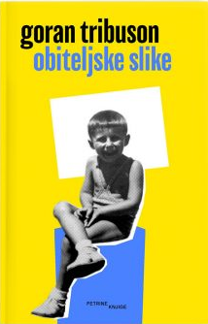
Author Tribuson, Goran
Title Obiteljske slike
Impresum Zagreb : Petrine knjige, 2022.
Description 522 str. ; 22 cm.
ISBN 9789538423307 : EUR 21,40 US$ 23,70
Anotation Obiteljske slike (Family Pictures) is a book of selected autobiographical records from the oeuvre of Goran Tribuson, which begins with two anthology stories, the one about the mother (Mrtva priroda) and the one about the father (Grobljanska lirika), and continues with a series of great, witty and touching records from the author's life, usually described through some p. ..

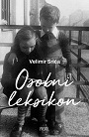
Author Srića, Velimir
Title Osobni leksikon
Impresum Zagreb : Profil knjiga, 2023.
Description 189 str., [8] str. s tablama : slike autora u boji ; 23 cm.
ISBN 9789533139357 : EUR 25.60 US$ 28,40
Anotation The author says about his book:
Someone said that memories are like a fire that warms inside, but if it is painful and strong, it can burn us. This book is an attempt to warm myself and everyone who has ever cared about me with that dangerous fire, but not to grieve for what has passed, but to rejoice because it all happened and was written down.

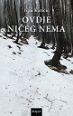
Author Katičić, Ivan
Title Ovdje ničeg nema
Impresum Zagreb : Disput, 2023.
Description 165 str. ; 21 cm.
ISBN 9789532604603 : EUR 19,30 US$ 21,40
Anotation In Katičić's short stories, we are greeted by places where "the sun is not welcome even in summer", or withered grass, bone-crushing rocks and wicked pits, in mountain meadows and in hearts. Grinding teeth, looks like whips, stone spikes ready to break the head and chains that really beat children. Deformed, defective, worn out by life, sweaty and smelly bodies. All sorts of stench, literal and metaphorical. Selfishness, stubbornness and stinginess. Narrow vistas and even narrower souls...


Author Horvat, Tihomir, književnik
Title Penjači : pripovijetke
Impresum Zagreb : Srednja Europa, 2023.
Description 316 str. ; 21 cm.
Note Bilješka o autoru i bibliografski podatci: str. 309-312. Str. 313-315: Penjači Tihomira Horvata / Julijana Matanović
ISBN 9789538281839 : EUR 19,30 US$ 21,40
Anoatition Penjači (The Climbers) stories tell about recognizable human destinies, show that the lives and destinies of "little ordinary
people" are worth telling. They encourage thinking and send a clear message that only an honest and healthy relationship with yourself, your environment and the world is the only and right way to become a "climber" in search of the meaning of life. The collection of stories The Climbers, dedicated to the memory of the writer Jozo Vrkić, contains 18 stories.

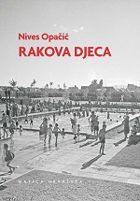
Author Opačić, Nives
Title Rakova djeca
Impresum Zagreb : Matica hrvatska, 2023.
Description 252 str. ; 20 cm.
ISBN 9789533412498 : EUR 24,30 US$ 27,00
Anotation In her new book, Children of Cancer, Nives Opačić decided to take a step forward and wrote a book that, unlike previous books, is not primarily devoted to words and their known and unknown meanings. Of course, there is more in Cancer's children, but this time the favorite linguist paid attention to topics that are close to her personally, such as the intimate meanings of some personal names, her love for music and musicians, walks in Zagreb's neighborhoods, and memories of the old places of her youth and childhood. . In this skilfully written and largely autobiographical book, an intimate recapitulation of life's path and incredible knowledge of Zagreb's cultural history are interwoven.

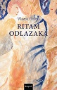
Author Golub, Vlasta
Title Ritam odlazaka
Impresum Zagreb : Disput, 2023.
Description 218 str. ; 21 cm.
ISBN 9789532604580 : EUR 20,40 US$ 22,60
Anotation The narrative structure of the novel Ritam odlazaka (Rhythm of departures) is based on a chained series of reminiscences, poetically intoned fragments in the form of flashes of memory of the four protagonists. The family connection between the characters remains blurred in the first half of the novel, left to the reader's desire for an almost detective-like finding of narrative logic in the course of the plot.

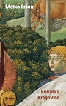
Author Sršen, Matko
Title Rokaška Kraljevina
Impresum Zagreb : Sandorf, 2023.
Description 309 str. ; 21 cm.
Note Rječnik dubrovčanizama, talijanizama i fraza: str. 299-309.
ISBN 9789533514734 : EUR 19,30 US$ 21,40
Anotation Rokaška Kraljevina (The Kingdom of Rokaška) is a children's state founded by small residents of the Izaroka district of
Dubrovnik's Old Town in the mid-fifties of the last century. Rokaška Kraljevina is not a children's book, but rather a war novel. Unusual in its kind, but still warlike, in which the little Rokaši are at war with the big policemen, members of the People's Militia. On the one hand, adults, armed with pistols and batons, and on the other, children who acquired their "royal skills" acting in "Hamlet" in Lovrijenac and in other Dubrovnik plays, armed with an imagination that transcends all social boundaries.

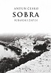
Author Česko, Antun
Title Sobra : ribarski zapisi
Impresum Zagreb : Durieux, 2023.
Description 182 str. ; 25 cm.
Note Rječnik: str. [169]-182.
ISBN 9789531885447 : EUR 20,30 US$ 22,50
Anotation Sobra : ribarski zapisi (Sobra - fisherman's notes) is a collection of twelve short stories that are all connected in continuity by place, time, plot, and characters. At the same time, everything is based on ultimate authenticity.

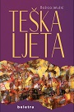
Author Jelušić, Božica
Title Teška ljeta
Impresum Zagreb : Beletra, 2023.
Description 161 str. ; 20 cm.
Note Str. 140-145: Pogovori : Placebo Božice Jelušić: Kava, brza vožnja Harleyem, let paraglajderom ili tekst o tome? / Božica Brkan ; str. 146-151 ; Škrinja suptilnosti i vulkan strasti / Lada Žigo Španić ; str. 152-157: Refleksije nad slojevitim štivom / Nives Franić ; str. 158-160: Umjetnička prijateljstva koja su pisala povijest / Sandra Pocrnić Mlakar.
ISBN 9789538209529 : EUR 21,50 US$ 23,90
Anotation Teška ljeta (Difficult Summer) by Božica Jelušić is a biographical novel-essay about the search for emotional refuge and remembering contemporaries who were supports, friends and inspiration. The fluent, lively and dense text requires careful concentration, and tells the story of her childhood in the province and the Zagreb artistic circles of the seventies and early eighties, where the poet gained her confidence as a writer among the role models and artists who inspired her.

Arts. General

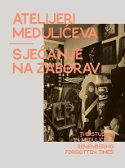
Author Jurčec Kos, Koraljka
Title Atelijeri Medulićeva - Sjećanje na zaborav : [Galerija Klovićevi dvori, Zagreb, 20. travnja 2023. - 28. svibnja 2023. = The Studios in Medulićeva - Remembering forgotten times : Klovićevi dvori Gallery, Zagreb, 20 April 2023 - 28 May 2023]
/ [Autori tekstova, texts written by Koraljka Jurčec Kos, Anamarija Komesarović, Ive Šimat Banov ;
urednice, editors Koraljka Jurčec Kos, Anamarija Komesarović].
Impresum Zagreb : Galerija Klovićevi dvori, 2023.
Description 144 str. : ilustr. ; 28 cm.
Note Katalog izložbe.
Language/s Tekst na hrv. i na engl. jeziku
ISBN 9789532711462 : EUR 18,30 US$ 20,30
UDC 7.022(497.521.2) * 75(497.5) * 73(497.5)
Anotation The studios at Medulićeva 12 have been a place of creation since 1969, and to this day many different artists have worked in these spaces - our exhibition rests on the diversity and uniqueness of each of them. Each room of this exhibition is unique and self-contained: a mirror of each individual artist. The exhibition is part of the series "Zagreb Painting and Sculpture Ateliers of the Second Half of the 20th Century", and is the first of three exhibitions that will be held once a year in Klović's mansions. The first exhibition focuses on the work of artists who created from the studio in Medulićeva street no. 12.

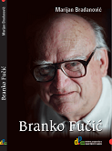
Author Bradanović, Marijan
Title Branko Fučić : povjesničar umjetnosti i konzervator
Impresum Rijeka : Društvo povjesničara umjetnosti Rijeka, 2023
ISBN 9789537663117 : EUR 32,30 US$ 35,80
Subject Fučić, Branko, povjesničar umjetnosti -- Život i djelo
UDC 7.072Fučić, B.
Anotation This intellectual and professional biography of Branko Fučić provides a rounded picture of life and work, i.e. the research development, flowering and fruitful work of Fučić, but also of the legacy of one of the research academic giants of Croatian art history, the history of literacy and the conservation profession. Therefore, Fučić's place in the national historiography on the history of art will fundamentally change after this work.

Urbanism.Architecture
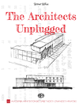
Author Rošin, Jerko
Title The Architects Unplugged
Impresum Zagreb : Alfa : Akademija arhitektonske umjetnosti i znanosti Hrvatske, 2023.
Description 419 str. : ilustr. u bojama ; 30 cm.
Language/s Tekst na hrv. i na engl. jeziku.
ISBN 9789533644769 (Alfa) : EUR 62,40 US$ 69,30
Subject Arhitekti -- Hrvatska
UDC 72-051(497.5)

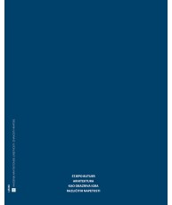
Author Butijer, Stjepo
Title Arhitektura kao obazriva igra različitih napetosti
/ Stjepo Butijer ; osvrti Andrija Mutnjaković ... [et al.].
Impresum Zagreb : Naklada Ljevak : Akademija arhitektonske umjetnosti i znanosti Hrvatske, 2022.
Description 493 str. : ilustr. u bojama, nacrti ; 31 cm.
ISBN 9789533556123 : EUR 59,80 US$ 66,40
Subject Butijer, Stjepo. Hrvatska arhitektura -- 20. st. Hrvatska arhitektura -- 21. st.
UDC 72Butijer, S. * 72(497.5)

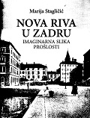
Author Stagličić, Marija
Title Nova riva u Zadru : imaginarna slika prošlosti
Impresum Zadar : Sveučilište u Zadru, 2022.
Description 103 str. : ilustr. (pretežno u bojama) ; 28 cm.
Note Summary: nova riva (new waterfront) in Zadar - a hypotehtical image of the past.
ISBN 9789533313856 : EUR 32,40 US$ 36,00
Subject Hrvatska arhitektura -- Zadar – Povijest. Zadar -- Zgrade i građevine -- 19. st.
Zadar -- Zgrade i građevine -- 20. st.
UDC 72(497.581.1Zadar) * 711.4(497.581.1Zadar)

Sculpture

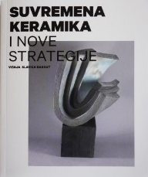
Author Slavica Gabout, Višnja
Title Suvremena keramika i nove strategije
/ Višnja Slavica Gabout ; [prijevod na engleski Leo Vidmar, Višnja Slavica Gabout].
Impresum Zagreb : ULUPUH - Hrvatska udruga likovnih umjetnika primijenjenih umjetnosti, 2022.
Description 156 str. : ilustr. u bojama ; 21 cm.
Language/s Tekst na hrv. i engl. jeziku.
Note Bibliografija.
ISBN 9789533272344 : EUR 24,40 US$ 27,10
Subject Keramika -- Hrvatska -- 2010.-2020. Keramika -- Hrvatska -- 2020.-2030.
UDC 738(497.5)

Paintings

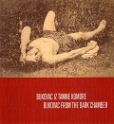
Author Puhara, Helena
Title Bukovac iz tamne komore = Bukovac from the dark chamber : Muzeji i galerije Konavala, Kuća Bukovac = Museums and Galleries of Konavle, Bukovac House
Impresum Cavtat : Muzeji i galerije Konavala = Museums and Galleries of Konavle, 2021.
Description 87 str. : ilustr. u bojama ; 21 cm.
Note Katalog izložbe stalnog postava. Bilješke ; Endnotes: str. 40-41.
Language/s Tekst na hrv. i na engl. jeziku.
ISBN 9789537226350 : EUR 17,10 US$ 19,00
Subject Bukovac, Vlaho -- Fotografske zbirke – Izložbe. Bukovac, Vlaho -- Portreti -- Izložbe
Bukovac, Vlaho – Biografije * Muzeji i galerije Konavala (Cavtat) -- Fotografske zbirke -- Izložbe
UDC 069:929 * 75Bukovac, V.

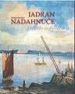
Title Jadran nadahnuće = Adriatic inspiration / Zbirka Večerina = Večerina Collection ; [predgovori, forewords Ervin Dubrović, Ana Petković Basletić ; životopisi umjetnika, biographies of artists Duško Večerina
Impresum Rijeka : Muzej grada, 2022.
Description 207 str. : ilustr. u bojama ; 27 cm.
Note Katalog izložbe.
Language/s Tekst usporedo na hrv. i engl. jeziku.
ISBN 9789538303180 : EUR 16,20 US$ 18,00
Subject Večerina, Duško -- Umjetničke zbirke – Izložbe. Zbirka Večerina -- Izložbe
UDC 7.074Večerina * 75(4)

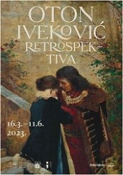
Author Iveković, Oton
Title Oton Iveković: Retrospektiva : Galerija Klovićevi dvori, Zagreb, 16. ožujka – 11. lipnja 2023.
/ [urednica Danijela Markotić ; tekstovi Danijela Markotić, Snježana Pintarić, Petra Vugrinec].
Impresum Zagreb : Galerija Klovićevi dvori, 2023.
Description 308 str. : ilustr. u bojama ; 28 cm.
Note Katalog izložbe.
ISBN 9789532711455 : EUR 30,50 US$ 33,90
Subject Iveković, Oton – Izložbe. Iveković, Oton -- Interpretacije i kritike
UDC 75Iveković, O.

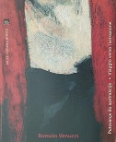
Author Venucci, Romolo
Title Romolo Venucci: Putovanje do apstrakcije = Viaggio verso l’astrazione
/ [Autori, Autore Ema Makarun, Ervin Dubrović, Enrico Lucchese ; prijevod, traduzione Rosalia Massarotto, Iva Gašparac
Impresum Rijeka : Muzej grada, 2022.
Description 103 str. : ilustr. (pretežno u bojama) ; 28 cm.
Note Katalog izložbe održane od 24. ožujka do 26. lipnja 2022. u Muzeju grada Rijeke (u muzejskoj "Kockici").
Language/s Tekst na hrv. i tal. jeziku.
ISBN 9789538303166 : EUR 12,90 US$ 14,30
UDC 75Venucci, R.
Anotation The painting oeuvre of the Rijeka painter Romolo Venucci can be experienced as the equivalent of the city's political changes in the 20th century. On one side, there are constant changes in state affiliation and government, and on the other, continuous changes in the artistic language. Venucci's oeuvre is consequently stylistically heterogenous. In his earlier works, we can see personal interpretations of historical Cubist, Futurist and Expressionist experiences, which Venucci met during his schooling in Hungary. After the Second World War, he focused on a more conventional statement, becoming close to realism.

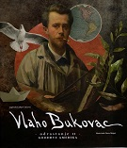
Author Crnčević, Lidija
Title Vlaho Bukovac : odrastanje II : goodbye Amerika
Impresum Gruda : Muzeji i galerije Konavala, 2022.
Description [53] str. : ilustr. u bojama ; 25 cm.
Note Ilustr. i na unut. str. om. listova.
ISBN 9789537226428 : EUR 19,50 US$ 21,60
Subject Bukovac, Vlaho -- Biografije
UDC 75Bukovac, V.

Photographs

Author Standl, Ivan
Title Ivan Standl : zagrebački fotograf 1832. - 1897. : Muzej grada Zagreba, Zagreb, 15. prosinca 2022. – 19. ožujka 2023. / [Autori tekstova Hrvoje Gržina ... [et al.] ; Autorice kataloških jedinica Ivana Gržina, Dunja Nekić, Dubravka Stančec ; glavna urednica Ivana Gržina].
Impresum Zagreb : Muzej grada Zagreba ; Hrvatska akademija znanosti i umjetnosti ; Muzej za umjetnost i obrt, 2023.
Description 167 str. : ilustr. u bojama ; 29 cm.
Note Katalog izložbe.
ISBN 9789538496004 : EUR 29,00 US$ 32,20
Subject Standl, Ivan – Izložbe. Hrvatska fotografija -- 19. st. -- Izložbe
UDC 77Standl, I.


Author Žanetić, Tomo
Title Snimio Tomo Žanetić
/ urednik Lidija Crnčević].
Impresum [Cavtat] : Muzeji i galerije Konavala, 2022.
Description [128] str. : ilustr. (pretežno u bojama) ; 30 cm.
Note Fotomonografija.
ISBN 9789537226404 : EUR 41,50 US$ 46,10
Subject Domovinski rat (1991.-1995.) – Fotografija. Dokumentarna fotografija -- Dubrovačko-neretvanska županija.
Ratna fotografija -- Dubrovačko-neretvanska županija
UDC 77.03:355(497.584) * 77Žanetić, T.

